Powys Teaching Health Board pharmaceutical needs assessment

September 2021

Contents

Executive summary 3
1 Introduction 8
2 Overview of Powys 24
3 General health needs of Powys 45
4 Identified patient groups – particular health issues 55
5 Provision of pharmaceutical services 71
6 Other NHS services 100
7 Health needs that can be met by pharmaceutical services 107
8 North Powys locality 114
9 Mid Powys locality 142
10 South Powys locality 169
11 Conclusions for the purpose of schedule 1 of the NHS (Pharmaceutical Services) (Wales) Regulations 2020 195
Appendix A – policy context and background papers 200
Appendix B – essential services 205
Appendix C – advanced services 209
Appendix D – enhanced services 212
Appendix E – terms of service for dispensing appliance contractors 216
Appendix F – Pharmaceutical needs assessment steering group membership 220
Appendix G – Patient and public questionnaire 221
Appendix H – full results of the patient and public questionnaire 233
Appendix I – contractor questionnaire 269
Appendix J – dispensing practice questionnaire 272
Appendix K – consultation report 275
Appendix L – opening hours 304

Executive summary

From 1 October 2021, the health board has a statutory responsibility to publish and keep up-to-date a statement of the needs for pharmaceutical services for the population in its area, referred to as a ‘pharmaceutical needs assessment’. This is Powys Teaching Health Board’s first pharmaceutical needs assessment and its development has been overseen by a steering group which included representation from the health board, Community Pharmacy Wales and Dyfed Powys Local Medical Committee.

The pharmaceutical needs assessment:

- Sets out the current health needs of the population and how they will change over the five year lifetime of the document (1 October 2021 to 30 September 2026),
- Describes the current provision of pharmaceutical services by pharmacies, dispensing appliance contractors and dispensing doctors both within and outside of the health board’s area,
- Takes into account any changes that will arise during the lifetime of the document such as demographic changes, housing developments, regeneration projects, and changes to the location of other NHS service providers, and
- Identifies any current gaps in service provision or any that will arise during the lifetime of the document.

From 1 October 2021 the pharmaceutical needs assessment will be used by the health board when considering whether or not to grant applications to join its pharmaceutical list or dispensing doctor list under The National Health Service (Pharmaceutical Services) (Wales) Regulations 2020. Decisions on such applications may be appealed to Welsh Ministers who will then also refer to the document when hearing any such appeal. It will also be used to inform decisions on applications for the relocation of existing pharmacy and dispensing doctor premises, applications to change pharmacy core opening hours, and in relation to the commissioning of new services from pharmacies.

Powys is a largely upland and very rural county in the middle of Wales covering over 5,000km². Whilst it occupies approximately 25% of the landmass of Wales it has only 5% of the population. The upland areas are dissected by river and their tributaries and this topography has shaped the development of the area, leading to the majority of the larger settlements and main transport routes being located in the valleys, often at important river crossings.

Migration in and out of Powys has been the key determinant of change in the size and structure of the Powys population because net natural change has been negative for some time with deaths exceeding births. The population is generally older, and the average age is rising faster than in Wales as a whole.

The Brecon Beacons National Park is in the south of the county and covers approximately 16% of Powys, containing some of the most spectacular and distinctive upland landforms in southern Britain. It is a diverse landscape, where sweeping uplands contrast with green valleys, with dramatic waterfalls, ancient woodland, caves, forests and reservoirs.

The mid-year 2019 estimates put the health board’s population at 132,435 and it is projected that the population will decline in size during the lifetime of this document. The population in Powys is older compared to the rest of Wales and the proportion of older people is growing. The working age adult population is smaller compared to Wales and it is predicted that the number of young people and working age adults will decrease, whilst the number of older people will increase.

Chapter 1 sets out the regulatory framework for the provision of pharmaceutical services which, for the purpose of this document, include those services provided by pharmacies and dispensing appliance contractors (referred to as essential, advanced and enhanced services) and the dispensing service provided by some GP practices to eligible patients. It also contains the views of 218 residents of the health board’s area on their use of pharmacies and dispensing doctors which were gained from an online questionnaire and show:

- Pharmacies are mainly used for the dispensing of prescriptions, to buy medicines or to get advice.
- Most people visit a pharmacy on a monthly basis.
- For those who have a preference as to the time at which they visit a pharmacy, 09.00 to 12.00 and 15.00 to 18.00 are the most popular times.
- With regard to the preferred day of the week on which to visit a pharmacy, 43% of responders didn’t have a preference, 26% said weekdays in general and 5.5% said weekends in general.
- The top four influences on the choice of which pharmacy to use are proximity to home address, a location that is easy to get to, trust in the staff, and the provision of good advice and information.
- 58% of respondents drive to a pharmacy and 30% walk.
- 84% of respondents can travel to a pharmacy within 20 minutes. 9% chose not to answer the question.

This chapter also contains information provided by contractors which could not be nationally sourced:

- 91% of the pharmacies are accessible by wheelchair,
- All of the pharmacies bar one have a consultation area,
- 70% of pharmacies said that they have sufficient capacity within their existing premises and staffing levels to meet an increase in demand, and
- 30% said they didn’t have sufficient capacity but could make adjustments in order to do so.

Following an overview of the demographic characteristics of the residents of the health board’s area in chapter 2, chapter 3 focusses on their health needs.

In order to ensure that those sharing a protected characteristic and other patient groups are able to access pharmaceutical services chapter 4 identifies the specific groups that are present in the health board’s area and their likely health needs.

Chapter 5 focusses on the provision of pharmaceutical services in the health board’s area and those providers who are located outside of the area but who provide services to those living within the health board’s area. As of April 2021 there are 23 pharmacies included in the health board’s pharmaceutical list, operated by 13 different contractors. There are no dispensing appliance contractors in the health board’s area. Of the 16 GP practices, 12 dispense to their eligible patients from 23 sites. The pharmacies are generally located in areas of greater population density and deprivation.

The majority of the population is within a 20-minute drive of a pharmacy. Those areas that aren’t either have no resident population or a very small population (up to 23 people per lower super output area).

The vast majority (59.6%) of items prescribed by the GP practices in 2019/20 were dispensed by one of the 23 pharmacies, with a further 33.3% dispensed or personally administered by the GP practices.

Looking at all the items prescribed by the GP practices and other NHS services which generate prescriptions, 6.9% of items in 2019/20 were dispensed outside of the health board’s area (either elsewhere in Wales or in England) by over 262 different pharmacies. However the majority (83%) were dispensed by just three contractors in either Swansea Bay University Health Board or Aneurin Bevan University Health Board.

Services which affect the need for pharmaceutical services either by increasing or reducing demand for a particular service are identified in chapter 6. Such services include the community hospitals, personal administration of items by GP practices, the GP out of hours service, Help me Quit, and community and primary care based services.

Having considered the general health needs of the population, chapter 7 focusses on those that can be met by pharmacies, dispensing appliance contractors and the dispensing service provided by some GP practices.

The health board has divided its area into three localities for the purpose of this document (north, mid and south), based upon the primary care clusters.

Each locality has a dedicated chapter which looks at the needs of the population, considers the current provision of pharmaceutical services to residents and identifies whether or not current provision meets the needs of those residents. Each chapter goes on to consider whether there are any gaps in service delivery that may arise during the lifetime of the pharmaceutical needs assessment.

In chapter 11 the health board has identified the following services as those that are necessary to meet the need for pharmaceutical services in its area:

- Essential, advanced and enhanced services provided at all premises included in a pharmaceutical list, and
- The dispensing service provided by those GP practices included in a dispensing doctor list.

Access to pharmaceutical services for the residents is good and the main conclusion of this pharmaceutical needs assessment is that there are currently no gaps in the provision of essential or advanced services.

Current needs for certain enhanced services have been identified in relation to Llanwrtyd Wells:

- Emergency hormonal contraception,
- Smoking cessation level 3,
- Flu vaccination,
- Common ailment service, and
- Emergency medicine supply.

However, the health board’s preference is for the existing pharmacy to provide this service and it will therefore work with the contractor to achieve this end.

The pharmaceutical needs assessment also looks at changes which are anticipated within the lifetime of the document. Given the current population demographics, housing projections, the projected decline in the size of the population, and the distribution of service providers across the health board’s area, the document concludes that the current provision will be sufficient to meet the future needs of the residents during the five-year lifetime of this pharmaceutical needs assessment.

A 60-day consultation has been undertaken on the findings of the consultation version of the pharmaceutical needs assessment, as required by the regulations, and the document has been reviewed in light of the responses received. A report on the consultation has been included as an appendix and details of the changes made to the pharmaceutical needs assessment are set out in that report.

1 Introduction

1.1 Purpose of a pharmaceutical needs assessment

The purpose of the pharmaceutical needs assessment is to assess and set out how the provision of pharmaceutical services can meet the health needs of the population of a health board’s area for a period of up to five years, linking closely to the Powys Public Service Board Well-being Assessment 2017. Whilst the wellbeing assessment focusses on the general health needs of the population of Powys, the pharmaceutical needs assessment looks at how those health needs can be met by pharmaceutical services commissioned by the health board.

If a person (a pharmacy or a dispensing appliance contractor) wants to provide pharmaceutical services, they are required to apply to the health board, in whose area the premises are to be located, to be included in its pharmaceutical list. In general, their application must offer to meet a need that is set out in that health board’s pharmaceutical needs assessment. There are however two exceptions to this e.g. change of ownership applications and relocations for business purposes.

If a GP wishes to dispense to a new area or from new or additional premises they are also required to apply to the health board to be included in its dispensing doctor list or for a new area or new or additional premises to be listed in relation to them. In general, their application must also offer to meet a need that is set out in that health board’s pharmaceutical needs assessment.

As well as identifying if there is a need for additional premises, the pharmaceutical needs assessment will also identify whether there is a need for an additional service or services. Identified needs could either be current or will arise within the five-year lifetime of the pharmaceutical needs assessment.

1.2 Health board duties in respect of the pharmaceutical needs assessment

Further information on the health board’s specific duties in relation to pharmaceutical needs assessments and the policy background to pharmaceutical needs assessments can be found in appendix A, however in summary the health board must:

- Publish its first pharmaceutical needs assessment by 1 October 2021;
- Publish revised statements (i.e. subsequent pharmaceutical needs assessments), on a five yearly basis, which comply with the regulatory requirements;
- Publish a subsequent pharmaceutical needs assessment sooner when it identifies changes to the need for pharmaceutical services which are of a significant extent, unless to do so would be a disproportionate response to those changes; and
- Produce supplementary statements which explain changes to the availability of pharmaceutical services in certain circumstances.

1.3 Pharmaceutical services

The services that a pharmaceutical needs assessment must include are defined within both the National Health Service (Wales) Act 2006 and the NHS (Pharmaceutical Services) (Wales) Regulations 2020.

Pharmaceutical services may be provided by:

- A pharmacy contractor who is included in the pharmaceutical list for the area of the health board;
- A dispensing appliance contractor who is included in the pharmaceutical list held for the area of the health board; and
- A doctor or GP practice that is included in a dispensing doctor list held for the area of the health board.

Each health board is responsible for preparing, maintaining and publishing its lists. In Powys Teaching Health Board’s area there are 23 pharmacies and 13 dispensing practices.

Contractors may operate as either a sole trader, partnership or a body corporate. The Medicines Act 1968 governs who can be a pharmacy contractor, but there is no restriction on who can operate as a dispensing appliance contractor.

1.3.1 Pharmaceutical services provided by pharmacy contractors

Unlike for GPs, dentists and optometrists, Powys Teaching Health Board does not hold contracts with the pharmacy contractors in its area. Instead they provide services under a contractual framework, sometimes referred to as the community pharmacy contractual framework, details of which (the terms of service) are set out in schedule 5 of the NHS (Pharmaceutical Services) (Wales) Regulations 2020, the Pharmaceutical Services (Advanced and Enhanced Services) (Wales) Directions 2005, and the Pharmaceutical Services (Advanced Services) (Appliances) (Wales) Directions 2010.

Pharmacy contractors provide three types of service that fall within the definition of pharmaceutical services and the community pharmacy contractual framework. They are:

- Essential services – all pharmacies must provide these services
  - Dispensing of prescriptions, including urgent supply of a drug or appliance without a prescription
  - Dispensing of repeatable prescriptions
  - Disposal of unwanted drugs
  - Promotion of healthy lifestyles
  - Signposting, and
  - Support for self-care

- Advanced services – pharmacies may choose whether to provide these services or not. If they choose to provide one or more of the advanced services they must meet certain requirements and must also be fully compliant with the essential services and clinical governance requirements.
  - Medicines use review and prescription intervention services (more commonly referred to as the medicines use review service)
  - Discharge medicines review service
  - Stoma appliance customisation
  - Appliance use review

- Enhanced services – service specifications for this type of service are developed by the health board and then commissioned to meet specific health needs.
  - Anticoagulation monitoring
  - Care home service
  - Disease specific medicines management service
  - Gluten free food supply service
  - Home delivery service
  - Language access service
  - Medication review service
  - Medicines assessment and compliance support service
  - Minor ailment scheme
  - Needle and syringe exchange
  - On demand availability of specialist drugs service
  - Out of hours service
  - Patient group direction service
  - Prescriber support service
  - Schools service
  - Screening service
  - Stop smoking service
  - Supervised administration service
  - Prescribing service
  - An anti-viral collection service
  - An emergency supply service

Further information on the essential, advanced and enhanced services requirements can be found in appendices B, C and D respectively.

Underpinning the provision of all of these services is the requirement on each pharmacy contractor to participate in a system of clinical governance. This system is set out within the NHS (Pharmaceutical Services) (Wales) Regulations 2020 and includes:

- A patient and public involvement programme
- A clinical audit programme
- A risk management programme
- A clinical effectiveness programme
- A staffing and staff management programme,
- An information governance programme, and
- A premises standards programme.

Pharmacies are required to open for not less than 40 hours per week, and these are referred to as core opening hours, but many choose to open for longer and these additional hours are referred to as supplementary opening hours. Under the NHS (Pharmaceutical Services) (Wales) Regulations 2020 it is possible for pharmacy contractors to successfully apply to open a pharmacy with a greater number of core opening hours in order to meet a need identified in a pharmaceutical needs assessment.

The proposed opening hours for each pharmacy are set out in the initial application, and if the application is granted and the pharmacy subsequently opens these form the pharmacy’s contracted opening hours. The contractor can subsequently apply to change their core opening hours and the health board will assess the application against the needs of the population of its area as set out in the pharmaceutical needs assessment to determine whether to agree to the change in core opening hours or not. If a pharmacy contractor wishes to change their supplementary opening hours they simply notify the health board of the change, giving at least three months’ notice.

1.3.2 Pharmaceutical services provided by dispensing appliance contractors

As with pharmacy contractors, Powys Teaching Health Board does not hold contracts with dispensing appliance contractors. Their terms of service are set out in schedule 6 of the NHS (Pharmaceutical Services) (Wales) Regulations 2020 and the Pharmaceutical Services (Advanced Services) (Appliances) (Wales) Directions 2010.

Dispensing appliance contractors provide the following services for appliances (not drugs), for example catheters and colostomy bags, which fall within the definition of pharmaceutical services:

- Dispensing of prescriptions (both electronic and non-electronic), including urgent supply without a prescription
- Dispensing of repeatable prescriptions
- Home delivery service for some items
- Supply of appropriate supplementary items (e.g. disposable wipes and disposal bags)
- Provision of expert clinical advice regarding the appliances, and
- Signposting

They may also choose to provide advanced services. If they do choose to provide them then they must meet certain requirements and must also be fully compliant with their terms of service and the clinical governance requirements. The two advanced services that they may provide are:

- Stoma appliance customisation
- Appliance use reviews

As with pharmacies, dispensing appliance contractors are required to participate in a system of clinical governance. This system is set out within the NHS (Pharmaceutical Services) (Wales) Regulations 2020 and includes:

- A patient and public involvement programme
- A clinical audit programme
- A risk management programme
- A clinical effectiveness programme
- A staffing and staff programme,
- An information governance programme, and
- A premises standards programme.

Further information on the requirements for these services can be found in appendix E.

Dispensing appliance contractors are required to open not less than 30 hours per week and these are referred to as core opening hours. They may choose to open for longer and these additional hours are referred to as supplementary opening hours. Under the NHS (Pharmaceutical Services) (Wales) Regulations 2020 it is possible for dispensing appliance contractors to successfully apply to open premises with a greater number of core opening hours in order to meet a need identified in a pharmaceutical needs assessment.

The proposed opening hours for each dispensing appliance contractor are set out in the initial application, and if the application is granted and the dispensing appliance contractor subsequently opens then these form the dispensing appliance contractor’s contracted opening hours. The contractor can subsequently apply to change their core opening hours. The health board will assess the application against the needs of the population of its area as set out in the pharmaceutical needs assessment to determine whether to agree to the change in core opening hours or not.

1.3.3 Pharmaceutical services provided by doctors

The NHS (Pharmaceutical Services) (Wales) Regulations 2020 allow doctors to dispense to eligible patients in certain circumstances. The regulations are complicated on this matter but in summary:

- Patients must live in a ‘controlled locality’ (an area which has been determined by the health board or a preceding organisation as rural in character, or on appeal by the Welsh Ministers), more than 1.6km (measured in a straight line) from a pharmacy, and
- Their practice must have premises approval and outline consent to dispense to that area.

There are some exceptions to this, for example patients who have satisfied the health board that they would have serious difficulty in accessing a pharmacy by reason of distance or inadequacy of means of communication.

1.4 Other NHS services

Other services which are commissioned or provided by Powys Teaching Health Board which affect the need for pharmaceutical services are also included within the pharmaceutical needs assessment.

1.5 How the assessment was undertaken

1.5.1 Pharmaceutical needs assessment steering group

Powys Teaching Health Board has overall responsibility for the publication of the pharmaceutical needs assessment, and the medical director is accountable for its development. The health board established a pharmaceutical needs assessment steering group whose purpose was to ensure that the development of a robust pharmaceutical needs assessment that complies with the NHS (Pharmaceutical Services) (Wales) Regulations 2020 and meets the needs of the local population. The membership of the steering group ensured all the main stakeholders were represented and can be found in appendix F.

1.5.2 Pharmaceutical needs assessment localities

The localities that have been used for the pharmaceutical needs assessment match the boundaries of the GP clusters, namely:

- North Powys
- Mid Powys, and
- South Powys.

All three clusters have multi-disciplinary and multi-organisational membership including the health board, county council, third sector, dentistry, optometry and pharmacies.

As a result services are planned and delivered on this footprint and it was therefore agreed that they should be used as the basis for the pharmaceutical needs assessment localities.

1.5.3 Patient and public engagement

In order to gain the views of patients and the public on pharmaceutical services, a questionnaire was developed and made available online from 16 November to 14 December 2020. It was shared with a wide range of stakeholders to ask them to share through their networks and communities, including:

- Powys Community Health Council,
- Powys Association of Voluntary Organisations (for cascade to third sector organisations in the county),
- Town and community councils,
- County councillors,
- Members of the Senedd and Members of Parliament.

It was also promoted via the health board’s website and social media platforms. Due to the ongoing Covid-19 pandemic it was not possible to hold face to face events to promote the questionnaire or to engage with patients and the public, and it is acknowledged that this will have affected the response rate. The questionnaire was made available in both Welsh and English, although no responses were received for the Welsh version.

A copy, which shows the questions asked, can be found in appendix G. The full results can be found in appendix H

A total of 218 people completed the questionnaire in English (no Welsh responses were received). The heat map below shows the location of those who responded based upon the postcode district that they live in with the darker the colour the greater the number of responses received. It should be noted that the postcode districts do not map to the boundaries of the health board’s area and responses were not received from all of the postcode districts.

Map 1 – map showing the postcode districts of those responding to the patient and public questionnaire

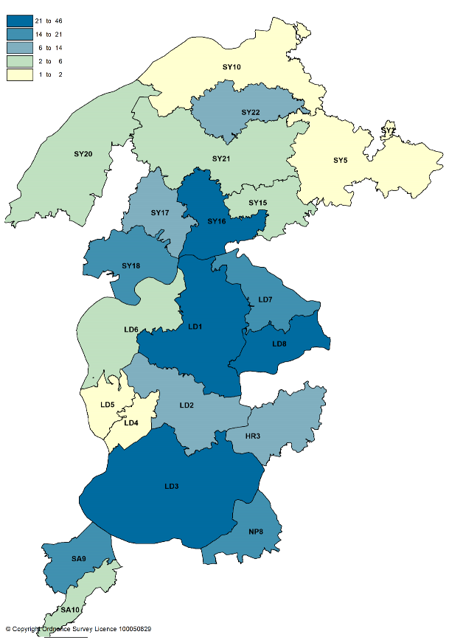

© Copyright Ordnance Survey Licence 100050829

In relation to the people who responded to the questionnaire:

- 58.7% have their prescriptions dispensed by a pharmacy and 38.5% by their GP practice.
- 90.4% said their preferred language when accessing services at a pharmacy or a GP practice is English, and 1.4% said Welsh.
- 68.8% are female and 21.6% are male.
- 81.2% of respondents are aged 35 to 74.

The most common reasons why people go to a pharmacy are to either collect medicines for themselves or someone else, to buy medicines for themselves or someone else, or to get advice for themselves.

Visiting a pharmacy monthly was the most common frequency (56% of respondents), with fortnightly or weekly the second most common frequency (11% each).

30.7% of respondents didn’t have a preference as to the most convenient time. For those that did, 86.5% indicated times between 09.00 and 18.00.

Just under half of respondents didn’t have a preferred day to visit a pharmacy (42.7%). For those that did, 53.8% said weekdays in general, 11.3% weekends in general and 7.5% Saturdays.

19% of respondents said there had been a time recently when they had not been able to use their normal pharmacy. When asked what they did instead the most common responses were to either wait until the pharmacy opened or go to another pharmacy.

The responses showed that the majority of people tend to always use the same pharmacy (75.5%), with 14.2% saying they use different pharmacies but prefer to visit one most often. Being close to home is the main factor when choosing which pharmacy to use, followed by being easy to get to.

When asked if there is a more convenient and/or closer pharmacy that they don’t use, 36 (16.5%) said yes. The most common reason for not using that pharmacy is the slow service.

Travelling to a pharmacy by car was the most common method (63.8%) followed by walking (33.2%). For the majority of the responders their journey time takes less than 15 minutes (75.3%), with 84.5% saying 20 minutes or less.

When asked if they would say that they have difficulty in getting to a pharmacy, 81.7% said no and 11.5% chose not to answer the question. For the 6.9% of respondents who said they have difficulty this was due to their health affecting their mobility, inconvenient opening times (in particular at lunchtimes), parking and concerns about going out during the pandemic.

In relation to those who are dispensed to by their GP practice the pattern of responses was similar with travelling by car the most popular way of travelling to their practice, followed by walking. 92.3% are within a 20-minute travel time of their practice.

For those who reported difficulty in getting to their GP practice’s dispensary, this was mainly down to inconvenient opening times, restrictions due to the pandemic and having to rely on someone else to take them.

Searching via the internet was the most popular way of finding information on a pharmacy for example opening hours and services offered, followed by calling the pharmacy, looking in the window, popping in and asking, and using social media.

When asked if they feel able to discuss something private with a pharmacist the majority either answered yes (59.2%) or they had never needed to (23.9%). 13.3% of respondents however said no, which is of concern particularly as only one pharmacy doesn’t have an area for confidential consultations.

When asked if they are aware of the other services that pharmacies provide as part of the NHS, the services that people were most aware of are:

- Flu vaccinations (second most commonly used),
- Common ailments scheme (most commonly used),
- Medicines use review service (third most commonly used), and
- Help to stop smoking.

118 people had further comments to make on local pharmacy services. There were 63 positive comments about pharmacies, 45 negative comments about pharmacies, two which were both positive and negative, and eight observations.

Themes from the positive comments include:

- The standard and quality of the service provided
- Trust in the pharmacist
- Ability to ask the pharmacist about common ailments and medicines
- Prepared to do the extra mile
- Friendly, helpful and approachable staff

With regard to the negative comments, the main themes were:

- too busy and understaffed
- opening hours (particularly at lunchtime, evenings and weekends),
- changes to ways of working due to the pandemic – for example having to queue outside and the length of time spent waiting
- poor communications with patients and between pharmacies and GP practices
- length of time for prescriptions to be dispensed
- lack of stock or items not being included leading to repeat visits
- inability to get through on the phone
- wrong items being dispensed.

In relation to any barriers to accessing services at either a pharmacy of the GP dispensary that have not already been mentioned, the main ones were:

- Opening hours, in particular lunchtime closures
- Covid pandemic has affected how pharmacies operate and people don’t want to leave their homes any more than absolutely necessary. The amount of time spent queuing puts people off.
- Staff very busy, can’t see a pharmacist

The Covid pandemic had affected the service received by respondents. Whilst the majority reported no problems, others highlighted their concerns about having to leave home, delays in items being ready or available, and having to queue (sometimes in bad weather).

1.5.4 Contractor engagement

An online questionnaire for pharmacies was undertaken via the All Wales Pharmacy Database validation exercise, and the approach was taken to only ask contractors for information that could not be sourced elsewhere.
A copy of the questionnaire can be found in appendix I.

The questionnaire was open from 18 November to 20 December 2020 and the results are summarised below. All of the pharmacies in the health board’s area responded. The health board is grateful for the support of Community Pharmacy Wales in agreeing to both incorporate the questions into the All Wales Pharmacy Database validation exercise and bringing the exercise forward.

21 of the pharmacies confirmed that their premises are accessible by wheelchair. 22 confirmed that they have a consultation area, 17 of which are accessible by wheelchair. The one pharmacy that does not have a consultation area confirmed that there are alternative arrangements for confidential discussions.

Having a consultation area that meets four specific requirements is a pre-requisite for being able to provide the advanced services. All 22 pharmacies confirmed that:

- the consultation area is a closed room,
- the consultation area is a designated area where both the patient and pharmacist can sit down together,
- the patient and pharmacist able to talk at normal volumes without being overheard by pharmacy staff or visitors to the pharmacy, and
- it is clearly designated as an area for confidential consultations distinct from the general public areas of the pharmacy.

Five pharmacies provided information on languages other than English that are spoken by staff:

- Welsh – four pharmacies
- Polish – one pharmacy
- Italian, Spanish and Romanian – one pharmacy.

Whilst pharmacies are required to dispense all valid NHS prescriptions for drugs they may choose which appliances they supply “in the normal course of business”. 19 pharmacies (83%) confirmed that they dispense all appliances, two don’t dispense stoma and incontinence appliances, and two only dispense dressings.

All of the pharmacies collect prescriptions from GP practices as a private, free-of-charge service.

Ten pharmacies deliver dispensed items to patients as a private, free-of-charge service and four provide it as a private, chargeable service. Five pharmacies restrict the service to certain patient groups:

- patients in genuine need with limited or no family support,
- housebound patients only by arrangement,
- housebound patients,
- Covid isolating patients, and
- Those with a clinical need or mobility issues.

Four restrict the delivery service to specified areas:

- delivery to the immediate area (one mile radius) or further where we dispense to that patient,
- Llandrindod town and surrounding villages, and Builth Wells,
- within a five-mile radius, ten miles by prior arrangement,
- Kerry, Newtown, Caersws and Tregynon.

In order to assist in the identification of any gaps in the current provision of enhanced services pharmacies were asked to confirm whether or not there is a requirement for an existing enhanced service which is not currently provided in the area, and to provide the evidence to support this. The replies were as follows:

- Care home original pack dispensing
- Contraception service. This would improve patient access to medicines and reduce GP workload.
- Provision of chronic obstructive pulmonary disease rescue packs
- Pharmacist to complete all relevant training
- Extension to common ailments scheme to cover uncomplicated urinary tract infections and impetigo.
- Looking to support additional services based on local need. We now have a full-time pharmacist.
- We would be happy to support local need where required
- Currently accredited for sore throat service and treat & triage which could be offered in branch. Waiting on the patient group direction.

When asked if there is a requirement for a new service that is not currently available the following were suggested:

- Phlebotomy services especially for mental health drugs and other point of care.
- Independent prescriber respiratory services. This would improve patient access to medicines, provide additional benefit from existing medicines and reduce GP workload. Microsuction service to reduce patient travel time and costs and provide a service locally.
- Increase scope of common ailments conditions e.g. impetigo and uncomplicated skin infections so as to save GP referrals
- Treating patient with uncomplicated infections
- We would be happy to offer new services based on local need

Recognising that the demand for pharmaceutical services is increasing for a number of reasons including the continued increase in the number of items being prescribed, the pharmacies were asking whether they can meet this increase. 16 pharmacies (70%) said that they have sufficient capacity within their existing premises and staffing levels to meet an increase in demand, with the remaining seven pharmacies (30%) saying they didn’t but could make adjustments in order to do so.

Twelve pharmacies have plans to develop or expand their premises or service provision:

- We are ready to expand service provision. We ask that paperwork and red tape are minimised as this will speed uptake. Would like to see present system streamlined to make status clear at all times. Too many separate bits make the current system confusing.
- When we reach enough trade, assuming that profit margins allow us to and the NHS trade is sufficiently secure to allow pay back of investment within a reasonable timespan, we will look to expand or move. We are aiming to expand emergency contraception and care home services this year.
- Independent prescribing services and video consultation services
- Thinking of creating additional clinical consultation room at the pharmacy
- Currently extending the premises
- We currently offer most services. If more become available we will be happy to further extend our service provision
- Will include smoking cessation in the near future.
- Once trained via the National Enhanced Services Accreditation process
- Addition of independent prescriber when GP surgeries are able to support again
- Happy to support new services based on local need
- Happy to support additional services based on local need
- Wheelchair access being supported by our Procurement team. Mobile ramp to be put in place. Deliveries offered with volunteer support.

An online questionnaire for dispensing practices was also undertaken and as with pharmacies the approach was taken to only ask contractors for information that could not be sourced elsewhere.

A copy of the questionnaire can be found in appendix J.

The questionnaire was open from 16 November to 14 December 2020 and the results are summarised below. Of the 13 dispensing practices in Powys seven responded, a response rate of 44%. The health board is grateful for the support of Dyfed Powys Local Medical Committee in encouraging contractors to complete the questionnaire.

The opening hours of the dispensaries vary from practice to practice:

- Four open all day, opening between 08.00 and 09.00 and closing between 17.30 and 18.00.
- Five close between 13.00 and 14.00. These dispensaries open at either 08.30 or 09.00 and close at either 17.00, 17.15 or 18.00. One of these used to open all day but agreed an hour’s closure at lunchtime due to the Covid pandemic. It expects to go back to being open all day in due course.
- One opens 09.00-13.00 and 14.00-17.00 Monday, Tuesday, Thursday and Friday. It used to open all day but agreed an hour’s closure at lunchtime due to the Covid pandemic. It expects to go back to being open all day in due course.
- One opens 09.00-13.00 Monday, Tuesday, Wednesday and Friday.
- One opens 17.00-18.30 Monday to Friday.

With regard to dispensing appliances:

- Three practices dispense all types of appliances,
- One practice dispenses all types excluding incontinence appliances,
- One practice dispenses all types excluding stoma and incontinence appliances, and
- Two practices only dispense dressings.

In relation to delivery services:

- One practice offers a delivery service that is free of charge on request with no restrictions on the areas delivered to or patient groups it is offered to.
- One practice provides a twice weekly delivery service to the shop/post office in a village. Patients can collect their medication during the shops opening hours.
- One practice provided a remote delivery to specified villages on a weekly basis before Covid but as a result of the pandemic this has been replaced with a Powys Association of Voluntary Organisations volunteer collection service which continues to run.
- One practice provides a delivery service to those who are housebound or are unable to get to the surgery, for example due to self-isolating.

Four practices confirmed that Welsh is spoken by dispensary staff. Other than English, no other languages were reported as spoken.

Three of the practices have sufficient capacity within their existing premises and staffing levels to manage an increase in demand for the dispensary service. Three said that they do not have sufficient capacity but could make adjustments to manage an increase in demand. One said that they do not have capacity and would have difficulty in managing an increase in demand.

In relation to changes that have been made to the dispensing service as a result of the Covid pandemic:

- Installation of a dispensing hatch so that medicines can be collected when the dispensary is closed but reception staff are on site.
- Encouraging use of My Health Online and avoiding paper requests for repeat medicines. A volunteer delivery service might be considered long term. A 24 hour “click and collect” would be useful in the new premises but expensive to purchase and install.
- Relocation of all dispensing to the main site with three clinical rooms converted to facilitate delivery of the service. A separate hatch has been installed to ensure patients are served one at a time. Also significant changes to the outside of the premises to ensure social distancing.
- Social distancing implemented in the dispensary with screens put in place. Staggered shift patterns and weekend working. Patients are seen, and medication handed over, at a window. Intercom system has been installed.
- A room next door to the dispensary is being used in place of the usual dispensary hatch in the waiting room. This room is manned by a receptionist. She hands out all dispensed medication through the window. There is an adjacent dispensary window and dispensary staff are on hand to answer any queries, hand out controlled drugs give advice etc. Increasing numbers of patients request their medication via My Health Online or email.
- Moved to a hub dispensary model so that the main site now also dispenses the majority of prescriptions for collection at one of the branch surgeries. Looking to remodel the dispensary at the main site to allow this to continue, and may extend this to include dispensing for another branch surgery. We are anticipating that this remodelling will allow for prescription collection to happen without patients accessing the main waiting area of the main site, so reducing footfall within the surgery building. This may incorporate a Pharmaself24 automated prescription collection point, but a decision on this is still being made. Decision to be made about reinstating the remote delivery service to specified villages.

1.5.5 Other sources of information

The following documents and websites were used as sources of information on the health needs of the population:

- Powys Public Service Board Well-being Assessment 2017
- Powys Local Development Plan 2011-2026
- Brecon Beacons National Park Authority Local Development Plan 2007-2022
- Brecon Beacons National Park Annual Monitoring Report 2019
- Nomis website
- StatsWales website
- The GP Contract website QOF database
- Public Health Wales Observatory website
- Welsh Index of Multiple Deprivation 2019 website
- NHS Wales Informatics Service Health Maps Wales website
- Welsh Cancer Intelligence and Surveillance unit website

1.5.6 Consultation

A report of the consultation including any changes to the pharmaceutical needs assessment is included at appendix K.

2 Overview of Powys

2.1 Introduction

Powys is a largely upland and very rural county in the middle of Wales covering over 5,000km², approximately a quarter of Wales. It borders 11 other Welsh counties and two English counties (Herefordshire and Shropshire).

The map below shows the rural urban classification for the Lower Super Output Areas in the area of the health board, and clearly demonstrates the rural nature of the county.

Map 2 – rural urban classification (2011) Powys Teaching Health Board

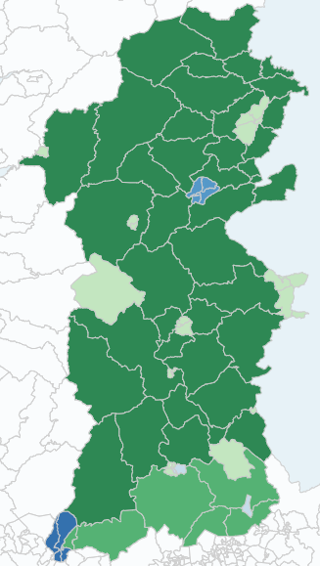
Crown copyright and database rights 2013 Ordnance Survey 100050829

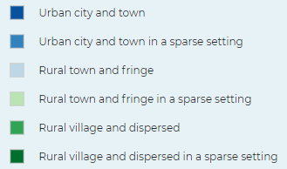

The upland areas are dissected by river and their tributaries and this topography has shaped the development of the area, leading to the majority of the larger settlements and main transport routes being located in the valleys, often at important river crossings.

Migration in and out of Powys has been the key determinant of change in the size and structure of the Powys population because net natural change has been negative for some time with deaths exceeding births. The population is generally older, and the average age is rising faster than in Wales as a whole.

The county is approximately 25% of the landmass of Wales but has only 5% of the population. Powys has the lowest population density in Wales at 26 people per km² compared to 152 for Wales. According to the Census 2011:

- 28.1% of people live in a ‘rural hamlet or isolated dwelling’,
- 30.6% in a ‘rural village’,
- 27.8% in ‘rural town and fringe’ settlements, and
- 13.5% in ‘urban town’ settlements.

Powys’ towns are small compared to Welsh standards, with the largest towns being Newtown, then Ystradgynlais, Welshpool and Llandrindod Wells.

According to the Powys Well-being Assessment 2017, Powys has one of the worst, poorly maintained road networks in Wales, with 5,500km of roads, and relatively low traffic congestion. As the elderly population increases, this may have a potential impact on healthcare and statutory services. Most people use their own vehicles for regular travel.

There is limited use of the subsidised bus services with only 1% of the population using public buses for regular travel according to Powys County Council. Powys has two railway lines (The Cambrian Line running through Welshpool and Newtown towards Aberystwyth, and The Heart of Wales lines running from Craven Arms to Llanelli). It is anticipated that with an ageing population the poor transport infrastructure will increase social isolation for the ageing population and lead to more people leaving the area.

Due to the sparse population, poor transport links and low broadband speeds there are few larger employers. As of March 2020:

- 82% of businesses employed up to four people,
- 11% employed between five and nine people,
- 4% employed between ten and 19 people,
- 2% employed between 20 and 49 people, and
- 1% employed between 50 and 99 people.

Tourism is a key economic sector for the county, contributing to the local economy financially by bring money into the area but also providing employment opportunities to residents. It has continued to grow over the past few years in Powys, with more tourists staying within the county.

Tourism seems to be more prominent in rural areas with Montgomeryshire seeing the most tourists staying overnight and southern localities towards Brecon seeing more day visitors.

The Brecon Beacons National Park is in the south of the county and covers approximately 16% of Powys, containing some of the most spectacular and distinctive upland landforms in southern Britain. It is a diverse landscape, where sweeping uplands contrast with green valleys, with dramatic waterfalls, ancient woodland, caves, forests and reservoirs. The highest point in the Park is Pen y Fan in the Brecon Beacons, at the centre of the National Park. Its distinctive table topped summit stands at 886m, and it is climbed by hundreds of thousands of people each year.

The Park is home to 33,000 people, over 9000 different plants and animals, and has a strong Welsh heritage and rich economic, social and cultural life. The largest settlement is the cathedral town of Brecon with a population of approximately 7,500. Meanwhile, over three million people a year come to the Brecon Beacons National Park to enjoy the unforgettable landscape and peace and tranquillity of the area. The mountains, uplands and valleys are all excellent walking country. Others come to enjoy such activities as horse riding, cycling and mountain biking, and water-based recreation.

2.2 Population

Based on StatsWales population estimates for mid-year 2019, the total population of Powys was 132,435, with slightly more females (50.5%) compared to males (49.5%). The population in Powys is older compared to the rest of Wales and the proportion of older people is growing. The working age adult population is smaller compared to Wales and it is predicted that the number of young people and working age adults will decrease, whilst the number of older people will increase.

Figure 1 –age of the population based on mid-year population estimates, 2019 in Powys and Wales

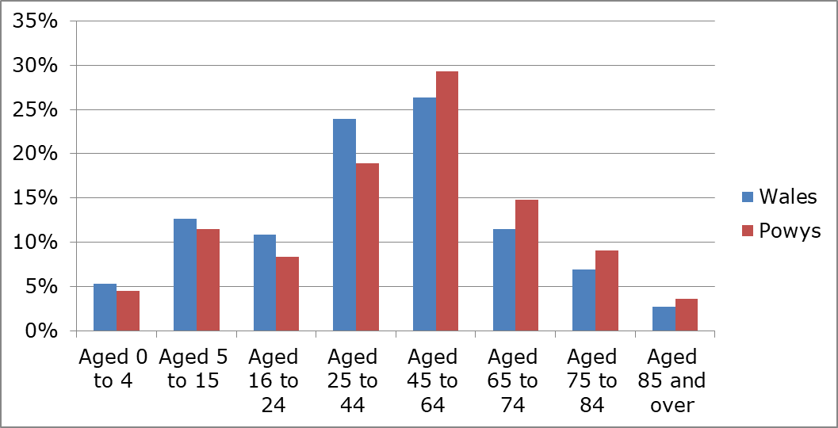

According to the Powys Well-being Assessment, migration into and out of the county is dominated by people aged 15 to 29. 1.6% of people aged 65 and over in Powys in 2015 migrated out of the county, compared to 12% of 20 to 24 year olds and 3.5% of 25 to 64 year olds.

The figure below shows how the age of the population has changed in the ten years 2009 to 2019, with a reduction in those aged under 44 and an increase in those aged 65 and over.

Figure 2 – change in the age of the population based on mid-year population estimates, 2009 and 2019

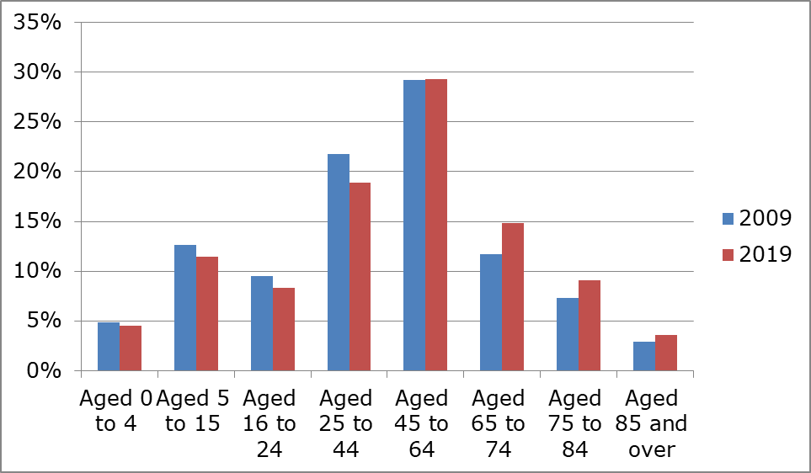

Within the lifetime of this document (2021 to 2026) it is projected that the decline in population seen since 2011 will continue by an estimated 1.3%.

2.3 Tourists

According to the 2019 Great Britain Tourism Survey, between 2017 and 2019, there were on average 0.706 million trips (including child trips) per annum to Powys by Great Britain residents. The number of nights (including child nights) spent away from home on these trips was approximately 2.269 million per annum. The value of spending on these trips was £114 million per annum.

These figures do not include day visits, which are covered in the GB Day Visits Survey. This survey tells us that in 2019 12 million day trips from home were made to destinations in Mid Wales per annum and the total expenditure about £1,021 million per annum.

Overseas tourists are covered separately in the International Passenger Survey 2019 which reports 45,060 international trips to Powys in 2019, with a total expenditure of £14.83 million.

2.4 Ethnicity

According to Census 2011 data, the majority of the health board’s population (98.4%) fell within the White ethnic group. The remaining 1.6% is residents who describe themselves as:

- Asian/Asian British – 0.9%
- Mixed/multiple ethnic groups – 0.6%

2.5 Household language

The number of residents in the health board for whom English or Welsh is not their main language was 2,287 at the 2011 Census, with 468 or 20.5% not able to speak English well and 109 or 4.8% not able to speak English at all. As can be seen from the figure below those who are unable to speak English well are aged 20 to 54, and those who are unable to speak English at all are aged 30 to 74. However these statistics are likely to be affected by the relatively low numbers.

Figure 3 – Proficiency in English by age

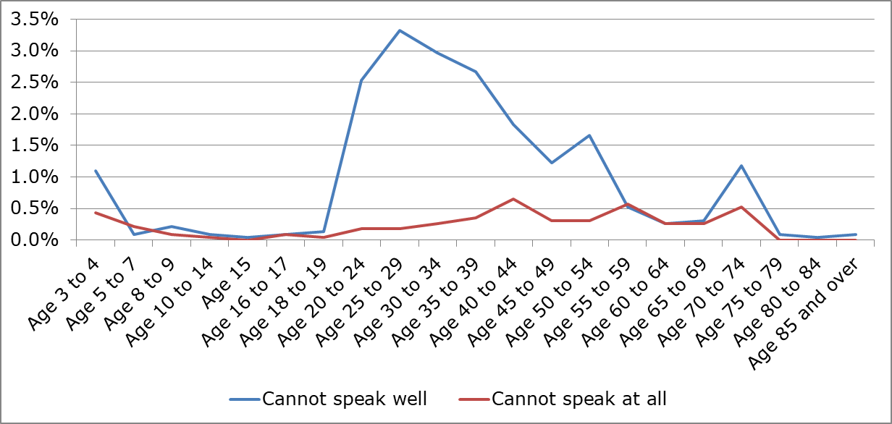

According to the 2011 Census, English or Welsh was the main language of the health board’s residents based on the combination of adults and children aged three years of age and older (98.2%). The next five most commonly spoken languages were:

- Polish – 0.6%
- Nepalese – 0.3%
- German, French and Hungarian – 0.1% each

2.6 Welsh language skills

72.0% of residents reported no skills in Welsh in the Census 2011, slightly lower than the figure for Wales (73.3%). The table below compares the Welsh language skills of Powys residents compared to Wales as a whole.

Table 1 – Welsh language skills in Powys compared to Wales

2.7 Religion

In 2011, 63.3% of the health board’s population was made up of residents who stated that they followed one of the main six religions and 27.9% stated that they followed no religion.

2.8 Welsh Index of Multiple Deprivation

The Welsh Index of Multiple Deprivation 2019 is the official measure for deprivation for small geographical areas called Lower Super Output Areas, from 1 (most deprived) to 1,909 (least deprived).

The index is based on eight domains, based on a range of different indicators, which are weighted and combined into an overall index of multiple deprivation. The weighting is the adjustment of the contribution of the domain indexes make to the overall index when they are combined. The figure below shows each domain and their weighting.

Figure 4 – the eight domains of the Welsh Index of Multiple Deprivation and their respective weighting

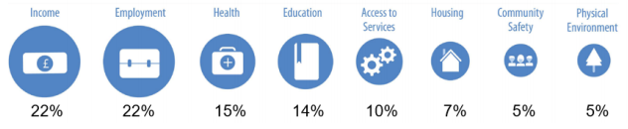

It is important to note that low deprivation does not equate to affluence and that not everyone living in a deprived area is deprived and not all deprived people live in deprived areas. An area itself is not deprived it is the circumstances of people who are living there that affect its deprivation ranks.

The map below shows each Lower Super Output Area within the health board’s area and where it sits in the index.

Map 3 – Map of the Welsh Index of Multiple Deprivation by Lower Super Output Area

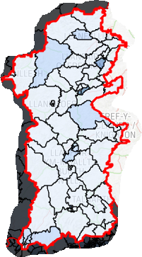
Crown Copyright and database right 2019. Ordnance Survey 100017916

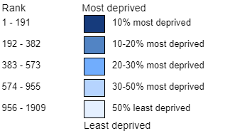
The figure below shows the number of the most deprived lower super output areas in Powys and Wales. As can be seen there is only one lower super output area in the most deprived 10% in Wales (in Ystradgynlais), and five in the most deprived 20% (in addition to the area in
Ystradgynlais, one area in each of Welshpool and Llandrindod, and two in Newtown).

Figure 5 – most deprived lower super output areas, Powys and Wales

 | Total lower super output areas (LSOAs) | Most deprived 10% LSOAs in Wales (ranks 1 - 191) | Most deprived 20% LSOAs in Wales (ranks 1 - 382) | Most deprived 30% LSOAs in Wales (ranks 1 - 573) | Most deprived 50% LSOAs in Wales (ranks 1 - 955)
Powys Teaching Health Board | 79 | 1 | 5 | 9 | 19
Wales | 1909 | 191 | 382 | 573 | 955

2.9 General fertility rate

Since 1955 (except in 1976) the number of births in the UK has been higher than the number of deaths. This natural change has resulted in the growth of the population. In the UK, the number of live births each year has varied over the last 60 years. Most noteworthy is the 1960s baby boom, the “echo” of baby boomers having children and latterly, births peaking again in the UK in 2012.

The table below shows the general fertility rate (the number of live births per 1,000 females aged 15-44 years old) in Powys in 2015 was lower than the average for Wales and has begun to decline.

Table 2 – general fertility rate in Powys and Wales, 2015

 | 2011 | 2012 | 2013 | 2014 | 2015
Wales | 61.4 | 61.2 | 58.9 | 59.1 | 59.1
Powys | 59.5 | 58.5 | 61.5 | 58.2 | 57.8

2.10 Life expectancy

Life expectancy in Powys is above average for Wales and has improved between 2005-2009 and 2010-2014 for both men (77.0 to 78.3 years) and females (81.4 to 82.3 years). However there has been a growing inequality gap appearing between genders, with females tending to outlive males, as well as between the least and most well off. This gap is expected to widen over the next 10 years.

Data at Middle Super Output Area shows the following variation in life expectancy within the county:

- Males: the highest Middle Super Output Area is Ffridd Faldwyn at 83.2yrs and the lowest is Newtown South West at 74.3yrs.
- Females: the highest Middle Super Output Area is Guilsfield Brook at 88.8yrs and the lowest is Welshpool at 80.1yrs.

Healthy life expectancy has also increased over the same time period for both men (63.5 to 65.3 years) and females (65.3 to 66.7 years).

Compared to the average across Wales, life expectancy and healthy life expectancy is significantly higher for men and women in Powys. However, while there has been a (non-significant) improvement in both life expectancy and healthy life expectancy for men and women, inequalities have widened between the highest and lowest quintiles as can be seen from the figure below, though not yet to the point of being statistically significant. It is possible that the current inequality gap in life expectancy and healthy life expectancy will continue to widen over the next 5-10 years due to socio-economic factors.

Figure 6 – Percentage of life expectancy in good health by deprivation fifth, 2005-2009 and 2010-2014, Powys

Males Females
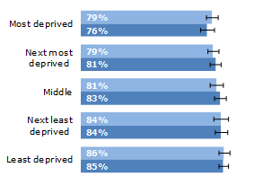
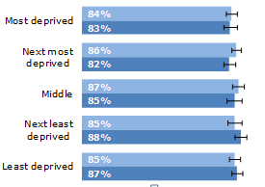

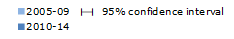

2.11 Deaths

Premature deaths from cancer and circulatory disease are the main causes of the difference in life expectancy between the most and least affluent parts of the Powys population. However the four main causes of ill health and premature mortality in Powys are:

- cancer
- circulatory diseases
- respiratory diseases, and
- mental health problems

Smoking is the single greatest cause of preventable mortality and a significant cause of health inequalities. Smoking causes a range of cancers; it leads to cardiovascular disease and a range of respiratory conditions, e.g. chronic obstructive pulmonary disease and emphysema.

Regular drinking to excess can cause cancer, stroke, heart disease, liver disease, brain damage, and damage to the nervous system.

Several serious conditions are associated with being overweight or obese. They include type 2 diabetes, hypertension, coronary heart disease and stroke, osteoarthritis and cancer.

In addition to healthy behaviours, there are links between social isolation, loneliness and preventable conditions, particularly in older people. Levels of self-reported mental well-being in the Powys population appear relatively high when compared with the average across Wales.

Improving mental health is a critical issue for people of all ages and its impact is cross cutting, affecting life chances, learning, home life, employment, safety, physical health, independence and life expectancy. One in four people in the UK will experience a mental health problem each year, and 25% of GP consultations are used for people with mental health problems. 11 years is the average time lost to life for males with mental health problems. Women with mental health problems on average lose six years.

2.12 People with disabilities

The projected population of children with disabilities is expected to decrease over the next ten years, in line with the decrease in child population. At present Autism Spectrum Disorders are the most common form of disability in children, followed by learning difficulties and conduct disorders. While the number of children with disabilities is expected to decrease, the complexity of the needs is expected to increase and present a greater challenge and cost to services.

Powys has a higher than average number of adults with a learning disability and a higher number of adults with sensory impairment.

According to the Census 2011, 10.2% of the population stated that their day-to-day activities are limited a lot by a long-term health problem or disability and 11.2% stated that their day-to-day activities were limited a little.

The figures below show the percentage of males and females who assessed their general health or status as good or very good in the Census 2011. Both show that residents in Ystradgynlais are least likely to assess their general health status as good or very good.

Figure 7 – percentage of males assessing their general health status as good or very good, Census 2011

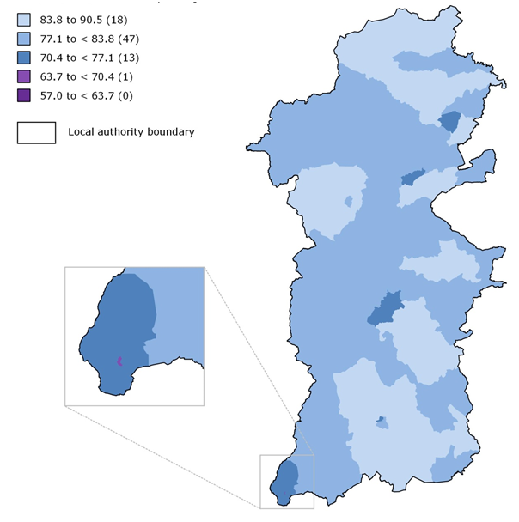
Produced by Public Health Wales Observatory, using Census 2011 data table LC3302EW (ONS)

© Crown Copyright and database right 2016, Ordnance Survey 100044810

Figure 8 – percentage of females assessing their general health status as good or very good, Census 2011¹⁸

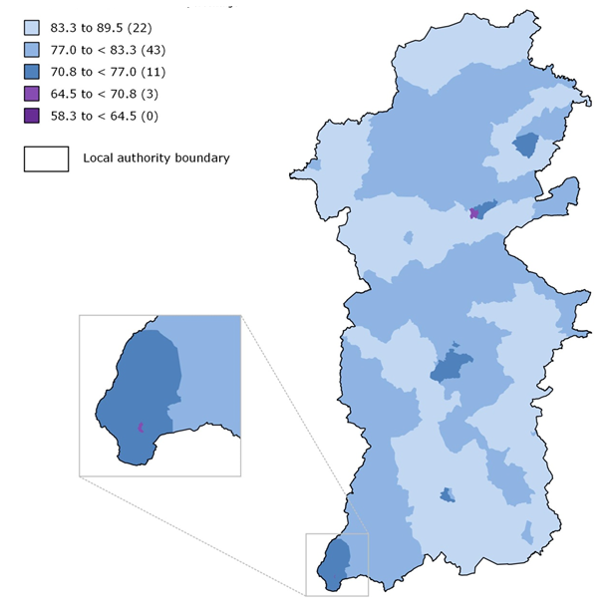
Produced by Public Health Wales Observatory, using Census 2011 data table LC3302EW (ONS)

© Crown Copyright and database right 2016, Ordnance Survey 100044810

2.13 Households

With regard to the composition of the households in Powys, as of the Census 2011:

- 14.0% were one person households (of which 50.1% are persons aged 65 and over i.e. 7.0% of all households),
- 77.8% were single families,
- 8.2% were other household types (includes complex households which didn’t contain only one person or a single family. For example, the age difference between the oldest person and the youngest is greater than 50 years. This indicates that there are more than two family generations present).

2.14 Car ownership

According to the 2011 Census data:

- 15.0% of the households in the health board’s area did not have a car or van
- 42.8% have one car or van
- 30.1% have two cars or vans
- 8.4% have three cars or vans and
- 3.6% have four or more cars or vans.

The figure below shows the variation at local authority and Wales level. As can be seen, fewer households do not have a car or van and more households have two or more cars compared to the average for Wales. This reflects the rural nature of the county.

Figure 9 – car ownership at local authority level

2.15 Economic activity

Powys has a high proportion of micro businesses. Although there has been growth of 3% in Powys, this is lower than the Welsh average (8%). Self-employment is high, and a large proportion of the population are working part-time jobs on a below average salary. There is also a high reliance on the public sector as a source of employment.

Economic activity rates are high in Powys, and there is a very low rate of people claiming unemployment benefits. There are low numbers of people seeking work, and productivity in Powys is low compared with the UK possibly as a result of the large number of people working in part time jobs.

Based on responses to the Census 2011, 69.6% of the population was economically active (i.e. employed, self-employed or unemployed but looking for work and able to start within two weeks, a full-time student), with the remainder economically inactive (either retired, a student, looking after home or family, long-term sick or disabled, or unemployed).

Of those who were economically active:

- 20.9% work part-time,
- 46.7% work full-time,
- 25.0% are self-employed,
- 4.4% were unemployed, and
- 3.1% were full-time students.

Of those who were economically inactive:

- 59.1% were retired,
- 12.1% were students,
- 10.4% were looking after home or family,
- 13.4% were long-term sick or disabled, and
- 4.9% were other.

2.16 Sexual orientation

“Sexual orientation” is an umbrella term that encompasses sexual identity, attraction and behaviour. It is a subjective view of oneself and may change over time and in different contexts.

In 2018, according to the Annual Population Survey, 2.4% of the Welsh population identified as lesbian, gay or bisexual, higher than in England (2.3%), Scotland (2.0%) and Northern Ireland (1.2%). All countries other than Northern Ireland saw an increase from the figures in 2014.

Across the UK:

- men were more likely to identify as lesbian, gay or bisexual than women
- Younger people (aged 16 to 24 years) were most likely to identify as lesbian, gay or bisexual
- More than two-thirds (68.7%) of people who identified as lesbian, gay or bisexual were single (never married or in a civil partnership).

Based on an estimated population size of 132,435 it is estimated that 3,178 of the Powys population is lesbian, gay or bisexual.

2.17 Carers

The Welsh Government defines a carer as “anyone of any age, who provides unpaid care and support to a relative, friend or neighbour who is disabled, physically or mentally ill, or affected by substance misuse”. Carers can be involved in a whole range of practical, physical, personal and administrative tasks. Examples might include: cooking; housework; lifting, washing and dressing the person cared for; helping with toileting needs; administering medication; and providing emotional support.

In 2018 there were 370,000 carers in Wales, the highest proportionate figure of all UK countries. The number of carers continues to rise and it is estimated that by 2037 there will be over half a million carers in Wales, a 40% rise.

Based on the Census 2011 there were 16,154 people living in Powys providing unpaid care (12.1% of the population). Of the total population:

- 7.7% provided unpaid care for one to 19 hours per week,
- 1.6% provided unpaid care for 20 to 49 hours per week, and
- 2.9% provided unpaid care for 50 or more hours per week.

2.18 Traveller and gypsy communities

The 2011 Census showed that 128 people (0.1%) identified as Gypsy/Traveller or Irish Traveller (this excludes Roma). However, it is likely that many households would not have completed the census – both because they were living on ‘unauthorised sites’ or encampments and as such did not appear on official records or because of a mistrust of the purpose of the census. Where people did receive forms potential lower than average literacy levels may have meant that some households would not have completed them, and where they were completed some households would have chosen not to identify as Gypsies/Travellers or Irish Travellers.

The Gypsy and Traveller caravan count of January 2020 shows that there were:

- One unauthorised site,
- Two authorised socially rented sites, and
- One authorised private site.

38 caravans were counted of which:

- 31 were on authorised local authority sites,
- One was on a private authorised site, and
- Six were on unauthorised sites, on land not owned by Gypsies but tolerated by the landowner.

Work started in September 2020 to convert an unofficial site on the outskirts of Machynlleth into a permanent one. It was completed and the first families moved in at the end of March 2021.

The age profile of the community in Powys illustrates the extent of the life expectancy issue for travellers. In comparison to the general profile, the age structure is heavily concentrated at the lower age bands, running consistently above proportional figures for Powys until mid-40s, after which it noticeably falls. Whilst cultural factors play a considerable role in their poor health, part of this issue may also be around engagement with services and the proximity of sites to healthcare services.

Figure 10 - Age profile for the health board’s population and Gypsy and Traveller community 2011

2.19 Offenders

Whilst there are no prisons in Powys there will offenders who are no longer serving prison terms; this may include those serving suspended sentences, those on probation, and those living in secure accommodation. At the time of writing there are no figures available for this cohort of the population.

2.20 Homeless and rough sleepers

In 2016-2017 the number of people approaching Powys County Council and being assessed differed quite significantly across the county with greater demand in the north of the county (Newtown and Welshpool).

The housing market in the north of the county was perceived in the Powys Homelessness Review as more fluid with a greater proportion of private rented sector stock at affordable rates and therefore the potential for higher turnover. One reason cited for the high demand in Welshpool was the recently improved train lines to Shrewsbury/West Midlands which has led to greater demand on local housing as it allows workers to commute across the border. Also, despite there being less demand in the south of the county it has been highlighted that finding solutions can be more difficult, so despite there being less cases the time taken with each case can be significantly longer.

Each year a count of rough sleepers is undertaken to give a single night snapshot. The estimated count is based on data collected over a two week period with assistance from the voluntary sector, faith groups, local businesses/residents, health and substance misuse agencies, and the police. The number of rough sleepers on a one night count in 2019 was zero however the estimated number of rough sleepers over a period of time during the count was four.

3 General health needs of Powys

3.1 General health needs

3.1.1 Cancer

Cancer is a major cause of ill health and according to Cancer Research UK one in two people in the UK will get cancer in their lifetime. It is a group of 200 diseases which together impose a heavy burden of disease.

In Powys, as in Wales as a whole, prostate, breast, colorectal and lung cancers are the most common types of cancer for all persons (2013-2017). For men in Powys the top four cancers are prostate, colorectal, lung and colon, whilst for women it is breast, colorectal, lung and colon.

A range of factors influence a person’s risk of developing cancer during their lifetime. Some of these factors cannot be modified as they relate to things like age, sex and genetic make-up. However many can be modified such as:

- Not smoking,
- Maintaining a healthy weight,
- Eating and drinking healthily,
- Cutting down on alcohol,
- Being more active, and
- Enjoying the sun safely.

It has been estimated that approximately 40% of cancers are directly related to these modifiable lifestyle behaviours.

Across Powys there is inequity in survival rates for certain cancers with those living in greater socioeconomic deprivation more likely to present with new cancers, but less likely to survive than those who are more affluent.

In relation to all malignancies (excluding nonmelanoma skin cancers) for the period 2013 to 2017, Powys Teaching Health Board had the lowest European Age Standardised Rate per 100,000 population for all persons (596.4) compared to the other health boards. At local authority level, Powys County Council had the third lowest rate with only Monmouthshire and Ceredigion having lower rates.

3.1.2 Cardiovascular disease

Cardiovascular diseases affect the blood supply to the heart and other vital organs and include:

- Congenital heart disease,
- Coronary heart disease,
- Heart failure,
- Atrial fibrillation,
- Cardiac rehabilitation.
- Stroke, and
- Peripheral vascular disease.

As with cancer taking steps to modify lifestyle behaviours will help reduce the risk of cardiovascular disease. There are nine main risk factors:

- High blood pressure,
- High cholesterol levels,
- Smoking, and
- Obesity.

Non-modifiable risk factors include age, male gender, ethnicity, and family history of premature cardiovascular disease.

Compared to the other health boards, Powys’ rate of deaths due to cardiovascular diseases per 100,000 population in 2017 was the second lowest at 249, with only Cardiff and Vale University Health Board having a lower rate. Compared to the other local authorities, Powys County Council’s rate was the seventh lowest out of 22.

3.1.3 Diabetes

There are two main types of diabetes, type 1 and type 2 with the latter being much more common. It can be preceded by a pre-diabetic state in which levels of sugar in the blood are raised but are not yet high enough to diagnose diabetes. People with type 2 diabetes have high rates of coronary heart disease and stroke. Other complications of diabetes include kidney failure, eye disease and circulatory and neurological problems in the foot and leg. Diabetes is more common in socio-economically deprived communities and in Black and Asian people.

According to Diabetes UK, Wales has the highest prevalence of diabetes in the UK, with more than 209,000 people, or 8% of the population, living with diabetes. The numbers are rising each year, with an additional 10,695 people diagnosed in 2020. Estimates suggest that there are a further 65,501 people with type 2 who have not yet been diagnosed, and that a further 580,000 people could be at risk of developing type 2 diabetes.

The disease costs the NHS in Wales approximately £500m each year, with around 80% of this spent on managing complications, most of which could be prevented. The two biggest modifiable risk factors are obesity and physical inactivity.

With Aneurin Bevan University Health Board, Powys Teaching Health Board has the highest death rate (age-standardised) (2015-2017) at 12.3 per 100,000 population, compared to 11.0 per 100,000 population for Wales.

Under the Quality and Outcomes Framework, GP practices establish and maintain a register of all patients aged 17 or over with diabetes. Figures for 2019 show a diabetes prevalence of 6.4% for the GP registered population in Powys. The figure below shows the variation in diabetes prevalence at locality level based on the registers maintained by the GP practices in that locality compared to the average for Wales.

As can be seen the highest prevalence rate is in Mid Powys locality and the lowest in the North Powys locality.

Figure 11 – Diabetes prevalence at locality and Wales level based on GP practice registers, 2019.

3.1.4 Mental health

Positive mental health is a key factor for good health and relevant to the whole population. In 2007 the World Health Organisation stated that there is no health without mental health, which means that public mental health is integral to all public health work. Improving mental health is a critical issue for people of all ages and its impact is cross cutting, affecting life chances, learning, home life, employment, safety, physical health, independence and life expectancy.

The Powys Population Needs Assessment 2017 states that:

- One in four people in the UK will experience a mental health problem each year;
- 25% of GP consultations are used for people with mental health problems;
- 11 years is the average time lost to life for males with mental health problems;
- Women with mental health problems on average lose six years;
- 8% of the Powys population report being treated for depression or anxiety and it is one of the top three leading causes of disability; and
- People are increasingly using mental health services in Powys, particularly young people.

It has been estimated that between 10-15% women suffer from post-natal depression. In Powys there are approximately 1,000 births per year, which means around 100 women may suffer post-natal depression.

In the UK, 25% of older adults have depression requiring an intervention and over 40% of those in their 80s are affected by depression. This is significant given Powys’ demography. It is also important to note that depression is the leading cause of suicides in England and Wales each year.

In relation to the death rate from suicide (age-standardised) per 100,000 population between 2015 and 2017, Powys County Council had the second highest rate of all local authorities (15.1), second only to Pembrokeshire (15.7). Powys Teaching Health Board had the highest rate of all health boards.

3.1.5 Dementia

Dementia is an umbrella term used to describe a range of progressive neurological disorders i.e. conditions affecting the brain. There are over 200 subtypes of dementia, but the five most common are:

- Alzheimer’s disease,
- vascular dementia,
- dementia with Lewy bodies,
- frontotemporal dementia, and
- mixed dementia.

Some people may have a combination of different types of dementia and these are commonly called mixed dementia.

Dementia damages the nerve cells in the brain so messages can’t be sent from and to the brain effectively, which prevents the body from functioning normally.

The Alzheimer’s Society (2014) reports there are over 850,000 people living with dementia in the UK today. Of these, approximately, 42,000 are people with young onset dementia, which affects people under the age of 65. As a person’s age increases, so does the risk of them developing dementia, roughly doubling every five years for people aged over 65 years. It is estimated that the number of people living with dementia in the UK by 2025 will rise to over one million. Rates of diagnosis are improving but many people with dementia are thought to still be undiagnosed.

Daffodil Cymru predicts that the number of people aged 65 and over with dementia in Powys will increase by 30% between 2020 and 2030.

3.1.6 Respiratory disease

Respiratory diseases are diseases of the airways and other structures of the lung. Among the most common are chronic obstructive pulmonary disease, asthma, occupational lung diseases such as coal miners’ pneumoconiosis, pneumonia and pulmonary hypertension.

Tobacco is the biggest cause of lung cancer in the UK, and people who smoke were first shown to be more likely to develop lung cancer relative to non-smokers in the 19502. It also increases the risk for cancers elsewhere in the body for example the mouth, lips, nose and sinuses, oesophagus, stomach, liver, bladder and colon/rectum.

Although chronic obstructive pulmonary disease can be the result of exposure to occupational hazards and air pollution, it is predominantly caused by active and second-hand tobacco smoke exposure. Other forms of tobacco such as cigars and water pipes also increase the risk of this disease.

Pneumonia can be acquired in either the community of a hospital/healthcare environment and can affect people of any age. In the UK, pneumonia affects around 0.5 to 1% of adults each year and is more widespread in autumn and winter. Smoking and exposure to tobacco smoke are risk factors for community acquired pneumonia.

Asthma is the most common chronic disease of childhood and the leading cause of childhood mortality from chronic disease as measured by school absences, emergency department visits and hospitalisation. It affects all ages, races and ethnicities. Exposure to cigarette smoke can trigger the development of the asthma and exacerbate symptoms.

The age standardised death rate per 100,000 population for all respiratory diseases in 2017 for Powys Teaching Health Board (141.6) was second lowest when compared to the other health boards, second only to Hywel Dda University Health Board. In relation to the other local authorities, Powys County Council ranks 16th out of 22.

Smoking cessation is one of the most effective ways to both prevent respiratory diseases and treat people with a respiratory disease.

3.1.7 Sexual health

Sexual health is the capacity and freedom to enjoy and express sexuality without exploitation, oppression or physical or emotional harm. Sexual health problems include:

- Sexually transmitted infections including human immunodeficiency virus infection,
- Unintended pregnancy,
- Abortion,
- Fertility problems, and
- Sexual dysfunction.

The most recent published data on sexually transmitted infections at local authority level (2015) shows that the percentage of positive tests per 100,000 population for gonorrhoea and chlamydia in Powys are the same as the average for Wales, 1.5% and 6.2% respectively. However, the percentage of positive tests per 100,000 population in those aged 15 to 24 years old is lower in Powys as can be seen from the figure below.

Figure 12 – Percentage of positive tests per 100,000 population for all ages and those aged 15 to 24, in 2015

 | Gonorrhoea |  | Chlamydia
Area | All ages | 15 to 24 year olds | All ages | 15 to 24 year olds
Powys | 1.5% | 0.5% | 6.2% | 7.0%
Wales | 1.5% | 1.7% | 6.2% | 12.7%

The data also show that rates for human immunodeficiency virus, gonorrhoea, chlamydia, genital herpes and genital warts per 100,000 population are lower in Powys than the average for Wales, for both men and women.

Teenage pregnancy is a possible cause and consequence of child poverty, which can increase the likelihood of health inequalities. Being a teenage mother or a child of a teenage mother increases the risk of health problems and other issues, for both mother and child. Higher teenage conception rates are associated with areas of higher deprivation and areas of higher unemployment.

The teenage pregnancy rate per 1,000 females aged under 18 (2015-2017) for Powys was 15.3 compared to an average for Wales was of 21.9.

As can be seen from the figure below, Powys rates of teenage pregnancies have fallen since 2006, although reached a plateau in 2011 to 2015 before falling again.

Figure 13 – teenage pregnancy rate per 1,000 females aged under 18, 2006-08 to 2016-17 in Powys and Wales

This mirrors the anticipated reduction in the number of children. There has been a drop in birth rates since 1991, and it is estimated that by 2035 there will be 20% fewer 0 to two year olds in Powys.

3.2 Risk factors

3.2.1 Alcohol

Alcohol is a major cause of death and illness in Wales with around 1,500 deaths attributable to alcohol each year (1 in 20 of all deaths). Across Wales consumption of alcohol has slightly decreased and adults under 45 now drink less. Whilst this decrease is good news, it masks persistent or increased drinking in over 45-year-olds.

Across Powys, 20.9% of respondents to the National Survey for Wales self-reported as non-drinkers, 61.0% as moderate drinkers, 15.2% as hazardous drinkers and 2.8% as harmful drinkers. The figure below summarises this data and shows that there were slightly more moderate drinkers compared to Wales, and slightly fewer hazardous drinkers.

Figure 14 – Percentage weekly consumption by drinking level 2016/17-2017/18

3.2.2 Obesity

Having a high body mass index (i.e. being overweight or obese) and physical inactivity are the third and fourth leading causes of ill health in the UK. Taken together they are arguably the most important contributor to poor wellbeing in communities today. Childhood obesity leads to and exacerbates adult obesity which in turn causes or exacerbates our most prevalent limiting long term ill health conditions. It is well accepted that adult obesity results in less healthy life expectancy and shorter life expectancy.

A healthy, balanced diet is an essential component of healthy living. A balanced diet combined with physical activity helps to regulate body weight and contributes to good health. Maintaining a healthy body weight also reduces the risk of health problems such as diabetes, coronary heart disease, stroke and some cancers. Regular physical activity is an essential part of healthy living. A lack of physical activity is among the leading causes of avoidable illness and premature death.

Government advice is that everyone should have at least five portions of a variety of fruit and vegetables every day. An adult portion of fruit or vegetables is 80g. According to the most recent results for Powys from the National Survey for Wales (July 2020):

- 6.74% of responders ate no fruit and vegetables the previous day,
- 65.90% ate some but less than five portions, and
- 27.35% ate at least five portions.

Physical activity guidelines for adults aged 19 to 64 include at least 150 minutes of moderate intensity activity a week or 75 minutes of vigorous intensity activity a week. According to the National Survey for Wales, 60.8% of Powys residents are meeting this target compared to 53.2% for Wales.

In Wales 59.9% of adults were classified as overweight or obese. For Powys the figure is 56.1%.

3.2.3 Smoking

Smoking remains a major cause of premature death in Wales. As set out in earlier sections of this chapter smoking and passive smoking have been linked to a range of serious illnesses including cancers and heart disease.

Across Wales, on average 17.4% of persons aged 16 and over self-reported a smoking status of ‘daily smoker’ or ‘occasional smoker’ in the most recent data from the National Survey of Wales. The average for Powys is 14.5%.

4 Identified patient groups – particular health issues

The following patient groups have been identified as living within, or visiting, Powys:

- Those sharing one or more of the following Equality Act 2010 protected characteristics,
- Age
- Disability, which is defined as a physical or mental impairment that has a substantial and long-term adverse effect on a person’s ability to carry out normal day-to-day activities
- Pregnancy and maternity
- Race. which includes colour, nationality, ethnic or national origins
- Religion (including a lack of religion) or belief (any religious or philosophical belief)
- Sex
- Sexual orientation
- Gender re-assignment
- Marriage and civil partnership.
- Homeless and rough sleepers
- Traveller and gypsy communities
- Refugees and asylum seekers
- Military veterans
- Service families
- Holiday makers and visitors to sporting, leisure and other facilities
- Gurkha and Nepalese population

Whilst some of these groups are referred to in other parts of the pharmaceutical needs assessment, this section focusses on their particular health issues.

4.1 Age

Health issues tend to be greater amongst the very young and the very old. However, whilst it is clear that the number and proportion of people aged 65 and over is set to rise and the prevalence of nearly all chronic and long-term conditions increases with age, it is important to recognise that the older population is very diverse in nature with many people remaining fit and active. While it is indeed the case that a growing older population will lead to an increasing number of people living with complex health and care needs, there will also be growing numbers across all older age groups living without any significant needs for support.

Furthermore, acquiring a health condition or disability does not necessarily equate to high levels of demand for health and care services. Many people aged 75 and over will have one or more health conditions but may not consider that their health condition has, or conditions have, a significant impact on their life.

In addition older people also provide a significant amount of their time and energy caring for others.

For older people:

- Cigarette smoking is implicated in eight of the top fourteen causes of death for people 65 years of age or older. Smoking causes disabling and fatal disease, including lung and other cancers, heart and circulatory diseases, and respiratory diseases such as emphysema. It also accelerates the rate of decline of bone density during ageing. At age 70, smokers have less dense bones and a higher risk of fractures than non-smokers. Female smokers are at greater risk for post-menopausal osteoporosis. Half of long-term smokers die of tobacco related illnesses, most prematurely, and many suffer from a variety of chronic conditions related to smoking.
- Even modest alcohol use in old age may be potentially harmful as a contributor to falls, compromised memory, medicine mismanagement, inadequate diet and limitations on independent living.
- Falls prevention is a key issue in the improvement of health and wellbeing amongst older people. Falls are a major cause of disability and death in older people in Wales, and result in significant human costs in terms of pain, loss of confidence and independence. It is estimated that between 230,000 and 460,000 people over the age of 60 fall in Wales each year. Between 11,500 and 45,900 of these suffer serious injury: fracture, head injury, or serious laceration.
- Loneliness can have significant and lasting effect on health. It is associated with higher blood pressure and depression and leads to higher rates of mortality, indeed comparable to those associated with smoking and alcohol consumption. It is also linked to a higher incidence of dementia with one study reporting a doubled risk of Alzheimer’s disease. Lonely people tend to make more use of health and social care services and are more likely to have early admission to residential or nursing care.
- Depression is the most common mental health need for older people and prevalence rises with age. Women are more often diagnosed with depression than men. At any one time, around 10-15% of the over 65s population nationally will have depression and 25% will show symptoms of depression. The prevalence of depression among older people in acute hospitals is 29% and among those living in care homes is 40%. More severe depression is less common, affecting 3-5% of older people.
- People with mental health needs can seek advice and support from their GP. However, two-thirds of older people with depression never discuss it with their GP, and of the third that do discuss it, only half are diagnosed and treated. This means of those with depression only 15 per cent, or one in seven, are diagnosed and receiving any kind of treatment. Even when they are diagnosed, older people are less likely to be offered treatment than those aged 16 to 64.
- Dementia is a common condition that affects about 800,000 people in the UK. The risk of developing dementia increases as you get older, and the condition usually occurs in people over the age of 65. Dementia is the second most common mental health problem in older people and 20% of people over 85, and 5% over 65, have dementia. In 2013 there were an estimated 45,529 people living with dementia in Wales, of those people, only 17,661 had received a formal diagnosis. By 2021 it is estimated that over 55,000 people in Wales will have dementia.
- Age is the single biggest factor associated with having a long term condition and 60% of people aged 65 and over are affected, but lifestyle factors such as smoking, excessive alcohol consumption, unhealthy diets and physical inactivity are estimated to cause approximately 50% of long term conditions.

For young people:

- Even before birth, factors which can affect a baby’s healthy life expectancy and life chances are already taking effect. At present, children born into poverty are more likely to be adults with poor health than those born into affluence. A baby born to a mother who is obese and smokes throughout pregnancy, is at greater risk of developing unhealthy lifestyles in the future which render them at greater risk of serious chronic conditions which will impact on their quality of life and their life expectancy. The effect on a person’s health and life expectancy, of childhood experiences and health behaviours continue to impact and accumulate throughout childhood and into adulthood.
- There is strong evidence that lifestyle behaviours that impact on longer term health and social care outcomes in adults are closely linked to lifestyle in the teenage years. Influencing positive lifestyle choices in teenagers will impact on health outcomes for young people and on future demand for a wide range of services by adults
- Breast feeding is well evidenced to provide health benefits for both mother and baby and to promote attachment, however young mothers are among the groups least likely to breast feed
- More than eight out of ten adults who have ever smoked regularly started before the age of 19
- Eight out of ten obese teenagers go on to become obese adults
- Untreated sexually transmitted infections can have longer term health impact including fertility. Young people’s sexual behaviour may also lead to unplanned pregnancy which has significant health risks and damages the longer-term health and life chances of both mothers and babies.

4.2 Disability

A 2010 study by the Improving Health and Lives Learning Disabilities Observatory noted that people with learning disabilities have poorer health than their non-disabled peers, differences in health status that are, to an extent, avoidable. It also noted that health inequalities faced by people with a learning disability began in childhood and that they were often caused as a result of lack of access to timely, appropriate and effective healthcare.

The outcomes for adults with disabilities compared to the wider population are poorer in almost every manner. People with learning disabilities have a shorter life expectancy and increased risk of early death when compared to the general population.

However people with learning disabilities are living longer than in the past and as a result, the number of older people with a learning disability is increasing. This is despite the fact that people with learning disabilities are 58 times more likely to die before the age of 50 than the rest of the population. Older people with a learning disability need more support to age well, to remain active and healthy for as long as possible. Research by the Disability Rights Commission in 2006 found that people with a learning disability are two and a half times more likely to have health problems than the rest of the community.

- Approximately 1.5 million people in the UK have a learning disability. Over 1 million adults aged over 20, and over 410,000 children aged up to 19 years old have a learning disability.
- 29,000 adults with a learning disability live with parents aged 70 or over, many of whom are too old or frail to continue in their caring role. In only 25% of these cases have a Local Authority planned alternative housing.
- Less than 20% of people with a learning disability work, but at least 65% of people with a learning disability want to work. Of those people with a learning disability that do work, most work part time and are low paid.
- People with a learning disability are 58 times more likely to die aged under 50 than other people. And four times as many people with a learning disability die of preventable causes compared to people in the general population.
- People with a learning disability are ten times more likely to have serious sight problems and six out of ten people with a learning disability need to wear glasses.

Studies have shown that individuals with disabilities are more likely than people without disabilities to report:

- Poorer overall health.
- Less access to adequate health care.
- Smoking and physical inactivity.

8% of the Powys population report being treated for depression or anxiety and it is one of the top three leading causes of disability.

Autistic spectrum disorders are the most common presentation of disability within children in Powys.

4.3 Pregnancy and maternity

There are many common health problems that are associated with pregnancy. Some of the more common ones are:

- Urinating a lot
- Pelvic pain
- Piles (haemorrhoids)
- Skin and hair changes
- Sleeplessness
- Stretch marks
- Swollen ankles, feet, fingers
- Swollen and sore gums, which may bleed
- Tiredness
- Vaginal discharge
- Vaginal bleeding
- Varicose veins.

4.4 Race

Public Health Wales has found that ethnicity is an important issue because, as well as having ‍specific needs relating to language and culture, persons from ethnic minority backgrounds are more likely to come from low income families, suffer poorer living conditions and gain lower levels of educational qualifications.

In addition, certain ethnic groups have higher rates of some health conditions. For example, South Asian and Caribbean-descended populations have a substantially higher risk of diabetes; Bangladeshi-descended populations are more likely to avoid alcohol but ‍to smoke, and sickle cell anaemia is an inherited blood disorder, which mainly affects people of African or Caribbean origin.

Raising the Standard: Race Equality Action Plan for Adult Mental Health Services aims to promote race equality in the design and delivery of mental health services in order to reduce the health inequalities experienced by some ethnic groups.

- Ethnic differences in health are most marked in the areas of mental wellbeing, cancer, heart disease, Human Immunodeficiency Virus, tuberculosis and diabetes
- An increase in the number of older black and minority ethnic people is likely to lead to a greater need for provision of culturally sensitive social care and palliative care

Black and minority ethnic populations may face discrimination and harassment and may be possible targets for hate crime.

4.5 Religion and belief

It should never be assumed that an individual belonging to a specific religious group will necessarily be compliant with or completely observant of all the views and practices of that group. Individual patients’ reactions to a particular clinical situation can be influenced by a number of factors, including what branch of a particular religion or belief they belong to, and how strong their religious beliefs are (for example, orthodox or reformed, moderate or fundamentalist). For this reason, each person should be treated as an individual.

- Possible link with ‘honour based violence’ which is a type of domestic violence motivated by the notion of honour and occurs in those communities where the honour concept is linked to the expected behaviours of families and individuals
- Female genital mutilation is related to cultural, religious and social factors within families and communities although there is no direct link to any religion or faith. It is an illegal practice that raises serious health related concerns
- There is a possibility of hate crime related to religion and belief.

4.6 Sex

- In Powys there has been a growing inequality gap appearing between genders, with females tending to outlive males. Females are also more likely to have a long healthy life expectancy than males.
- Men tend to use health services less than women and present later with diseases than women do. Consumer research by the Department of Health and Social Care into the use of pharmacies in 2009 showed men aged 16 to 55 to be ‘avoiders’ i.e. they actively avoid going to pharmacies, feel uncomfortable in the pharmacy environment as it currently stands due to perceptions of the environment as feminised/for older people/lacking privacy and of customer service being indiscreet.
- 11 years is the average time lost to life for males with mental health problems. Males in Powys are now more willing to access these services than in the past. Women with mental health problems on average lose six years.
- Women are more likely to report, consult for and be diagnosed with depression and anxiety. It is possible that depression and anxiety are under-diagnosed in men. Suicide is more common in men, as are all forms of substance abuse
- Among males, overweight/obesity is projected to increase above the Wales rate by 2025.
- Men are more likely to die from coronary heart disease prematurely and are also more likely to die during a sudden cardiac event. Women’s risk of cardiovascular disease in general increases later in life and women are more likely to die from stroke
- In Wales the percentage of adults reporting to be overweight or obese is higher in men than women for each age group
- 19% of adults in Wales were drinking above the weekly guidelines in 2016/17-2017/18. Drinking above guidelines was more prevalent in males than females in all 10-year age groups. For some age groups, the difference was as much as double for males compared to females. Males aged 55-74 had the highest levels of drinking in Wales at around a third drinking above 14 units of alcohol in a usual week.
- Morbidity and mortality are consistently higher in men for virtually all cancers that are not sex specific. At the same time, cancer morbidity and mortality rates are reducing more quickly for men than women.

4.7 Sexual orientation

The public health white paper ‘Healthy Lives, Healthy People’ identified poor mental health, sexually transmitted infections, problematic drug and alcohol use and smoking as the top public health issues facing the UK.

All of these disproportionately affect Lesbian Gay Bisexual Transgender (LGBT) populations:

- Illicit drug use amongst LGB people is at least eight times higher than in the general population
- Around 25% of LGB people indicate a level of alcohol dependency
- Nearly half of LGBT individuals smoke, compared with a quarter of their heterosexual peers
- Lesbian, gay and bisexual people are at higher risk of mental disorder, suicidal ideation, substance misuse and deliberate self-harm
- 41% of trans people reported attempting suicide compared to 1.6% of the general population

4.8 Gender re-assignment

- Drugs and alcohol are processed by the liver as are cross-sex hormones. Heavy use of alcohol and/or drugs whilst taking hormones may increase the risk of liver toxicity and liver damage
- Alcohol, drugs and tobacco and the use of hormone therapy can all increase cardiovascular risk. Taken together, they can also increase the risk already posed by hormone therapy
- Smoking can affect oestrogen levels, increasing the risk of osteoporosis and reducing the feminising effects of oestrogen medication
- Transgender people face a number of barriers that can prevent them from engaging in regular exercise. Many transgender people struggle with body image and as a result can be reluctant to engage in physical activity
Gender dysphoria is the medical term used to describe this discomfort. Transgender people are likely to suffer from mental ill health as a reaction to the discomfort they feel. This is primarily driven by a sense of difference and not being accepted by society. If a transgender person wishes to transition and live in the gender role they identify with, they may also worry about damaging their relationships, losing their job, being a victim of hate crime and being discriminated against. The fear of such prejudice and discrimination, which can be real or imagined, can cause significant psychological distress.

4.9 Homeless and rough sleepers

The mean age at death for someone who is homeless in England and Wales is 44 years for men and 42 for women compared to the mean age at death for the general population of England and Wales which is 76 and 81 respectively (2017). Even those people who sleep rough for only a few months are likely to die younger than they would have done if they had never slept rough. Standardised mortality ratios for excluded groups, including homeless people, are around ten times that of the general population.

Homeless and Inclusion Health standards for commissioners and service providers describes tri-morbidity as a combination of physical ill-health with mental ill-health and drug or alcohol misuse which is commonly found in the homeless. It goes on to say that this complexity is often associated with advanced illness when the person presents to a health service provider, in the context of a person lacking social support who often feels ambivalent about both accessing care and their own self-worth.

Oral health problems are very common amongst homeless populations, and this population has a greater number of missing and decayed teeth and fewer filled teeth.

When homeless people die they do not commonly die as a result of exposure or other direct effects of homelessness: they die of treatable medical problems, human immunodeficiency virus related disease, liver and other gastrointestinal disease, respiratory disease, or acute and chronic consequences of drug and alcohol dependence.

Sleeping rough is dangerous and is seriously detrimental to a person’s physical and mental health. People who sleep rough are 17 times more likely to be victims of violence than the general public.

The three most common causes of deaths amongst homeless people in England and Wales in 2017 were:

  - accidents (40%)
  - liver disease (9%)
  - suicide (9%).

People sleeping on the street are almost 17 times more likely to have been victims of violence. More than one in three people sleeping rough have been deliberately hit or kicked or experienced some other form of violence whilst homeless. Homeless people are over nine times more likely to take their own life than the general population.

According to report by Centrepoint, homeless young people are amongst the most socially disadvantaged in society. Previous research has shown that many have complex problems including substance misuse, mental and physical health problems, and have suffered abuse or experienced traumatic events. 42% of homeless young people have a diagnosed mental health problem or report symptoms of poor mental health, 18% have attempted suicide, 31% have a physical health problem (such as problems with their breathing, joints and muscles, or frequent headaches), 21% have a history of self-harm, 52% report problems with their sleep, 55% smoke, and 50% use illegal substances.

4.10 Traveller and gypsy communities

Gypsies and Travellers have significantly poorer health outcomes compared with the general population and are frequently subject to racial abuse and discrimination. They have the lowest life expectancy of any ethnic group in the UK and experience:

- high infant mortality rates,
- high maternal mortality rates,
- low child immunisation levels, and
- high rates of mental health issues including suicide, substance misuse and diabetes, as well as high rates of heart disease and premature morbidity and mortality.

Gypsies and Travellers have high levels of unmet dental need, low rates of registration with a dentist and very little use of preventative services.

Despite experiencing worse health and having significant health needs, travellers are less likely to receive effective, continuous healthcare. Identified barriers to healthcare access include:

- inequalities in registration with GPs (due to discrimination, mismatch in expectations, the perception that they will be “expensive patients”, and the reluctance of GPs to visit sites),
- poor literacy, and
- lack of “cultural awareness/competence” amongst service providers.

The same barriers exist when it comes to accessing dental services.

Factors that contribute to the high rate of premature mortality include missed opportunities for preventative healthcare, particularly among Gypsy and Traveller men, and effective treatment for pre-existing conditions.

4.11 Refugees and asylum seekers

People who migrate to Wales will do so for a variety of reasons, and consequently are a diverse group. They will frequently have faced adversity during their journey which will result in complex service needs.
Health problems of vulnerable migrants are frequently related to destitution and lack of access to services, rather than to complex or long-standing ill-health.

Refugees and asylum seekers may have high levels of psychological ill-health. Survivors of torture and trafficking have often experienced extreme circumstances in which they have been exposed to uncontrollable and unpredictable events, which can result in severe and longer-term post-trauma disorders.

Not being able to communicate in English can cause problems when it comes to obtaining a medical history, explaining treatment options and seeking consent.

4.12 Military veterans

A veteran is defined as “anyone who has served for at least one day in the Armed Forces (Regular or Reserve), as well as Merchant Navy seafarers and fishermen who have served in a vessel that was operated to facilitate military operations by the Armed Forces.” There is no routine source of information on military veterans in Wales, so the number resident in Wales is unknown. Studies identify that most veterans in general view their time in the Services as a positive experience and do not suffer adverse health effects as a result of the time they have served.

However, for a minority, adverse physical and mental health outcomes can be substantial and can be compounded by other factors – such as financial and welfare problems. Key health issues facing the veteran population relate to common mental health problems (but also include Post Traumatic Stress Disorder) and substance misuse – including excess alcohol consumption and to a much lesser extent - use of illegal drugs. In addition, time in the Services has been identified to be associated with musculoskeletal disorders for some veterans.

Other issues that studies have identified as being of importance to veterans include:

- Accessing suitable housing and preventing homelessness.
- Supporting veterans into employment.
- Accessing appropriate financial advice and information about relevant benefits.
- Accessing health and support services.
- Supporting veterans who have been in the criminal justice system.
- Loneliness and isolation.
- Ready access to services to ensure early identification and treatment (physical & mental health).
- Supporting a veterans wider family.

Research suggests that most people ‘do not suffer with mental health difficulties even after serving in highly challenging environments’. However, some veterans face serious mental health issues.

The most common problems experienced by veterans (and by the general population) are:

- depression
- anxiety
- alcohol abuse.

Probable Post Traumatic Stress Disorder affects about 4% of veterans. Each year, about 0.1% of all regular service leavers are discharged for mental health reasons. Each health board in Wales has appointed an experienced clinician as a veteran therapist with an interest or experience of military (mental) health problems. The veteran therapist will accept referrals from health care staff, GPs, veteran charities and self-referrals from ex-service personnel. The primary aim of Veterans’ NHS Wales is to improve the mental health and well-being of veterans with a service related mental health problem. The secondary aim is to achieve this through the development of sustainable, accessible and effective services that meet the needs of veterans with mental health and well-being difficulties who live in Wales. A 2016 report from ‘Forces in Mind’ provides the findings from a review of the mental and related health needs of veterans and family members in Wales.

The report identified that a lot of good work had been developed in Wales in recent years to better meet the mental and related health needs of veterans and their family members, however the report also identified areas where it was felt additional work was needed to be undertaken to meet the needs of veterans. This included:

- A need for a strategic focus and co-ordination in terms of planning/commissioning of services for veterans - both generalist and specialist - across sectors and regions.
- A need to ensure consistency and implementation across Wales of the Armed Forces Forums and Champions.
- A need to ensure the long-term sustainability of/capacity within services.
- A need to establish effective local multi-agency partnerships to improve assessment and referral pathways.
- Meeting the needs of veterans with highly complex needs particularly those with dual diagnosis (mental health and substance misuse) and those involved in the criminal justice system.
- To meet the unmet need among veterans and families, with more prevention, identification and early intervention needed within generalist/mainstream services to prevent pressure on crisis services.
- To recognise and appropriately cater for the practical, social and emotional support needs of the families of veterans with mental health problems including safeguarding issues particularly around domestic violence and the long-term well-being of children.

A Welsh Government report from 2014 ‘Improving Access to Substance Misuse Treatment for Veterans’ identified that Substance Misuse Area Planning Boards lead on local collaborative planning, commissioning and delivery for services to ensure that the needs of veterans are met. A 2011 report from Public Health Wales on ‘Veterans’ health care needs assessment of specialist rehabilitation services in Wales’ identified a range of recommendations to support veterans with respect to their physical health and disability with regards to specialist rehabilitation service provision.

4.13 Service families

The health needs of this patient group are likely to be similar to the general population as they live civilian lives. However aspects of military life, in particular deployment and relocations, will have an impact on them, particularly their mental health. According to the Hampshire County Council Veterans, Reservists and Armed Forces Families Health Needs Assessment 2015 this may include:

- Isolation and mental health problems in the at-home parent partner or spouse.
- Relationship difficulties.
- A range of psychological, mental health or behavioural problems in children as they move through the stages of the deployment cycle and their family circumstances change.
- Disruption to schooling due to frequent moves

4.14 Holiday makers and visitors to sporting, leisure and other facilities

It is not anticipated that the health needs of this patient group are likely to be very different to those of the general population of Powys. As they may only be in the area for a day or two, their health needs are likely to be:

- Treatment of an acute condition which requires the dispensing of a prescription
- The need for repeat medication
- Support for self-care, or
- Signposting to other health services such as a GP or dentist.

A review conducted by the National Public Health Service for Wales on the impact of tourism on health found the following:

- There is little research done on the health impacts of tourism in the UK;
- Holidaymakers have different patterns of consulting in primary care than the resident population, consulting more often for respiratory, gastrointestinal, minor infections and skin complaints;
- Workload for GPs in popular holiday resorts can increase in summer months;
- Holidaymakers are often ill prepared for their trip, forgetting vital medications and travelling after major illnesses and surgery. Comprehensive pre-trip counselling by health professionals in the ‘donor’ areas, especially for those with chronic conditions, could reduce burden on health services in the ‘host’ areas;
- Local residents are more likely to present at Accident and Emergency for illnesses, and tourists are more likely to present at Accident and Emergency for accidents in one Australian seaside resort;
- Tourists often have little local knowledge of conditions, putting them at increased risk of accidents, especially in relation to the natural environment;
- Comprehensive data collection on tourist health episodes and good communication and information sharing between health services, tourist industry and local government can aid planning for the health impacts of tourism;
- Risky behaviour in terms of alcohol use, drug use and sexual behaviour increase when people are on holiday; and
- The hedonistic, ‘carnivalised’, transient atmosphere of UK seaside resorts, together with easy access to alcohol can contribute to risk taking in the sexual behaviour of young people. Young people are often drawn into the leisure and entertainment industry geared towards adults which can leave them open to exploitation.

4.15 Gurkha and Nepalese population

Gurkha soldiers have been based in Brecon since 1974, and up to 80 Nepalese families have since made their home in and round the town.

Many of the health and healthcare needs of the ex-Gurkha population will be similar to those of the general veteran population, however there will be some issues that are specific to them as members of the Nepali community and their living circumstances here in the UK, and many of these will also affect their families.

A study published in January 2020 reported that the most common health problems amongst participants were:

- High blood pressure – 62% of participants
- Diabetes – 43% of participants
- High cholesterol – 23% of participants
- Asthma – 14% of respondents, and
- Tuberculosis – 5% of respondents

With regard to lifestyle-related behaviours, participants self-reported as follows:

- Physical activity per week
  - 19.2% did no physical activity,
  - 51.2% did between one and five hours per week, and
  - 29.6% did six or more hours per week.
- 50.3% ate more than five portions of fruit and vegetables a day
- 20.7% smoked, and
- 60.4% consume alcohol.

Although 96% of participants reported that they were registered with a GP, only 45% had registered with a dentist. 39% of participants had seen a GP once or twice in the previous 12 months, 28% hadn’t seen a GP and 6% had seen the GP 11 or more times. Whilst 38% of participants had wellbeing check-ups such as screenings, blood sugar monitoring and cholesterol measurement, the update of disease screening was very low. Only 25% of females had had cervical screening, and only 10% breast screening.

Self-medication and asking friends or families for medical advice were more popular choices than making an appointment to see a GP. Many expressed language barriers as a key concern for accessing health and social care services. Elderly participants, in particular, reported their negative experiences and highlighted the key issues were delayed appointments, concerns related to prescriptions (for example clarity on dosage and side effects), costs and language barriers.

Cultural issues and concerns about privacy-confidentiality were barriers restricting discussion about and use of sexual and reproductive health services. Focus group discussions undertaken as part of the study revealed that economic hardship, family/relationship problems, language barriers, cultural differences, feelings of loneliness and extreme weather in the UK were major reasons behind poor mental wellbeing.

5 Provision of pharmaceutical services

This chapter looks at the provision of pharmaceutical services at health board level by contractors within Powys and those located elsewhere in Wales or in England between 2018/19 and 2020/21.

The main finding is that there are no gaps in the provision of pharmaceutical services at the level of the health board and there is sufficient capacity within the existing contractors to meet both the current and future needs of the population. In coming to this conclusion the health board has noted:

- all of the enhanced services are dependent on people either presenting at a pharmacy and requesting the service or being referred by another health care provider;
- there are other providers of some of the services, for example GP practices;
- the location of the current providers of each service, ensuring a good geographical spread of providers across Powys;
- the travel times to pharmacies; and
- the fact that all of the pharmacies and six of the dispensing GP practices have stated that they either have sufficient capacity to manage an increase in demand, or can make adjustments to do so.

However, this may not be the case at locality level and further analysis is undertaken within the later locality chapters.

5.1 Current provision within Powys Teaching Health Board area

There are 23 pharmacies included in the pharmaceutical list for the area of the health board as of August 2021, operated by 13 different contractors.

Of the 16 GP practices in the health board area, 12 dispense to eligible patients from 23 sites within the health board’s area. Practices over the border in England may also dispense to some Powys residents. As of May 2021 the GP practices dispensed to 54,207 of their registered patients (47.8% of the total list size for all 12 practices). The percentage of dispensing patients at practice level varied between 0.03 to 91.3% of registered patients.

The map below shows the location of the pharmacies and dispensing practice premises. Pharmacies are represented by purple dots and dispensing doctor premises by yellow diamonds. It should be noted that where premises are in close proximity that the dots and diamonds overlap. Due to the size of the area covered by the health board many of the premises are not shown individually, however more detailed maps can be found in the locality chapters.

Map 4 – location of pharmacies and dispensing practice premises in the health board’s area
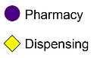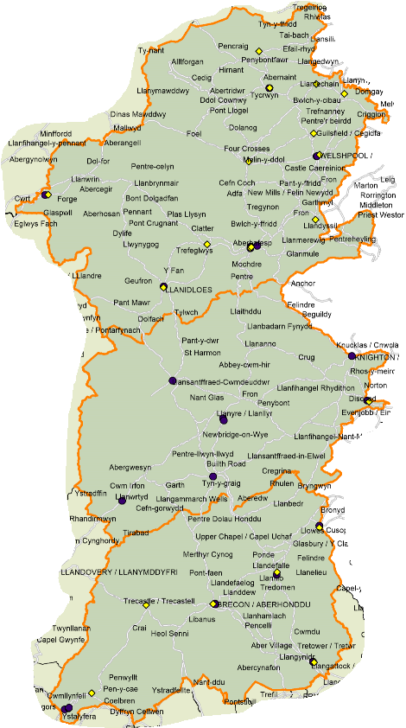
© Copyright Ordnance Survey Licence 100050829

The map below shows the location of the pharmacy and dispensing practice premises within the health board’s area compared to population density. Due to the size of the area covered by the health board many of the premises are not shown individually, however more detailed maps can be found in the locality chapters. As can be seen, pharmacies are generally located in more populated areas and GP dispensing sites in areas of lower population density, although there are exceptions.

Map 5 – location of pharmacies and dispensing practice premises compared to population density

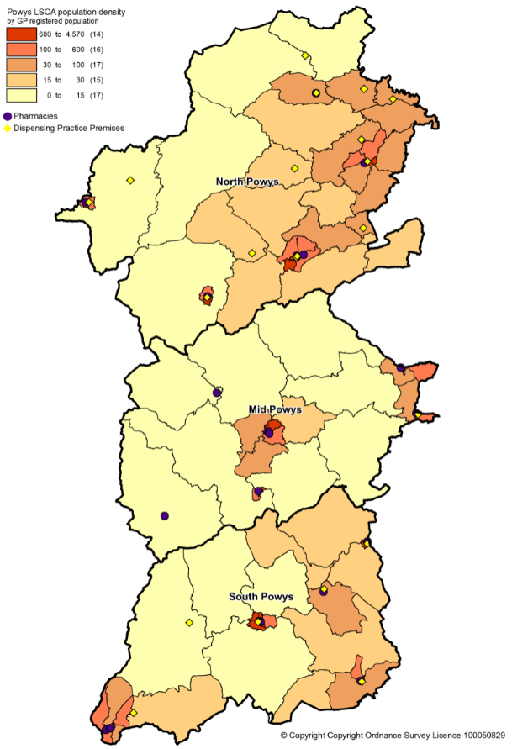
© Copyright Ordnance Survey Licence 100050829

The map below shows the location of the pharmacy and dispensing practice premises within the health board’s area compared to the Welsh Index of Multiple Deprivation 2019.

Map 6 – location of pharmacies and dispensing practice premises compared to levels of deprivation by lower super output area

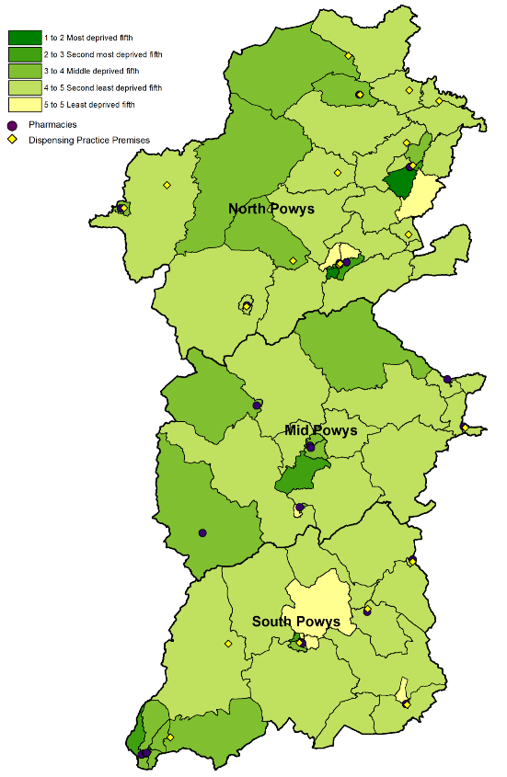
© Copyright Ordnance Survey Licence 100050829

In 2019/20 59.6% of items prescribed by GP practices in the health board’s area were dispensed by pharmacies within the health board’s area and 33.3% were dispensed or personally administered by the GP practices. In 2020/21, a slightly lower percentage was dispensed by pharmacies within the health board’s area (59.3%) with a corresponding increase in the percentage dispensed or personally administered by the GP practices (33.9%).

5.1.1 Access to premises

The health board has chosen a travel time of 20 minutes by car as an appropriate access standard. In order to assess whether residents are able to access a pharmacy in line with this standard travel times were analysed by NHS Wales Informatics Service.

As can be seen from the map below, there are parts of the health board that are not within a 20 minute drive of a pharmacy. In general these are areas of very low population density however this is looked at in more detail in the relevant locality chapters.

The position would improve if access to the dispensing practice premises is taken into account. However, access to dispensing practice premises has not been included in the analysis as it cannot be assumed that people will be registered with their nearest practice or that they meet the eligibility criteria to be dispensed to.

Map 7 – Time taken to access the pharmacies by car

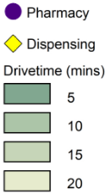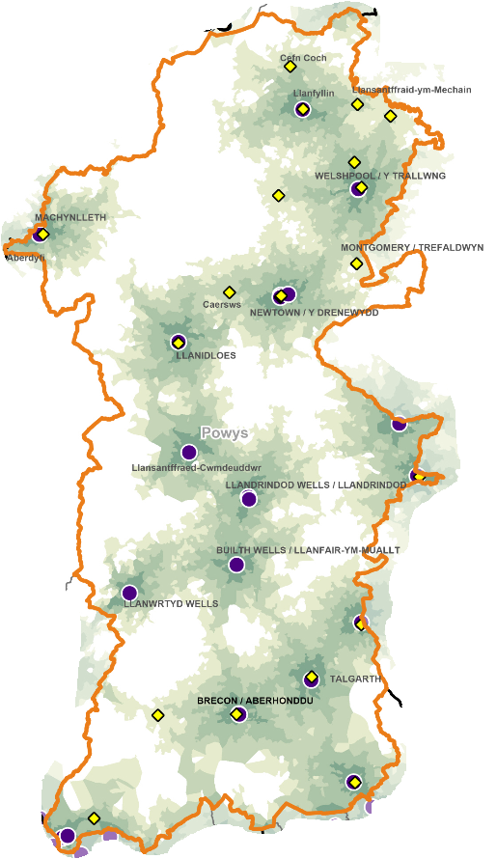

© Copyright Ordnance Survey Licence 100050829

Responses to the public and patient questionnaire provide the following insights into accessing pharmacies:

- 58% of responders drive to a pharmacy, 30% walk, 8.7% chose not to answer the question, 1.8% by bike and 0.9% went by “other” (community car/taxi, or a family member goes on their behalf).
- For 84.5% of responders the journey to a pharmacy takes less than 20 minutes, for 6.3% it takes more than 20 minutes and 9.2% chose not to answer the question.

In relation to accessing dispensing practice premises:

- 27.1% drive, 5.9% walk, 2.8% by “other” (the practice doesn’t dispense or medicines are delivered either to the person or an alternative location for collection), 0.4% by taxi and 63.8% chose not to answer the question mainly because it wasn’t relevant to them.
- For 33.0% of responders the journey to a pharmacy takes less than 20 minutes, for 2.8% it takes more than 20 minutes and 64.2% chose not to answer the question.

5.1.2 Access to essential services

Whilst the majority of people will visit a pharmacy during the 8.30am to 6.30pm period, Monday to Friday, following a visit to their GP or another healthcare professional, there will be times when people will need, or choose, to access a pharmacy outside of those times. This may be to have a prescription dispensed after being seen by the out of hours GP service, or to collect dispensed items on their way to or from work, or it may be to access one of the other services provided by a pharmacy outside of a person’s normal working day. The patient and public engagement questionnaire showed that whilst 30.7% of respondents didn’t have a preferred time to visit a pharmacy and 8.3% chose not to answer the question, the most convenient times for other responders were:

- 09.00 to 12.00 – 23.4% of respondents
- 12.00 to 15.00 – 11.9%, and
- 15.00 to 18.00 – 17.4%.

Appendix L provides information on the pharmacies opening hours as of August 2021 and at that point in time there were:

- One pharmacy opens seven days a week
- 12 pharmacies open Monday to Saturday
- Eight pharmacies open Monday to Friday, and Saturday mornings
- Two pharmacies that open Monday to Friday.

A weekday evening and Sunday rota operates across the health board’s area which provides for:

- Opening on weekday evenings until 18.00 or 18.30, and
- An hour on Sunday morning and an hour on Sunday afternoon.

GP practices are contracted to provide services between 08.00 and 18.30, Monday to Friday, excluding bank and public holidays. GP dispensaries will generally be open at the same time as the GP practice and dispense prescriptions issued as part of a consultation during this time as well as dispensing repeat prescriptions.

Should GP practice opening hours change then the health board has the ability to direct existing pharmacies to open for longer hours where necessary.

At the time of writing there are no planned GP practice mergers. One practice, Caereinion Medical Practice, will be moving into a new health centre in 2022.

5.1.3 Access to medicines use review service

In 2018/19 a total of 6,200 medicine use reviews were provided by 22 of the 23 pharmacies:

- eight pharmacies provided the maximum number of 400, and
- seven pharmacies provided less than 200 medicines use reviews.

In 2019/20 a total of 5,324 medicine use reviews were provided by 22 pharmacies:

- three pharmacies provided the maximum number of 400, and
- eight pharmacies provided less than 200 medicines use reviews.

On 18 March 2020 the service was suspended due to the Covid pandemic, however it is anticipated that once the service is reinstated the pharmacies will resume provision.

Up to 400 medicines use reviews can be provided at each pharmacy per year, giving a potential maximum number of 9,200 per annum if all the pharmacies provided the service. However with one pharmacy not providing the service the actual number of medicines use reviews that could be undertaken each year is 8,800.

The map below shows the location of those pharmacies that provided the service in 2019/20.

Map 8 – location of the pharmacies providing medicines use reviews in 2019/20

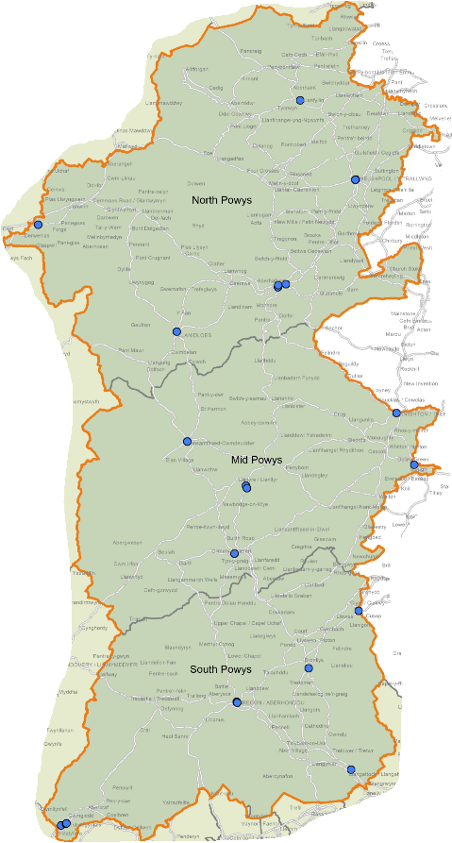

© Copyright Ordnance Survey Licence 100050829

5.1.4 Access to the discharge medicines review service

In 2018/19, 14 of the 23 pharmacies provided this service, and a total of 162 full service interventions were claimed over the year.

In 2019/20, 13 pharmacies provided this service, and a total of 239 full service interventions were claimed over the year. The map below shows the location of these pharmacies.

Map 9 – location of the pharmacies providing discharge medicines reviews in 2019/20

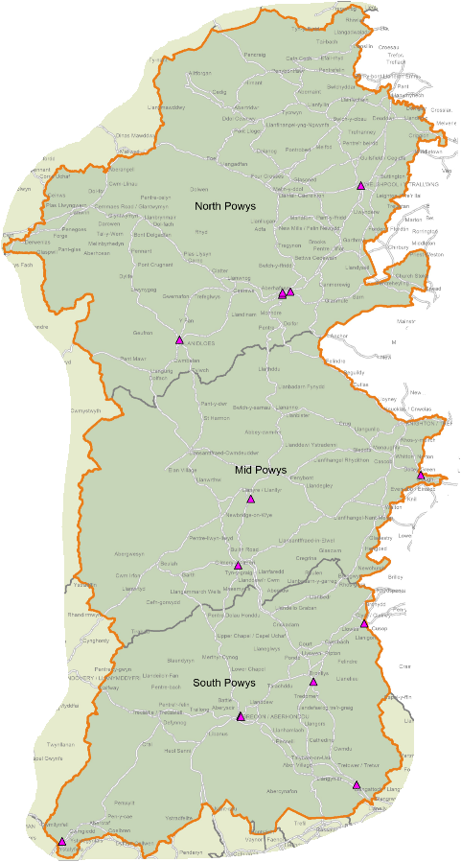

© Copyright Ordnance Survey Licence 100050829

Nineteen pharmacies provided the service in 2020/21, and a total of 226 full service interventions were claimed over that period.

Until 31 March 2021 up to 140 discharge medicines reviews could be provided at each pharmacy per year, giving a potential maximum number of 3,220 per annum. However, this cap has been removed with effect from 1 April 2021.

5.1.5 Access to appliance use reviews

No pharmacies provided this service in 2018/19, 2019/20 or 2020/21. However it is noted that the majority of prescriptions for appliances are dispensed outside of the health board’s area.

5.1.6 Access to stoma appliance customisations

No pharmacies provided this service in 2018/19, 2019/20 or 2020/21. However it is noted that the majority of prescriptions for appliances are dispensed outside of the health board’s area.

5.1.7 Access to the emergency hormonal contraception enhanced service

The aim of this service is to improve access to emergency contraception and sexual health advice through pharmacies. Increasing the use of emergency hormonal contraception following unprotected sexual intercourse will help reduce the number of unplanned pregnancies. Following provision of the service females can be referred into mainstream contraception services. The service also aims to increase awareness of sexually transmitted infections, the risks associated with them and how to protect against them.

In 2018/19 18 of the 23 pharmacies provided a total of 671 consultations under this service.

In 2019/20 the same number of pharmacies provided a total of 633 consultations under this service over the year. The map below shows the location of these pharmacies.

Map 10 – location of pharmacies providing emergency hormonal contraception in 2019/20

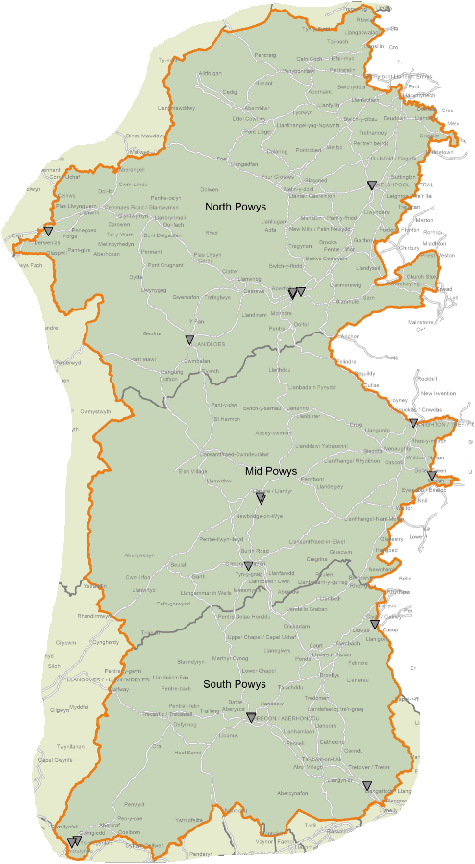

© Copyright Ordnance Survey Licence 100050829

In 2020/21, 20 pharmacies were commissioned to provide the service and claimed for a total of 531 consultations.

In 2021/22, 17 pharmacies are commissioned to provide the service as of August 2021.
5.1.8 Access to the smoking cessation level 2 enhanced service

The smoking cessation level 2 service links pharmacies with the intensive behavioural support service provided by Help Me Quit. Under this arrangement, pharmacies supply nicotine replacement therapy to smokers who are receiving smoking cessation behavioural support from Help Me Quit, in response to a referral letter or appointment card that indicates the client’s dependence on nicotine. The Help Me Quit service provides a six week programme of support, during which a referral letter will be issued for each pharmacy supply of nicotine replacement therapy. Following successful completion of the programme, Help Me Quit will issue a discharge referral letter to a pharmacy for a further six week supply of nicotine replacement therapy to be supplied at fortnightly intervals.

In 2018/19 14 of the 23 pharmacies provided the service, reducing to 13 in 2019/20. The map below shows the location of these pharmacies.

Map 11 – location of pharmacies providing the smoking cessation level 2 enhanced service in 2019/20

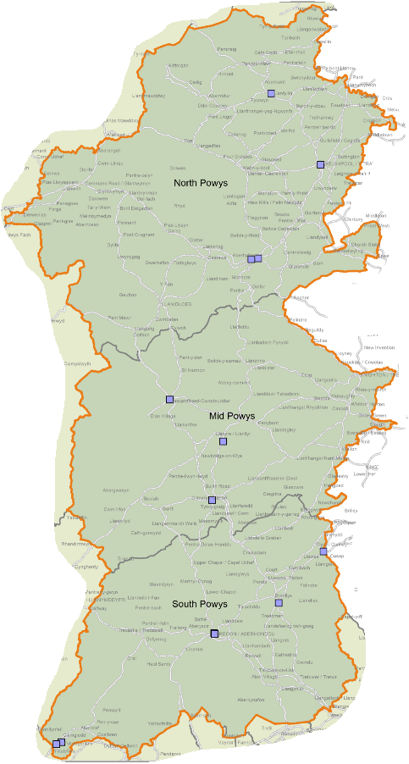

© Copyright Ordnance Survey Licence 100050829

In 2020/21, all the pharmacies were commissioned to provide the service and 17 claimed for it.

In 2021/22, 21 of the pharmacies are commissioned to provide it as of August 2021.

5.1.9 Access to the Help me quit @ pharmacy enhanced service

Formerly referred to as the level 3 smoking cessation service, this service is designed to provide patients with a comprehensive support and treatment service to help them stop smoking over a 12 week programme, involving eight consultations.

In 2018/19, 12 of the 23 pharmacies provided the service increasing to 15 in 2019/20. The map below shows the location of these pharmacies.

Map 12 – location of pharmacies providing the smoking cessation level 3 enhanced service in 2019/20

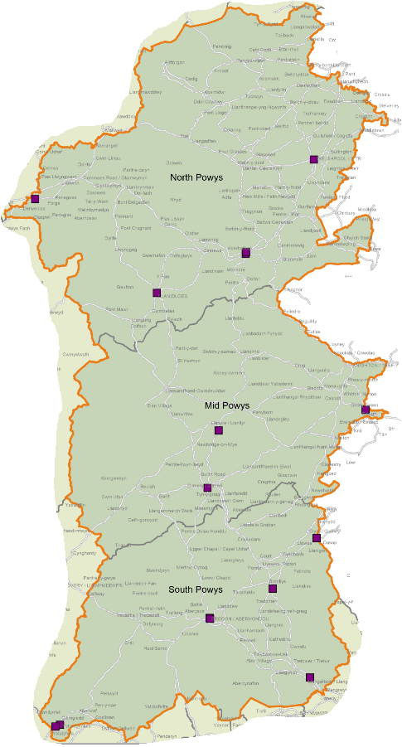

© Copyright Ordnance Survey Licence 100050829

In 2020/21, all of the pharmacies were commissioned to provide the service and 16 claimed for providing it.

In 2021/22, 19 of the pharmacies are commissioned to provide the service as of August 2021.

5.1.10 Access to the flu vaccination enhanced service

This service allows pharmacies to provide influenza immunisation for those patients in nationally and locally agreed at risk groups. It supports the wider provision of influenza immunisation and aims to increase the proportion of at risk individuals who receive immunisation thus helping to reduce morbidity and mortality.

In 2018/19, 17 of the 23 pharmacies provided 1,875 vaccinations increasing to 19 pharmacies providing 2,379 vaccinations in 2019/20. The map below shows the location of these pharmacies.

Map 13 – location of pharmacies providing the flu vaccination enhanced service in 2019/20

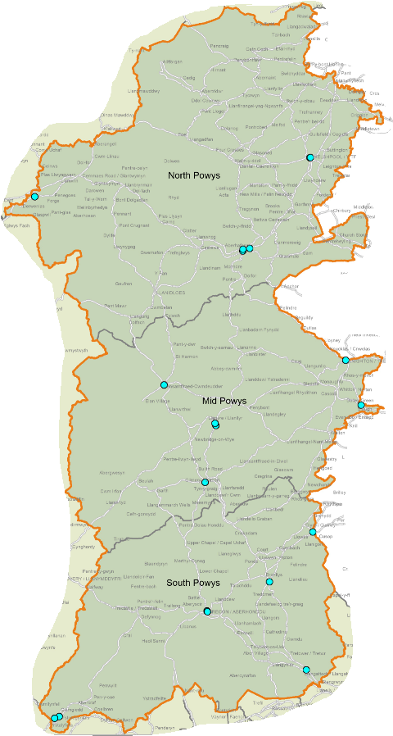

© Copyright Ordnance Survey Licence 100050829

In 2020/21, 22 pharmacies were commissioned to provide the service and claimed for 4,262 vaccinations.

In 2021/22, nine of the pharmacies are commissioned to provide the service as of August 2021, however this figure is expected to increase to the same level as in the previous year before the service starts in September.

5.1.11 Access to the common ailment service

The common ailment service provides advice and treatment on a range of specified conditions such as acne, chickenpox, conjunctivitis, head lice, sore throat/tonsillitis and verrucae. Patients register with a pharmacy and receive a consultation with a pharmacist and advice on management and treatment where required, or referral if necessary, and is provided as an alternative to making a GP appointment. It is aimed at making pharmacies the first port of call for the provision of advice and, where necessary, the treatment of common illnesses.

In 2018/19 20 pharmacies provided the service, increasing to 21 in 2019/20. The map below shows the location of these pharmacies.

Map 14 – location of pharmacies providing the common ailment service in 2019/20

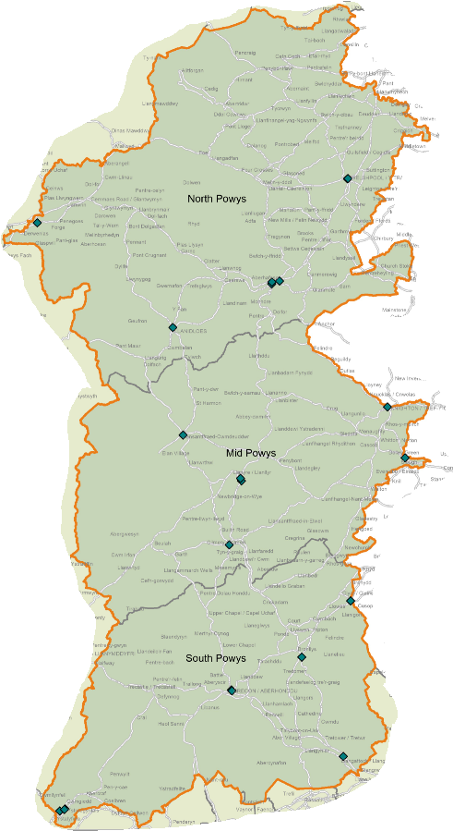

© Copyright Ordnance Survey Licence 100050829

In 2020/21, 22 pharmacies were commissioned to provide the service and 21 claimed for providing it.

In 2021/22, 22 of the pharmacies are commissioned to provide the service as of August 2021.

5.1.12 Access to the emergency medicines supply enhanced service

The emergency medicines supply service is commissioned to enable pharmacies to supply patients with a quantity of previously prescribed medication in circumstances where a supply is urgently required and it is not practical for the person to first obtain a prescription, for example when their GP practice is closed or the patient is visiting the area and is not registered with a GP practice in the health board’s area. The purpose of this service is to reduce the burden on out of hours, emergency care and GP services in relation to managing patient requests for emergency supplies of medication outside of normal GP working hours.

The Human Medicines Act 2012 remains the primary legislation governing the emergency supply of medication at the request of a patient and all supplies of medication made must be made in accordance with these regulations.

In 2018/19 21 of the pharmacies provided the service, increasing to 22 in 2019/20. The map below shows the location of these pharmacies.

Map 15 – location of the pharmacies providing the emergency medicines supply enhanced service in 2019/20

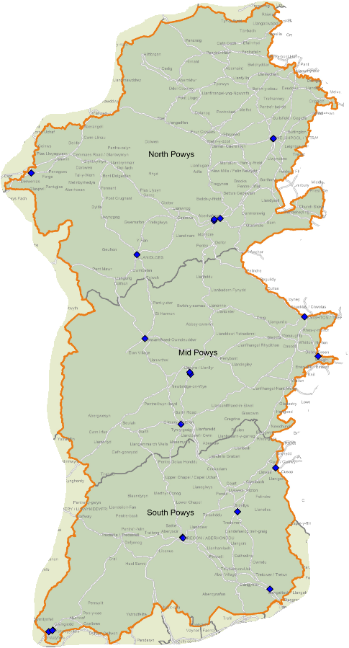

© Copyright Ordnance Survey Licence 100050829

In 2020/21, 22 pharmacies were commissioned to provide the service and 21 claimed for providing it.

In 2021/22, 22 of the pharmacies are commissioned to provide the service as of August 2021.
5.1.13 Supervised consumption service

Under this service, the pharmacy supervises the administration of medication in accordance with an appropriate prescription. It therefore contributes to a reduction in risks associated with inappropriate use or diversion of prescribed medicines.

Eight pharmacies provided this service in 2018/19, increasing to 11 in 2019/20. In 2020/21, 20 pharmacies were commissioned to provide the service. This has increased to 21 in 2021/22 as of August 2021.

5.1.14 Needle exchange service

This service contributes to a comprehensive needle and syringe programme and to wider arrangements for harm reduction through the provision of an easy access and a user-friendly, low threshold service for all injecting drug users which includes the distribution of injecting equipment in packs, and information on harm reduction (for example, on safer injecting or overdose prevention).

Eight pharmacies provided this service in 2018/19, increasing to ten in 2019/20. In 2020/21, 11 pharmacies were commissioned to provide the service and the same number is commissioned to provide it in 2021/22 (as of August 2021).

5.1.15 Just in case packs

This service provides an easily identifiable source of palliative care medication and facilitates the effective management of unexpected breakthrough symptoms by healthcare professionals in urgent situations, until the patient’s needs can be fully reviewed and tailored medication provided.

17 pharmacies provided this service in 2018/19, reducing to 16 in 2019/20. In 2020/21, 22 pharmacies were commissioned to provide the service and the same number is commissioned to provide it in 2021/22 (as of August 2021).

5.1.16 Care home support and medicines optimisation

This service consists three levels:

- Review medicines management processes within care homes to facilitate the safe ordering, supply, storage and administration of medicines and appliances and reduce avoidable waste.
- Review therapeutic risk areas of prescribing which have regularly shown to occur in care homes.
- Work with residents’ GP(s) to conduct a full medication review with the resident.

Seven pharmacies were commissioned to provide levels one and two in 2020/21.

The service was suspended during the Covid pandemic and was then reintroduced with effect from April 2021 in an amended form pending a national review of the service specification. As of August 2021, two pharmacies are commissioned to provide the service.

5.1.17 Medicine administration record charts

The aim of this service is to support the safe administration of medication (including the maintenance of comprehensive records) to patients by domiciliary care workers, where this has been agreed as part of a wider social care support package.

In 2020/21, 21 pharmacies were commissioned to provide this service and 21 are commissioned to provide it in 2021/22 (as of August 2021).

5.1.18 Palliative care stocks

This service facilitates prompt and effective access to an agreed range of palliative care medicines within normal working hours (including via a rota for extended hours where appropriate), with minimal inconvenience to patients and professionals.

In 2020/21, five pharmacies were commissioned to provide this service and five are commissioned to provide it in 2021/22 (as of August 2021).

5.1.19 Respiratory rescue medicines service

Under this service a respiratory rescue medication pack can be provided to patients, where clinically appropriate, who are considered to be at high risk of an exacerbation of their respiratory condition. It aims to support patients to effectively manage their respiratory conditions at home by supplying anticipatory medication and structured education. By supporting planned early intervention and effective management of respiratory exacerbations it is anticipated that there will be a reduced need for unplanned out of hours care or hospital admission.

In 2020/21, nine pharmacies were commissioned to provide this service and eight are commissioned to provide it in 2021/22 (as of August 2021).

5.1.20 Patient sharps

This service allows pharmacies to provide patients who use sharps as part of their treatment for an ongoing medical condition with a safe and convenient means of disposing of filled sharps containers, and obtaining replacement containers where required.

In 2020/21, 22 pharmacies were commissioned to provide this service and 22 are commissioned to provide it in 2021/22 (as of August 2021).

5.1.21 Waste reduction scheme

The aim of this service is to reduce prescribing waste and over ordering of repeat medication by utilising pharmacists and their support staff to ascertain directly from patients whether or not each item presented for dispensing is actually required.

In 2020/21, 19 pharmacies were commissioned to provide this service and 18 are commissioned to provide it in 2021/22 (as of August 2021).

5.1.22 Independent prescriber service

Currently there is one service for independent prescribers which provides patients presenting in the pharmacy with a relevant acute condition access to effective advice and treatment, provided by a community pharmacist independent prescriber.

In 2020/21, one pharmacy was commissioned to provide this service and one is commissioned to provide it in 2021/22 (as of August 2021).

This is a developing service that is largely dependent upon the rate at which pharmacists are able to access the required training.

5.1.23 Inhaler review service

This service aims to improve patient outcomes, reduce medicines waste and support the prudent prescribing or medicines associated with the treatment of asthma and chronic obstructive pulmonary disease. It is currently suspended across both Powys and the rest of Wales.

5.1.24 Sore throat test and treat service

Under this service patients can access appropriate assessment and advice for the management of sore throat from an accredited pharmacist, and, where appropriate, can be supplied with antibiotics or other appropriate treatments at NHS expense to treat their condition. It provides an alternative location from which patients can seek advice and treatment, rather than seeking treatment via a prescription from their GP or out of hours provider, walk in centre or accident and emergency

It is currently suspended across both Powys and the rest of Wales.

5.1.25 Dispensing service provided by some GP practices

Dispensing GP practices will provide the dispensing service during their core hours which are 8.00 to 18.30 from Monday to Friday excluding public and bank holidays. Of the 16 practices in the health board’s area 12 dispense to their eligible patients from 23 premises.

Normally when a patient requires medication their GP will give them a prescription which is then dispensed by a pharmacy or dispensing appliance contractor. However, in certain circumstances practices can instead dispense the medication at the practice premises. The regulations around the provision of this service are complicated but in summary a GP may dispense medication to a patient where:

- the patient lives in an area that has been determined to be a “controlled locality” i.e. an area that is rural in character;
- the patient lives more than 1.6km (measured in a straight line) from a pharmacy;
- the practice has been given consent to dispense to the area in which the patient lives; and
- the practice has “premises approval” for the premises at which the dispensing is undertaken.

As of May 2021 54,207 people were registered as a dispensing patient with their practice, 38.9% of all patients registered with a practice in the health board’s area. 10 of the practices have consent to dispense to all of their practice area except for those areas that are within 1.6km of a pharmacy. For the remaining three:

- Ystradgynlais Group Practice can dispense to all of its practice area with the exception of The Ystrad and Cwmlas.
- The Brecon Medical Group Practice can dispense to all of its practice area with the exception of Brecon Town.
- Presteigne Medical Practice can dispense to all of its practice area with the exception of Presteigne and Knighton.

5.1.26 Access to pharmaceutical services on public and bank holidays

The health board has a duty to ensure that residents of its area are able to access pharmaceutical services every day. Pharmacies and dispensing appliance contractors are not required to open on public and bank holidays, or Easter Sunday, although some choose to do so. On these days the health board operates a rota in order to ensure that a pharmacy is open and residents are able to access their prescribed medicines. The service supports the GP out of hours service by providing timely and effective care at times when GP practices are closed.

5.2 Current provision outside Powys Teaching Health Board’s area

5.2.1 Access to essential services and dispensing appliance contractor equivalent services

Patients have a choice of where they access pharmaceutical services; this may be close to their GP practice, their home, their place of work or where they go for shopping, recreational or other reasons. Consequently not all the prescriptions written by the GP practices are dispensed within the same area although as noted in the previous section, the vast majority of items are. In 2019/20, 214,458 items (6.9%) were dispensed outside of the health board’s area by a total of 262 pharmacies.

The majority (83%) of these items were dispensed by three contractors:

- 87,377 by a pharmacy in Ystalyfera, Swansea Bay University Health Board’s area
- 78,682 by a pharmacy in Gilwern, Aneurin Bevan University Health Board’s area, and
- 12,545 by a pharmacy in Swansea.

A further 14% of these items were dispensed by nine pharmacies, and the remaining 3% were dispensed by 250 pharmacies.

43,218 items were dispensed in England in 2019/20 by 459 pharmacies and dispensing appliance contractors. 67% of these were dispensed by dispensing appliance contractors, 28% by pharmacies and 5% by distance selling premises (also known as internet pharmacies).

Based on the number of items dispensed, the top ten dispensers accounted for 79% of the items dispensed in England.

Figure 15 – top ten dispensers of prescriptions in England, 2019/20

Number of items | Type of contractor | Location
10,270 | Dispensing appliance contractor | West Sussex
7,964 | Dispensing appliance contractor | Peterborough
3,866 | Dispensing appliance contractor | Staffordshire
2,269 | Pharmacy | Shropshire
2,080 | Pharmacy | Shropshire
1,987 | Pharmacy | Merseyside
1,581 | Dispensing appliance contractor | Greater Manchester
1,452 | Dispensing appliance contractor | Buckinghamshire
1,321 | Distance selling premises | Worcestershire
1,195 | Dispensing appliance contractor | Devon

The remaining 21% of items were dispensed by 449 different pharmacies/ dispensing appliance contractors.

In 2020/21, 240,262 items (6.9%) were dispensed outside of the health board’s area by a total of 203 pharmacies with very similar patterns as 2019/20.

Slightly fewer items were dispensed in England in 2020/21 (37,497) by slightly fewer pharmacies and dispensing appliance contractors (383). 61.1% were dispensed by dispensing appliance contractors, 32.3% by pharmacies and 6.6% by distance selling premises. The same top ten dispensers as in 2019/20 accounted for 74.2% of the items dispensed in England.

An analysis of these contractors shows that the main reasons for prescriptions being dispensed out of area are:

- The proximity of pharmacies just over the border with another health board or in England which residents choose to use,
- GP practice boundaries extending beyond the area of the health board (Crickhowell Group Practice has a branch surgery in the area of Aneurin Bevan University Health Board),
- Dispensing appliance contractors specialising in the provision of certain appliances and delivering them to residents,
- Residents choosing to have a prescription dispensed near to where they work or whilst they are otherwise away from home for reasons such as recreation or a holiday.

5.2.2 Access to advanced services

Information on the type of advanced services provided by pharmacies outside the health board’s area to its residents is not available. When claiming for advanced services contractors merely claim for the total number provided for each service. The exception to this is the stoma appliance customisation service where payment is made based on the information contained on the prescription. However even with this service just the total number of relevant appliance items is noted for payment purposes. It can be assumed however that residents of the health board’s area will access these services from contractors outside of the area.

5.2.3 Access to enhanced services

As with advanced services information on the provision of enhanced services by pharmacies outside the health board’s area to its residents is not available. It can be assumed however that residents of the health board’s area will access these services from contractors outside of the area.

5.2.4 Dispensing service provided by some GP practices

Some residents of the health board’s area will choose to register with a GP practice outside of the area and will access the dispensing service offered by their practice. This may include practices in England.

5.3 Choice with regard to obtaining pharmaceutical services

As can be seen from sections 5.1 and 5.2, the residents of the health board’s area currently exercise their choice of where to access pharmaceutical services to a considerable degree. Within the health board’s area they have a choice of 23 pharmacies, operated by 13 different contractors. Outside of the health board’s area residents chose to access a further 262 pharmacies in Wales and 459 contractors in England in 2019/20, although many are not used on a regular basis.

6 Other NHS services

The following NHS services are deemed, by the health board, to affect the need for pharmaceutical services within its area:

- Community hospitals - increase the demand for the dispensing essential service as outpatient prescriptions written in hospitals are dispensed within primary care.
- Personal administration of items by GPs – similar to hospital pharmacies this also reduces the demand for the dispensing essential service. Items are sourced and personally administered by GPs and other clinicians at the practice thus saving patients having to take a prescription to a pharmacy, for example for a vaccination, in order to then return with the vaccine to the practice so that it may be administered.
- GP out of hours service – whether a patient is given a full or part course of treatment after being seen by the out of hours service will depend on the nature of their condition. This service will therefore affect the need for pharmaceutical services, in particular the essential service of dispensing.
- Minor injury units - reduce the demand for the dispensing essential service as they administer medication to treat the injury but do also issue prescriptions.
- Kaleidoscope drug and alcohol services – this service issues prescriptions and will therefore affect the need for pharmaceutical services, in particular the essential service of dispensing and the supervised administration enhanced service.
- Continence community specialist nursing - this service issues prescriptions and will therefore affect the need for pharmaceutical services, in particular the essential service of dispensing.
- Optometrist independent prescriber - this service issues prescriptions and will therefore affect the need for pharmaceutical services, in particular the essential service of dispensing.
- Services provided by GPs under their General Medical Services contract – certain services provided by the GP practices will reduce the need for the provision of pharmaceutical services, in particular the enhanced services.
- The community mental health team - this service issues prescriptions and will therefore affect the need for pharmaceutical services, in particular the essential service of dispensing.
- Dental services - practices issue prescriptions and will therefore affect the need for pharmaceutical services, in particular the essential service of dispensing.
- Help Me Quit – the smoking cessation service provided in locations other than pharmacies will both increase and reduce the need for the smoking cessation enhanced services.

6.1 Community hospitals

The hospitals and centres in Powys prescribed 10,097 items in 2019/20 which were dispensed by pharmacies either in Powys or in neighbouring areas. This fell to 6,400 items in 2020/21.

6.2 Personal administration of items by GPs

Under their primary medical services contract with the health board there will be occasion where a GP or other healthcare profession at the practice personally administers an item to a patient.

Generally when a patient requires a medicine or appliance their GP will give them a prescription which is dispensed by their preferred pharmacy or dispensing appliance contractor. In some instances however the GP or practice nurse will supply the item against a prescription and this is referred to as personal administration as the item that is supplied will then be administered to the patient by the GP or the nurse. This is different to the dispensing of prescriptions and only applies to certain specified items for example vaccines, anaesthetics, injections, intra-uterine contraceptive devices and sutures.

For these items the practice will produce a prescription however the patient is not required to take it to a pharmacy, have it dispensed and then return to the practice for it to be administered. Instead the practice will retain the prescription and submit it for reimbursement to the NHS Wales Shared Services Partnership at the end of the month.

It is not possible to quantify the total number of items that were personally administered by GP practices in Wales as the published figures include items which have been either personally administered or dispensed by dispensing practices. However as a minimum in 2019/20 0.3% of items prescribed by the GP practices were personally administered by practices that do not also dispense. The figure was the same in 2020/21.

6.3 GP out of hours service

The GP out of hours service is provided via NHS 111 and Shropdoc for all of Powys with the exception of Ystradgynlais where the service is provided by Swansea Bay University Health Board. Shropdoc is a not-for-profit company that provides urgent medical services for patients when their GP practice is closed.

Calls to 111 are answered by trained call handlers who will take basic details and identify any life threatening conditions which may require a 999 call to the ambulance service.

The patient will be called back by either a doctor or a nurse usually within one hour. The doctor or nurse will discuss the patient’s medical condition. It may be possible to resolve concerns with advice over the phone or with a prescription to a local pharmacy. When appropriate, the patient will be offered an appointment to see a GP at one of the primary care centres or a home visit depending on the severity of the patient’s condition.

The primary care centres in Powys are located at:

- Brecon War Memorial Hospital,
- Llandrindod Wells War Memorial Hospital,
- Newtown Hospital, and
- Victoria Memorial Hospital, Welshpool.

A total of 3,042 items were prescribed by the service in 2019/20 and dispensed as part of the provision of pharmaceutical services:

- 52.2% of items were dispensed by pharmacies in North Powys,
- 19.2% by pharmacies in South Powys,
- 19.1% by pharmacies in Mid Powys,
- 5.0% by contractors in England,
- 2.7% by pharmacies in Aneurin Bevan University Health Board’s area,
- 0.9% by pharmacies in Hywel Dda Health Board’s area, and
- 0.6% elsewhere in Wales.

The figure fell very slightly in 2020/21 to 3,012 items which were dispensed as follows:

- 57.5% of items were dispensed by pharmacies in North Powys,
- 24.7% by pharmacies in South Powys,
- 17.8% by pharmacies in Mid Powys,
- 5.5% by contractors in England,
- 3.8% by pharmacies in Aneurin Bevan University Health Board’s area,
- 1.2% by pharmacies in Hywel Dda Health Board’s area, and
- 0.6% elsewhere in Wales.

6.4 Minor injury units

There are four units offering treatment for minor injuries such as cuts and sprains:

- Breconshire War Memorial Hospital, Brecon
- Llandrindod Wells Memorial Hospital, Llandrindod Wells,
- Victoria Memorial Hospital, Welshpool, and
- Ystradgynlais Community Hospital, Ystradgynlais.

No prescriptions are issued by the units.

6.5 Kaleidoscope drug and alcohol services

Kaleidoscope provides drug and alcohol services to children, young people and adults across Powys. The service, which started in April 2011, is a partnership between Kaleidoscope and North Wales provider CAIS with CAIS delivering the young persons’ services.

Treatment centres have been established in the key towns of Welshpool, Newtown, Llandrindod wells, Brecon and Ystradgynlais, with sessions also run from other locations (such as Presteigne) on an outreach basis.

6.6 Continence Community Specialist Nursing

The continence service provides specialist nurses who are able to assess, treat and manage bladder and bowel dysfunction. The service is provided for patients of all ages (children from age of four), male and female.

The service is based at Montgomeryshire County Infirmary in Newtown and runs out-patient clinics across Powys in community hospitals. Home visits are carried out when necessary but not routinely.

The service organises the delivery of containment products to individuals’ homes, residential and hospitals following thorough assessment.

The service also controls the supply of continence related products that are available on prescription. Prescriptions are generated and signed by a nurse prescriber and then dispensed as part of pharmaceutical services or in England.

In 20219/20, a total of 15,512 items were prescribed by the service of which:

- 7,711 items were prescribed for residents in North Powys,
- 3,495 for residents in Mid Powys, and
- 4,306 for residents in South Powys.

99.5% of items were dispensed by contractors in England, 0.45% by pharmacies in Powys and 0.05% in Aneurin Bevan University Health Board’s area.

The number of items prescribed in 2020/21 fell to 11,375 which were dispensed as follows:

- 99.7% by contractors in England,
- 0.3% by pharmacies in Powys and 0.1% in Aneurin Bevan University Health Board’s area.
6.7 Optometrist independent prescriber

An optometrist independent prescriber is based in Brecon. Patients with eye conditions are referred to the service by local primary care services, including GPs. Prescriptions generated are dispensed as part of pharmaceutical services. In 2020/21, 190 items were prescribed which were predominantly dispensed by eight pharmacies in Powys (98.4%). The balance was dispensed elsewhere in Wales.

6.8 Services provided by GPs under their General Medical Services contract

The GP practices in Powys provide the following services which reduce the need for pharmaceutical services:

- Provision of emergency hormonal contraception
- Flu vaccinations
- Advice and treatment for common ailments
- Provision of medicine administration record charts and just in case packs.

Practices may choose to provide other services which are the same or similar to those provided by pharmacies, for example support to stop smoking, but as they are not commissioned by the health board they fall outside the definition of ‘other NHS services’.

6.9 Community mental health team

The team prescribed 2,470 items which were dispensed by pharmacies either in Powys or in neighbouring areas. Slightly more items were prescribed in 2020/21 (2,721).

6.10 Dental services

The dental practices and service prescribed 9,058 items which were dispensed by pharmacies either in Powys or in neighbouring areas. 10,597 items were dispensed in 2020/21.

6.11 Help Me Quit

Help Me Quit is the single brand for NHS stop smoking services in Wales. It provides:

- Free confidential and non-judgemental support from a friendly stop smoking expert
- Support that is either face to face or over the phone
- Support that is either one to one or a meeting with other smokers
- Weekly sessions tailored to meet the person’s needs
- Monitoring progress
- Access to free stop smoking medication

Services are provided at a number of locations across Powys, including community hospitals and medical centres in addition to pharmacies. The map below shows the location of smoking cessation services as at March 2021.

Figure 16 – location of smoking cessation services, Powys 2021

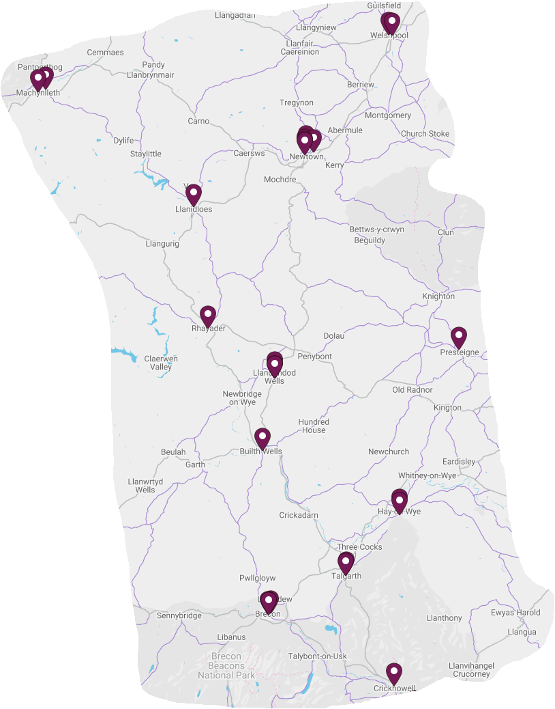

Map data ©2021 Google

The service both increases the demand for pharmaceutical services by referring people to pharmacies for either the level 2 or 3 smoking cessation services, but also reduces the demand as the level 3 service is provided by other providers.

7 Health needs that can be met by pharmaceutical services

Each health related visit to a pharmacy provides a valuable opportunity to support behaviour change through making every one of these contacts count. Making healthy choices such as stopping smoking, improving diet and nutrition, increasing physical activity, losing weight and reducing alcohol consumption could make a significant contribution to reducing the risk of disease, improving health outcomes for those with long-term conditions, reducing premature death and improving mental wellbeing. Pharmacies are ideally placed to encourage and support people to make these healthy choices as part of the provision of pharmaceutical services.

7.1 Need for drugs and appliances

Everyone will at some stage require prescriptions to be dispensed irrespective of whether or not they are in one of the groups identified in section four. This may be for a one-off course of antibiotics or for medication that they will need to take, or an appliance that they will need to use, for the rest of their life in order to manage a long-term condition. This health need can only be met within primary care by the provision of pharmaceutical services be that by pharmacies, dispensing appliance contractors or dispensing doctors.

Coupled with this is the safe collection and disposal of unwanted or out of date dispensed drugs. Both the health board and pharmacies have a duty to ensure that people living at home or in a residential care home (i.e. an establishment that exists wholly or mainly for the provision of residential accommodation together with board and personal care, but no nursing care) can return unwanted or out of date dispensed drugs for their safe disposal.

A waste reduction enhanced service can help reduce prescribing waste and over-ordering of repeat medication by utilising pharmacists and their support staff to ascertain directly from patients whether or not each item presented for dispensing is actually required.

Access to specialist palliative care medicines is critical to support end of life care provided in a person’s home, however due to the specialist nature of the medicines they may not always be stocked by a pharmacy. An enhanced service can ensure participating pharmacies stock an agreed range of specialist medicines and make a commitment to ensure users have prompt access to those medicines during core and supplementary opening hours.

Access to palliative care medication out of hours has been identified by professionals as one of the biggest concerns when caring for the terminally ill and consequently compromises the delivery of good palliative care. When a patient is identified as requiring palliative care support and it is anticipated that their medical condition may deteriorate in the foreseeable future, it is essential that they or their carers are able to access the required medicines. A ‘Just in Case’ bag enhanced service can ensure access to a range of standard palliative care drugs. Following the issuing of a prescription a pharmacy can supply such a bag which is then kept in the patient’s home until needed.

A medication administration service can help support patients who have difficulty in self-administrating their own medication. Dispensing and supply medication with a medicines administration record or a monitored dosage system or an automatic pill dispenser to patients who meet the eligibility criteria for the service will reduce administration errors, support patients to take their medicines as prescribed, and reduce admissions to residential, nursing or hospital care.

Provision of nicotine replacement therapy to people who are receiving behavioural support through a smoking cessation service will help improve access to this therapy for those who wish to stop smoking, and also contribute to improving success rates.

There may be occasion when someone runs out of their regular medicines at the weekend or on a public or bank holiday when their GP practice is closed and they are unable to access a prescription for a further supply. As an alternative to the person phoning the GP out of hours service, an emergency supply of prescribed medication enhanced service can allow pharmacies to provide an emergency supply of a person’s regular prescribed medication under the NHS, rather than on a private basis under the Human Medicines Regulations 2012. Such a service will therefore reduce demand on the GP out of hours service and provide a more efficient service for people.

7.2 Substance misuse

The provision of a supervised administration of medicines enhanced service by pharmacists can:

- Assist prescribing clinicians in the provision of community based prescribing;
- Ensure that the patient takes the correct doses of medication as prescribed;
- Prevent prescribed medication being diverted to the illegal market;
- Reduce the possibility of accidental poisoning, particularly of children; and
- Reduce incidents of accidental death through overdose.

A needle exchange pack enhanced service will assist in the reduction of the sharing of needles (and equipment) which can consequently result in blood-borne viruses and other infections (such as Human Immunodeficiency Virus, hepatitis C) being transmitted by providing clients with convenient access to a pack of sterile injecting equipment and a facility for the safe disposal of used equipment. In turn this could lead to a reduction in the prevalence of blood-borne viruses, therefore also benefiting wider society.

There are also elements of essential service provision which will help address this health need:

- Pharmacies are required to participate in up to six public health campaigns each calendar year by promoting public health messages to users. The topics for these campaigns are selected by the health board and could include drug and alcohol abuse. Public health campaigns could include raising awareness about the risks of alcohol consumption through discussing the risks of alcohol consumption over the recommended amounts, displaying posters and distributing leaflets, scratch cards and other relevant materials
- Where the pharmacy does not provide the enhanced services of needle and syringe exchange and the supervised consumption of substance misuse medicines, signposting people using the pharmacy to other providers of the services.
- Signposting people who are potentially dependent on alcohol to local specialist alcohol treatment providers
- Using the opportunity presented by medicines use reviews, e.g. for anti-hypertensive medicines and medicines for the treatment of diabetes, to discuss the risks of alcohol consumption and in particular, during public health campaigns or in discussion with customers requesting particular over the counter medicines, to raise awareness of the risks of alcohol misuse
- Providing healthy living advice during medicines use review consultations.

7.3 Cancer

In addition to dispensing prescriptions, pharmacies can contribute to many of the public health issues relating to cancer care as part of the essential services they provide:

- Disposal of unwanted drugs, including controlled drugs
- Pharmacies are required to participate in up to six public health campaigns each calendar year by promoting public health messages to users. The topics for these campaigns are selected by the health board and could include cancer awareness and/or screening
- Providing appropriate advice to people who use the pharmacy and appear to smoke or are overweight with the aim of increasing that person’s knowledge and understanding of the health issues which are relevant to their personal circumstances.
- Signposting people using the pharmacy to other providers of services or support.

Support for people who wish to stop smoking, whether that is under the level 2 or level 3 services, will also help reduce the incidence of some cancers.

7.4 Long-term conditions

In addition to dispensing prescriptions, pharmacies can contribute to many of the public health issues relating to long-term conditions as part of the essential services they provide:

- Where a person presents a prescription, and they appear to have diabetes, be at risk of coronary heart disease (especially those with high blood pressure), smoke or are overweight, the pharmacy is required to give appropriate advice with the aim of increasing that person’s knowledge and understanding of the health issues which are relevant to their circumstances
- Pharmacies are required to participate in up to six public health campaigns each calendar year by promoting public health messages to users. The topics for these campaigns are selected by the health board and could include long-term conditions.
- Signposting people using the pharmacy to other providers of services or support.
- Providing healthy living advice during medicines use review consultations.

Provision of the medicine use review, appliance use review, stoma appliance customisation and discharge medicines review advanced services, and the flu vaccination enhanced service will also assist people to manage their long-term conditions in order to maximise their quality of life.

Support for people who wish to stop smoking, whether that is under the level 2 or level 3 services, will also help reduce the incidence of circulatory diseases and cardiovascular diseases.

7.5 Obesity

Four elements of the essential services will address this health need:

- Where a person presents a prescription, and they are overweight, the pharmacy is required to give appropriate advice with the aim of increasing the person’s knowledge and understanding of the health issues which are relevant to their circumstances
- Pharmacies are required to participate in up to six public health campaigns each calendar year by promoting public health messages to users. The topics for these campaigns are selected by the health board and could include obesity
- Signposting people using the pharmacy to other providers of services or support
- Providing healthy living advice during medicines use review consultations.

7.6 Sexual health

Alongside chlamydia screening and emergency hormonal contraception enhanced services there are elements of essential service provision which will help address this health need:

- Pharmacies are required to participate in up to six public health campaigns each calendar year by promoting public health messages to users. The topics for these campaigns are selected by the health board and could include sexually transmitted infections and human immunodeficiency virus
- Signposting people using the pharmacy to providers of sexually transmitted infections screening services
- Providing healthy living advice during medicines use review consultations.

Ensuring the provision of emergency hormonal contraception through pharmacies will improve access to the service, particularly at times when GP practices are closed.

7.7 Teenage pregnancy

An emergency hormonal contraception enhanced service coupled with elements of essential service provision will help address this health need:

- Pharmacies are required to participate in up to six public health campaigns each calendar year by promoting public health messages to users. The topics for these campaigns are selected by the health board and could include teenage pregnancy
- Where the pharmacy does not provide an emergency hormonal contraception enhanced service, signposting people using the pharmacy to other providers of the service.

7.8 Smoking

In addition to a smoking cessation enhanced services there are elements of essential service provision which will help address this health need:

- Where a person presents a prescription, and they appear to have diabetes, be at risk of coronary heart disease (especially those with high blood pressure), smoke or are overweight, the pharmacy is required to give appropriate advice with the aim of increasing that person’s knowledge and understanding of the health issues which are relevant to their circumstances
- Pharmacies are required to participate in up to six public health campaigns each calendar year by promoting public health messages to users. The topics for these campaigns are selected by the health board and could include smoking
- Where the pharmacy does not provide the smoking cessation enhanced service, signposting people using the pharmacy to other providers of the service
- Routinely discussing stopping smoking when selling relevant over the counter medicines
- Providing healthy living advice during medicines use review consultations.

Smoking cessation enhanced services can link pharmacies with, and enhance, the intensive behavioural support service provided by Help Me Quit either through the supply of nicotine replacement therapy to smokers who are receiving intensive smoking cessation behavioural support from Help Me Quit or by the provision of treatments such as Varenicline via a patient group direction. This will also improve choice for patients who will be able to receive this treatment without seeing their GP.

7.9 Support for self-care

Support for self-care is an essential service and can help a person manage a medical condition, including in the case of a carer, to help the carer to assist in the management of another person’s medical condition. The service requires pharmacies to provide appropriate advice on treatment options and changes to the person’s lifestyle.

A common ailments service allows people to speak to a pharmacist, rather than their GP, for a defined list of common ailments. The pharmacist will supply medication from an agreed formulary, give advice or refer the patient to the GP if necessary. Medicines are supplied free of charge thereby removing the payment barrier, which can prevent patients choosing to see a pharmacist instead of their GP.

Alternatively where the pharmacist is an independent prescriber people with a relevant acute condition included in a list of conditions covered by an enhanced service could be seen by the pharmacist can assess, diagnose and prescribe a medicine as appropriate.

Test and treat enhanced services can also help reduce pressure on GP practices and out of hours services, by allowing pharmacists to assess and diagnose and either prescribe a treatment or supply it under a patient group direction.

7.10 Vaccinations

Pharmacies have provided flu vaccinations for a number of years, enhancing the service provided by GP practices by increasing the number of locations at, and the times and days on, which vaccines can be given.

8 North Powys locality

8.1 Key facts

- This locality consists of two upper super output areas.
- The greatest life expectancy at birth for men is in the northern upper super output area at 80.3 years (2015 to 2017) whereas for women it is in the southern upper super output area (84.3 years).
- Those aged 16 and over in the north were more likely to eat five fruit or vegetable portions a day (2010 to 2015) at 40.8%, whereas in the south it was 35.1%.
- Slightly more adults aged 16 and over in the south met the physical activity guidelines in 2010 to 2015 compared to those in the north (37.3% compared to 36.9%).
- 18% of adults aged 16 and over in the north smoked (2010 to 2015) compared to 20.6% in the south.
- Those aged 16 and over drank above the guidelines (2010 to 2015) in the north compared to in the south (42.0% compared to 38.4%).
- Teenage pregnancy rates 2013 to 2017 were lower in the north compared to the south (11.5% and 20.2% respectively).
- Those aged 16 to 64 were more likely to rate their health as good, very good or excellent in the north between 2010 and 2015 compared to the south (88.2% compared to 86.0%).
- Those aged 16 to 64 were more likely to be of a healthy weight between 2010 and 2015 in the south compared to the north (45.4% compared to 39.7%).
- Premature deaths from key non communicable diseases between 2016 and 2018 were higher in the south compared to the north (274.1 per 100,000 European age-standardised rate compared to 261.4).
- Approximately 12.7% of the housing to be built between 2011 and 2026 identified in appendix 2 of the Powys Joint Housing Land Availability Study is located in Newtown.
- Caereinion Medical Practice is due to move into a new health centre in 2022. The practice has successfully applied to be able to dispense from these new premises.

8.2 Current provision of pharmaceutical services within the locality’s area

There are eight pharmacies in the locality operated by six different contractors, and all seven of the GP practices dispense from a total of 11 premises. The level of dispensing ranges from 21% to 92% of the practices’ registered populations.

The map below shows the location of the pharmacies and dispensing doctor premises within the locality.

Map 16 – location of pharmacies and dispensing doctor premises

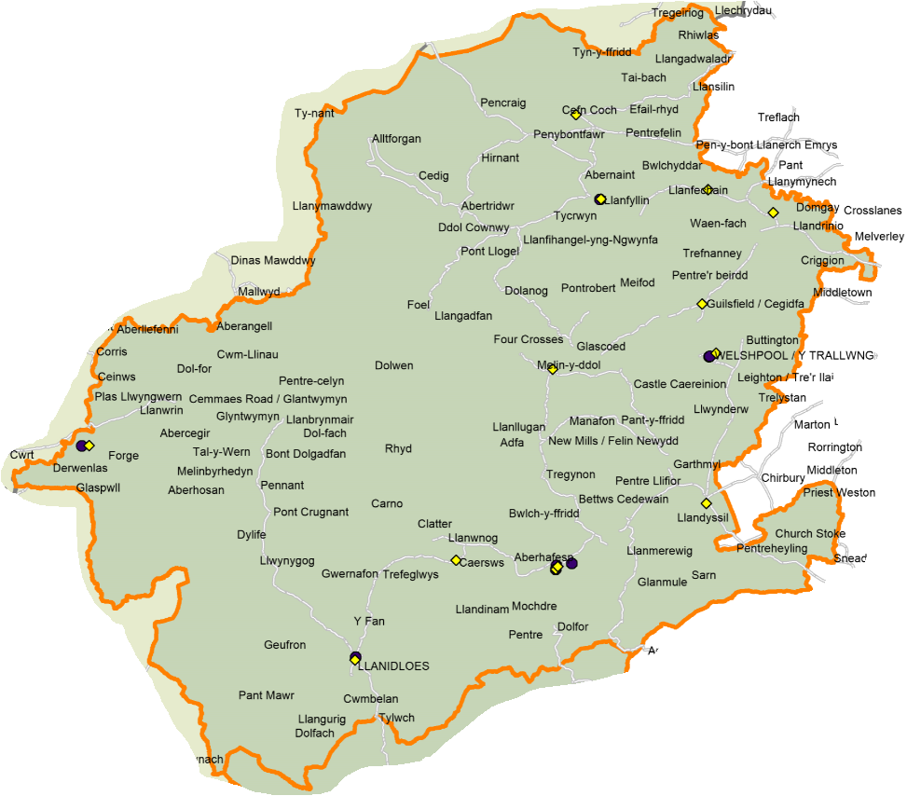

© Crown Copyright Ordnance Survey Mapping License 100050829

As can be seen from the map below the pharmacies and the majority of the dispensing doctor premises are located in areas of greater population density. It should be noted that where premises are close to each other the symbols will overlap.

Map 17 – location of pharmacies and dispensing doctor premises compared to population density, per lower super output area

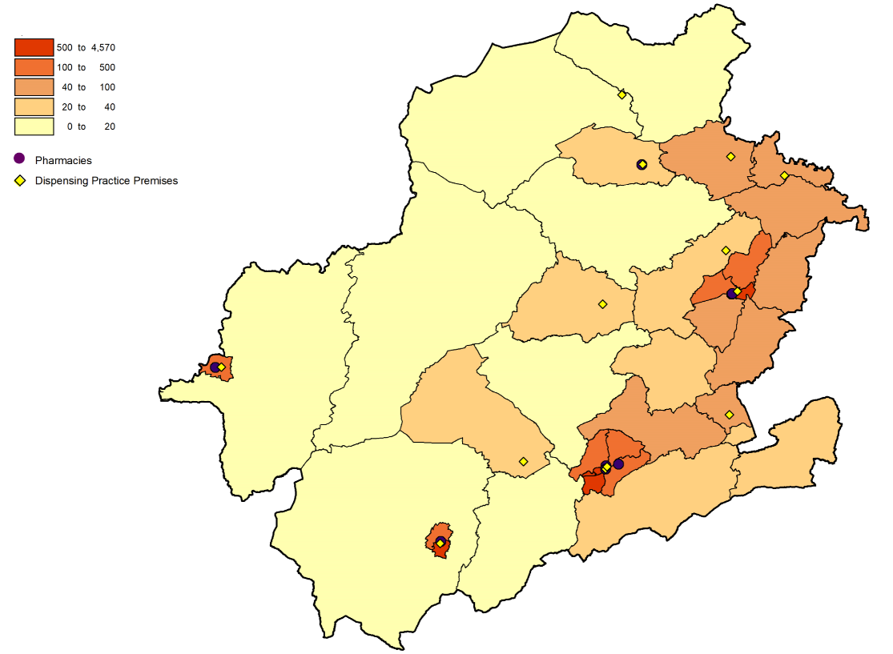
© Crown Copyright Ordnance Survey Mapping License 100050829

The map below shows the location of the pharmacies and dispensing doctor premises in relation to the Welsh Index of Multiple Deprivation quintiles.

Map 18 – location of pharmacies and dispensing doctor premises compared to the Welsh Index of Multiple Deprivation, per lower super output area

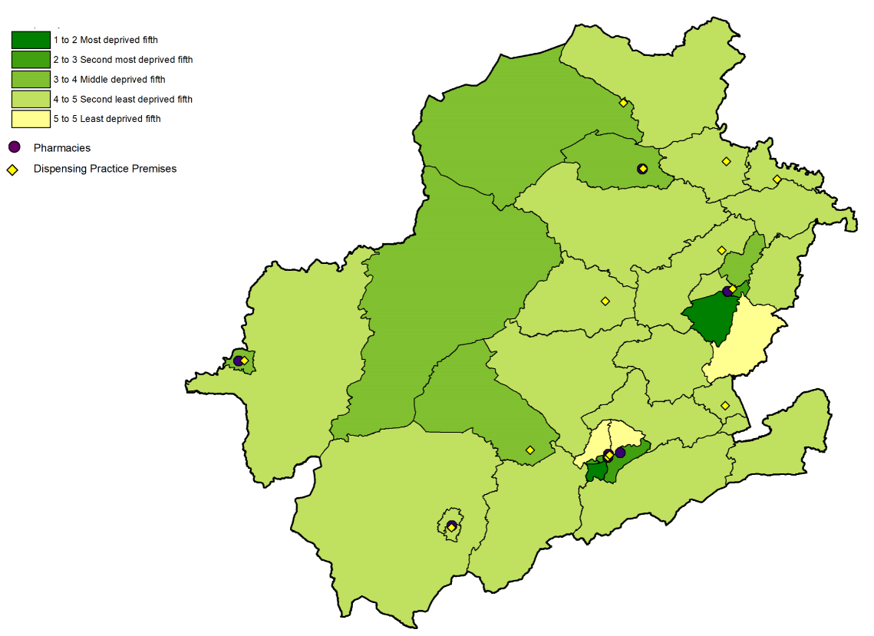
© Crown Copyright Ordnance Survey Mapping License 100050829

In 2019/20, 44.5% of prescriptions written by the GP practices in the locality were dispensed by a pharmacy within the locality, and the dispensing practices dispensed or personally administered 54.2% of the prescribed items. Whilst the data available doesn’t show the percentage split between dispensed and personally administered items, based on the level of personal administration elsewhere in Wales it can be assumed that less than 2% of items were personally administered.

In 2020/21, slightly more items were dispensed by a pharmacy within the locality (46.8%) whilst the dispensing practices dispensed or personally administered 51.0% of items prescribed.

The map below shows the drive time to the pharmacies and dispensing doctor premises, with the darker the green the shorter the drive. As can be seen the areas of very low population density are not within a 20-minute drive of a pharmacy. It should be noted that where premises are close to each other the symbols will overlap.

Map 19 – access to pharmacies and dispensing doctor premises in the locality

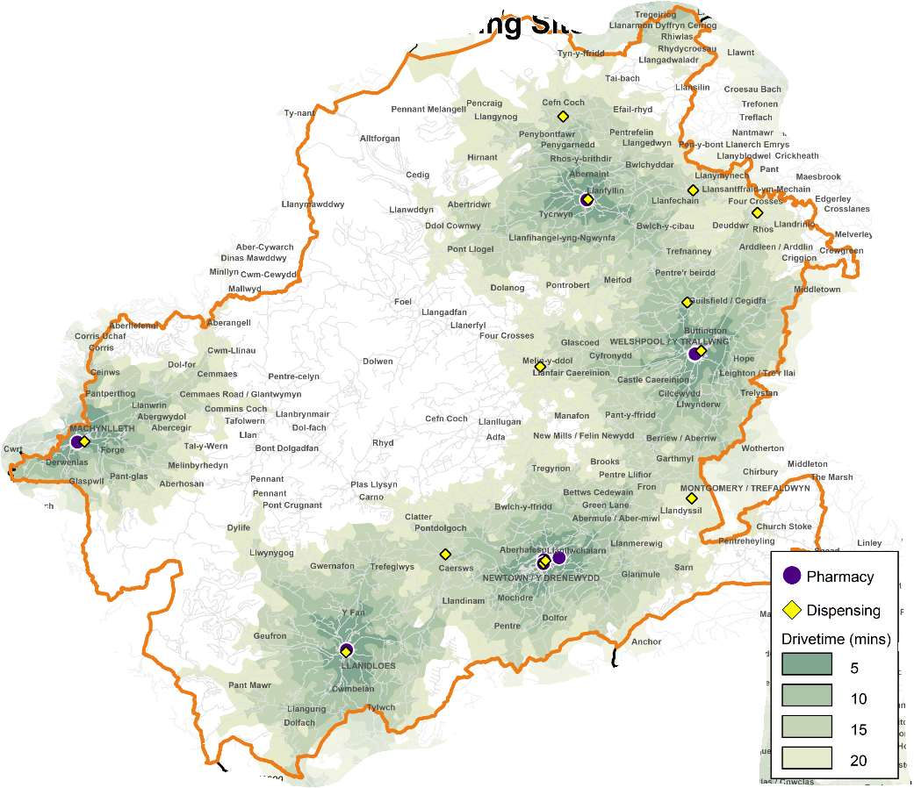

© Crown Copyright Ordnance Survey Mapping License 100050829

With regard to when the pharmacies are open, at the time of drafting:

- Three open Monday to Friday, and part of Saturday,
- Four open Monday to Saturday, and
- One opens Monday to Sunday in Newtown.

With regard to the times at which these pharmacies are open between Monday and Friday:

- One opens at 08.30 with the remainder opening at 09.00,
- Six close at 17.30 (one closes at 11:00 on Wednesdays), one at 18.30 and one at 19.00.

A weekday evening rota operates across the locality so that a pharmacy is open in Welshpool until 18.00 and a pharmacy in Llanfyllin stays open until 18.30.

Three pharmacies remain open all day in Newtown and Llanfyllin, the others close at lunchtime.

On Saturday, all the pharmacies open at 09.00. A pharmacy in Newtown remains open all day. The other four pharmacies that are open all day close for lunch at varying times between 13.00 and 14.15. Two pharmacies close at 17.00, two at 17.30 and one at 18.00.

Sunday opening hours are secured between 10.00 and 16.00 by a pharmacy in Newtown.

Pharmacy opening hours are likely to change during the lifetime of this document and therefore where someone is looking for the most up-to-date times they should refer to the NHS 111 Wales website.

All of the pharmacies responded to the pharmacy contractor questionnaire and the following information is taken from those responses.

Seven of the pharmacies are accessible by wheelchair, and six have a consultation area that is accessible by wheelchair although wheelchair access at one needs improving. All eight of the consultations areas are:

- closed rooms,
- a designated area where the patient and pharmacist can sit down together and talk at normal volumes without being overheard, and
- clearly designated as an area for confidential consultations distinct from the general public areas of the pharmacy.

Three pharmacies confirmed that Welsh is spoken by staff, one of which confirmed that Italian, Spanish and Romanian are also spoken. One pharmacy confirmed that Polish is spoken by staff. The health board has noted that 72.0% of residents had no Welsh language skills and 98.0% have English as their main language (local authority level data, Census 2011). This coupled with the availability of Language Line and bilingual posters and leaflets means that the health board has not identified any issues for those who wish to access services in a language other than English.

All of the pharmacies dispense prescriptions for all types of appliances.

All of the pharmacies collect prescriptions from GP practices. In relation to the delivery of dispensed items:

- four provide a free of charge delivery service on request,
- two provide a delivery service for a fee,
- two only provide a delivery service to:
  - delivery to the immediate area (mile radius) or further where we dispense to that patient,
  - Kerry, Newtown, Caersws and Tregynon, and
- two restrict the delivery service to:
  - patients in genuine need with limited or no family or support,
  - housebound patients,
  - Covid isolating patients.

Suggestions by pharmacies for existing services that are not currently provided in the area included:

- Contraception service – this would improve patient access to medicines and reduce GP workload,
- Currently accredited for the sore throat treat and triage service which could be offered in branch. Waiting on the patient group direction.

Three pharmacies were of the opinion that there is a requirement for a new enhanced service which is not currently available:

- Independent prescriber respiratory services. This would improve patient access to medicines, provide additional benefit from existing medicines, and reduce GP workload.
- Microsuction service
- Increase scope of common ailments conditions, e.g. impetigo, uncomplicated skin infections, so as to save GP referrals.

Six pharmacies confirmed that they have sufficient capacity within their existing premises and staffing levels to manage an increase in demand for the services they provide, and two said they don’t but could make adjustments.

Two pharmacies have plans to develop or expand their service provision or premises:

- One is considering creating an additional consultation room
- A mobile ramp is being installed at one pharmacy to improve wheelchair access to the premises

Others expressed a willingness to provide more services based on local need, with one requesting a more streamlined process for the commissioning of new services with a view to reducing administrative time.

Three of the dispensing practices responded to the dispensing doctor questionnaire and the following information is taken from those responses. They provide services over five premises.

Four of the GP practice premises open between 08.00 and 09.00 with one closing at 17.00 and 18.00. Two close at lunchtime although this is temporary change in response to the Covid pandemic. The practice intends to revert back to the usual opening hours (08.30 to 18.30) in due course. The fifth dispensary opens 09.00 to 13.00 each weekday other than Thursdays.

With regard to the dispensing of prescriptions for appliances:

- Two practices dispense all types of appliance, and
- One only dispenses dressings.

One practice provides a delivery service to specified areas on a weekly basis, however this has been replaced with a Powys Association of Voluntary Organisations volunteer collection service. Another practice provides a private, delivery service that is free of charge.

All three practices have staff who are able to speak Welsh.

One practice has sufficient capacity to manage the increase in demand in their area, and the other two don’t but could make adjustments to do so. One of these, Caereinion Medical Practice, is due to move into a new health centre in 2022.

In relation to dispensing related services that were reported as provided:

- Three provide medicine administration record charts, and
- Three provide just in case packs.

Practices reported making the following changes to their dispensing service that they will take into the “new normal”:

- One practice has moved a hub dispensary model so that the majority of prescriptions are now dispensed at one site and then transported to the other sites for collection. The practice is also reviewing how dispensed items are collected which may require remodelling of the premises with the possible installation of an automated collection point.
- Encourage use of My Health Online for the ordering of repeat medication. A volunteer delivery service might be considered long term. Whilst an automated collection point would be useful the cost of purchase and installation may be prohibitive.
- Continue with social distancing practices.

8.2.1 Medicines use review service

In 2018/19 and 2019/20 all eight pharmacies provided this service, with two providing the maximum number of 400 in 2018/19 and one in 2019/20. At the time of writing the service has been suspended until April 2021 due to the Covid pandemic, however it is anticipated that once the service is reinstated the pharmacies will resume provision.

The map below shows the locations where the service was provided in 2019/20. It should be noted that where pharmacies are in close proximity the blue circles representing them may overlap.

Map 20 – location of the pharmacies providing the medicines use review service in 2019/20

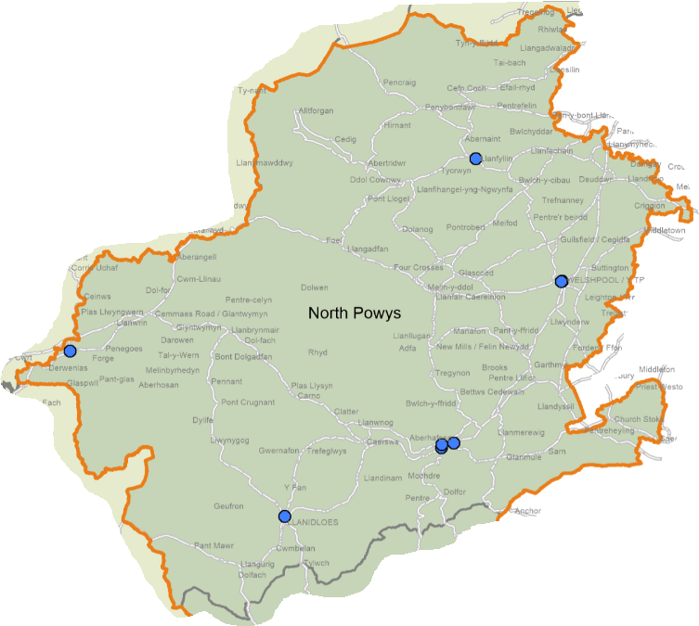

© Crown Copyright Ordnance Survey Mapping License 100050829

8.2.2 Discharge medicines review

In 2018/19, four of the pharmacies provided this service with none providing the maximum number of 140 reviews. This increased to five pharmacies in 2019/20, again with none providing the maximum number. In 2020/21, all of the pharmacies provided the service.

The map below shows the locations where the service was provided in 2019/20. It should be noted that where pharmacies are in close proximity the pink triangles representing them may overlap.

Map 21 – location of the pharmacies providing discharge medicines reviews in 2019/20
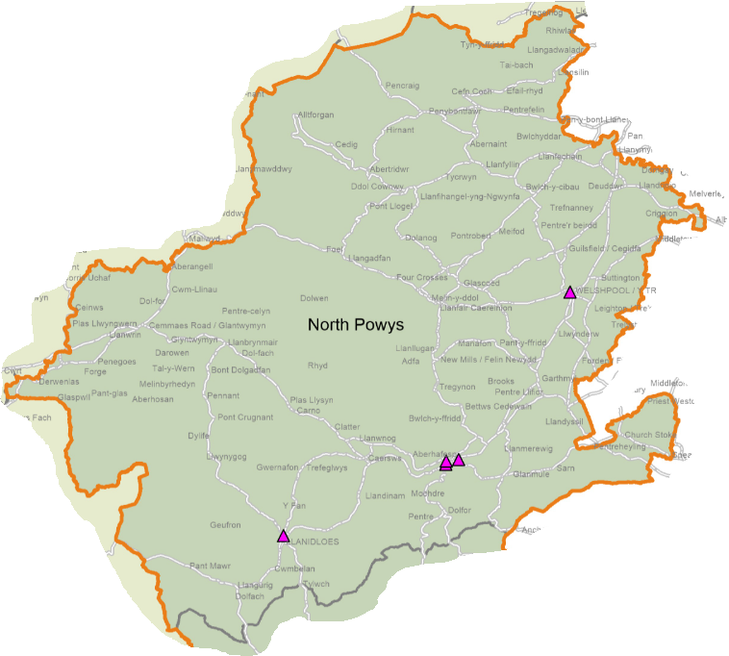

© Crown Copyright Ordnance Survey Mapping License 100050829

8.2.3 Appliance use reviews

None of the pharmacies in the locality provide this service despite dispensing prescriptions for appliances.

8.2.4 Stoma appliance customisation

None of the pharmacies in the locality provide this service despite dispensing prescriptions for appliances.

8.2.5 Emergency hormonal contraception

Seven of the pharmacies provided this service in 2018/19 and 2019/20. In 2020/21, seven pharmacies are commissioned to provide the service and provided it.

The map below shows the locations where the service was provided in 2019/20. It should be noted that where pharmacies are in close proximity the grey triangles representing them may overlap.

Map 22 – location of the pharmacies providing the emergency hormonal contraception service in 2019/20

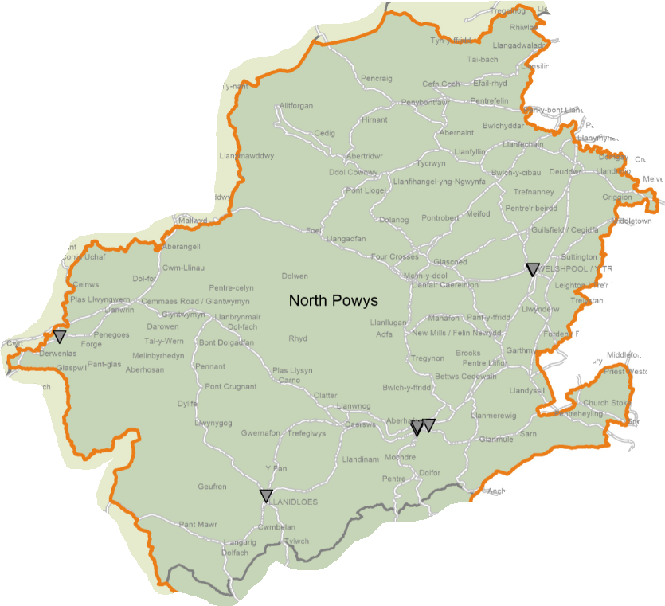

© Crown Copyright Ordnance Survey Mapping License 100050829

In 2021/22 all of the pharmacies are commissioned to provide the service.

8.2.6 Smoking cessation service level 2

Six of the pharmacies provided this service in 2018/19 reducing to four in 2019/20. In 2020/21 all eight were commissioned to provide it and they are also all commissioned to provide it in 2021/22.

The map below shows the locations where the service was provided in 2019/20. It should be noted that where pharmacies are in close proximity the blue squares representing them may overlap.

Map 23 – location of the pharmacies providing the smoking cessation level 2 service in 2019/20
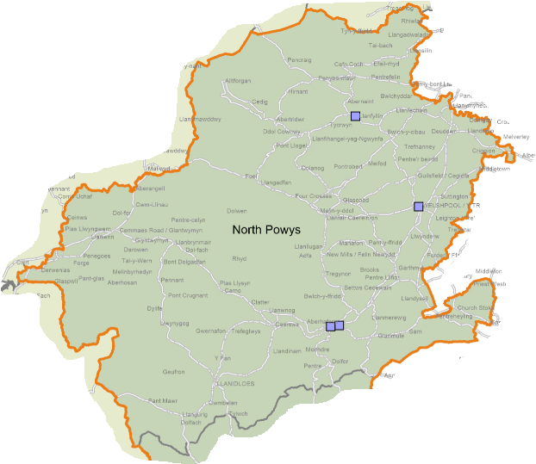

© Crown Copyright Ordnance Survey Mapping License 100050829

8.2.7 Smoking cessation service level 3

Three of the pharmacies provided this service in 2018/19 increasing to five in 2019/20. In 2020/21 seven are commissioned to provide it.

The map below shows the locations where the service was provided in 2019/20. It should be noted that where pharmacies are in close proximity the maroon squares representing them may overlap.

Map 24 – location of the pharmacies providing the smoking cessation level 3 service in 2019/20

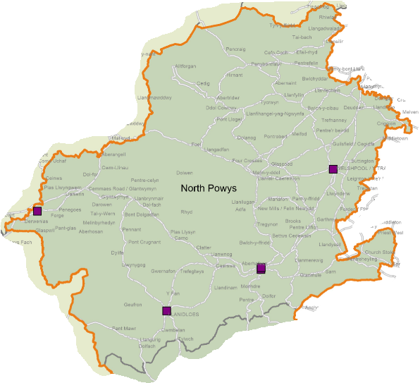

© Crown Copyright Ordnance Survey Mapping License 100050829

Seven pharmacies are commissioned to provide the service in 2021/22.

8.2.8 Flu vaccination

Four of the pharmacies provided this service in 2018/19, increasing to six in 2019/20. In 2020/21, six pharmacies were commissioned to provide the service.

The map below shows the locations where the service was provided in 2019/20. It should be noted that where pharmacies are in close proximity the turquoise circles representing them may overlap.

Map 25 – location of the pharmacies providing flu vaccinations in 2019/20

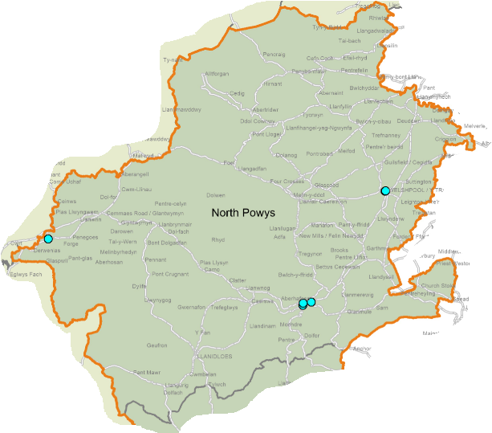

© Crown Copyright Ordnance Survey Mapping License 100050829

As of August 2021, three pharmacies are commissioned to provide the service in 2021/22, however this figure is expected to increase to the same level as in the previous year before the service starts in September.

8.2.9 Common ailment service

Five of the pharmacies provided this service in 2018/19, increasing to seven in 2019/20. In 2020/21 all eight were commissioned to provide it.

The map below shows the locations where the service was provided in 2019/20. It should be noted that where pharmacies are in close proximity the green diamonds representing them may overlap.

Map 26 – location of the pharmacies providing the common ailment service in 2019/20

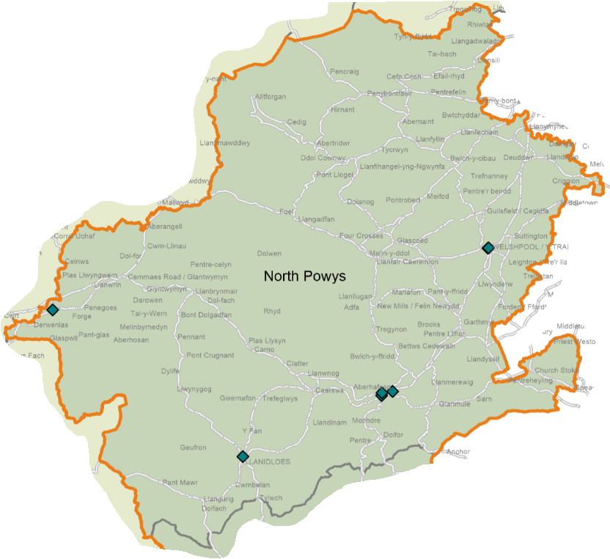

© Crown Copyright Ordnance Survey Mapping License 100050829

All eight are commissioned to provide the service in 2021/22.

8.2.10 Emergency medicine supply

All of the pharmacies provided this service in 2018/19 and 2019/20. In 2020/21 seven of the pharmacies were commissioned to provide it.

The map below shows the locations where the service was provided in 2019/20. It should be noted that where pharmacies are in close proximity the blue diamonds representing them may overlap.

Map 27 – location of the pharmacies providing the emergency medicine supply service in 2019/20

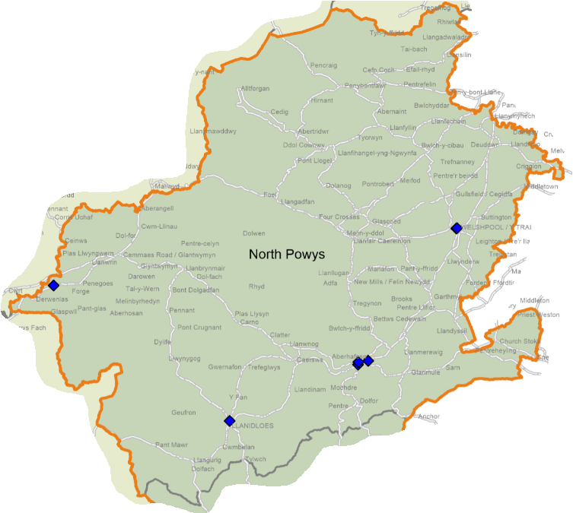

© Crown Copyright Ordnance Survey Mapping License 100050829

In 2021/22 all of the pharmacies are commissioned to provide the service.

8.2.11 Supervised consumption service

None of the pharmacies provided this service in 2018/19, increasing to three in 2019/20. In 2020/21 six were commissioned to provide it. Increasing to seven in 2021/22 (as of August 2021).

8.2.12 Needle exchange service

Two of the pharmacies provided this service in 2018/19, increasing to three in 2019/20. Three were commissioned to provide the service in 2020/21 and as of August 2021 three are commissioned to provide it in 2021/22.

8.2.13 Just in case packs

Five of the pharmacies provided this service in 2018/19, reducing to four in 2019/20. In 2020/21 seven were commissioned to provide it, and seven are also commissioned in 2021/22 as of August 2021.

8.2.14 Care home support and medicines optimisation

Two pharmacies were commissioned to provide this service in 2020/21 and this has fallen to one in 2021/22 (as of August 2021). In addition there are out of area providers of the service.

8.2.15 Medicine administration record charts

Six pharmacies were commissioned to provide this service in 2020/21 and six are commissioned to provide it in 2021/22 as of August 2021.

8.2.16 Palliative care stocks

One pharmacy was commissioned to provide this service in 2020/21 and one is commissioned in 2021/22 (as of August 2021).

8.2.17 Respiratory rescue medicines service

One pharmacy was commissioned to provide this service in 2020/21 and as of August 2021 one is commissioned to provide it in 2021/22.

8.2.18 Patient sharps

All eight pharmacies were commissioned to provide this service in 2020/21 and are also commissioned in 2021/22.

8.2.19 Waste reduction scheme

Six pharmacies were commissioned to provide this service in 2020/21 and six are commissioned in 2021/22 as of August 2021.

8.2.20 Independent prescriber service

One pharmacy was commissioned to provide this service in 2020/21 and 1,560 items were prescribed under the service in 2019/20. Of these, 99.8% were dispensed at the pharmacy. 1,456 items were prescribed in 2021/21, with 99.7% dispensed at the pharmacy.

The pharmacy is also commissioned to provide the service in 2021/22.

8.3 Current provision of pharmaceutical services outside the locality’s area

Some residents choose to access contractors outside both the locality and the health board’s area in order to access services:

- Offered by dispensing appliance contractors
- Which are located near to where they work, shop or visit for leisure or other purposes.

Whilst the majority of prescriptions written by the GP practices in 2019/20 were dispensed by either the eight pharmacies in the locality or the seven dispensing practices, 1.3% was dispensed outside the locality:

- 0.9% by contractors in England,
- 0.3% by pharmacies in Hywell Dda University Health Board, and
- 0.1% elsewhere in Wales.

2.2% were dispensed outside the locality in 2020/21:

- 0.9% by contractors in England,
- 0.5% by pharmacies in each of Swansea Bay and Aneurin Bevan Health Boards, and
- 0.3% by pharmacies in Hywell Dda University Health Board.

In addition residents may have accessed one or more pharmaceutical services provided by another pharmacy outside of both the locality and the health board’s area; however it is not possible to quantify this activity from the recorded data.

8.4 Other NHS services

The GP practices in the locality provide the following services which affect the need for pharmaceutical services:

- Provision of emergency hormonal contraception
- Flu vaccinations
- Advice and treatment for common ailments
- Three practices provide medicine administration record charts and just in case packs.

Practices may choose to provide other services which are the same or similar to those provided by pharmacies, for example support to stop smoking, but as they are not commissioned by the health board they fall outside the definition of ‘other NHS services’.

Less than 2.0% of items prescribed by the GP practices are likely to have been personally administered by the practices in 2019/20 and 2020/21.

At the time of drafting none of the GP practices offer extended opening hours. Should this change during the lifetime of this document the health board is able to direct a pharmacy to open outside of its normal opening hours if there is a need to do so.

In 2019/20, 2,819 items were prescribed by the Kaleidoscope Drug and Alcohol Service based in Newtown and dispensed by over 30 pharmacies as follows:

- North Powys – 90.2% of items
- Mid Powys – 3.3%
- South Powys - 3.1%
- England – 2.7%
- Hywel Dda University Health Board – 0.4%
- Elsewhere in Wales – 0.3%

1,858 items were prescribed by the service in 2020/21 with the majority (91.5%) dispensed by pharmacies within the locality, followed by 6.1% dispensed in England, 1.2% in South Powys and 0.9% in Mid Powys.

Smoking cessation services are provided by Help Me Quit at a number of locations across North Powys other than at pharmacies.

The following hospitals are in the locality and generate prescriptions which are dispensed under pharmaceutical services:

- Bro Ddyfi Hospital, Machynlleth
- Montgomeryshire County Infirmary, Newtown
- Llanidloes War Memorial Hospital, Llanidloes
- Victoria Memorial Hospital, Welshpool
- Bryntirion Resource Centre, Welshpool
- Fan Gorau Unit, Newtown
- Park Street Clinic, Newtown
- Ynys Y Plant Children's Centre, Newtown

No other NHS services have been identified that are located within the locality and which affect the need for pharmaceutical services.

8.5 Choice with regard to obtaining pharmaceutical services

As can be seen from sections 8.2 and 8.3, those living within the locality and registered with one of the GP practices generally choose to access one of the pharmacies in the locality in order to have their prescriptions dispensed or, if eligible, to be dispensed to by their practice. Those that look outside the locality usually do so either to access a neighbouring pharmacy or a dispensing appliance contractor outside of the health board’s area.

In 2019/20 over 90 contractors dispensed items prescribed by one of the GP practices in this locality, of which:

- eight were located within the locality,
- 12 were located elsewhere within the health board’s area,
- 69 were located elsewhere in Wales, and
- A number of prescriptions were dispensed in England.

Over 109 contractors dispensed the prescriptions written in 2020/21, as follows:

- eight were located within the locality,
- 15 were located elsewhere within the health board’s area,
- 84 were located elsewhere in Wales, and
- A number of prescriptions were dispensed in England.

8.6 Gaps in provision

8.6.1 Provision of essential services

The health board has noted the following points:

- The pharmacies are spread across the locality and are generally located in areas of greater population density and higher deprivation.
- Those parts of the locality with very low levels of population density (up to 20 people per lower super output area) are not within a 20-minute drive of a pharmacy.
- 752 houses are to be built between 2011 and 2026 in Newtown, 301 in Welshpool, 255 in Llanidloes, 169 in Llanfyllin and 160 in Churchstoke.
- Six pharmacies confirmed that they have sufficient capacity within their existing premises and staffing levels to manage an increase in demand for the services they provide, and two said they don’t but could make adjustments.

Based on the above, the health board has not identified any current or future needs for these services within the locality.

8.6.2 Provision of dispensing services by GP practices

The health board has noted the following points:

- all seven of the GP practices dispense from a range of premises across the locality.
- The premises are generally located in areas of lower population density and deprivation.
- Caereinion Medical Practice is due to move into a new health centre and has successfully applied to dispense from these new premises.

Based on the above, the health board has not identified any current or future needs for these services within the locality.

8.6.3 Medicines use review service

The health board has noted the following points:

- Prior to the suspension of this service it was provided by all of the pharmacies.
- Two pharmacies provided the maximum number of medicines use reviews in 2018/19. One did in 2019/20.
- Six pharmacies confirmed that they have sufficient capacity within their existing premises and staffing levels to manage an increase in demand for the services they provide, and two said they don’t but could make adjustments.

Based on the above, the health board has not identified any current or future needs for this service within the locality.

8.6.4 Discharge medicines review

The health board has noted the following points:

- The increasing numbers of pharmacies providing this service over the last three years. Seven of the pharmacies had provided this service in 2020/21, at the point of drafting.
- The skills required by pharmacists to provide this service are the same as for the medicines use review service. All the pharmacies will therefore be capable of providing this service.
- The IT systems in the hospitals are not currently able to transfer information on discharges to the IT systems in the pharmacies. Therefore if a patient does not take their discharge letter to the pharmacy the pharmacist may not be able to identify that they are eligible to receive the service. This is being looked into and the position may improve during the lifetime of this document.
- Due to the range of medicines included within the service only a small proportion of patients being discharged will be eligible to receive the service.
- As discharge letters are sent electronically to the GP practices there is a reduced risk of transcription errors in relation to medicines. In addition GP practices may undertake medicines reconciliations post discharge.
- Six pharmacies confirmed that they have sufficient capacity within their existing premises and staffing levels to manage an increase in demand for the services they provide, and two said they don’t but could make adjustments.

The health board is therefore satisfied that the relatively low level of provision of this service is more likely due to the number of eligible patients presenting to a pharmacy than an inability or unwillingness of the pharmacies to provide the service.

Based on the above, the health board has not identified any current or future needs for this service within the locality.

8.6.5 Appliance use reviews

The health board has noted that all the pharmacies confirmed that they dispense prescriptions for all types of appliances but that none of them provide the appliance use review service. It has therefore considered whether or not there is a current or future need for this service in the locality.

In 2019/20, 43,218 items prescribed by the GP practices were dispensed in England and 67% of these were dispensed by a dispensing appliance contractor. In addition, the three dispensing appliance contractors based in Wales will have received prescriptions for appliances. In relation to the items prescribed by the incontinence service, 99.5% were dispensed by contractors in England.

Neither the health board nor the community health council has received any complaints or issues around the provision of appliances and related services.

Based on the above, the health board is satisfied that there are no current or future needs for the provision of this service in the locality.

8.6.6 Stoma appliance customisation

The health board has noted that all the pharmacies confirmed that they dispense prescriptions for all types of appliances but that none of them provide the stoma appliance customisation service. It has therefore considered whether or not there is a current or future need for this service in the locality.

In 2019/20, 43,218 items prescribed by the GP practices were dispensed in England and 67% of these were dispensed by a dispensing appliance contractor. In addition, the three dispensing appliance contractors based in Wales will have received prescriptions for appliances. In relation to the items prescribed by the incontinence service, 99.5% were dispensed by contractors in England.

Neither the health board nor the community health council has received any complaints or issues around the provision of appliances and related services.

It is noted that not every stoma appliance that is prescribed will require customisation. It is therefore possible that the pharmacies are dispensing stoma appliances that do not require customisation and those appliances that do are being dispensed and customised by dispensing appliance contractors based elsewhere in Wales or in England.

Based on the above, the health board is satisfied that there are no current or future needs for the provision of this service in the locality.

8.6.7 Emergency hormonal contraception

The health board has noted the following points:

- Seven of the pharmacies were commissioned to provide this service in 2020/21.
- The service is also provided by GP practices and sexual health clinics.
- There is a growing focus on long-acting reversible contraception for eligible females.
- Six pharmacies confirmed that they have sufficient capacity within their existing premises and staffing levels to manage an increase in demand for the services they provide, and two said they don’t but could make adjustments.

Whilst one of the pharmacies is not commissioned to provide this service the health board has noted that the GP practice in the town does. The health board has not identified any current or future needs for this service within the locality.

8.6.8 Smoking cessation service level 2

The health board has noted the following points:

- All of the pharmacies were commissioned to provide this service in 2020/21.
- Demand for the service is dictated by people wishing to stop smoking.
- Six pharmacies confirmed that they have sufficient capacity within their existing premises and staffing levels to manage an increase in demand for the services they provide, and two said they don’t but could make adjustments.

Based on the above, the health board has not identified any current or future needs for this service within the locality.

8.6.9 Smoking cessation service level 3

The health board has noted the following points:

- Seven of the pharmacies are commissioned to provide this service in 2021/22 at the point of drafting.
- Demand for the service is dictated by people wishing to stop smoking.
- Six pharmacies confirmed that they have sufficient capacity within their existing premises and staffing levels to manage an increase in demand for the services they provide, and two said they don’t but could make adjustments.

Based on the above, the health board has not identified any current or future needs for this service within the locality.

8.6.10 Flu vaccination

The health board has noted the following points:

- Six of the pharmacies were commissioned to provide this service in 2020/21.
- There are other providers of the service, for example the GP practices.
- Six pharmacies confirmed that they have sufficient capacity within their existing premises and staffing levels to manage an increase in demand for the services they provide, and two said they don’t but could make adjustments.

Whilst two of the pharmacies are not commissioned to provide this service the health board has noted that the GP practices in the two towns do. The health board has not identified any current or future needs for this service within the locality.

8.6.11 Common ailment service

The health board has noted the following points:

- All of the pharmacies were commissioned to provide this service in 2020/21.
- There are other providers of the service, for example the GP practices.
- Six pharmacies confirmed that they have sufficient capacity within their existing premises and staffing levels to manage an increase in demand for the services they provide, and two said they don’t but could make adjustments.

Based on the above, the health board has not identified any current or future needs for this service within the locality.

8.6.12 Emergency medicine supply

The health board has noted the following points:

- All of the pharmacies were commissioned to provide this service in 2020/21.
- Six pharmacies confirmed that they have sufficient capacity within their existing premises and staffing levels to manage an increase in demand for the services they provide, and two said they don’t but could make adjustments.

Based on the above, the health board has not identified any current or future needs for this service within the locality.

8.6.13 Supervised consumption service

The health board has noted the following points:

- All of the pharmacies were commissioned to provide this service in 2020/21.
- Six pharmacies confirmed that they have sufficient capacity within their existing premises and staffing levels to manage an increase in demand for the services they provide, and two said they don’t but could make adjustments.

Based on the above, the health board has not identified any current or future needs for this service within the locality.

8.6.14 Needle exchange service

The health board has noted the following points:

- Three of the pharmacies were commissioned to provide this service in 2020/21.
- Six pharmacies confirmed that they have sufficient capacity within their existing premises and staffing levels to manage an increase in demand for the services they provide, and two said they don’t but could make adjustments.

Based on the above, the health board has not identified any current or future needs for this service within the locality.

8.6.15 Just in case packs

The health board has noted the following points:

- Seven of the pharmacies were commissioned to provide this service in 2020/21.
- Six pharmacies confirmed that they have sufficient capacity within their existing premises and staffing levels to manage an increase in demand for the services they provide, and two said they don’t but could make adjustments.

Based on the above, the health board has not identified any current or future needs for this service within the locality.

8.6.16 Care home support and medicines optimisation

The health board has noted the following points:

- Two of the pharmacies were commissioned to provide this service in 2020/21.
- Six pharmacies confirmed that they have sufficient capacity within their existing premises and staffing levels to manage an increase in demand for the services they provide, and two said they don’t but could make adjustments.

Based on the above, the health board has not identified any current or future needs for this service within the locality.

8.6.17 Medicine administration record charts

The health board has noted the following points:

- Six of the pharmacies were commissioned to provide this service in 2020/21.
- Six pharmacies confirmed that they have sufficient capacity within their existing premises and staffing levels to manage an increase in demand for the services they provide, and two said they don’t but could make adjustments.

Based on the above, the health board has not identified any current or future needs for this service within the locality.

8.6.18 Palliative care stocks

The health board has noted the following points:

- One pharmacy was commissioned to provide this service in 2020/21.
- Six pharmacies confirmed that they have sufficient capacity within their existing premises and staffing levels to manage an increase in demand for the services they provide, and two said they don’t but could make adjustments.

Based on the above, the health board has not identified any current or future needs for this service within the locality.

8.6.19 Respiratory rescue medicines service

The health board has noted the following points:

- One pharmacy was commissioned to provide this service in 2020/21.
- Six pharmacies confirmed that they have sufficient capacity within their existing premises and staffing levels to manage an increase in demand for the services they provide, and two said they don’t but could make adjustments.

Based on the above, the health board has not identified any current or future needs for this service within the locality.

8.6.20 Patient sharps

The health board has noted the following points:

- All of the pharmacies were commissioned to provide this service in 2020/21.
- Six pharmacies confirmed that they have sufficient capacity within their existing premises and staffing levels to manage an increase in demand for the services they provide, and two said they don’t but could make adjustments.

Based on the above, the health board has not identified any current or future needs for this service within the locality.

8.6.21 Waste reduction scheme

The health board has noted the following points:

- Six of the pharmacies were commissioned to provide this service in 2020/21.
- Six pharmacies confirmed that they have sufficient capacity within their existing premises and staffing levels to manage an increase in demand for the services they provide, and two said they don’t but could make adjustments.

Based on the above, the health board has not identified any current or future needs for this service within the locality.

8.6.22 Independent prescriber service

The health board has noted the following points:

- This is a fledgling service which is reliant upon training courses being available and pharmacists being able to complete them.
- Currently one pharmacy is commissioned to provide the service.
- It can take up to two years from a pharmacist deciding to undertake the training to complete it. It is therefore envisaged that within the lifetime of this document the health board will commission independent prescriber services from the pharmacies in the locality.
- Six pharmacies confirmed that they have sufficient capacity within their existing premises and staffing levels to manage an increase in demand for the services they provide, and two said they don’t but could make adjustments.

In line with Pharmacy: Delivering a Healthier Wales, the health board would like to see all of the current pharmacies with an independent prescriber. However it has not identified any current or future needs for these services within the locality.

9 Mid Powys locality

9.1 Key facts

- This locality consists of one upper super output area.
- The life expectancy at birth for men is 79.7 years (2015 to 2017) whereas for women it is 84.7 years.
- 39.3% of those aged 16 and over in the north eat five fruit or vegetable portions a day (2010 to 2015).
- 39.2% of adults aged 16 and over met the physical activity guidelines in 2010 to 2015.
- 19.9% of adults aged 16 and over smoked (2010 to 2015).
- The locality has the lowest percentage of adults aged 16 and over who drink above the guidelines (2010 to 2015) at 32.7%.
- Teenage pregnancy rates 2013 to 2017 were 17.5% per 1,000 females aged under 18.
- 86.1% of those aged 16 to 64 rated their health as good, very good or excellent.
- 41.3% of those aged 16 to 64 were of a healthy weight between 2010 and 2015.
- The European age-standardised rate of premature deaths from key non communicable diseases between 2016 and 2018 was 257.8 per 100,000.
- Approximately 11.5% of the housing to be built between 2011 and 2026 identified in appendix 2 of the Powys Joint Housing Land Availability Study is located in Llandrindod Wells (680 houses).

9.2 Current provision of pharmaceutical services within the locality’s area

There are seven pharmacies in the locality operated by four different contractors. Of the five GP practices only one provides a dispensing service to 0.03% of its patients.

The map below shows the location of the pharmacies and dispensing doctor premises within the locality.

Map 28 – location of pharmacies and dispensing doctor premises

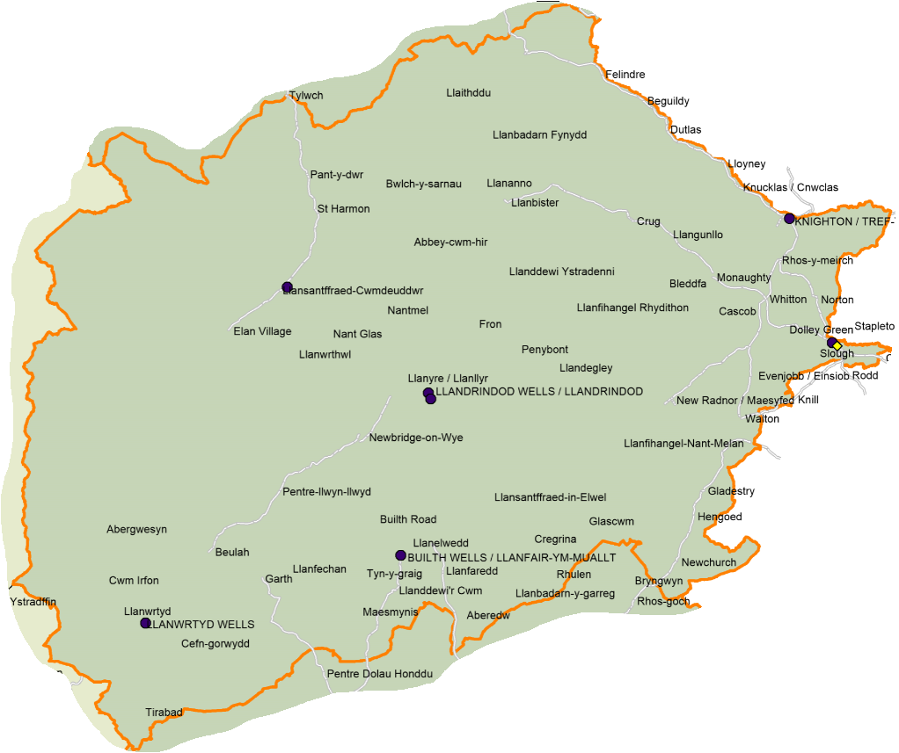

© Crown Copyright Ordnance Survey Mapping License 100050829

As can be seen from the map below with two exceptions, the pharmacies are located in areas of greater population density. The dispensing practice premises is also located in an area of greater population density. It should be noted that where premises are close to each other the symbols will overlap.

Map 29 – location of pharmacies and dispensing doctor premises compared to population density, per lower super output area

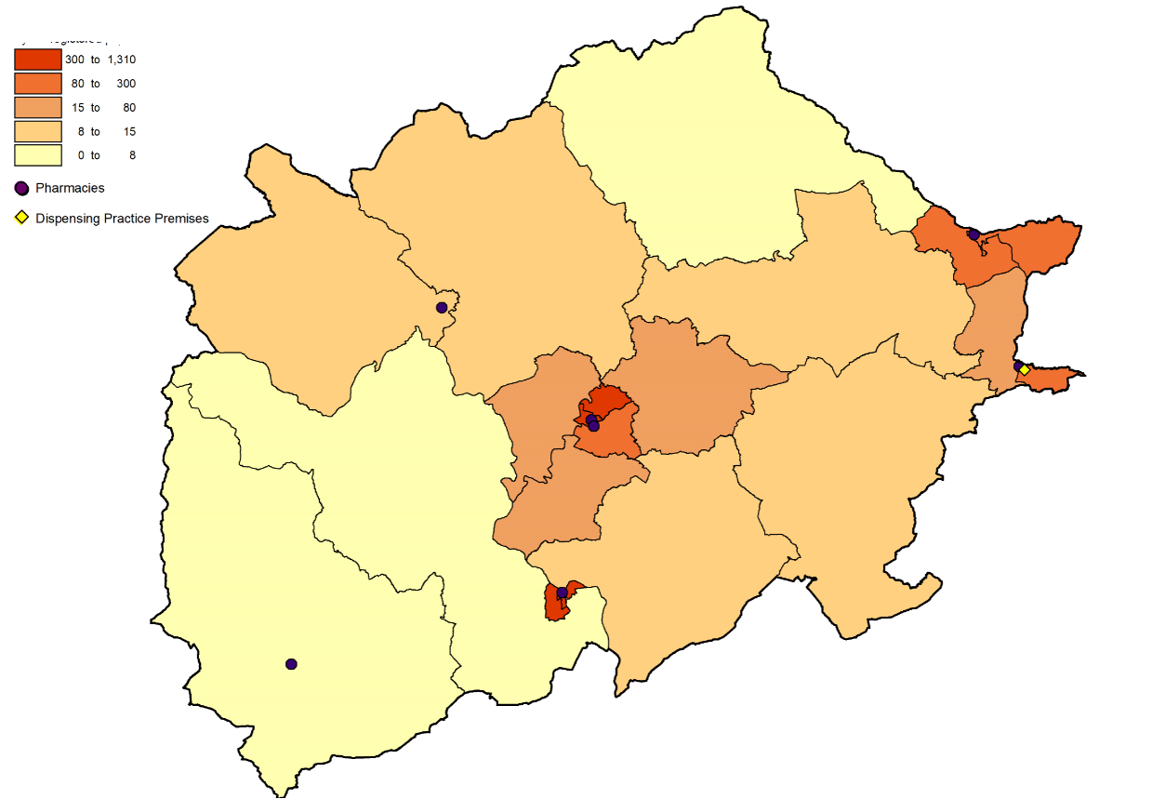

© Crown Copyright Ordnance Survey Mapping License 100050829

The map below shows the location of the pharmacies and dispensing doctor premises in relation to the Welsh Index of Multiple Deprivation quintiles.

Map 30 – location of pharmacies and dispensing doctor premises compared to the Welsh Index of Multiple Deprivation 2019, per lower super output area

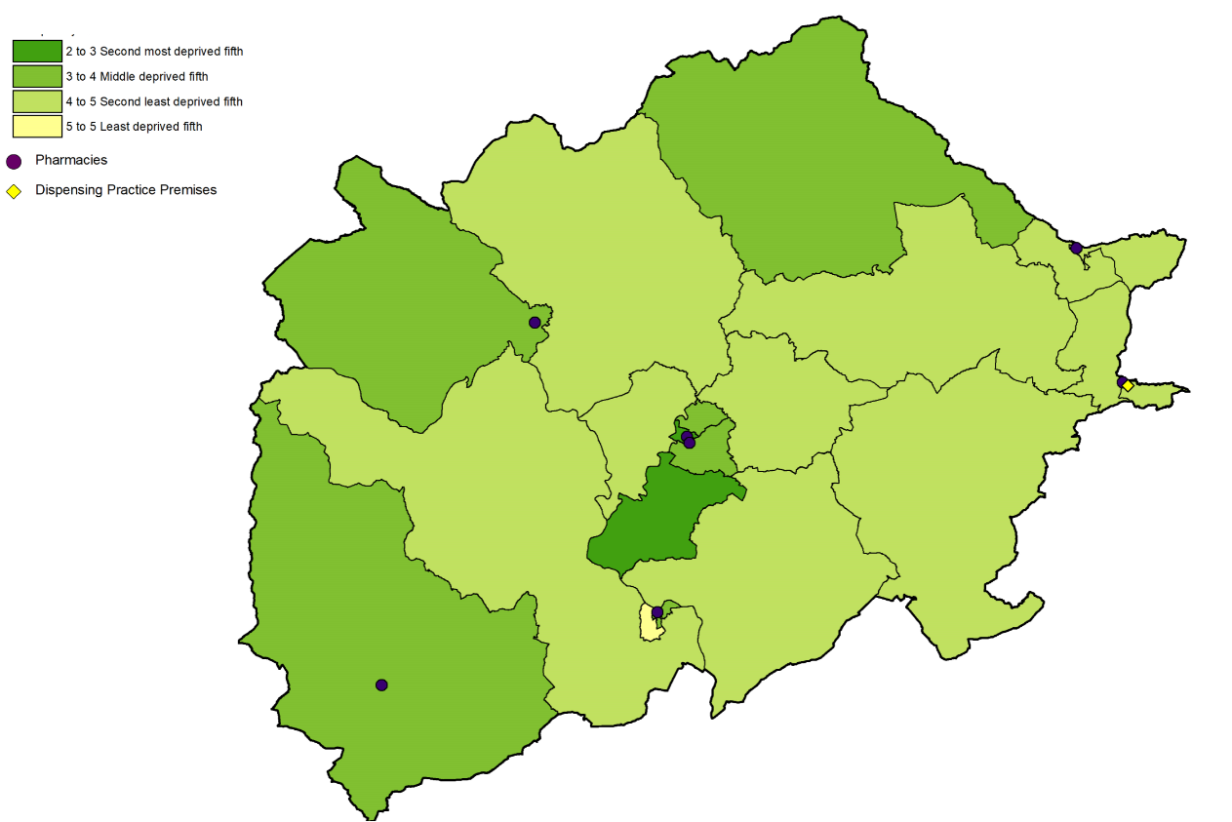

© Crown Copyright Ordnance Survey Mapping License 100050829

In 2019/20, 96.4% of prescriptions written by the GP practices in the locality were dispensed by a pharmacy within the locality, and the dispensing practice dispensed or personally administered 0.2% of the prescribed items. The GP practice registered patient list data confirms that the dispensing practice is only dispensing to one of its patients and this is reflected in the number of items reported as having been dispensed by the practice in 2019/20 which is more reflective of a non-dispensing practice.

A similar percentage of prescriptions written by the GP practices were dispensed by a pharmacy within the locality in 2020/21 (96.7%) or dispensed or personally administered by the dispensing practice (0.1%).

The map below shows the drive time to the pharmacies, with the darker the green the shorter the drive. As can be seen the areas of very low population density are not within a 20-minute drive of a pharmacy. It should be noted that where premises are close to each other the symbols will overlap.

Map 31 – access to pharmacies in the locality

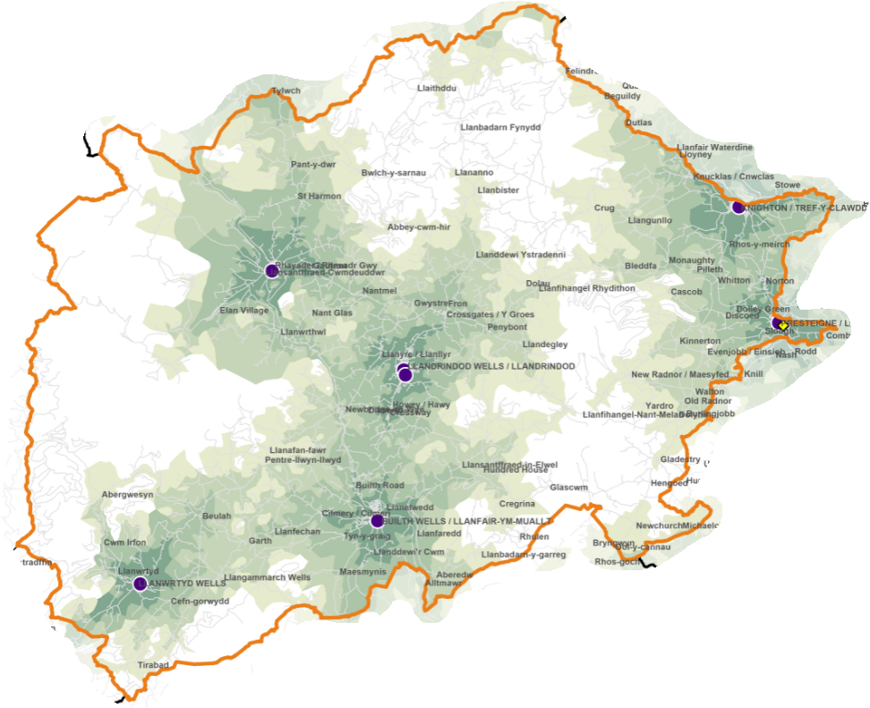

© Crown Copyright Ordnance Survey Mapping License 100050829

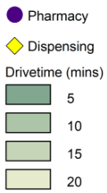

With regard to when the pharmacies are open, at the time of drafting:

- One opens Monday to Friday,
- Two open Monday to Friday, and part of Saturday, and
- Four open Monday to Saturday.

With regard to the times at which these pharmacies are open between Monday and Friday:

- Three open at 08.30 with the remainder opening at 09.00,
- One closes at 16.30 (17.30 on Wednesdays), four close at 17.30, one at 17.45 and one at 18.00.

A weekday evening rota operates across the locality so that a pharmacy is open until 18.00 in Presteigne, and until 18.30 in Builth Wells, Knighton and Llandrindod Wells.

Only the pharmacy in Llanwrtyd Wells is open all day; the others close at lunchtime at varying times between 12.30 and 14.00.

On Saturday, the pharmacies open at either 08.30 or 09.00. The pharmacy in Presteigne and one in Llandrindod Wells close at lunchtime, and the remainder are open until 17.00 or 17.30 although do close for lunchtime at varying times between 13.00 and 14.00.

None of the pharmacies open on Sundays and there is no rota in place. In the past when a Sunday opening hours rota has been in place there was insufficient demand and it was therefore terminated.

Pharmacy opening hours are likely to change during the lifetime of this document and therefore where someone is looking for the most up-to-date times they should refer to the NHS 111 Wales website.

All of the pharmacies responded to the pharmacy contractor questionnaire and the following information is taken from those responses.

All of the pharmacies are accessible by wheelchair, and six have a consultation area that is accessible by wheelchair. The pharmacy that does not have a consultation area confirmed that it does have access to alternative arrangements for confidential discussions. The seven consultation areas are:

- closed rooms,
- a designated area where the patient and pharmacist can sit down together and talk at normal volumes without being overheard, and
- clearly designated as an area for confidential consultations distinct from the general public areas of the pharmacy.

None of the pharmacies confirmed that any languages other than English are spoken. The health board has noted that 72.0% of residents had no Welsh language skills and 98.0% have English as their main language (local authority level data, Census 2011). This coupled with the availability of Language Line and bilingual posters and leaflets means that the health board has not identified any issues for those who wish to access services in a language other than English.

All of the pharmacies dispense prescriptions for all types of appliances.

All of the pharmacies collect prescriptions from GP practices. In relation to the delivery of dispensed items:

- two provide a free of charge delivery service on request,
- two provide a delivery service for a fee but restrict the service:
  - one pharmacy delivers to Llandrindod town and surrounding villages, and Builth Wells, and
  - one pharmacy delivers within a five-mile radius, ten miles by prior arrangement.

Suggestions by pharmacies for existing services that are not currently provided in the area included:

- Provision of chronic obstructive pulmonary disease packs, and
- Extension of the common ailments scheme to cover uncomplicated urinary tract infections and impetigo.

One pharmacy was of the opinion that there is a requirement for a new enhanced service which is not currently available namely the treatment of patients with uncomplicated infections.

Six pharmacies confirmed that they have sufficient capacity within their existing premises and staffing levels to manage an increase in demand for the services they provide, and one said it doesn’t but could make adjustments.

Three pharmacies have plans to develop or expand their premises or service provision:

- One is currently extending its premises,
- One plans to provide smoking cessation in the near future, and
- One plans the addition of an independent prescriber when GP practices are able to support again.

Another pharmacy said that it is happy to support additional services based on local need.

The dispensing practice did not respond to the dispensing doctor questionnaire.

9.2.1 Medicines use review service

In 2018/19 and 2019/20 six of the pharmacies provided this service, with two providing the maximum number of 400 in 2018/19 and one in 2019/20. At the time of writing the service has been suspended until April 2022 due to the Covid pandemic, however it is anticipated that once the service is reinstated that the pharmacies will resume provision.

The map below shows the locations where the service was provided in 2019/20. It should be noted that where pharmacies are in close proximity the blue circles representing them may overlap.

Map 32 – location of the pharmacies providing the medicines use review service in 2019/20

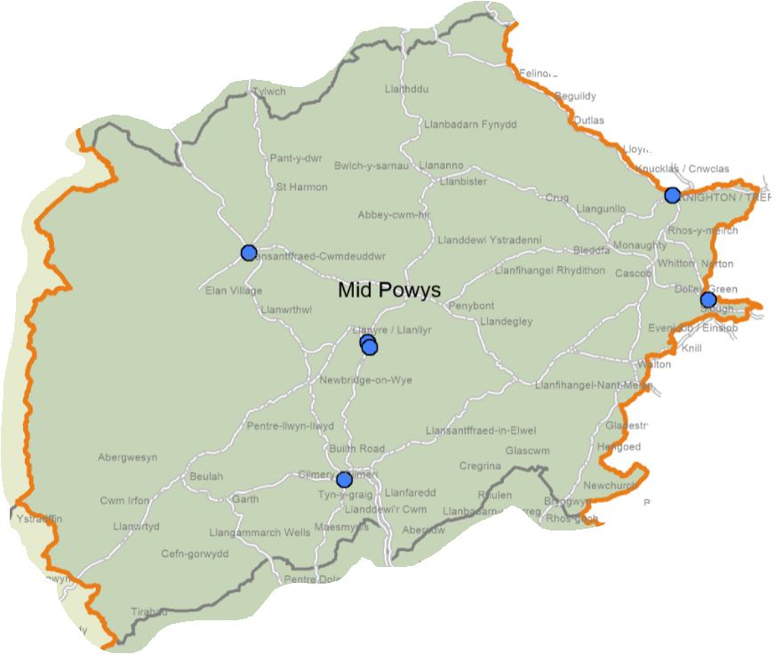
© Crown Copyright Ordnance Survey Mapping License 100050829

9.2.2 Discharge medicines review

In 2018/19, four of the pharmacies provided this service with none providing the maximum number of 140 reviews. This reduced to three pharmacies in 2019/20, again with none providing the maximum number.

The map below shows the locations where the service was provided in 2019/20. It should be noted that where pharmacies are in close proximity the pink triangles representing them may overlap.

Map 33 – location of the pharmacies providing discharge medicines reviews in 2019/20

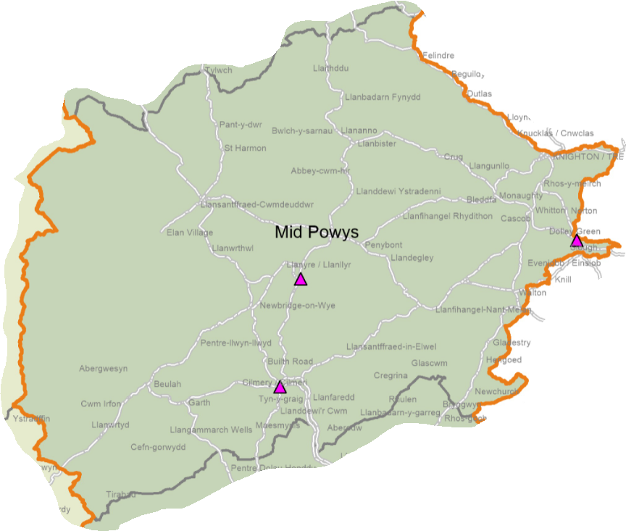
© Crown Copyright Ordnance Survey Mapping License 100050829

In 2020/21, four of the pharmacies provided the service.

9.2.3 Appliance use reviews

None of the pharmacies in the locality provide this service despite dispensing prescriptions for appliances.

9.2.4 Stoma appliance customisation

None of the pharmacies in the locality provide this service despite dispensing prescriptions for appliances.

9.2.5 Emergency hormonal contraception

Five of the pharmacies provided this service in 2018/19 and 2019/20. The map below shows the locations where the service was provided in 2019/20. It should be noted that where pharmacies are in close proximity the grey triangles representing them may overlap.

Map 34 – location of the pharmacies providing the emergency hormonal contraception service in 2019/20

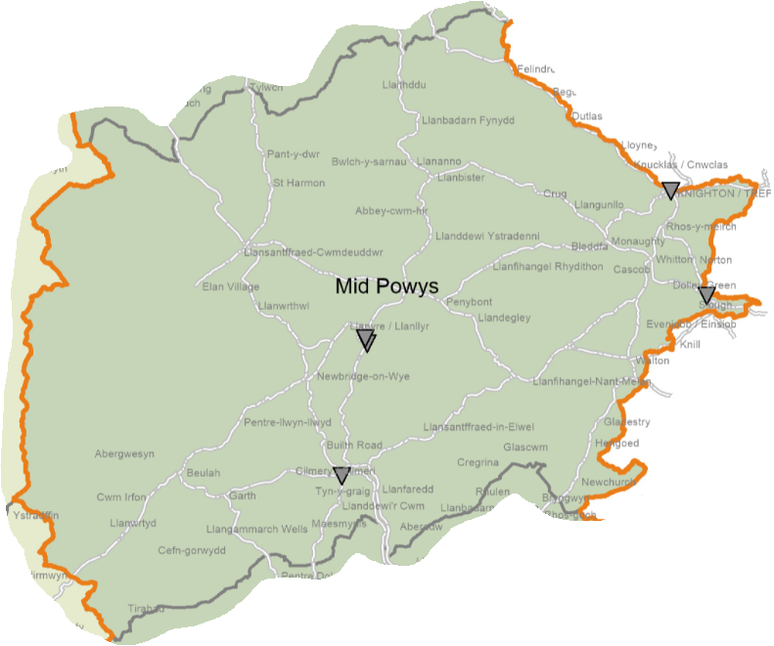

© Crown Copyright Ordnance Survey Mapping License 100050829

In 2020/21 six were commissioned to provide and provided it.

9.2.6 Smoking cessation service level 2

Two of the pharmacies provided this service in 2018/19 increasing to three in 2019/20. The map below shows the locations where the service was provided in 2019/20. It should be noted that where pharmacies are in close proximity the blue squares representing them may overlap.

Map 35 – location of the pharmacies providing the smoking cessation level 2 service in 2019/20

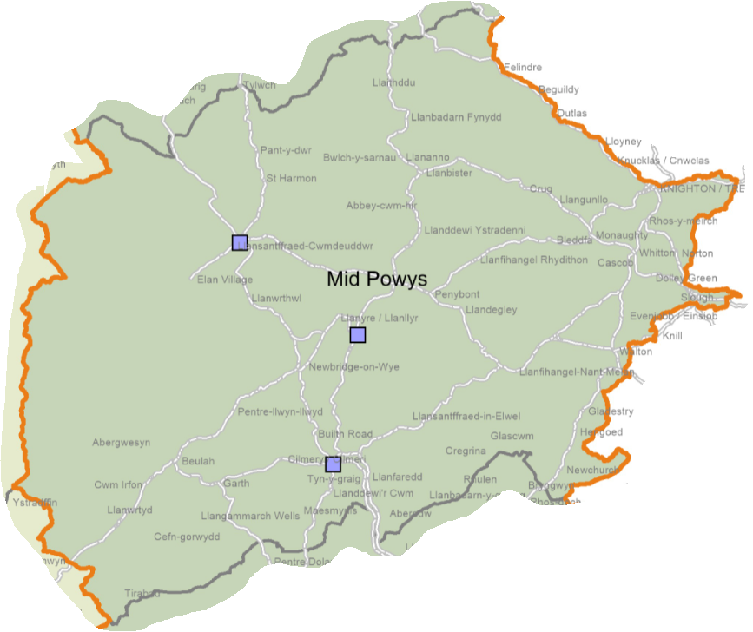
© Crown Copyright Ordnance Survey Mapping License 100050829

In 2020/21 six pharmacies were commissioned to provide it. Six pharmacies are commissioned to provide the service in 2021/22 as of August 2021.

9.2.7 Smoking cessation service level 3

Four of the pharmacies provided this service in 2018/19 reducing to three in 2019/20. The map below shows the locations where the service was provided in 2019/20. It should be noted that where pharmacies are in close proximity the maroon squares representing them may overlap.

Map 36 – location of the pharmacies providing the smoking cessation level 3 service in 2019/20

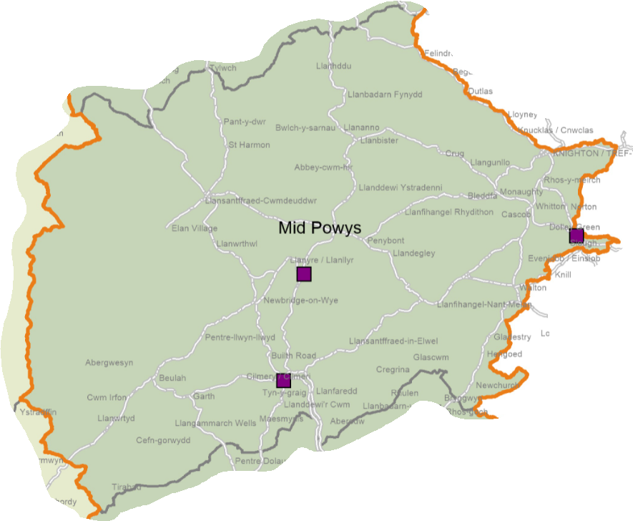

© Crown Copyright Ordnance Survey Mapping License 100050829

In 2020/21 six were commissioned to provide the service. They are also commissioned to provide the service in 2021/22.

9.2.8 Flu vaccination

Six of the pharmacies have provided the service in 2018/19 and 2019/20. The map below shows the locations where the service was provided in 2019/20. It should be noted that where pharmacies are in close proximity the turquoise circles representing them may overlap.

Map 37 – location of the pharmacies providing flu vaccinations in 2019/20

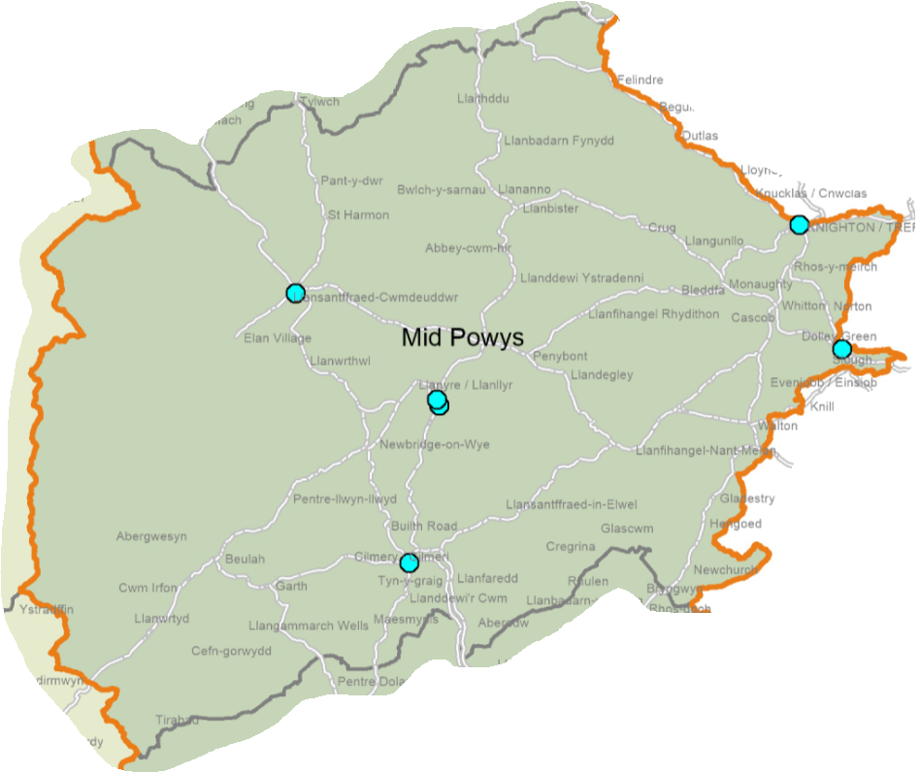

© Crown Copyright Ordnance Survey Mapping License 100050829

In 2020/21, six pharmacies were commissioned to provide the service.

As of August 2021, three pharmacies are commissioned to provide the service in 2021/22, however this figure is expected to increase to the same level as in the previous year before the service starts in September.

9.2.9 Common ailment service

Six of the pharmacies have provided the service in 2018/19 and 2019/20. The map below shows the locations where the service was provided in 2019/20. It should be noted that where pharmacies are in close proximity the green diamonds representing them may overlap.

Map 38 – location of the pharmacies providing the common ailment service in 2019/20

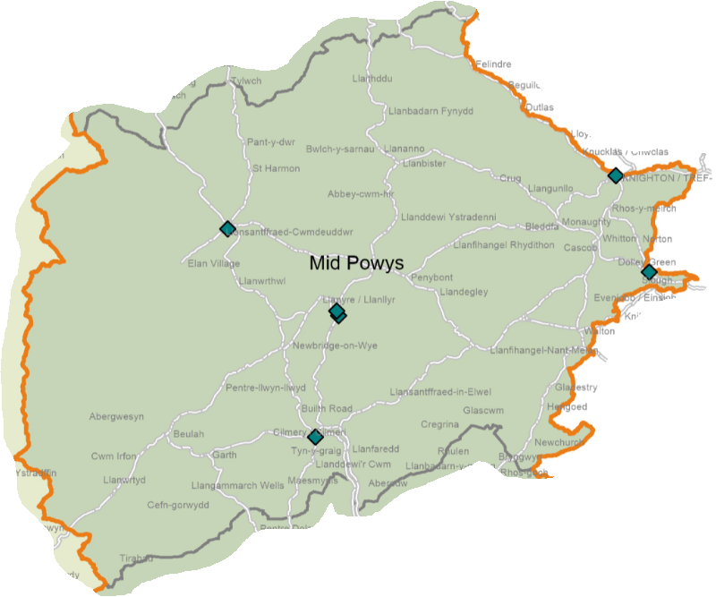

© Crown Copyright Ordnance Survey Mapping License 100050829

In 2020/21, six pharmacies were commissioned to provide the service, and six are commissioned to provide it in 2021/22 as of August 2021.

9.2.10 Emergency medicine supply

Six of the pharmacies have provided the service in 2018/19 and 2019/20. The map below shows the locations where the service was provided in 2019/20. It should be noted that where pharmacies are in close proximity the blue diamonds representing them may overlap.

Map 39 – location of the pharmacies providing the emergency medicine supply service in 2019/20

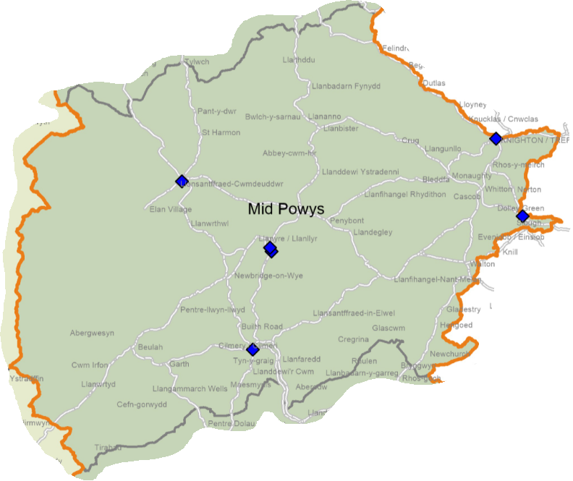

© Crown Copyright Ordnance Survey Mapping License 100050829

In 2020/21, six pharmacies were commissioned to provide the service and six are commissioned in 2021/22 as of August 2021.

9.2.11 Supervised consumption service

Two of the pharmacies provided this service in 2018/19, increasing to three in 2019/20. Six were commissioned to provide it in 2020/21 and six are commissioned to provide it in 2021/22 as of August 2021.

9.2.12 Needle exchange service

Two of the pharmacies provided this service in 2018/19, increasing to three in 2019/20. In 2020/21 four were commissioned to provide it and four are commissioned to provide it in 2021/22 as of August 2021.

9.2.13 Just in case packs

Five of the pharmacies provided this service in 2018/19, increasing to six in 2019/20. In 2020/21 seven were commissioned and all seven are commissioned to provide it in 2021/22 as of August 2021.

9.2.14 Care home support and medicines optimisation

Two pharmacies were commissioned to provide this service in 2020/21 falling to one pharmacy in 2021/22 as of August 2021. In addition there are out of area providers of the service.

9.2.15 Medicine administration record charts

All seven pharmacies were commissioned to provide this service in 2020/21 and are commissioned to provide it in 2021/22 as of August 2021.

9.2.16 Palliative care stocks

One pharmacy was commissioned to provide this service in 2020/21 and one is commissioned to provide it in 2021/22 as of August 2021.

9.2.17 Respiratory rescue medicines service

Five of the pharmacies were commissioned to provide this service in 2020/21 and five are commissioned to provide it in 2021/22 as of August 2021.

9.2.18 Patient sharps

Six of the pharmacies were commissioned to provide this service in 2020/21 and six are commissioned to provide it in 2021/22 as of August 2021.

9.2.19 Waste reduction scheme

Five pharmacies were commissioned to provide this service in 2020/21 and five are commissioned to provide it in 2021/22 as of August 2021.

9.2.20 Independent prescriber service

No pharmacies are commissioned to provide this service in 2020/21 or 2021/22 (as of August 2021).

9.3 Current provision of pharmaceutical services outside the locality’s area

Some residents choose to access contractors outside both the locality and the health board’s area in order to access services:

- Offered by dispensing appliance contractors
- Which are located near to where they work, shop or visit for leisure or other purposes.

Whilst the majority of prescriptions written by the GP practices in 2019/20 were dispensed by either the seven pharmacies in the locality or the dispensing practice, 2.1% were dispensed outside the locality:

- 0.9% by contractors in England,
- 0.5% by pharmacies in Cwm Taf Morgannwg University Health Board,
- 0.4% in North Powys,
- 0.2% in South Powys, and
- 0.1% elsewhere in Wales.

Slightly fewer prescriptions (1.3%) were dispensed outside the locality in 2020/21:

- 0.9% by contractors in England, and
- 0.4% in Cwm Taf Morgannwg University Health Board.

In addition residents may have accessed one or more pharmaceutical services provided by another pharmacy outside of both the locality and the health board’s area; however it is not possible to quantify this activity from the recorded data.

9.4 Other NHS services

The GP practices in the locality provide the following services which affect the need for pharmaceutical services:

- Provision of emergency hormonal contraception
- Flu vaccinations
- Advice and treatment for common ailments.

Practices may choose to provide other services which are the same or similar to those provided by pharmacies, for example support to stop smoking, but as they are not commissioned by the health board they fall outside the definition of ‘other NHS services’.

1.5% of items prescribed by the GP practices were personally administered by the practices in 2019/20 (1.2% in 2020/21).

At the time of drafting none of the GP practices offer extended opening hours. Should this change during the lifetime of this document the health board is able to direct a pharmacy to open outside of its normal opening hours if there is a need to do so.

In 2019/20, 1,471 items were prescribed by the Kaleidoscope Drug and Alcohol Service based in Llandrindod Wells and dispensed by over 17 pharmacies as follows:

- Mid Powys – 93.7% of items
- England – 3.4%
- North Powys – 1.9%
- Aneurin Bevan University Health Board’s area - 0.5%
- South Powys – 0.4%, and
- Hywel Dda University Health Board’s area – 0.1%

The number of items prescribed in 2020/21 was lower at 1,204. They were dispensed predominantly dispensed by pharmacies in Mid Powys (96.3%), England (2.2%) and North Powys (1.0%).

Smoking cessation services are provided by Help Me Quit at a number of locations across North Powys other than at pharmacies.

The following hospitals are in the locality and may generate prescriptions which are dispensed under pharmaceutical services:

- Llandrindod Wells Memorial Hospital, Llandrindod Wells
- Glan Irfon, Builth Wells
- Knighton Community Hospital, Knighton
- The Hazels, Llandrindod Wells

No other NHS services have been identified that are located within the locality and which affect the need for pharmaceutical services.

9.5 Choice with regard to obtaining pharmaceutical services

As can be seen from sections 9.2 and 9.3, those living within the locality and registered with one of the GP practices generally choose to access one of the pharmacies in the locality in order to have their prescriptions dispensed or, if eligible, to be dispensed to by their practice. Those that look outside the locality usually do so either to access a neighbouring pharmacy or a dispensing appliance contractor outside of the health board’s area.

In 2019/20 over 110 contractors dispensed items prescribed by one of the GP practices in this locality, of which:

- seven were located within the locality,
- 13 were located elsewhere within the health board’s area,
- 87 were located elsewhere in Wales, and
- A number of prescriptions were dispensed in England.

Fewer contractors dispensed the prescriptions written in 2021/22, as follows:

- seven were located within the locality,
- 12 were located elsewhere within the health board’s area,
- 58 were located elsewhere in Wales, and
- A number of prescriptions were dispensed in England.

9.6 Gaps in provision

9.6.1 Provision of essential services

The health board has noted the following points:

- The pharmacies are spread across the locality and are generally located in areas of greater population density and higher deprivation.
- Those parts of the locality with very low levels of population density (up to 15 people per lower super output area) are not within a 20-minute drive of a pharmacy.
- There is no provision within the locality on Sundays, although at certain times of the year pharmacies make a commercial decision to open on this day. There is provision on Sundays in the other two localities. In the past a Sunday rota operated but there was very little usage of it.
- 680 houses are to be built between 2011 and 2026 in Llandrindod Wells, 186 in Builth Wells and Llanelwedd, 133 in Knighton, 122 in Presteigne and 117 in Rhayader.
- Six pharmacies confirmed that they have sufficient capacity within their existing premises and staffing levels to manage an increase in demand for the services they provide, and one said it doesn’t but could make adjustments.

Based on the above, the health board has not identified any current or future needs for these services within the locality.

9.6.2 Provision of dispensing services by GP practices

The health board has noted that only one practice dispenses to a very small proportion of its patients. As there is a pharmacy within 1.6km of each of the other practices it is not possible for them to successfully apply for outline consent and premises approval should they wish to start dispensing.

Based on the above, the health board has not identified any current or future needs for these services within the locality.

9.6.3 Medicines use review service

The health board has noted the following points:

- Prior to the suspension of this service it was provided six of the pharmacies.
- Two pharmacies provided the maximum number of medicines use reviews in 2018/19. One did in 2019/20.
- Six pharmacies confirmed that they have sufficient capacity within their existing premises and staffing levels to manage an increase in demand for the services they provide, and one said it doesn’t but could make adjustments.

Based on the above, the health board has not identified any current or future needs for this service within the locality.

9.6.4 Discharge medicines review

The health board has noted the following points:

- The fluctuating numbers of pharmacies providing this service over the last three years. Four of the pharmacies had provided this service in 2020/21, at the point of drafting.
- The skills required by pharmacists to provide this service are the same as for the medicines use review service. All the pharmacies will therefore be capable of providing this service.
- The IT systems in the hospitals are not currently able to transfer information on discharges to the IT systems in the pharmacies. Therefore if a patient does not take their discharge letter to the pharmacy the pharmacist may not be able to identify that they are eligible to receive the service. This is being looked into and the position may improve during the lifetime of this document.
- Due to the range of medicines included within the service only a small proportion of patients being discharged will be eligible to receive the service.
- As discharge letters are sent electronically to the GP practices there is a reduced risk of transcription errors in relation to medicines. In addition GP practices may undertake medicines reconciliations post discharge.
- Six pharmacies confirmed that they have sufficient capacity within their existing premises and staffing levels to manage an increase in demand for the services they provide, and one said it doesn’t but could make adjustments.

The health board is therefore satisfied that the relatively low level of provision of this service is more likely due to the number of eligible patients presenting to a pharmacy than an inability or unwillingness of the pharmacies to provide the service.

Based on the above, the health board has not identified any current or future needs for this service within the locality.

9.6.5 Appliance use reviews

The health board has noted that all the pharmacies confirmed that they dispense prescriptions for all types of appliances but that none of them provide the appliance use review service. It has therefore considered whether or not there is a current or future need for this service in the locality.

In 2019/20, 43,218 items prescribed by the GP practices were dispensed in England and 67% of these were dispensed by a dispensing appliance contractor. In addition, the three dispensing appliance contractors based in Wales will have received prescriptions for appliances. In relation to the items prescribed by the incontinence service, 99.5% were dispensed by contractors in England.

Neither the health board nor the community health council has received any complaints or issues around the provision of appliances and related services.

Based on the above, the health board is satisfied that there are no current or future needs for the provision of this service in the locality.

9.6.6 Stoma appliance customisation

The health board has noted that all the pharmacies confirmed that they dispense prescriptions for all types of appliances but that none of them provide the stoma appliance customisation service. It has therefore considered whether or not there is a current or future need for this service in the locality.

In 2019/20, 43,218 items prescribed by the GP practices were dispensed in England and 67% of these were dispensed by a dispensing appliance contractor. In addition, the three dispensing appliance contractors based in Wales will have received prescriptions for appliances. In relation to the items prescribed by the incontinence service, 99.5% were dispensed by contractors in England.

Neither the health board nor the community health council has received any complaints or issues around the provision of appliances and related services.

It is noted that not every stoma appliance that is prescribed will require customisation. It is therefore possible that the pharmacies are dispensing stoma appliances that do not require customisation and those appliances that do are being dispensed and customised by dispensing appliance contractors based elsewhere in Wales or in England.

Based on the above, the health board is satisfied that there are no current or future needs for the provision of this service in the locality.

9.6.7 Emergency hormonal contraception

The health board has noted the following points:

- Six of the pharmacies were commissioned to provide this service in 2020/21.
- The service is also provided by GP practices and sexual health clinics.
- There is a growing focus on long-acting reversible contraception for eligible females.
- Six pharmacies confirmed that they have sufficient capacity within their existing premises and staffing levels to manage an increase in demand for the services they provide, and one said it doesn’t but could make adjustments.

The health board has identified the current need for a provider of the service in Llanwrtyd Wells as it is not currently provided by the pharmacy and the GP practice operates on a part-time basis. The health board’s preference is for the existing pharmacy to provide this service and will work with the contractor to achieve this end.

The health board has not identified any future needs for this service within the locality.

9.6.8 Smoking cessation service level 2

The health board has noted the following points:

- Six the pharmacies were commissioned to provide this service in 2020/21.
- Demand for the service is dictated by people wishing to stop smoking.
- Six pharmacies confirmed that they have sufficient capacity within their existing premises and staffing levels to manage an increase in demand for the services they provide, and one said it doesn’t but could make adjustments.

Based on the above, the health board has not identified any current or future needs for this service within the locality.

9.6.9 Smoking cessation service level 3

The health board has noted the following points:

- Six of the pharmacies are commissioned to provide this service in 2021/22 at the point of drafting.
- Demand for the service is dictated by people wishing to stop smoking.
- Six pharmacies confirmed that they have sufficient capacity within their existing premises and staffing levels to manage an increase in demand for the services they provide, and one said it doesn’t but could make adjustments.

The health board has identified the current need for a provider of the service in Llanwrtyd Wells as it is not currently provided by the pharmacy and there is no other provider of the service via Help Me Quit in the village. The health board’s preference is for the existing pharmacy to provide this service and will work with the contractor to achieve this end.

The health board has not identified any future needs for this service within the locality.

9.6.10 Flu vaccination

The health board has noted the following points:

- Six of the pharmacies were commissioned to provide this service in 2020/21.
- There are other providers of the service, for example the GP practices.
- Six pharmacies confirmed that they have sufficient capacity within their existing premises and staffing levels to manage an increase in demand for the services they provide, and one said it doesn’t but could make adjustments.

The health board has identified the current need for a provider of the service in Llanwrtyd Wells as it is not currently provided by the pharmacy and the GP practice operates on a part-time basis. The health board’s preference is for the existing pharmacy to provide this service and will work with the contractor to achieve this end.

The health board has not identified any future needs for this service within the locality.

9.6.11 Common ailment service

The health board has noted the following points:

- Six of the pharmacies were commissioned to provide this service in 2020/21.
- There are other providers of the service, for example the GP practices.
- Six pharmacies confirmed that they have sufficient capacity within their existing premises and staffing levels to manage an increase in demand for the services they provide, and one said it doesn’t but could make adjustments.

The health board has identified the current need for a provider of the service in Llanwrtyd Wells as it is not currently provided by the pharmacy and the GP practice operates on a part-time basis. The health board’s preference is for the existing pharmacy to provide this service and will work with the contractor to achieve this end.

The health board has not identified any future needs for this service within the locality.

9.6.12 Emergency medicine supply

The health board has noted the following points:

- Six the pharmacies were commissioned to provide this service in 2020/21.
- Six pharmacies confirmed that they have sufficient capacity within their existing premises and staffing levels to manage an increase in demand for the services they provide, and one said it doesn’t but could make adjustments.

The health board has identified the current need for a provider of the service in Llanwrtyd Wells as it is not currently provided by the pharmacy and the GP practice operates on a part-time basis. The health board’s preference is for the existing pharmacy to provide this service and will work with the contractor to achieve this end.

The health board has not identified any future needs for this service within the locality.

9.6.13 Supervised consumption service

The health board has noted the following points:

- Six of the pharmacies were commissioned to provide this service in 2020/21.
- Six pharmacies confirmed that they have sufficient capacity within their existing premises and staffing levels to manage an increase in demand for the services they provide, and one said it doesn’t but could make adjustments.

Based on the above, the health board has not identified any current or future needs for this service within the locality.

9.6.14 Needle exchange service

The health board has noted the following points:

- Four of the pharmacies were commissioned to provide this service in 2020/21.
- Six pharmacies confirmed that they have sufficient capacity within their existing premises and staffing levels to manage an increase in demand for the services they provide, and one said it doesn’t but could make adjustments.

Based on the above, the health board has not identified any current or future needs for this service within the locality.

9.6.15 Just in case packs

The health board has noted the following points:

- All of the pharmacies were commissioned to provide this service in 2020/21.
- Six pharmacies confirmed that they have sufficient capacity within their existing premises and staffing levels to manage an increase in demand for the services they provide, and one said it doesn’t but could make adjustments.

Based on the above, the health board has not identified any current or future needs for this service within the locality.

9.6.16 Care home support and medicines optimisation

The health board has noted the following points:

- Two of the pharmacies were commissioned to provide this service in 2020/21. In addition there are out of area providers of the service.
- Six pharmacies confirmed that they have sufficient capacity within their existing premises and staffing levels to manage an increase in demand for the services they provide, and one said it doesn’t but could make adjustments.

Based on the above, the health board has not identified any current or future needs for this service within the locality.

9.6.17 Medicine administration record charts

The health board has noted the following points:

- All of the pharmacies were commissioned to provide this service in 2020/21.
- Six pharmacies confirmed that they have sufficient capacity within their existing premises and staffing levels to manage an increase in demand for the services they provide, and one said it doesn’t but could make adjustments.

Based on the above, the health board has not identified any current or future needs for this service within the locality.

9.6.18 Palliative care stocks

The health board has noted the following points:

- One pharmacy was commissioned to provide this service in 2020/21.
- Six pharmacies confirmed that they have sufficient capacity within their existing premises and staffing levels to manage an increase in demand for the services they provide, and one said it doesn’t but could make adjustments.

Based on the above, the health board has not identified any current or future needs for this service within the locality.

9.6.19 Respiratory rescue medicines service

The health board has noted the following points:

- Five of the pharmacies were commissioned to provide this service in 2020/21.
- Six pharmacies confirmed that they have sufficient capacity within their existing premises and staffing levels to manage an increase in demand for the services they provide, and one said it doesn’t but could make adjustments.

Based on the above, the health board has not identified any current or future needs for this service within the locality.

9.6.20 Patient sharps

The health board has noted the following points:

- Six of the pharmacies were commissioned to provide this service in 2020/21.
- Six pharmacies confirmed that they have sufficient capacity within their existing premises and staffing levels to manage an increase in demand for the services they provide, and one said it doesn’t but could make adjustments.

Based on the above, the health board has not identified any current or future needs for this service within the locality.

9.6.21 Waste reduction scheme

The health board has noted the following points:

- Five of the pharmacies were commissioned to provide this service in 2020/21.
- Six pharmacies confirmed that they have sufficient capacity within their existing premises and staffing levels to manage an increase in demand for the services they provide, and one said it doesn’t but could make adjustments.

Based on the above, the health board has not identified any current or future needs for this service within the locality.

9.6.22 Independent prescriber service

The health board has noted the following points:

- This is a fledgling service which is reliant upon training courses being available and pharmacists being able to complete them.
- None of the pharmacies are commissioned to provide the service.
- It can take up to two years from a pharmacist deciding to undertake the training to complete it. It is therefore envisaged that within the lifetime of this document the health board will commission independent prescriber services from the pharmacies in the locality.
- Six pharmacies confirmed that they have sufficient capacity within their existing premises and staffing levels to manage an increase in demand for the services they provide, and one said it doesn’t but could make adjustments.

In line with Pharmacy: Delivering a Healthier Wales, the health board would like to see all of the current pharmacies with an independent prescriber. However it has not identified any current or future needs for these services within the locality.

10 South Powys locality

10.1 Key facts

- This locality consists of one upper super output area.
- The life expectancy at birth for men is 79.1 years (2015 to 2017) whereas for women it is 83.6 years, both being the lowest in Powys.
- 36.4% of those aged 16 and over in the north eat five fruit or vegetable portions a day (2010 to 2015).
- 36.0% of adults aged 16 and over met the physical activity guidelines in 2010 to 2015, the lowest percentage in Powys.
- 20.0% of adults aged 16 and over smoked (2010 to 2015).
- The locality has the highest percentage of adults aged 16 and over in Powys who drink above the guidelines (2010 to 2015) at 44.7%.
- Teenage pregnancy rates 2013 to 2017 were 16.3 per 1,000 females aged under 18.
- 84.7% of those aged 16 to 64 rated their health as good, very good or excellent.
- 41.6% of those aged 16 to 64 were of a healthy weight between 2010 and 2015.
- The European age-standardised rate of premature deaths from key non communicable diseases between 2016 and 2018 was 253.1 per 100,000, the lowest rate in Powys.
- The locality is covered by two local development plans – one for the Brecon Beacons National Park Authority and the other for rest of Powys. 8.8% of the housing to be built between 2011 and 2026 identified in appendix 2 of the Powys Joint Housing Land Availability Study is located in Ystradgynlais (525 houses). In the Brecon Beacons National Park Annual Monitoring Report for 2018/19, 302 houses are to be built in Brecon between 2007 and 2022, 112 in Gilwern, and 108 in Talgarth.

The Brecon Beacons National Park Authority Local Development Plan 2007-2022 identified a requirement for 1990 dwellings between 2007 and 2022, of which 870 have been completed as of 31 March 2019.

10.2 Current provision of pharmaceutical services within the locality’s area

There are eight pharmacies in the locality operated by seven different contractors. All four of the GP practices dispense from a total of six premises. The level of dispensing ranges from 14% to 60% of the practices’ registered populations.

The map below shows the location of the pharmacies and dispensing doctor premises within the locality.

Map 40 – location of pharmacies and dispensing doctor premises

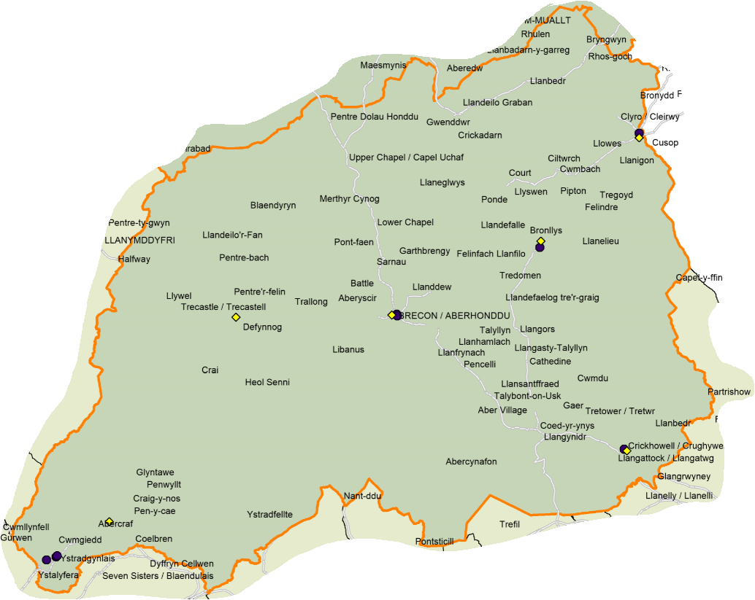

© Crown Copyright Ordnance Survey Mapping License 100050829

As can be seen from the map below, with one exception, the pharmacies and dispensing practice premises are located in areas of greater population density. It should be noted that where premises are close to each other the symbols will overlap.

Map 41 – location of pharmacies and dispensing doctor premises compared to population density, per lower super output area

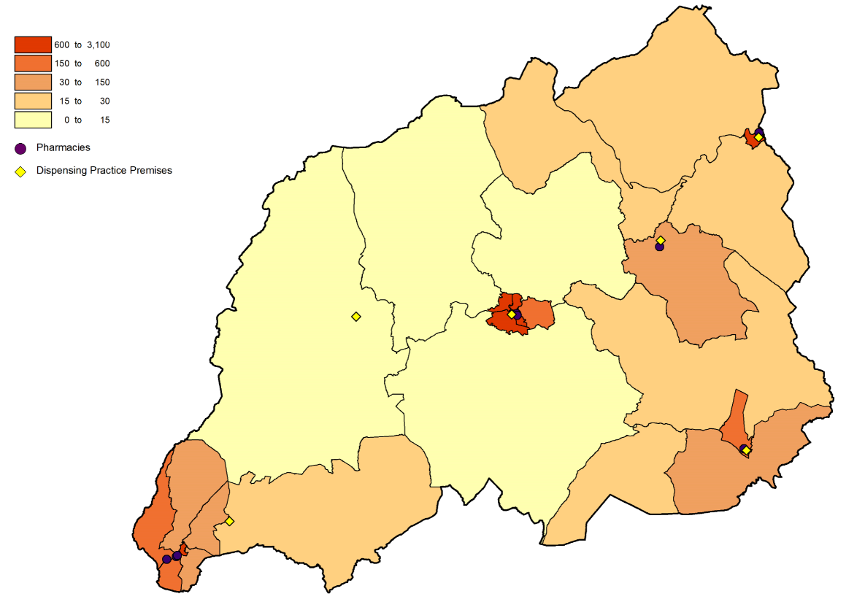

© Crown Copyright Ordnance Survey Mapping License 100050829

The map below shows the location of the pharmacies and dispensing doctor premises in relation to the Welsh Index of Multiple Deprivation quintiles.

Map 42 – location of pharmacies and dispensing doctor premises compared to the Welsh Index of Multiple Deprivation 2019, per lower super output area

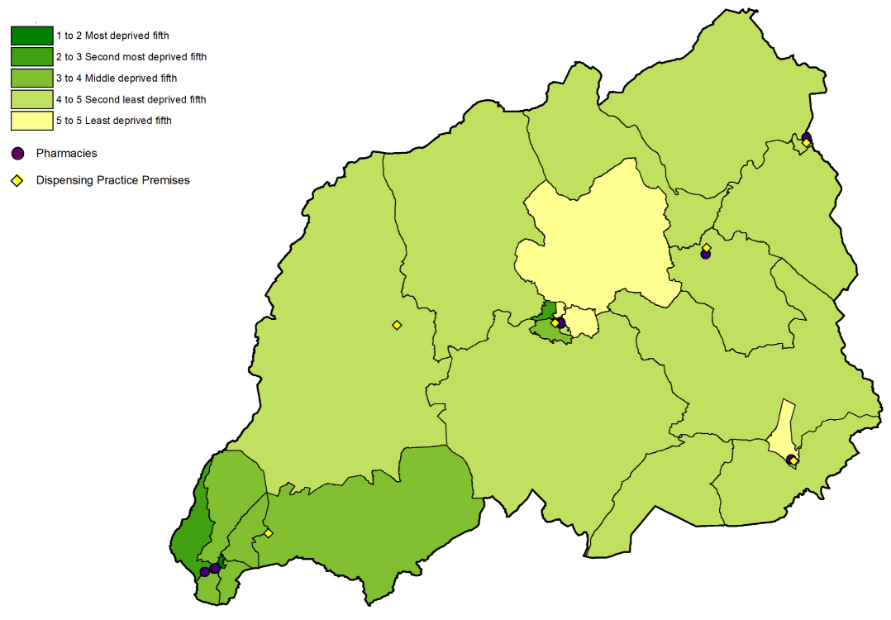

© Crown Copyright Ordnance Survey Mapping License 100050829

In 2019/20, 55.6% of prescriptions written by the GP practices in the locality were dispensed by a pharmacy within the locality, and 27.6% of items were dispensed or personally administered by the four practices.

In 2020/21, slightly fewer items were dispensed by a pharmacy within the locality (54.7%) whilst the dispensing practices dispensed or personally administered 28.3% of items prescribed.

The map below shows the drive time to the, with the darker the green the shorter the drive. As can be seen the areas of low population density are not within a 20-minute drive of a pharmacy. It should be noted that where premises are close to each other the symbols will overlap.

The position would improve if access to the dispensing practice premises is taken into account.

Map 43 – access to pharmacies in the locality

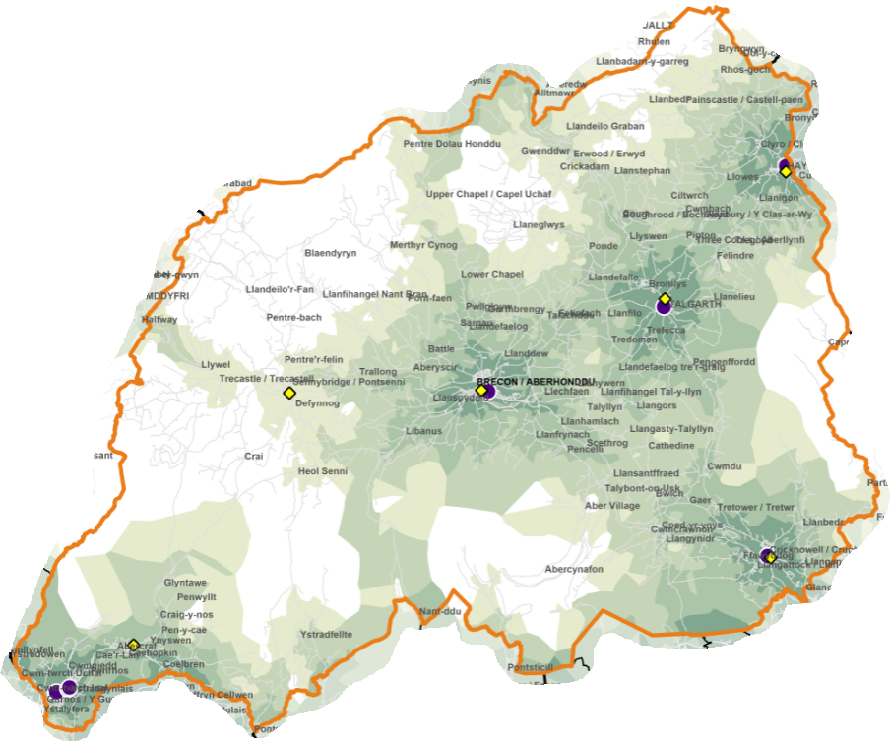

© Crown Copyright Ordnance Survey Mapping License 100050829

With regard to when the pharmacies are open, at the time of drafting:

- One opens Monday to Friday,
- Five open Monday to Friday, and part of Saturday, and
- Two open Monday to Saturday.

With regard to the times at which these pharmacies are open between Monday and Friday:

- One opens at 08.30 with the remainder opening at 09.00,
- Six close at 17.30 (although one closes at 17.00 on Tuesdays to Thursdays), and two close at 18.00.

A weekday evening rota operates across the locality so that a pharmacy is open until 18.00 in Lower Cwmtwrch and two are open until 18.00 in Brecon.

One pharmacy in Brecon is open all day. The other pharmacies close at lunchtime at varying times between 12.30 and 14.00.

On Saturday one pharmacy opens at 08.30 and six at 09.00. Two pharmacies close at 11.30, three at 13.00 and one at 15.30 (which also closes for lunch between 13.00 and 14.00). One pharmacy is open until 17.30, although it does close for lunch between 13:00 and 14:00.

A Sunday rota operates so that:

- A pharmacy in Ystradgynlais is open three weeks out of four between 11.30 and 12.30, and
- A pharmacy is open in Brecon between 16.00 and 17.00.

Pharmacy opening hours are likely to change during the lifetime of this document and therefore where someone is looking for the most up-to-date times they should refer to the NHS 111 Wales website.

All of the pharmacies responded to the pharmacy contractor questionnaire and the following information is taken from those responses.

Seven of the pharmacies are accessible by wheelchair, and six of these have a consultation area that is accessible by wheelchair. All eight pharmacies have consultations areas that are:

- closed rooms,
- a designated area where the patient and pharmacist can sit down together and talk at normal volumes without being overheard, and
- clearly designated as an area for confidential consultations distinct from the general public areas of the pharmacy.

One pharmacy confirmed that staff speak Welsh. The health board has noted that 72.0% of residents had no Welsh language skills and 98.0% have English as their main language (local authority level data, Census 2011). This coupled with the availability of Language Line and bilingual posters and leaflets means that the health board has not identified any issues for those who wish to access services in a language other than English.

Four pharmacies dispense prescriptions for all types of appliances, two do not dispense prescriptions for stoma and incontinence appliances, and two just dispense dressings.

All of the pharmacies collect prescriptions from GP practices. In relation to the delivery of dispensed items:

- four provide a free of charge delivery service on request, and
- two only delivery to specific patient groups (housebound patients only by arrangement; those with a clinical need or mobility issues) but didn’t indicate whether this is a free or chargeable service.

There was one suggestion for an existing service that is not currently provided in the area, namely care home original pack dispensing.

One pharmacy was of the opinion that there is a requirement for a new enhanced service which is not currently available, namely phlebotomy services especially for those on mental health drugs and other point of care.

Four pharmacies confirmed that they have sufficient capacity within their existing premises and staffing levels to manage an increase in demand for the services they provide, and four said that they don’t but could make adjustments.

Two pharmacies have plans to develop or expand their premises or service provision:

- One plans to expand its emergency contraception and care home services
- One plans to introduce independent prescriber services and video consultations.

All of the practices responded to the pharmacy contractor questionnaire and the following information is taken from those responses.

Five of the GP practice premises open at 08.30 or 09.00 and close between 17.00 and 17.30. Three of them close at lunchtime. The sixth dispensary has limited opening hours (17.00 to 18.30 on Mondays, Wednesdays, and Fridays, and 13.00 to 18.30 on Tuesdays and Thursdays).

With regard to the dispensing of prescriptions for appliances:

- One practice dispenses all types of appliance,
- One practice doesn’t dispense incontinence appliances,
- One doesn’t dispense stoma and incontinence appliances, and
- One only dispenses dressings.

One practice provides a twice weekly delivery service to the shop/post office in a village, and another delivers to housebound patients who are unable to get to the surgery e.g. due to self-isolation.

One practice confirmed that staff are able to speak Welsh.

Two practices have sufficient capacity to manage the increase in demand in their area, one doesn’t but could make adjustments to do so, and one doesn’t have sufficient capacity but could not make adjustments.

In relation to dispensing related services that were reported as provided:

- One practice provides dossette boxes,
- Two provide medicine administration record charts,
- Two provide just in case packs, and
- One provides medication in blistered racks for care homes.

Practices reported making the following changes to their dispensing service that they will take into the “new normal”:

- Increased usage of My Health Online or emails for ordering repeat medication.
- Changes made to premises to ensure social distancing, including use of protective glass screens, windows, hatches and intercoms.

10.2.1 Medicines use review service

In 2018/19 and 2019/20 all eight pharmacies provided this service, with none providing the maximum number of 400. At the time of writing the service has been suspended until April 2022 due to the Covid pandemic, however it is anticipated that once the service is reinstated that the pharmacies will resume provision.

10.2.2 Discharge medicines review

In 2018/19, six of the pharmacies provided this service with none providing the maximum number of 140 reviews. This reduced to five pharmacies in 2019/20, again with none providing the maximum number.

The map below shows the locations where the service was provided in 2019/20. It should be noted that where pharmacies are in close proximity the pink triangles representing them may overlap.

Map 44 – location of the pharmacies providing discharge medicines reviews in 2019/20

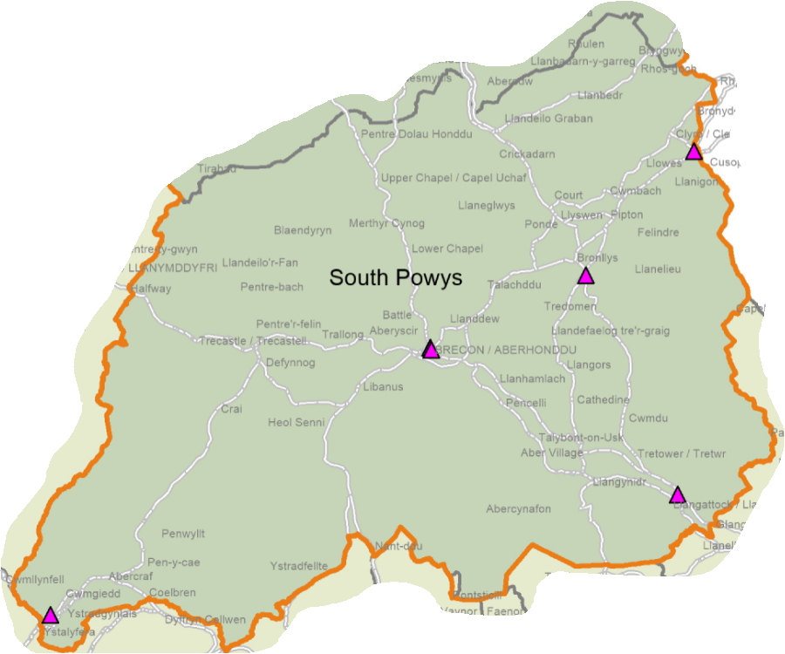

© Crown Copyright Ordnance Survey Mapping License 100050829

In 2020/21, six of the pharmacies provided the service.

10.2.3 Appliance use reviews

None of the pharmacies in the locality provide this service despite dispensing prescriptions for appliances.

10.2.4 Stoma appliance customisation

None of the pharmacies in the locality provide this service despite dispensing prescriptions for appliances.

10.2.5 Emergency hormonal contraception

Six of the pharmacies provided this service in 2018/19 and 2019/20. The map below shows the locations where the service was provided in 2019/20. It should be noted that where pharmacies are in close proximity the grey triangles representing them may overlap.

Map 45 – location of the pharmacies providing the emergency hormonal contraception service in 2019/20

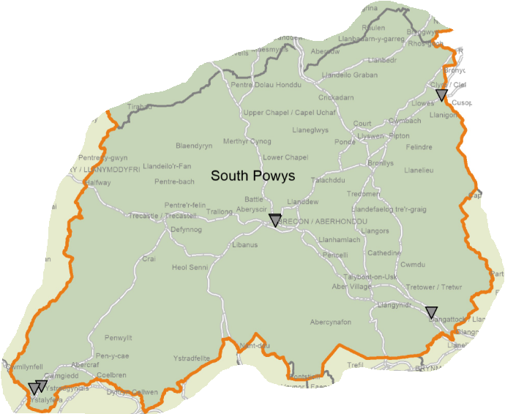

© Crown Copyright Ordnance Survey Mapping License 100050829

In 2020/21 seven were commissioned to provide the service, and this has reduced to six pharmacies in 2021/22.

10.2.6 Smoking cessation service level 2

Six of the pharmacies provided this service in 2018/19 and 2019/20. The map below shows the locations where the service was provided in 2019/20. It should be noted that where pharmacies are in close proximity the blue squares representing them may overlap.

Map 46 – location of the pharmacies providing the smoking cessation level 2 service in 2019/20

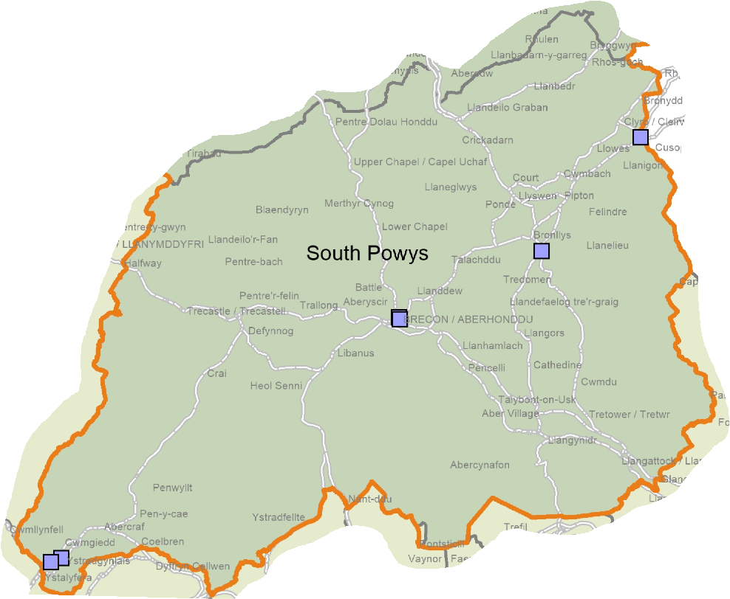

© Crown Copyright Ordnance Survey Mapping License 100050829

In 2020/21, seven pharmacies were commissioned to provide the service, and seven are commissioned to provide it in 2021/22.

10.2.7 Smoking cessation service level 3

Five of the pharmacies provided this service in 2018/19 increasing to seven in 2019/20. The map below shows the locations where the service was provided in 2019/20. It should be noted that where pharmacies are in close proximity the maroon squares representing them may overlap.

Map 47 – location of the pharmacies providing the smoking cessation level 3 service in 2019/20

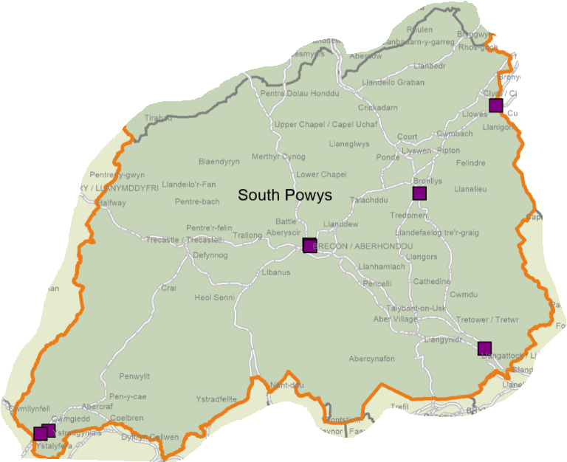

© Crown Copyright Ordnance Survey Mapping License 100050829

In 2020/21, seven pharmacies were commissioned to provide the service and seven are also commissioned in 2021/22.

10.2.8 Flu vaccination

Seven of the pharmacies have provided the service in 2018/19 and 2019/20. The map below shows the locations where the service was provided in 2019/20. It should be noted that where pharmacies are in close proximity the turquoise circles representing them may overlap.

Map 48 – location of the pharmacies providing flu vaccinations in 2019/20

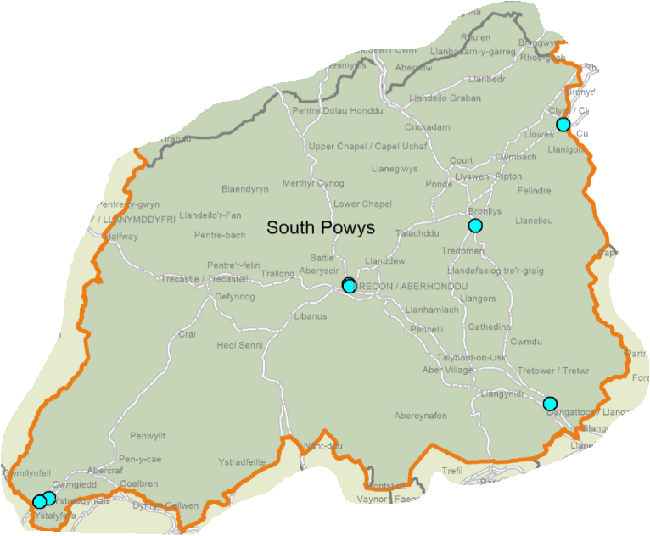

© Crown Copyright Ordnance Survey Mapping License 100050829

In 2020/21, seven pharmacies were commissioned to provide the service. As of August 2021, three pharmacies are commissioned to provide the service in 2021/22, however this figure is expected to increase to the same level as in the previous year before the service starts in September.

10.2.9 Common ailment service

All eight of the pharmacies have provided the service in 2018/19 and 2019/20. In 2020/21, all eight were commissioned to provide the service and continue to be in 2021/22.

10.2.10 Emergency medicine supply

Seven of the pharmacies provided the service in 2018/19, increasing to all eight in 2019/20. In 2020/21, all of the pharmacies were commissioned to provide it and continue to be in 2021/22.

10.2.11 Supervised consumption service

Three of the pharmacies provided this service in 2018/19, increasing to four in 2019/20. In 2020/21, all of the pharmacies were commissioned to provide it and continue to be in 2021/22.

10.2.12 Needle exchange service

Four of the pharmacies provided this service in 2018/19 and 2019/20. In 2020/21, four were commissioned to provide it and four are commissioned to provide it in 2021/22.

10.2.13 Just in case packs

Seven of the pharmacies provided this service in 2018/19, reducing to six in 2019/20. In 2020/21, all eight were commissioned to provide it and continue to be in 2021/22.

10.2.14 Care home support and medicines optimisation

In 2020/21, one pharmacy was commissioned to provide this service at the time of drafting. As of August 2021, none of the pharmacies are commissioned to provide. There are, however, out of area providers of the service.

10.2.15 Medicine administration record charts

In 2020/21, all eight pharmacies were commissioned to provide it and continue to be in 2021/22

10.2.16 Palliative care stocks

In 2020/21, three pharmacies were commissioned to provide it and three are commissioned to provide it in 2021/22

10.2.17 Respiratory rescue medicines service

In 2020/21, three of the pharmacies were commissioned to provide it and three are commissioned to provide it in 2021/22.

10.2.18 Patient sharps

In 2020/21, all of the pharmacies were commissioned to provide it and continue to be in in 2021/22.

10.2.19 Waste reduction scheme

In 2020/21, all of the pharmacies were commissioned to provide it and continue to be in in 2021/22.

10.2.20 Independent prescriber service

In 2021/22, none of the pharmacies are commissioned to provide this service, although it is noted one plans to do so.

10.3 Current provision of pharmaceutical services outside the locality’s area

Some residents choose to access contractors outside both the locality and the health board’s area in order to access services:

- Offered by dispensing appliance contractors
- Which are located near to where they work, shop or visit for leisure or other purposes.

Whilst the majority of prescriptions written by the GP practices in 2019/20 were dispensed by either the eight pharmacies in the locality or the dispensing practices, 16.7% were dispensed outside the locality:

- 8.4% by pharmacies in Swansea Bay Morgannwg University Health Board
- 7.4% by pharmacies in Aneurin Bevan Morgannwg University Health Board
- 0.5% by contractors in England, and
- 0.4% in pharmacies in Cwm Taf Morgannwg University Health Board.

Broadly the same pattern of dispensing occurred in 2020/21 with 16.9% of items dispensed outside of the locality.

In addition residents may have accessed one or more pharmaceutical services provided by another pharmacy outside of both the locality and the health board’s area; however it is not possible to quantify this activity from the recorded data.

10.4 Other NHS services

The GP practices in the locality provide the following services which affect the need for pharmaceutical services:

- Provision of emergency hormonal contraception
- Flu vaccinations
- Advice and treatment for common ailments.

Some provide:

- medicine administration record charts, and
- just in case packs.

Practices may choose to provide other services which are the same or similar to those provided by pharmacies, for example support to stop smoking, but as they are not commissioned by the health board they fall outside the definition of ‘other NHS services’.

Less than 2.0% of items prescribed by the GP practices are likely to have been personally administered by the practices.

At the time of drafting none of the GP practices offer extended opening hours. Should this change during the lifetime of this document the health board is able to direct a pharmacy to open outside of its normal opening hours if there is a need to do so.

In 2019/20, 1,329 items were prescribed by the Kaleidoscope Drug and Alcohol Service based in Brecon and dispensed by 25 pharmacies as follows:

- South Powys – 94.5% of items
- Swansea Bay University Health Board’s area – 2.5%
- Mid Powys – 1.0%
- North Powys – 0.9%
- Aneurin Bevan University Health Board’s area - 0.8%, and
- Hywel Dda University Health Board’s area – 0.3%

More items were prescribed in 2020/21 (2,387) and dispensed by 26 pharmacies:

- South Powys – 58.3% of items
- North Powys –37.4%
- Swansea Bay University Health Board’s area – 1.6%
- Aneurin Bevan University Health Board’s area – 1.4%
- Mid Powys – 1.0%
- English pharmacies – 0.3%, and
- 0.1% elsewhere in Wales.

The optometrist independent prescriber based in Brecon prescribed 65 items in 2019/20, 96.9% of which were dispensed by three pharmacies in the locality. The remaining 3.1% were dispensed by contractors in England and Cwm Taf Morgannwg University Health Board’s area.

This increased to 190 items in 2020/21, of which 95.8% were dispensed by five pharmacies in the locality. Pharmacies in Mid Powys dispensed 2.1% of the items, with 0.5% being dispensed in each of North Powys and Swansea Bay University Health Board’s area.

Smoking cessation services are provided by Help Me Quit at a number of locations across North Powys other than at pharmacies.

The following hospitals are in the locality and may generate prescriptions which are dispensed under pharmaceutical services:

- Breconshire War Memorial Hospital, Brecon
- Bronllys Hospital, Bronllys
- Ystradgynlais Community Hospital, Ystradgynlais
- Brecon Children's Centre, Brecon
- Ty Illtyd Mental Health Resource Centre, Brecon
- Ystradgynlais Mental Health Resource Centre, Ystradgynlais

No other NHS services have been identified that are located within the locality and which affect the need for pharmaceutical services.

10.5 Choice with regard to obtaining pharmaceutical services

As can be seen from sections 10.2 and 10.3, those living within the locality and registered with one of the GP practices generally choose to access one of the pharmacies in the locality in order to have their prescriptions dispensed or, if eligible, to be dispensed to by their practice. Those that look outside the locality usually do so either to access a neighbouring pharmacy or a dispensing appliance contractor outside of the health board’s area.

In 2019/20 over 210 contractors dispensed items written by one of the GP practices in this locality, of which:

- eight were located within the locality,
- five were located elsewhere within the health board’s area,
- 195 were located elsewhere in Wales, and
- A number of prescriptions were dispensed in England.

Fewer contractors dispensed items in 2020/21:

- eight were located within the locality,
- four were located elsewhere within the health board’s area,
- 130 were located elsewhere in Wales, and
- A number of prescriptions were dispensed in England.

10.6 Gaps in provision

10.6.1 Provision of essential services

The health board has noted the following points:

- The pharmacies are spread across the locality and are located in areas of greater population density and generally higher deprivation.
- Those parts of the locality with very low levels of population density (up to 20 people per lower super output area) are not within a 20 minute drive of a pharmacy.
- 525 houses are to be built between 2011 and 2026 in Ystradgynlais and 302 in Brecon, 112 in Gilwern, and 180 in Talgarth between 2007 and 2022.
- Four pharmacies confirmed that they have sufficient capacity within their existing premises and staffing levels to manage an increase in demand for the services they provide, and four said that they don’t but could make adjustments.

Based on the above, the health board has not identified any current or future needs for these services within the locality.

10.6.2 Provision of dispensing services by GP practices

The health board has noted that all of the practices dispense from a range of premises across the locality, with no correlation between location and either population density or deprivation

The health board has not identified any current or future needs for this service within the locality.

10.6.3 Medicines use review service

The health board has noted the following points:

- Prior to the suspension of this service it was provided by all of the pharmacies.
- None provided the maximum number of medicines use reviews in either 2018/19 or 2019/20.
- Four pharmacies confirmed that they have sufficient capacity within their existing premises and staffing levels to manage an increase in demand for the services they provide, and four said that they don’t but could make adjustments.

Based on the above, the health board has not identified any current or future needs for this service within the locality.

10.6.4 Discharge medicines review

The health board has noted the following points:

- The fluctuating numbers of pharmacies providing this service over the last three years. Seven of the pharmacies had provided this service in 2020/21, at the point of drafting.
- The skills required by pharmacists to provide this service are the same as for the medicines use review service. All the pharmacies will therefore be capable of providing this service.
- The IT systems in the hospitals are not currently able to transfer information on discharges to the IT systems in the pharmacies. Therefore if a patient does not take their discharge letter to the pharmacy the pharmacist may not be able to identify that they are eligible to receive the service. This is being looked into and the position may improve during the lifetime of this document.
- Due to the range of medicines included within the service only a small proportion of patients being discharged will be eligible to receive the service.
- As discharge letters are sent electronically to the GP practices there is a reduced risk of transcription errors in relation to medicines. In addition GP practices may undertake medicines reconciliations post discharge.
- Four pharmacies confirmed that they have sufficient capacity within their existing premises and staffing levels to manage an increase in demand for the services they provide, and four said that they don’t but could make adjustments.

The health board is therefore satisfied that the relatively low level of provision of this service is more likely due to the number of eligible patients presenting to a pharmacy than an inability or unwillingness of the pharmacies to provide the service.

Based on the above, the health board has not identified any current or future needs for this service within the locality.

10.6.5 Appliance use reviews

The health board has noted that all the pharmacies confirmed that they dispense prescriptions for all types of appliances but that none of them provide the appliance use review service. It has therefore considered whether or not there is a current or future need for this service in the locality.

In 2019/20, 43,218 items prescribed by the GP practices were dispensed in England and 67% of these were dispensed by a dispensing appliance contractor. In addition, the three dispensing appliance contractors based in Wales will have received prescriptions for appliances. In relation to the items prescribed by the incontinence service, 99.5% were dispensed by contractors in England.

Neither the health board nor the community health council has received any complaints or issues around the provision of appliances and related services.

Based on the above, the health board is satisfied that there are no current or future needs for the provision of this service in the locality.

10.6.6 Stoma appliance customisation

The health board has noted that all the pharmacies confirmed that they dispense prescriptions for all types of appliances but that none of them provide the stoma appliance customisation service. It has therefore considered whether or not there is a current or future need for this service in the locality.

In 2019/20, 43,218 items prescribed by the GP practices were dispensed in England and 67% of these were dispensed by a dispensing appliance contractor. In addition, the three dispensing appliance contractors based in Wales will have received prescriptions for appliances. In relation to the items prescribed by the incontinence service, 99.5% were dispensed by contractors in England.

Neither the health board nor the community health council has received any complaints or issues around the provision of appliances and related services.

It is noted that not every stoma appliance that is prescribed will require customisation. It is therefore possible that the pharmacies are dispensing stoma appliances that do not require customisation and those appliances that do are being dispensed and customised by dispensing appliance contractors based elsewhere in Wales or in England.

Based on the above, the health board is satisfied that there are no current or future needs for the provision of this service in the locality.

10.6.7 Emergency hormonal contraception

The health board has noted the following points:

- Seven of the pharmacies were commissioned to provide this service in 2020/21.
- The service is also provided by GP practices and sexual health clinics.
- There is a growing focus on long-acting reversible contraception for eligible females.
- Four pharmacies confirmed that they have sufficient capacity within their existing premises and staffing levels to manage an increase in demand for the services they provide, and four said that they don’t but could make adjustments.

Based on the above, the health board has not identified any current or future needs for this service within the locality.

10.6.8 Smoking cessation service level 2

The health board has noted the following points:

- Seven of the pharmacies were commissioned to provide this service in 2020/21.
- Demand for the service is dictated by people wishing to stop smoking.
- Four pharmacies confirmed that they have sufficient capacity within their existing premises and staffing levels to manage an increase in demand for the services they provide, and four said that they don’t but could make adjustments.

Based on the above, the health board has not identified any current or future needs for this service within the locality.

10.6.9 Smoking cessation service level 3

The health board has noted the following points:

- Seven of the pharmacies are commissioned to provide this service in 2021/22 at the point of drafting.
- Demand for the service is dictated by people wishing to stop smoking.
- Four pharmacies confirmed that they have sufficient capacity within their existing premises and staffing levels to manage an increase in demand for the services they provide, and four said that they don’t but could make adjustments.

Based on the above, the health board has not identified any current or future needs for this service within the locality.

10.6.10 Flu vaccination

The health board has noted the following points:

- Seven of the pharmacies were commissioned to provide this service in 2020/21.
- There are other providers of the service, for example the GP practices.
- Four pharmacies confirmed that they have sufficient capacity within their existing premises and staffing levels to manage an increase in demand for the services they provide, and four said that they don’t but could make adjustments.

Based on the above, the health board has not identified any current or future needs for this service within the locality.

10.6.11 Common ailment service

The health board has noted the following points:

- All of the pharmacies were commissioned to provide this service in 2020/21.
- There are other providers of the service, for example the GP practices.
- Four pharmacies confirmed that they have sufficient capacity within their existing premises and staffing levels to manage an increase in demand for the services they provide, and four said that they don’t but could make adjustments.

Based on the above, the health board has not identified any current or future needs for this service within the locality.

10.6.12 Emergency medicine supply

The health board has noted the following points:

- All of the pharmacies were commissioned to provide this service in 2020/21.
- Four pharmacies confirmed that they have sufficient capacity within their existing premises and staffing levels to manage an increase in demand for the services they provide, and four said that they don’t but could make adjustments.

Based on the above, the health board has not identified any current or future needs for this service within the locality.

10.6.13 Supervised consumption service

The health board has noted the following points:

- All of the pharmacies were commissioned to provide this service in 2020/21.
- Four pharmacies confirmed that they have sufficient capacity within their existing premises and staffing levels to manage an increase in demand for the services they provide, and four said that they don’t but could make adjustments.

Based on the above, the health board has not identified any current or future needs for this service within the locality.

10.6.14 Needle exchange service

The health board has noted the following points:

- Four of the pharmacies were commissioned to provide this service in 2020/21.
- Four pharmacies confirmed that they have sufficient capacity within their existing premises and staffing levels to manage an increase in demand for the services they provide, and four said that they don’t but could make adjustments.

Based on the above, the health board has not identified any current or future needs for this service within the locality.

10.6.15 Just in case packs

The health board has noted the following points:

- All of the pharmacies were commissioned to provide this service in 2020/21.
- Four pharmacies confirmed that they have sufficient capacity within their existing premises and staffing levels to manage an increase in demand for the services they provide, and four said that they don’t but could make adjustments.

Based on the above, the health board has not identified any current or future needs for this service within the locality.

10.6.16 Care home support and medicines optimisation

The health board has noted the following points:

- One of the pharmacies is commissioned to provide this service in 2020/21. In addition there are out of area providers of the service.
- Four pharmacies confirmed that they have sufficient capacity within their existing premises and staffing levels to manage an increase in demand for the services they provide, and four said that they don’t but could make adjustments.

Based on the above, the health board has not identified any current or future needs for this service within the locality.

10.6.17 Medicine administration record charts

The health board has noted the following points:

- All of the pharmacies were commissioned to provide this service in 2020/21.
- Four pharmacies confirmed that they have sufficient capacity within their existing premises and staffing levels to manage an increase in demand for the services they provide, and four said that they don’t but could make adjustments.

Based on the above, the health board has not identified any current or future needs for this service within the locality.

10.6.18 Palliative care stocks

The health board has noted the following points:

- Three pharmacies were commissioned to provide this service in 2020/21.
- Four pharmacies confirmed that they have sufficient capacity within their existing premises and staffing levels to manage an increase in demand for the services they provide, and four said that they don’t but could make adjustments.

Based on the above, the health board has not identified any current or future needs for this service within the locality.

10.6.19 Respiratory rescue medicines service

The health board has noted the following points:

- Three pharmacies were commissioned to provide this service in 2020/21.
- Four pharmacies confirmed that they have sufficient capacity within their existing premises and staffing levels to manage an increase in demand for the services they provide, and four said that they don’t but could make adjustments.

Based on the above, the health board has not identified any current or future needs for this service within the locality.

10.6.20 Patient sharps

The health board has noted the following points:

- All of the pharmacies were commissioned to provide this service in 2020/21.
- Four pharmacies confirmed that they have sufficient capacity within their existing premises and staffing levels to manage an increase in demand for the services they provide, and four said that they don’t but could make adjustments.

Based on the above, the health board has not identified any current or future needs for this service within the locality.

10.6.21 Waste reduction scheme

The health board has noted the following points:

- All of the pharmacies were commissioned to provide this service in 2020/21.
- Four pharmacies confirmed that they have sufficient capacity within their existing premises and staffing levels to manage an increase in demand for the services they provide, and four said that they don’t but could make adjustments.

Based on the above, the health board has not identified any current or future needs for this service within the locality.

10.6.22 Independent prescriber service

The health board has noted the following points:

- This is a fledgling service which is reliant upon training courses being available and pharmacists being able to complete them.
- Currently none of the pharmacies are commissioned to provide the service.
- It can take up to two years from a pharmacist deciding to undertake the training to complete it. It is therefore envisaged that within the lifetime of this document the health board will commission independent prescriber services from the pharmacies in the locality.
- Four pharmacies confirmed that they have sufficient capacity within their existing premises and staffing levels to manage an increase in demand for the services they provide, and four said that they don’t but could make adjustments.

In line with Pharmacy: Delivering a Healthier Wales, the health board would like to see all of the current pharmacies with an independent prescriber. However it has not identified any current or future needs for these services within the locality.

11 Conclusions for the purpose of schedule 1 of the NHS (Pharmaceutical Services) (Wales) Regulations 2020

The pharmaceutical needs assessment has considered the current provision of pharmaceutical services across the health board’s area alongside the demography and health needs of the population. It has analysed whether current provision meets the needs of the population and whether there are any gaps in the provision of pharmaceutical service either now or within the lifetime of this document.

The health board wishes to see a consistent service offer from pharmacies across its area so that residents are able to access services at convenient locations. To deliver that vision the health board has identified a number of gaps in the provision of services and these are articulated as current and future needs in the following sections of this chapter.

11.1 Current provision

Powys Teaching Health Board has identified the following services as those that are necessary to meet the need for pharmaceutical services in its area:

- Essential, advanced and enhanced services provided at all premises included in the pharmaceutical lists
- The dispensing service provided by those GP practices included in the dispensing doctor list.

Preceding sections of this document have set out the provision of these services in each locality.

It has also identified the provision of the above services by contractors outside of its area, whether that is in Wales or England, as contributing towards meeting the need for pharmaceutical services in its area.

11.2 Other NHS services

In undertaking this pharmaceutical needs assessment Powys Teaching Health Board considers the following other NHS services as affecting the need for pharmaceutical services and has taken them into account:

- Community hospitals
- Personal administration of items by GPs
- The GP out of hours service
- Minor injury units
- Kaleidoscope drug and alcohol services
- Continence Community Specialist Nursing
- Optometrist independent prescriber
- Services provided by GPs under their General Medical Services contract
- Community mental health team
- Dental services
- Help Me Quit

11.3 Current gaps in provision

11.3.1 Current access to essential services

In order to assess the provision of essential services against the needs of the population the health board considered access (travelling times and opening hours) as the most important factor in determining the extent to which the current provision of essential services meets the needs of the population.

A travel time standard of 20 minutes by car was agreed and travel times for the population to a pharmacy were mapped against that standard. The health board has noted that there are a number of areas of lower population density (up to 20 people per lower super output area) were it takes longer than 20 minutes to drive to a pharmacy. However, as the population that would serve a pharmacy in these areas would be insufficient to make the pharmacy financially viable the health board has not identified any current or future needs in relation to the provision of essential services.

11.3.2 Current access to advanced services

At the time of drafting the medicine use review service is suspended.

The discharge medicines review service was provided by ten of the pharmacies in 2020/21 at the time of drafting. It is noted that the number of pharmacies providing the service has fluctuated over the last three years, and the health board has set out its findings as to why that may be in the locality chapters.

The health board has noted that one of the reasons that prescriptions are dispensed by contractors outside of its area is because they are dispensed by dispensing appliance contractors, either elsewhere in Wales or England. Those contractors provide both of the appliance advanced services, and stoma and incontinence nurses will provide equivalent services.

The health board has not identified any current or future needs for any of the four advanced services.

11.3.3 Current access to enhanced services

The health board has identified the following current needs in relation to the provision of enhanced services.

11.3.3.1 Emergency hormonal contraception

The health board has identified the current need for a provider of this service in Llanwrtyd Wells as it is not currently provided by the pharmacy and the GP practice operates on a part-time basis. The health board’s preference is for the existing pharmacy to provide this service and will work with the contractor to achieve this end.

11.3.3.2 Smoking cessation service level 3

The health board has identified the current need for a provider of the service in Llanwrtyd Wells as it is not currently provided by the pharmacy and there is no other provider of the service via Help Me Quit in the village. The health board’s preference is for the existing pharmacy to provide this service and will work with the contractor to achieve this end.

11.3.3.3 Flu vaccination

The health board has identified the current need for a provider of the service in Llanwrtyd Wells as it is not currently provided by the pharmacy and the GP practice operates on a part-time basis. The health board’s preference is for the existing pharmacy to provide this service and will work with the contractor to achieve this end.

11.3.3.4 Common ailment service

The health board has identified the current need for a provider of the service in Llanwrtyd Wells as it is not currently provided by the pharmacy and the GP practice operates on a part-time basis. The health board’s preference is for the existing pharmacy to provide this service and will work with the contractor to achieve this end.

11.3.3.5 Emergency medicine supply

The health board has identified the current need for a provider of the service in Llanwrtyd Wells as it is not currently provided by the pharmacy and the GP practice operates on a part-time basis. The health board’s preference is for the existing pharmacy to provide this service and will work with the contractor to achieve this end.

11.3.4 Current access to the GP dispensing service

The health board has noted the dispensing service provided by 12 of the 16 GP practices to eligible patients and has not identified any current needs in relation to the provision of this service.

11.4 Future gaps in provision

The health board has taken into account the following known future developments:

- The ageing population,
- The projected decline in the number of residents,
- Housing developments, and
- Relocation of GP practices.

In addition it has taken into account Pharmacy; Delivering A healthier Wales which sets outs the long-term goals for service transformation to ensure the most health gain from prescribed medicines.

11.4.1 Future access to essential services

Taking into account its findings in relation the current provision of the essential services the health board has not identified any future needs in relation to them.

11.4.2 Future access to advanced services

Taking into account its findings in relation the current provision of the four advanced services the health board has not identified any future needs in relation to them.

11.4.3 Future access to enhanced services

Taking into account its findings in relation the current provision of the enhanced services the health board has not identified any future needs in relation to them.

11.4.4 Future access to the GP dispensing service

Taking into account its findings in relation the current provision this service the health board has not identified any future needs in relation to it.

Appendix A – policy context and background papers

Welsh Government establishes the overall structure in which community pharmacies, dispensing appliance contractors and dispensing doctors operate by providing the legislative and policy framework. Within the framework, the responsibility for planning and providing pharmaceutical services is vested in health boards who must plan health services to meet the needs of their resident populations. This includes determining the number and location of pharmacies and dispensing appliance contractors in their areas.

The general duty to ensure the provision of pharmaceutical services, as with other aspects of NHS primary care services, is conferred directly on health boards under the NHS (Wales) Act 2006 (the 2006 Act). Health boards manage local lists of approved providers, referred to as pharmaceutical lists, and the inclusion of pharmacy and dispensing appliance contractor premises on pharmaceutical lists entitles contractors to provide NHS pharmaceutical services at those premises.

These arrangements govern the provision of pharmaceutical services and not the right to open and conduct a pharmacy business in Wales. That is dealt with under separate UK-wide legislation, the Medicines Act 1968.

The Welsh Ministers have extensive powers and duties to make regulations and to issue directions to health boards, which govern the detail of the pharmaceutical services system in Wales. This includes specifying the terms of service for pharmacies and dispensing appliance contractors and the application of the control of entry test, which is the test that until 1 April 2021 had to be satisfied before a health board would grant an application for entry, or amend an entry, on the pharmaceutical list.

Under the NHS (Pharmaceutical Services) (Wales) Regulations 2013 (the 2013 Regulations), and preceding regulations, those persons wishing to provide pharmaceutical services submitted an application to the health board in accordance with the 2013 Regulations. The health board then decided whether or not the application satisfied the relevant test. The 2013 Regulations allowed for the health board’s decision to be challenged by lodging an appeal with the Welsh Ministers.

The previous system of pharmaceutical services delivery was therefore driven by those who wished to provide pharmaceutical services. It is they who decided which services they wished to provide and from what location.

That meant that the system was reactive to applications and health boards were not able to plan where pharmacies or dispensing appliance contractors were located or direct which services must be provided from those locations.

Rationale for change

In 2010 the then Minister for Health and Social Services established a Task and Finish Group to review the regulatory framework, to consider Welsh Government policy on control of entry and the provision of pharmaceutical services by health professions other than pharmacists (e.g. doctors) and to make recommendations for changes to legislation, if appropriate, to bring about a long term, cost effective and sustainable system which would afford patients appropriate access to pharmaceutical services.

In 2011 Welsh Government consulted on the recommendations of the Task and Finish group. The consultation “Proposals to reform and modernise the National Health Service (Pharmaceutical Services) Regulations 1992” sought views on proposals to deliver a new approach for determining applications to provide pharmaceutical services in Wales based more on an assessment of local needs by health boards. However it was recognised that to make such a change required the creation and inclusion of appropriate powers in the 2006 Act.

Following the consultation, the 2013 Regulations came into force on 10 May 2013 but did not contain provisions to introduce pharmaceutical needs assessments.

The Public Health (Wales) Act 2017 (the 2017 Act) inserted section 82A into the 2006 Act which makes provision for a new duty for health boards in Wales to prepare and publish an assessment of need for pharmaceutical services. Section 82A gave the Welsh Ministers powers to make regulations setting out the requirements for pharmaceutical needs assessments in Wales.

Intended effect and beneficial outcomes

The intended effect of introducing pharmaceutical needs assessments is to improve the planning and delivery of pharmaceutical services by ensuring the health boards robustly consider the pharmaceutical needs of their populations and align services more closely with them. This will require health boards to take a more integrated approach to identifying the pharmaceutical needs of populations, including considering the contribution of all pharmaceutical services providers (e.g. pharmacies and dispensing doctors). Health boards will use these assessments to identify where additional premises are required, where existing providers are adequately addressing pharmaceutical needs, and where additional services are required from existing premises.

The change will provide contractors with increased certainty, reducing business risk and allowing them to invest in the delivery of wider services than they do currently. Importantly, pharmacies in particular will also become more responsive to the needs of the populations they serve, and provide services effectively to address identified pharmaceutical needs.

Policy, legislative framework and regulation

Section 80 of the 2006 Act places a duty on health boards to make arrangements for the provision of the pharmaceutical services that are set out in subsections 80(3)(a) to (d). These core pharmaceutical services are essentially dispensing services. There is a duty on Welsh Ministers to make regulations governing the way in which health boards make these arrangements.

Section 81 of the 2006 Act sets out the arrangements that Welsh Ministers may make for the provision of additional pharmaceutical services. ‘Additional pharmaceutical services’ are defined as services of a kind that do not fall within section 80 i.e. advanced and enhanced services. Section 81 gives Welsh Ministers the power to give directions to a health board (i) requiring it to arrange for the provision of additional pharmaceutical services, or (ii) authorising the health board to arrange for the provision of pharmaceutical services if it wishes.

Section 83 of the 2006 Act contains the core of the Welsh Ministers’ regulation making powers in relation to the provision of the pharmaceutical services and, amongst other things, sets out the requirement for regulations to require a health board to prepare and publish a pharmaceutical list, and sets out the tests which those persons wishing to provide pharmaceutical services must pass in order to do so (known as the ‘control of entry test’).

Section 84 sets out a requirement for Welsh Ministers to provide for rights of appeal against decisions that are made by health boards in exercise of powers conferred upon them by regulations made under section 83.

Part 7 of the 2017 Act made provision to amend the 2006 Act in respect of pharmaceutical services. Section 111 of the 2017 Act inserted a new section 82A in to the 2006 Act conferring powers on the Welsh Ministers to make regulations in respect of pharmaceutical needs assessments. The Public Health (Wales) Act 2017 (Commencement No.4) Order 2019 brought Part 7 of the 2017 Act into force on 1 April 2019. As a result, the Welsh Ministers have now made subordinate legislation setting out requirements for pharmaceutical needs assessments in Wales.

The 2013 Regulations were revoked and replaced by the NHS (Pharmaceutical Services) (Wales) Regulations 2020. Part 2 of the NHS (Pharmaceutical Services) Regulations 2020 imposes the legal requirements on health boards to complete pharmaceutical needs assessments.

The NHS (Pharmaceutical Services) Regulations 2020came into force on 1st April 2020 and health boards have until 1 April 2021 to publish their first pharmaceutical needs assessment.

In summary the NHS (Pharmaceutical Services) Regulations 2020 set out the:

- Services that are to be covered by the pharmaceutical needs assessment
- Information that must be included in the pharmaceutical needs assessment (it should be noted that health boards are free to include any other information that they feel is relevant)
- Date by which health boards must publish their first pharmaceutical needs assessment
- Requirement on health boards to publish further pharmaceutical needs assessments on a five yearly basis
- Requirement to publish a revised assessment sooner than on a five yearly basis in certain circumstances
- Requirement to publish supplementary statements in certain circumstances
- Requirement to consult with certain people and organisations at least once during the production of the pharmaceutical needs assessment, for at least 60 days; and
- Matters the health board is to have regard to when producing its pharmaceutical needs assessment.

Once a health board has published its first pharmaceutical needs assessment it is required to produce a revised pharmaceutical needs assessment within five years or sooner if it identifies changes to the need for pharmaceutical services which are of a significant extent. The only exception to this is where the health board is satisfied that producing a revised pharmaceutical needs assessment would be a disproportionate response to those changes.

In addition a health board may publish a supplementary statement where it identifies changes to the availability of pharmaceutical services which are relevant to the granting of applications referred to in Section 83 of the 2006 Act, and

- It is satisfied that making a revised assessment would be a disproportionate response to those changes, or
- It is in the course of making a revised assessment and is satisfied that immediate modification of its pharmaceutical needs assessment is essential in order to prevent detriment to the provision of pharmaceutical services in its area.

Developing the detailed requirements

A working group was established in November 2015 to develop the detailed requirements for conducting a pharmaceutical needs assessment and to review and amend the tests and procedures as they apply to the provision of NHS pharmaceutical services. The group, which met on a number of occasions, consisted health board pharmacy leads with knowledge of the previous control of entry system and expertise in community pharmacy, NHS Shared Services Partnership primary care (pharmacy) leads, who have expertise in the process of determining control of entry applications, and Welsh Government staff. The group has made a significant contribution to the development of the Welsh Government’s policy on pharmaceutical needs assessments, including the resultant proposals contained within the NHS (Pharmaceutical Services) Regulations 2020.

Appendix B – essential services

- Dispensing of prescriptions

Service description

The supply of medicines and appliances ordered on NHS prescriptions, together with information and advice, to enable safe and effective use by patients, and maintenance of appropriate records.

Aims and intended outcomes

To ensure patients receive ordered medicines and appliances safely and appropriately by the pharmacy:

- Performing appropriate legal, clinical and accuracy checks
- Having safe systems of operation, in line with clinical governance requirements
- Having systems in place to guarantee the integrity of products supplied
- Maintaining a record of all medicines and appliances supplied which can be used to assist future patient care
- Maintaining a record of advice given, and interventions and referrals made, where the pharmacist judges it to be clinically appropriate.

To ensure patients are able to use their medicines and appliances effectively by pharmacy staff:

- Providing information and advice to the patient or their representative on the safe use of their medicine or appliance
- Providing when appropriate broader advice to the patient on the medicine, for example its possible side effects and significant interactions with other substances.

- Dispensing of repeatable prescriptions

Service description

The management and dispensing of repeatable NHS prescriptions for medicines and appliances in partnership with the patient and the prescriber.

This service includes requirements additional to those for dispensing, such that the pharmacist ascertains the patient’s need for a repeat supply and communicates any clinically significant issues to the prescriber.

Aims and intended outcomes
- To increase patient choice and convenience, by allowing them to obtain their regular prescribed medicines and appliances directly from a community pharmacy for a period agreed by the prescriber
- To minimise wastage by reducing the number of medicines and appliances dispensed which are not required by the patient
- To reduce the workload of general medical practices, by lowering the burden of managing repeat prescriptions.

- Disposal of unwanted drugs

Service description

Acceptance by community pharmacies, of unwanted medicines which require safe disposal from private households and people living in a residential care home. The health board is required to arrange for the collection and disposal of waste medicines from pharmacies.

Aims and intended outcomes

- To ensure the public has an easy method of safely disposing of unwanted medicines
- To reduce the volume of stored unwanted medicines in people’s homes by providing a route for disposal thus reducing the risk of accidental poisonings in the home and diversion of medicines to other people not authorised to possess them
- To reduce the risk of exposing the public to unwanted medicines which have been disposed of by non-secure methods
- To reduce environmental damage caused by the inappropriate disposal methods for unwanted medicines.

- Promotion of healthy lifestyles

Service description

The provision of opportunistic healthy lifestyle and public health advice to patients receiving prescriptions who appear to:

- Have diabetes; or
- Be at risk of coronary heart disease, especially those with high blood pressure; or
- Who smoke; or
- Are overweight,

and pro-active participation in national/local campaigns, to promote public health messages to general pharmacy visitors during specific targeted campaign periods

Aims and intended outcomes

- To increase patient and public knowledge and understanding of key healthy lifestyle and public health messages so they are empowered to take actions which will improve their health.
- To target the ‘hard to reach’ sectors of the population who are not frequently exposed to health promotion activities in other parts of the health or social care sector.

- Signposting

Service description

The provision of information to people visiting the pharmacy, who require further support, advice or treatment which cannot be provided by the pharmacy, but is available from other health and social care providers or support organisations who may be able to assist the person. Where appropriate, this may take the form of a referral.

Aims and intended outcomes

- To inform or advise people who require assistance, which cannot be provided by the pharmacy, of other appropriate health and social care providers or support organisations
- To enable people to contact and/or access further care and support appropriate to their needs
- To minimise inappropriate use of health and social care services.

- Support for self-care

Service description

The provision of advice and support by pharmacy staff to enable people to derive maximum benefit from caring for themselves or their families.

Aims and intended outcomes

- To enhance access and choice for people who wish to care for themselves or their families
- People, including carers, are provided with appropriate advice to help them self-manage a self-limiting or long-term condition, including advice on the selection and use of any appropriate medicines
- People, including carers, are opportunistically provided with health promotion advice when appropriate, in line with the advice provided in essential service – promotion of healthy lifestyles service
- People, including carers, are better able to care for themselves or manage a condition both immediately and in the future, by being more knowledgeable about the treatment options they have, including non-pharmacological ones
- To minimise inappropriate use of health and social care services.

Appendix C – advanced services

- Medicines use review and prescription intervention service

Service description

This service includes MURs undertaken periodically, as well as those arising in response to the need to make a significant prescription intervention during the dispensing process. A MUR is about helping patients use their medicines more effectively.

Recommendations made to prescribers may also relate to the clinical or cost effectiveness of treatment.

Aims and intended outcomes

To improve patient knowledge and use of medicines by:

- Establishing the patient’s actual use, understanding and experience of taking their medicines;
- Identifying, discussing and assisting in resolving poor or ineffective use of their medicines;
- Identifying side effects and drug interactions that may affect patient compliance;
- Improving the clinical and cost effectiveness of prescribed medicines thereby reducing medicine wastage.

- Discharge medicines review service

Service description

The DMR service will provide support to patients recently discharged between care settings by ensuring that changes to patients’ medicines made in one care setting (e.g. during a hospital admission) are enacted as intended in the community helping to reduce the risk of preventable medicines related problems and supporting adherence with newly prescribed medication. The service, which builds on the existing MUR service, will provide an opportunity to support patients to improve their knowledge and use of drugs.

Aims and intended outcomes

The underlying purpose of this service is, with the patient’s agreement, to contribute to a reduction in risk of medication errors and adverse drug events by, in particular –

- Increasing the availability of accurate information about a patient’s medicines,
- Improving communication between healthcare professionals and others involved in the transfer of patient care, and patients and their carers,
- Increasing patient involvement in their own care by helping them to develop a better understanding of their medicines, and
- Reducing the likelihood of unnecessary or duplicated prescriptions being dispensed thereby reducing wastage of medicines.

- Stoma appliance customisation

Service description

Stoma appliance customisation is the customisation of a quantity of more than one stoma appliance, where:

- The stoma appliance to be customised is listed in Part IXC of the Drug Tariff
- The customisation involves modification to the same specification of multiple identical parts for use with an appliance; and
- Modification is based on the patient’s measurement or record of those measurements and if applicable, a template.

Aims and intended outcomes

The underlying purpose of the service is to:

- Ensure the proper use and comfortable fitting of the stoma appliance by a patient; and
- Improve the duration of usage of the appliance, thereby reducing wastage of such appliances.

- Appliance use review

Service description

An AUR is about helping patients use their appliances more effectively. Recommendations made to prescribers may also relate to the clinical or cost effectiveness of treatment.

Aims and intended outcomes

The underlying purpose of the service is, with the patient’s agreement, to improve the patient’s knowledge and use of any specified appliance by, in particular:

- Establishing the way the patient uses the specified appliance and the patient’s experience of such use
- Identifying, discussing and assisting in the resolution of poor or ineffective use of the specified appliance by the patient
- Advising the patient on the safe and appropriate storage of the specified appliance
- Advising the patient on the safe and proper disposal of the specified appliances that are used or unwanted.

Appendix D – enhanced services

- An anticoagulant monitoring service, the underlying purpose of which is for the pharmacy contractor to test the patient’s blood clotting time, review the results and adjust (or recommend adjustment to) the anticoagulant dose accordingly.

- A care home service, the underlying purpose of which is for the pharmacy contractor to provide advice and support to residents and staff in a care home relating to—

- The proper and effective ordering of drugs and appliances for the benefit of residents in the care home
- The clinical and cost effective use of drugs
- The proper and effective administration of drugs and appliances in the care home
- The safe and appropriate storage and handling of drugs and appliances, and
- The recording of drugs and appliances ordered, handled, administered, stored or disposed of.

- A disease specific management service, the underlying purpose of which is for the pharmacy contractor to advise on, support and monitor the treatment of patients with specified conditions, and where appropriate to refer the patient to another health care professional.

- A gluten free food supply service, the underlying purpose of which is for the pharmacy contractor to supply gluten free foods to patients.

- A home delivery service, the underlying purpose of which is for the pharmacy contractor to deliver drugs and appliances to patients at their home.

- A language access service, the underlying purpose of which is for the pharmacy contractor to provide, either orally or in writing, advice and support to patients in a language understood by them relating to—

- Drugs which they are using
- Their health, and
- General health matters relevant to them,

and where appropriate referral to another health care professional.

- A medication review service, the underlying purpose of which is for the pharmacy contractor to —

- Conduct a review of the drugs used by a patient on the basis of information and test results included in the patient’s care record, with the objective of considering the continued appropriateness and effectiveness of the drugs for the patient,
- Advise and support the patient regarding their use of drugs, including encouraging the active participation of the patient in decision making relating to their use of drugs, and
- Where appropriate, to refer the patient to another health care professional.

- A medicines assessment and compliance support service, the underlying purpose of which is for the pharmacy contractor to —

- Assess the knowledge of, compliance with and use of, drugs by vulnerable patients and patients with special needs, and
- Offer advice, support and assistance to vulnerable patients and patients with special needs regarding the use of drugs with a view to improving their knowledge of, compliance with and use of, such drugs.

- A minor ailment scheme, the underlying purpose of which is for the pharmacy contractor to provide advice and support to eligible patients complaining of a minor ailment, and where appropriate to supply drugs to the patient for the treatment of the minor ailment.

- A needle and syringe exchange service, the underlying purpose of which is for the pharmacy contractor to —

- Provide sterile needles, syringes and associated materials to drug misusers
- Receive from drug misusers used needles, syringes and associated materials, and
- Offer advice to drug misusers and where appropriate referral to another health care professional or a specialist drug treatment centre.

- An on demand availability of specialist drugs service, the underlying purpose of which is for the pharmacy contractor to ensure that patients or health care professionals have prompt access to specialist drugs.

- Out of hours services, the underlying purpose of which is for the pharmacy contractor to dispense drugs and appliances in the out of hours period (whether or not for the whole of the out of hours period).

- A patient group direction service, the underlying purpose of which is for the pharmacy contractor to supply a prescription only medicine to a patient under a patient group direction.

- A prescriber support service, the underlying purpose of which is for the pharmacy contractor to support health care professionals who prescribe drugs, and in particular to offer advice on—

- The clinical and cost effective use of drugs
- Prescribing policies and guidelines, and
- Repeat prescribing.

- A schools service, the underlying purpose of which is for the pharmacy contractor to provide advice and support to children and staff in schools relating to—

- The clinical and cost effective use of drugs in the school
- The proper and effective administration and use of drugs and appliances in the school
- The safe and appropriate storage and handling of drugs and appliances, and
- The recording of drugs and appliances ordered, handled, administered, stored or disposed of.

- A screening service, the underlying purpose of which is for the pharmacy contractor to —

- Identify patients at risk of developing a specified disease or condition
- Offer advice regarding testing for a specified disease or condition
- Carry out such a test with the patient’s consent, and
- Offer advice following a test and refer to another health care professional as appropriate.

- A stop smoking service, the underlying purpose of which is for the pharmacy contractor to —

- Advise and support patients wishing to give up smoking, and
- Where appropriate, to supply appropriate drugs and aids.

- A supervised administration service, the underlying purpose of which is for the pharmacy contractor to supervise the administration of prescribed medicines at their premises.

- A prescribing service, the underlying purpose of which is for the pharmacy contractor to prescribe medicines in circumstances specified by the relevant local health board.

- An antiviral collection service, the underlying purpose of which is for the pharmacy contractor to supply antiviral medicines, in accordance with regulation 247 of the Human Medicines Regulations 2012 (exemption for supply in the event or in anticipation of pandemic disease), to patients for treatment or prophylaxis.

- An emergency supply service, the underlying purpose of which is to ensure that in cases of urgency, patients, at their request have prompt access to drugs of appliances:

- Which have previously been prescribed for them in an NHS prescription but for which they do not have an NHS prescription, and
- Where in the case of prescription only medicines the requirements of regulation 225(1) of the Human Medicines Regulations 2012 (emergency sale etc by Pharmacist: at patient’s request) are satisfied.

Appendix E – terms of service for dispensing appliance contractors

- Dispensing of prescriptions

Service description

The supply of appliances ordered on NHS prescriptions, together with information and advice and appropriate referral arrangements in the event of a supply being unable to be made, to enable safe and effective use by patients, and maintenance of appropriate records.

Aims and intended outcomes

To ensure patients receive ordered appliances safely and appropriately by the dispensing appliance contractor:

- Performing appropriate legal, clinical and accuracy checks
- Having safe systems of operation, in line with clinical governance requirements
- Having systems in place to guarantee the integrity of products supplied
- Maintaining a record of all appliances supplied which can be used to assist future patient care
- Maintaining a record of advice given, and interventions and referrals made, where the dispensing appliance contractor judges it to be clinically appropriate
- Providing the appropriate additional items such as disposable bags and wipes
- Delivering the appropriate items if required to do so in a timely manner and in suitable packaging that is discreet.

To ensure patients are able to use their appliances effectively by staff providing information and advice to the patient or carer on the safe use of their appliance(s).

- Dispensing of repeatable prescriptions

Service description

The management and dispensing of repeatable NHS prescriptions appliances in partnership with the patient and the prescriber.

This service includes the requirements that are additional to those for dispensing, such that the dispensing appliance contractor ascertains the patient’s need for a repeat supply and communicates any clinically significant issues to the prescriber.

Aims and intended outcomes

- To increase patient choice and convenience, by allowing them to obtain their regular prescribed appliances directly from a dispensing appliance contractor for a period agreed by the prescriber
- To minimise wastage by reducing the number of appliances dispensed which are not required by the patient
- To reduce the workload of GP practices, by lowering the burden of managing repeat prescriptions.

- Home delivery service

Service description

To provide a home delivery service in respect of certain appliances.

Aims and intended outcomes

To preserve the dignity of patients by ensuring that certain appliances are delivered:

- With reasonable promptness, at a time agree with the patient
- In a package that displays no writing or other markings which could indicate its content; and
- In such a way that it is not possible to identify the type of appliance that is being delivered.

- Supply of appropriate supplementary items

Service description

The provision of additional items such as disposable wipes and disposal bags in connection with certain appliances.

Aims and intended outcomes

To ensure that patients have a sufficient supply of wipes for use with their appliance, and are able to dispose of them in a safe and hygienic way.

- Provide expert clinical advice regarding the appliances

Service description

The provision of expert clinical advice by a suitably trained person who has relevant experience in respect of certain appliances.

Aims and intended outcomes

To ensure that patients are able to seek appropriate advice on their appliance to increase their confidence in choosing an appliance that suits their needs as well as gaining confidence to adjust to the changes in their life and learning to manage an appliance.

- Where a telephone care line is provided, during the period when the dispensing appliance contractor is closed advice is either to be provided via the care line or callers are directed to NHS Direct Wales

Service description

Provision of advice on certain appliances via a telephone care line outside of the dispensing appliance contractor’s contracted opening hours. The dispensing appliance contractor is not required to staff the care line all day, every day, but when it is not staffed callers must be given a telephone number or website contact details for NHS Direct Wales who may be consulted for advice.

Aims and intended outcomes

Callers to the telephone care line are able to access advice 24 hours a day, seven days a week on certain appliances in order to manage their appliance.

- Signposting

Service description

Where a patient presents a prescription for an appliance which the dispensing appliance contractor does not supply the prescription is either:

- With the consent of the patient, passed to another provider of appliances, or
- If the patient does not consent, they are given contact details for at least two other contractors who are able to dispense it.

Aims and intended outcomes

To ensure that patients are able to have their prescription dispensed.

Appendix F – Pharmaceutical needs assessment steering group membership

Role | Organisation
Medical director (lead executive) | Powys Teaching Health Board
Public health consultant | Powys Teaching Health Board
Communications lead | Powys Teaching Health Board
Pharmaceutical adviser (medicines management) | Powys Teaching Health Board
Head of pharmacy | Powys Teaching Health Board
Director of contractor services | Community Pharmacy Wales
Medical secretary | Dyfed Powys Local Medical Committee
Portfolio holder for adult social care and Welsh language | Powys County Council
Adviser | Primary Care Commissioning CIC

Appendix G – Patient and public questionnaire

We are inviting you to tell us about pharmacy services in your area.

The services we are looking at include local services that you receive from pharmacies (or chemists). To do a good job, we need to regularly review what services we have, what our local people need, and how things might change in the future. This process is called a ‘pharmaceutical needs assessment’ or and we are preparing our first one for the area covered by Powys Teaching Health Board with the help of a company called Primary Care Commissioning Community Interest Company (PCC) who specialise in this kind of work. The feedback you provide will be shared with PCC but will only be used for the purpose of this survey and developing the pharmaceutical needs assessment. Any personal data you provide will be held in accordance with our privacy policy.

Many people call them chemists but in this survey we use the word pharmacy. By a pharmacy, we mean a place you would use to get a prescription or buy medicines which you can only buy from a pharmacy or to talk to a pharmacist for advice about an illness that you may have or medicines that you take. We don’t mean the pharmacy at a hospital or the part of a pharmacy where you buy beauty products or any shops where you can buy medicines.

Your views are important to us so please spare a few minutes to complete this questionnaire. There are 30 questions in total in relation to your experience of pharmacies and the dispensing service provided by some GP practices, but you won’t need to answer all of them as some of them will not be applicable to you. There are also a number of questions about you. We anticipate it will take you around 15 to 20 minutes to complete, depending on how much additional information you would like to give us.

We really would like and value your input, but if you don’t want to take part, please just ignore this questionnaire; your decision will not affect the care you receive from the NHS or your pharmacy in any way.

The questionnaire is anonymous; you don’t have to give your name and address. Any information you do give will not be linked to you.

The results of our questionnaire will be published in the draft pharmaceutical needs assessment and a 60 day consultation on that document will take place in the Spring next year. Please keep an eye on our website and social media pages for further details.

We realise that you may have experienced difficulties in going to a pharmacy over the last few months, and that there have been delays beyond the control of the pharmacy staff in dispensing your prescriptions. These will have been due to Covid-19 as well as national drug shortages which have become more of a problem over the last couple of years. We would like to understand your experience of going to a pharmacy before and during the pandemic so that we can best plan for services going forward.

If you would like more information about the questionnaire or have questions on how to complete it, please email Info.MedicinesManagement.Powys@wales.nhs.uk with “PNA questionnaire” in the subject header.

About you

Please tell us your postcode

By providing us with the first three digits of your postcode, you are consenting for us to use this information to understand which part of Powys you live in. This information will only be used for the purposes of this questionnaire so that we can identify whether we have received responses from across Powys or from particular areas. Please do not provide us with your full postcode.

For example, if your postcode is LD3 0LU just type LD3 in the box below.

Some people have all or most of their medicines dispensed by their GP practice. Does this apply to you?

- Yes
- No
- I don’t know

If you answered yes, questions 1 to 14 are about pharmacies so please answer those if you use a pharmacy. If you don’t use a pharmacy then please move to question 15.

Preferred language

The Welsh Language Standards are a set of statutory requirements which are relevant to the Health Board. They state clearly our responsibilities to provide bilingual services to patients and the public. Please could you therefore tell us your preferred language when you access services at a pharmacy or GP practice?

- Welsh
- English
- Other [text box]

How you use your pharmacy - either in person or by having someone else go there for you

- Why do you usually visit a pharmacy? Please tick any or all that apply.

- To get a prescription for myself
- To buy medicines for myself
- To get advice for myself
- To get a prescription for someone else
- To buy medicines for someone else
- To get advice for someone else
- I don’t visit a pharmacy as I use an online/internet pharmacy
- I don’t visit a pharmacy as my medicines are delivered to me
- I don’t go to a pharmacy; someone goes on my behalf
- Other [text box]

2. How often do you use a pharmacy?

- Daily
- Weekly
- Fortnightly
- Monthly
- Quarterly
- I don’t use a pharmacy
- Other [text box]

3. What time is the most convenient for you to use a pharmacy?

- Before 7 am
- 7am to 9am
- 9am to 12 noon
- 12 noon to 3pm
- 3pm to 6pm
- 6pm to 9pm
- 9pm to midnight
- I don’t have a preference

4. What day is the most convenient for you to use a pharmacy?

- Monday
- Tuesday
- Wednesday
- Thursday
- Friday
- Saturday
- Sunday
- Weekdays in general
- Weekends in general
- I don’t have a preference

5. Has there been a time recently when you were not able to use your normal pharmacy?

- Yes
- No
- Not applicable

6. If you answered ‘yes’ to question 5 can you tell us what you did? Please tick all statements that apply.

- I went to another pharmacy
- I waited until the pharmacy was open
- I went to my GP
- I went to the general hospital
- I went to a minor injury unit
- I contacted the GP Out of Hours (OOH) service
- I called NHS 111 Wales
- Other [text box]

Your choice of pharmacy

7. Please could you tell us whether you:

- Always use the same pharmacy?
- Use different pharmacies but I prefer to visit one most often?
- Always use different pharmacies?
- Rarely use a pharmacy?
- Never use a pharmacy?
8. We would like to know what influences your choice of pharmacy. Please could you tell us why you use this pharmacy? Please tick all the statements that apply to you.

- Close to my home
- Close to work
- Close to my doctor
- Close to children’s school or nursery
- Close to other shops
- The pharmacy delivers my medicines
- The location of the pharmacy is easy to get to
- It is easy to park at the pharmacy
- I just like the pharmacy
- I can speak to the staff in my preferred language
- I trust the staff who work there
- The staff know me and look after me
- The staff don’t know me
- I’ve always used this pharmacy
- The service is quick
- They usually have what I need in stock
- The pharmacy has good opening hours
- The pharmacy collects my prescription and delivers my medicines
- The pharmacy was recommended to me
- The pharmacy provide good advice & information
- The customer service
- It is very accessible i.e. wheelchair/baby buggy friendly
- It’s a well-known big chain
- It’s not one of the big chains
- There is a private area if I need to talk to the pharmacist
- It’s an online/internet pharmacy
- It’s not an online/internet pharmacy and so I can visit it and talk to the staff face-to-face
- I can order my repeat medicines using their app
- Other [text box]

9. Is there a more convenient and/or closer pharmacy that you don’t use?

- Yes
- No
- Don’t know

10. ...and if you have answered yes to question 9, please could you tell us why you do not use that pharmacy?

- It is not easy to park at the pharmacy
- I have had a bad experience in the past
- The service is too slow
- The staff are always changing
- The staff don’t know me
- I know the staff and would prefer them not to know what medicines I am taking
- They don’t have what I need in stock
- The pharmacy does not deliver medicines
- There is not enough privacy
- It’s not open when I need it
- It’s not wheelchair/baby buggy friendly
- Other [text box]

Travelling to a pharmacy

11. If you go to the pharmacy by yourself or with someone, how do you usually get there?

- On foot
- By bus
- By car
- By bike
- By taxi
- Other [text box]

12. ...and how long does it usually take to get there?

- Less than 5 minutes
- Between 5 and 15 minutes
- More than 15 minutes but less than 20 minutes
- More than 20 minutes

13. Would you say that you have difficulty in getting to a pharmacy?

- Yes
- No

14. If you have difficulty getting to a pharmacy please tell us why.

[Text box]

Travelling to your GP practice for your medication

15. If your GP practice dispenses your medication for you, how do you usually get to your practice to pick up your medicines?

- On foot
- By bus
- By car
- By bike
- By taxi
- Other [text box]

16. ...and how long does it usually take to get there?

- Less than 5 minutes
- Between 5 and 15 minutes
- More than 15 minutes but less than 20 minutes
- More than 20 minutes

17. Would you say that you have difficulty in getting to your GP practice’s dispensary, i.e. the area within your GP practice’s premises where drugs are dispensed?

- Yes
- No

18. If you have difficulty getting to your GP practice’s dispensary please tell us why.

[Text box]

Pharmacy services in general

19. We would like to know how you find out information about a pharmacy such as opening times or the service being offered. Please tick any or all that apply.

- I would call them
- I would call NHS 111 Wales or use their website
- I would search the internet
- I would use social media
- I would ask a friend
- I would just pop in and ask them
- Look in the window
- I would find out from reading the local newspaper or magazine
- Not applicable
- Other [text box]

20. Do you feel able to discuss something private with your pharmacist?

- Yes
- No
- Never needed to
- Don’t know

21. Are you aware that you may be able to access the following services from pharmacies as part of the NHS? Please select those that you are aware of.

- Flu vaccinations (for those who are in one of the at risk groups)
- Medicines use review service – this is an opportunity for you to sit down with the pharmacist and discuss all the medicines you are taking to help you get the maximum benefit from them.
- Discharge medicines review service – this service is for people whose medicines have changed during a hospital stay, to help them understand the changes that have been made and to make sure future prescriptions are for the right medicines.
- Appliance use review service - this is an opportunity to discuss appliances such as those for stomas and colostomies with a pharmacist or a specialist nurse to ensure your appliances are doing what you need them to do.
- Emergency hormonal contraception, also referred to as the ‘morning after pill’
- Help to stop smoking
- Common ailments scheme – pharmacists can provide you with advice and free treatment for common minor illnesses and ailments so that you do not need to see a GP.

22. Have you used any of the services listed in question 21?

- Flu vaccinations (for those who are in one of the at risk groups)
- Medicines use review service
- Discharge medicines review service
- Appliance use review service
- Emergency hormonal contraception, also referred to as the ‘morning after pill’
- Help to stop smoking
- Common ailments scheme

23. Is there anything else you would like to tell us about your experience of your local pharmacy or GP dispensing services?

[Text box]

24. Are there any barriers to you accessing services at your pharmacy or your GP dispensary that you have not mentioned?

[Text box]

Services during Covid-19

25. Did you receive a letter advising you to shield?

- Yes
- No (please move to question 28)

26. If you answered yes to question 25, please can you tell us where you (and this could include a friend, family member or a volunteer) got your medicines from?

- A pharmacy
- My GP practice

27. If you answered yes to question 25, please can you tell us about your experience of getting your medicines whilst you were shielding?

28. If you were not a shielding patient, please can you tell us about your experience of getting your medicines during the COVID 19 pandemic lockdown?

Equality monitoring

In order to monitor the effectiveness of our Equality Policy and practice, and to ensure our services are delivered in a way that is fair to all and free from bias, we would appreciate your cooperation in providing, on an entirely voluntary basis, the information as requested below. The information is confidential and anonymous, and will be used solely for statistical monitoring purposes. It is separated from any correspondence received from you and will be securely destroyed after we have captured the information.

In submitting this form, I hereby acknowledge and give explicit consent to Powys Teaching Health Board to use my personal data, including all sensitive equality data (e.g. sexual orientation/ gender reassignment) freely provided by me for the purposes of lawfully monitoring and reporting to comply with equality legislation.

Age: Please indicate your age range by ticking the appropriate box

- 0-15 years
- 16-24 years
- 25-34 years
- 35-44 years
- 45-54 years
- 55-64 years
- 65-74 years
- 75 and above

Gender Identity: At birth were you described as

- Male
- Female
- Intersex
- Prefer not to say
- Other (please state): [text box]

Gender Identity: Which of the following describes how you think of yourself

- Male
- Female
- Intersex
- Prefer not to say
- Other (please state): [text box]

Pregnancy and Maternity: Are you currently pregnant, or have you been pregnant in the last year?

- Yes
- No
- Prefer Not To Say

Pregnancy and Maternity: Have you taken maternity leave within the past year?

- Yes
- No
- Prefer Not To Say

National Identity: How would you describe your national identity?

- Welsh
- English
- Scottish
- Northern Irish
- Irish
- British
- Prefer Not To Say
- Other (please state): [text box]

Ethnic Group: What is your ethnic group?

- White
- Mixed / Mixed British
- Black / Black British
- Asian / Asian British
- Arab
- Prefer Not To Say
- Other (please state): [text box]

Sexual Orientation: Which of the following options best describes how you think of yourself?

- Heterosexual / Straight
- Gay / Lesbian
- Bisexual
- Prefer Not To Say
- Other (please state): [text box]

Religion or Belief: What is your religion?

- Christian (all denominations)
- Buddhist
- Hindu
- Muslim
- Sikh
- Jewish
- Atheist
- No Religion
- Prefer Not To Say
- Other (please state): [text box]

Marital Status: Are you married or in a civil partnership?

- Yes
- No
- Prefer Not To Say

Disability: Do you consider yourself to have a disability?

- Yes
- No
- Prefer Not To Say

Language: What is your preferred language?

- English
- Welsh
- Prefer Not To Say
- Other (please state): [text box]

Language: Can you understand, speak, read or write Welsh?

- Understand Spoken Welsh
- Speak Welsh
- Read Welsh
- Write Welsh
- None Of The Above
- Prefer Not To Say

Caring Responsibilities: Do you look after or give help or support to family members, friends, neighbours or others because of either (a) long term physical or mental ill health or disability or (b) problems relating to old age?

- Yes
- No
- Prefer Not To Say

Appendix H – full results of the patient and public questionnaire

Please tell us your postcode.

Postcode | Number of responses
HR3 | 6
LD1 | 22
LD2 | 9
LD3 | 45
LD4 | 1
LD5 | 1
LD6 | 3
LD7 | 14
LD8 | 22
NP8 | 14
SA10 | 2
SA9 | 14
SY10 | 1
SY15 | 2
SY16 | 26
SY17 | 7
SY18 | 14
SY2 | 1
SY20 | 4
SY21 | 2
SY22 | 6
SY5 | 1
Chose not to provide | 1

Some people have all or most of their medicines dispensed by their GP practice. Does this apply to you?

 | Number of responses
Yes | 84
No | 128
I don't know | 1
Chose not to answer | 5

Preferred language

The Welsh Language Standards are a set of statutory requirements which are relevant to the Health Board. They state clearly our responsibilities to provide bilingual services to patients and the public. Please could you therefore tell us your preferred language when you access services at a pharmacy or GP practice?

Preferred language | Number of responses
English | 197
Welsh | 3
Other | 1 (British Sign Language)
Chose not to answer | 17

Q1. Why do you usually visit a pharmacy?
 | Number of responses
To get a prescription for myself | 169
To get a prescription for someone else | 116
To buy medicines for myself | 101
To get advice for myself | 85
To buy medicines for someone else | 56
To get advice for someone else | 35
Chose not to reply | 18
Other | 7
I don’t visit a pharmacy as my medicines are delivered to me | 5
I don’t go to a pharmacy, someone goes on my behalf | 4
I don’t visit a pharmacy I use an online/internet pharmacy | 1

Where ‘Other’ was selected the following additional information was provided:

“since covid my husband has gone to fetch mine and my mother-in-law's prescriptions”
“Flu vax”
“I try to buy other products while in the pharmacy such as toiltries as a gestyre to help keep the chemist viable on the high street”
“To use the services they provide like flu vaccinations”
“I collect prescriptions for other people”
“Or a family member collects my script”
“To see the prescribing pharmacist instead of the dr for certain health issues”
“Sometimes I have used a volunteer to collect prescriptions.”
“To buy other non-pharmaceutical items”
“By items other than medicines”
“Formerly for flu jabs.”

Q2. How often do you use a pharmacy?

 | Number of responses
Daily | 4
Weekly | 24
Fortnightly | 24
Monthly | 122
Quarterly | 19
I don’t use a pharmacy | 1
Other | 5
Chose to respond | 19

Where ‘Other’ was selected the following additional information was provided:

“I often have to go back again as after queuing for an hour, my meds are usually not ready or incomplete”
“Monthly for prescriptions and when necessary”
“As required mostly when the dispensing GP practice does not have the items prescribed”
“When necessary”
“As and when needed”
“Occasionally more often but at least every 4 weeks for repeat prescriptions”

Q3. What time is the most convenient for you to use a pharmacy?

 | Number of responses
Before 7am | 0
7am to 9am | 6
9am to 12 noon | 51
12 noon to 3pm | 26
3pm to 6pm | 38
6pm to 9pm | 11
9pm to midnight | 1
I don’t have a preference | 67
Chose not to respond | 18

Q4. What day is the most convenient for you to use a pharmacy?

 | Number of responses
Monday | 6
Tuesday | 5
Wednesday | 6
Thursday | 4
Friday | 7
Saturday | 8
Sunday | 1
Weekdays in general | 57
Weekends in general | 12
I don’t have a preference | 93
Chose not to respond | 19

Q5. Has there been a time recently when you were not able to use your normal pharmacy?

 | Number of responses
Yes | 42
No | 153
Not applicable | 4
Chose not to reply | 19

Q6. If you answered ‘yes’ to question 5 can you tell us what you did?

 | Number of responses
I went to another pharmacy | 11
I waited until the pharmacy was open | 15
I went to my GP | 4
I went to the general hospital | 2
I went to a minor injury unit | 1
I contacted the GP Out of Hours (OOH) service
I called NHS Direct Wales or NHS 111 Wales | 2
Chose not to reply | 176
Other | 11

Where ‘Other’ was selected the following additional information was provided:

“Was turned away because the queue was too long and they were closing in half an hour”
“We use [name] volunteers.”
“Bank holiday”
“they wouldn't dispense the medication because the pharmacist was at lunch even though they confirmed the medicine was waiting in the drawer. This meant I had to come back another day. Had the medicine not been dispensed I would accept this but it was ready in the drawer, the assistant would not let me have it until a pharmacist was actually present , this is red tape gone mad. there should be a facility for you to collect more than one months regular supply especially if you are trying to reduce your exposure to Cov-19. it would also reduce the queues”
“During the period of shielding, neighbours collected my regular scrip for me”
“My meds were issued from surgery, I rather go to chemist beacuse they open on a sat”
“One part of the Pharmacy/Chemist keeps blaming the Surgery for loss of paperwork constantly, over the last ten years.”
“Several pharmacys in [location] seem very disorganised when it comes to dispensing medicine. The queues seem unnecessarily long. I chose another one with a shorter wait”
“It was closed as they were doing flu jabs in the GP practice.”
“Emailed GP.”
“Dispensing stops every day 1-2pm for pharmacists lunch but I can only get there in my lunch break. Have to ask work for an early lunch.”
“Shielding from covid”
“I waited until the queue outside had gone down - on several occasions”

Q7. Please could you tell us whether you:

 | Number of responses
Always use the same pharmacy | 165
Use different pharmacies but I prefer to visit one most often? | 31
Always use different pharmacies? | 0
Rarely use a pharmacy? | 2
Never use a pharmacy | 0
Chose not to answer | 20

Q8. Please could you tell us why you use this pharmacy?

 | Number of responses
Close to my home | 138
The location of the pharmacy is easy to get to | 102
I trust the staff who work there | 90
The pharmacy provide good advice & information | 83
The staff know me and look after me | 79
Close to my doctor | 75
They usually have what I need in stock | 72
The service is quick | 71
I’ve always used this pharmacy | 69
The customer service | 68
There is a private area if I need to talk to the pharmacist | 67
It’s not one of the big chains | 58
I just like the pharmacy | 56
The pharmacy has good opening hours | 56
Close to other shops | 53
It is easy to park at the pharmacy | 45
Close to work | 40
I can speak to the staff in my preferred language | 27
It is very accessible i.e. wheelchair/baby buggy friendly | 20
It’s a well-known big chain | 20
Chose not to reply | 20
Other | 18
It’s not an online/internet pharmacy and so I can visit it and talk to the staff face-to-face | 17
The pharmacy collects my prescription and delivers my medicines | 16
Close to children’s school or nursery | 14
The pharmacy delivers my medicines | 13
It’s an online/internet pharmacy | 6
The pharmacy was recommended to me | 5
I can order my repeat medicines using their app | 5
The staff don’t know me | 2

Where ‘Other’ was selected the following additional information was provided:

“They reorder my prescription and I just pick it up”
“They provide a repeat prescription ordering service that works well”
“I can get my flu jab done there also”
“It's the only pharmacy in town”
“My medicines are hard to get hold of at the moment. There is a national shortage, whether that be due to COVID or Brexit, they are the only ones that ever seem to have it. Their service s awful otherwise.”
“There is another pharmacy not far from the doctors surgery and I sometimes use that one”
“Order repeat medication on line from GP. Pharmacy collects scripts from GP and I just have to pop in and collect the next day.”
“Only one in town”
“Last time, I chose [pharmacy] much slicker operation, smaller queues.”
“I switched from [pharmacy] as their customer service was appalling. My repeat prescriptions were unfulfilled on first visit nine times out of ten. They blamed the GP surgery and the GP surgery blamed them for this. I moved to [pharmacy] who, until recently, provided a much more reliable service.”
“It is the only one in the local area so no choice even though I hate going there!”
“Prescribing pharmacist”
“There is only one pharmacy in my town.”
“There is no "choice" that does not involve a car journey of 16 miles or more”
“I can order my repeats from them”
“no alternative pharmacy in [location]”
“Only choice of Pharmacy near to me.”
“GP Surgery sends prescriptions direct to that surgery, so I cannot use on-line delivery or go elsewhere..!”
“The pharmacy collects my prescription and packages my medicines ready for me to collect”
“It satisfies all my medical needs.”
“Efficient, courteous, knowledgeable and discreet.”

Q9. Is there a more convenient and/or closer pharmacy that you don’t use?

 | Number of responses
Yes | 36
No | 159
Don’t know | 2
Chose not to answer | 21

Q10. ...and if you have answered yes to question 9, please could you tell us why you do not use that pharmacy?

 | Number of responses
It is not easy to park at the pharmacy | 0
I have had a bad experience in the past | 6
The service is too slow | 10
The staff are always changing | 1
The staff don’t know me | 1
I know the staff and would prefer them not to know what medicines I am taking | 2
They don’t have what I need in stock | 0
It's not easy to park at the pharmacy | 5
The pharmacy does not deliver medicines | 0
There is not enough privacy | 0
It’s not open when I need it | 1
It’s not wheelchair/baby buggy friendly | 0
Chose not to reply | 182
Other | 10

Where ‘Other’ was selected the following additional information was provided:

“My repeat prescription was first done at the one I usually use so no need to go to the other one now.”
“NO CUSTOMER SERVICE .. THE WAITING TIME IS STUPID .. NO PRIVERCY ... NEVER HAVE WHAT I NEED .. THEY SHOUT OUT YOUR DETAILS AND MED'S FOR EVERYONE T HEAR AND ARE VERY RUDE.”
“I am not allowed to use it. I live too near to it.”
“I do use it sometimes especially if I have a late appointment at the surgery and the one is closed and I just need that prescription which will not be on my repeat prescription.”
“Quality of advice about medicines”
“I don't use the dispensary attached to my GP practice as I prefer to keep the prescribing and dispensing of medicines separate. I won't use the [pharmacy] in the same town as the pharmacy I use; I find their staff officious.”
“They were delivering medicine to home for free as Due to having a stroke, sometimes they don’t turn up , then the delivery suddenly stopped! When I was able to drive there to collect medicine, I asked them why ? Was told I would have to pay to have them delivered = £63 for 3 months”
“Shambolic dispensing, 1) no fast track queues or dedicated staff for collecting/ dispencing pre ordered prescriptions that are just sat on the shelf 2) little evidence of technology such as bar code scanning that would reduce the need to check a computer screen for confirmation of every dispense, or issue of identity cards that could be used to instantly reference and track the location of the prescription.”
“My GP sends my prescription to Pharmacy A. I also work at another site where i could use Pharmacy B, if my prescription went there”
“Prefer not to use [pharmacy] in [location] as the staff are uncaring, slow, change regularly and seem not to be under the control of a competent shop manager.”
“GP surgery send prescriptions direct to local pharmacy, so I cannot use other, preferred options.”
“I have a long and satisfactory relationship with them. There is no need to go anywhere else.”
“The pharmacy in the medical practice will not serve patients who live within a mile of the practice.”

Q11. If you go to the pharmacy by yourself or with someone, how do you usually get there?

 | Number of responses
By car | 127
On foot | 66
Chose not to respond | 19
By bike | 4
Other | 2
By bus | 0

Where ‘Other’ was selected the following additional information was provided:

“Community car/taxi”
“I can’t leave the house, my family go to the pharmacy”

Q12. ...and how long does it usually take to get there?

 | Number of responses
Less than 5 minutes | 52
Between 5 and 15 minutes | 112
More than 15 minutes but less than 20 minutes | 20
More than 20 minutes | 14
Chose not to answer | 20

Q13. Would you say that you have difficulty in getting to a pharmacy?

 | Number of responses
Yes | 15
No | 178
Chose not to answer | 25

Q14. If you have difficulty getting to a pharmacy please tell us why.

“I don’t drive”
“The only problem is when the Dyfi Valley is flooded - then it's a 10 mile journey.”
“Health conditions that mean I cannot walk very far, and also have cognitive difficulties.”
“It is convenient for me to go during my lunch break but that is usually when the pharmacist is on their lunch break too.”
“IF FEELING ILL IT IS HARD HAVING TO WAIT SO LONG FOR MED'S .. THEY ALL CLOSE EARLY THE LASTEST IS 7PM”
“Have to drive and find somewhere close to park and hope that the pharmacist isn't on his lunch”
“Don’t drive have to rely on someone taking me”
“Some way to travel, unhelpful as closed for lunch and sometimes prescription not ready, have to return specially next day”
“I am afraid to be hanging around inside this pharmacy as I am very vulnerable (cancer treatment and COPD) but they refused to put me on the delivery list.”
“Mobility”
“I suffered a Stroke”
“It would be difficult if I didn't have a car”
“R/A”
“Covid-19 makes me wary of going to the pharmacy. Street parking - can be an issue/accessibility.”
“Covid shielding”
“Sometimes as the opening hours are less now due to COVID I'm not able to get there before 5, so have to wait until I can.”
“Hip problem makes walking slow and difficult”
“Can't walk. Arthritis”
“Parking”

Q15. If your GP practice dispenses your medication for you, how do you usually get to your practice to pick up your medicines?

 | Number of responses
Chose not to answer | 139
By car | 59
On foot | 13
Other | 6
By taxi | 1
By bus | 0

Where ‘Other’ was selected the following additional information was provided:

“It is delivered to the village by a volounteer”
“No they do not dispense medication”
“To the shop in the village”
“GP does not dispense”
“They don't dispense”
“[Pharmacy] collect my prescription from the surgery and then I collect it from the chemist”

Q16. ...and how long does it usually take to get there?

 | Number of responses
Less than 5 minutes | 18
Between 5 and 15 minutes | 38
More than 15 minutes but less than 20 minutes | 16
More than 20 minutes | 6
Chose not to answer | 140

Q17. Would you say that you have difficulty in getting to your GP practice’s dispensary, i.e. the area within your GP practice’s premises where drugs are dispensed?

 | Number of responses
Yes | 11
No | 63
Chose not to answer | 144

Q18. If you have difficulty getting to your GP practice’s dispensary please tell us why.

“Condition of road and single carriage way”
“Meds being dispensed out of a window, not very accessible”
“Have. To re lay on some one taking me”
“Opening times, and they are poorly organised”
“Opening hours”
“I live outside the permitting area”
“Shielding due to Covid-19. Volunteer currently collects prescription.”
“R/A”
“The opening hours are very limited and it is difficult to access whilst working”
“Covid restrictions”
“I work full time and it’s not open on a Saturday”
“I can’t always drive, have to arrange cars and lifts. No public transport and too far to cycle when not well.”
“Problem walking”

Q19. We would like to know how you find out information about a pharmacy such as opening times or the service being offered.

 | Number of responses
I would call them | 87
I would call NHS Direct Wales or NHS 111 Wales | 10
I would use the NHS 111 Wales website
I would search the internet | 140
I would use social media | 41
I would ask a friend | 21
I would just pop in and ask them | 60
Look in the window | 82
I would find out from reading the local newspaper or magazine | 0
Not applicable | 4
Chose not to reply
Other | 3

Where ‘Other’ was selected the following additional information was provided:

“It is so difficult get up to date info on websites or to get through on phone so it has to be a combination of many sources”
“There is no point calling [pharmacy], they just ignore the phone. So you have to queue for 30 minutes just to ask a questionl. :/”
“It's impossible to get through on the phone now to get information - they're just not answering, they said they don't have enough staff.”
“Local knowledge”
“Ring MIU”

Q20. Do you feel able to talk about something private/sensitive with a pharmacist?

 | Number of responses
Yes | 129
No | 29
Never needed to | 52
Don’t know | 6
Chose not to answer | 2

Q21. Are you aware that you may be able to access the following services from pharmacies as part of the NHS?

 | Number of responses
Flu vaccinations (for those who are in one of the at risk groups) | 182
Common ailments scheme – pharmacists can provide you with advice and free treatment for common minor illnesses and ailments so that you do not need to see a GP. | 160
Help to stop smoking | 108
Emergency hormonal contraception, also referred to as the ‘morning after pill’ | 93
Discharge medicines review service – this service is for people whose medicines have changed during a hospital stay, to help them understand the changes that have been made and to make sure future prescriptions are for the right medicines. | 46
Medicines use review service – this is an opportunity for you to sit down with the pharmacist and discuss all the medicines you are taking to help you get the maximum benefit from them. | 121
Appliance use review service - this is an opportunity to discuss appliances such as those for stomas and colostomies with a pharmacist or a specialist nurse to ensure your appliances are doing what you need them to do. | 26

Q22. Have you used any of the services listed in question 21?

 | Number of responses
Flu vaccinations (for those who are in one of the at risk groups) | 59
Medicines use review service | 56
Discharge medicines review service | 7
Appliance use review service | 1
Emergency hormonal contraception, also referred to as the ‘morning after pill’ | 16
Help to stop smoking | 8
Common ailments scheme | 87

Q23. Is there anything else you would like to tell us about your experience of your local pharmacy or GP dispensing services?

“No, long may it stay there”
“excellent service”
“its great”
“Always friendly and efficient repeat service .”
“Much too busy and although the staff are usually friendly there doesnt seem to be a reliable system in place. Staff take ages to find the prescription searching in various baskets going upstairs,checking the computer etc. It takes a very lo g time.”
“Getting my repeat prescription is very difficult. They quite often do not have everything in stock and they get the dates wrong. It is not an efficient pharmacy”
“Very kind, knowledgable, and take the time to listen and discuss my worries.”
“The service provided by primrose pharmacy in [location] is outstanding”
“I like the support my local pharmacy gives to me and my family. We trust it implicitly and it’s an important part of our community.”
“[pharmacy] very short staffed and give priority often to people buying make up etc.”
“Always use pharmacy as medicines are dispensed under supervision of qualified pharmacist. Not so in GP dispensary.”
“Friendly and knowledgeable local service.”
“I don’t like the fact the pharmacist who I know & trust & lives locally is quite often moved to another branch, & replaced with a pharmacist from another area, who I don’t know & sometimes they are not very helpful, why this has to happen, I can’t understand.???”
“I have a batch prescription and one I need to order. They used to be synchronised but just before March 2020 got out of synch. I’ve only just (Nov 20) got them synchronised again despite asking [pharmacy] every time I collect, phoning the GP pharmacist (“the problem is with [pharmacy]”). [pharmacy] staff refusing to look at their computer to check dates (“computer won’t tell us that”,). I would have thought during lockdown in particular they would have been keen to reduce visits if they could. [pharmacy] used to be really good but have gone down hill in last 12 months or so.”
“Almost always very good experience.”
“My local pharmacy in [location] is brilliant.”
“[pharmacy] in [location] is slow, disorganised, and generally unwelcoming.”
“My pharmacy is always friendly. I stopped using the one at the GP surgery becuswe it was always closed when I was able To go before/after work or during lunch time, or on a weekend. And I always had issues with my medication.‘I never have this issue with the pharmacy I use Now.”
“There are too many changes of staff so one cannot build a relationship with them.”
“I would rather go to my local pharmacist for advice on ailments, than my local Doctors. First class advice without having to wait.”
“They seldom have the medicines ready when they say they will”
“Just that I have to use the [pharmacy] because the other pharmacy is too slow and often doesnt have the stock in, I also had issues with prescriptions not being picked up from the GP and not very good customer service. Automatically would be 30 minute wait for 1 item which bearing in mind I dont live in town and am often unwell is a long time to be left standing waiting. The [pharmacy] that I use are still slow but not nearly as bad.”
“Excellent”
“There could not be a better service anywhere they are always available no matter what2
“I have found our local pharmacy to provide an invaluable service, as a family, we have used this quite a lot when one of us has been poorly, but by being able to see a Pharmacist and them being able to advise best course of action, this has saved us from wasting the time of the local doctor, which if we didn't have this service provided by the Pharmacist, then the doctors would be much busier. The only issue I have, is that there have been many times where I have gone to pick up prescription from pharmacy and have been unable to get it due to them being on lunch, which happens to clash with my lunchtime, so then i have to make a special trip out after work, so it would be good if prescriptions could be collected at any time of the day”
“Wish there was an on-line service”
“[pharmacy] always has a long queue. You have to be prepared to wait up to or even over 30 minutes.”
“[pharmacy] filing system is awful. It means there is always a long wait. I have to use them, because they are the only ones that have a stock. I would love to go to [pharmacy] instead, but I can't.”
“they are terribly slow and inefficient, lots of staff but not systematic”
“[pharmacy] IS VERY GOOD AND HELPFUL JUST A SHAME THEY DONT DELIVER OR HAVE A DOOR OR WAY TO THE COUNTOR WITHOUT HAVING TO GO THROUGH THE STORE AT THIS TIME WITH COVID .. [pharmacy] ARE DREEDFUL AND CANT GET THEIR QUEUES DOWN OR BE POLITE .. [pharmacy] ARE BEETER BUT THE QUEUE ARE STUPID AND PEOPLE STANDING OUT IN THE RAIN ... THEY DO DELIVER BUT CANT GET ON THEIR LIST EASY SO EVEN IF YOU ARE ILL YOU HAVE TO GO THERE .. MORE ARE NEEDED IN A TOWN THE SIZE OF [location]”
“They provide an excellent service”
“It is always busy. The drugs needed are often not there and have to be ordered, requiring another visit.”
“It takes ages to pick up a prescription. Have to queue inside or out and then wait for it to be located and if you need to wait for a prescription to be dispensed, takes forever and they haven't always got items in stock so you may have to go back again to pick up the balance of the prescribed items. At the moment often have to queue outside and it is all a bit chaotic”
“Have made dispensing errors Risperidone instead of Ropinirole. Also I am prescribed Paracetamol capsules. Throughout first lock down we were going to [location] several times a week due to restrictions on numbers you can buy. They said they were only able to get Capulets. October meds given caplets showed prescription she apologised profusely and changed them. November medication again capulets which were changed to Capsules”
“Opening hours are much better then GP's and can pick up other shopping while there. Pharmacy staff seem much more helpful then gp staff. Pharmacy staff are always willing to go the extra mile for you”
“The pharmacy I use are habitually reliable, a major requirement I believe, and extremely helpful and friendly”
“Our GP only dispenses 1 months supply, 3 - 6 months supply would be more helpful and would cut down on risky trips to the surgery”
“My pharmacy is the best,excellent customer service..always the same..”
“Our local pharmacy is great. Staff always take extra care and will help with anything, even if not really their job.”
“Approachable pharmacist, who is knowledgeable and extremely helpful.”
“On more than one occasion the Pharmacist has pointed out an error made by the GP”
“They are excellent”
“The service is excellent at my local pharmacy and it offers great opening hours. They offer a wide variety of good not just prescriptions and is a health service hub for the town. I would not want to have a pharmacy based at the doctors surgery. During Covid our local pharmacy has been outstanding.”
“Always very friendly and efficient”
“Always a friendly service and completely trust them. Would be lost without them.”
“Long ques , (before Covid) regular prescription not ready”
“Always a queue ,sometimes a long one ie 30 mins”
“As stated above, I prefer to keep prescribing and dispensing separate partly because this what I am used to (previously lived in a city) and also because I had huge problems with my late mother's GP/dispensary [location] who wouldn't review her medications until I threatened to complain.”
“Always received great service and information. Always a friendly face to welcome you”
“There isn't always good communication between our doctors and chemist. We often get told that prescriptions haven't been passed on or we have to wait days for delivery of items”
“They never have all of my repeat items, I can't get through on the phone to find out if my prescription is ready, I often have to queue for an hour or more, only to have to go back the next day and do it again!”
“I have found the service from [pharmacy] is appalling. I have waited for 45 minutes to an hour in a queue to be served. I have been told by a pharmacist that they do not have my prescription when they do, and it has only been found when I insist that it is there. They frequently don't have my repeat medication ready when I arrive to collect it after the due date.”
“Local, independent pharmacies are an invaluable part of the community”
“regularly unable to obtain medication, even pre covid. doesn't keep me informed as to why there's a problem or what they are doing to source a suitable replacement. Severe lack of communication which they blame on understaffing issues. Also have been given out of date meds on two occasions even though packet as been checked and initialled twice! Again they blamed understaffing issues.”
“Very friendly, efficient, speedy.”
“Excellent service in our pharmacy. They offer many services and the collection of my repeat prescription and text notifications very helpful.”
“No”
“Excellent service”
“I find both the pharmacy I do use and the one I don’t use in [location] both have long queuing systems. In my pharmacy the medication is not always ready despite dropping the prescription off at an earlier date. The queues I understand may be to extra pressure due to Covid-19.”
“i have always found the staff helpful and friendly”
“Close it down, get rid of some staff. Rebuild in a more economic way.”
“GP surgeries should not have a dispensary if there is a pharmacy in the same village or close by. If they do, it is just a business opportunity that diverts resources away from primary care”
“Have experienced difficulty getting HRT. I wanted to use patches but they were not available for me, I therefore had use a different course of treatment, it was quite frustrating.”
“Excellent independent prescribing service”
“[pharmacy] never answer the telephone due to workload”
“Used the pharmacy prescribing service”
“Pharmacy:- Always able to see them ,get great advice & right treatment”
“I find it frustrating that they don't always get our prescriptions ready on time and they are not always correct.”
“Very helpful and professional pharmacists and staff .”
“Prev Covid19 I always picked up my prescriptions but since lockdown they began delivering without my asking. Alwayscquick and friendly delivery.”
“The chemist my husband and I use are wonderful. Nothing is too much trouble for them. During the pandemic since March, I don’t know where we would have been without them. On one occasion we couldn’t get to them, the delivery service had finished for the day, so one if the staff hand delivered the item on her way home!”
“Always happy to help and friendly service”
“Very poor communication with local surgery, often have to trek from one to the other to find out what is happening with a prescription. Also some staff at pharmacy are so unhelpful they are rude. Hate going there”
“A little perfunctory”
“They are wonderful, personable prepared to go the extra mile.”
“All good”
“Always friendly and very helpful.”
“would like a local delivery service”
“Absolutely fantastic. The staff are extremely friendly and helpful and the pharmacist is very approachable and respectful. A first class service”
“Invaluable service to our local community”
“Pharmacy very good Doctors surgery could do a lot better see more people give out prescriptions .just because they are doing a flu clinic why do they need to close and you are unable to pick up your repeat prescription even when it is ready OAP don't have social media of FB and travel for miles to be turned away .very wrong !!!”
“Delivery to our village shop would be useful.”
“Difficult to get hold of the pharmacist, as they are busy.”
“Very helpful”
“Local pharmacy [pharmacy] and their staff have been amazing through the past 8 months when doctors at the surgery have made it difficult to be seen”
“excellent service to the extent they drove to my home 8 miles away with one of the meds they forgotten to include in the bag.”
“Lots of staffing problems in last 24 months so longer queues. Disorganised and items frequently missing from repeat prescriptions, meaning two journeys. Seriously considering changing pharmacy but as surgery sends batch repeat prescriptions not sure how to go about this without disruption.”
“The only issue we would have is that you have to give 48 hours notice for repeat prescriptions”
“Prescriptions not always ready on time. Some orders have been incomplete or alternatively, some items have been dispensed when not ordered.”
“Being able to access delivery of my medication during the first lockdown period would have been helpful as as I was shielding”
“Neraest pharmacy [pharmacy] isalways understaffed, has long waiting times, is late with dispensing and has poor communication with GP and patients.”
“Dislike the cozy arrangement where, by default, [GP practice] passes prescriptions for processing in [pharmacy] - to the extent that my "paper script collected from surgery" has inadvertently been sent there.”
“The communication between the pharmacy and the GP surgery is often very poor. Either the prescription is not there, it is wrong, they haven't got it, the quantity is different, the repeat is not there when it should be etc etc.”
“No”
“Very helpful, informative and considerate”
“I find them helpful with any queries.”
“the wait is frequently very long and sometimes because of the length of queue you have to wait outside with no shelter”
“For common ailments have spoken to [pharmacy] or [pharmacy] who have been very helpful.I have not used the practice where I collect prescriptions.”
“It's a bit odd that they close between 1-2pm, every day. Plus, there is no pharmacy open on a Sunday in our area, for emergency prescriptions. One has to travel all the way to [location]! Sometimes I get lucky and the [hospital] help out, providing they have the meds on hand. This is something I feel very strongly about.”
“They are too busy, not enough staff. Mistakes have been made, I check everything now.”
“There are often mistakes or some medications aren't in stock, despite the meds being on regular repeat, meaning multiple visits are required. I understand some of this is due to low stock due to COVID, however if some are not in stock when the prescription is due, I think they should then be ordered, as I have been to collect (sometimes a couple of days after the date due to work) to then be told they haven't been able to get one and will now need to order it. I don't understand why this wasn't done at the time it was put together rather than waiting for me to pick up? As this adds another day or two or sometimes longer depending when I can come back to collect because of work.”
“Local pharmacy provides an excellent service.”
“[pharmacy] in [location] is brilliant.The pharmacist is so knowledgeable and staff are really helpful.”
“I actually trust the lead pharmacist more than many of the GPs I have a good relationship with him. I’d argue he/they are far better at noticing medication reviews are needed than GPs. My health has been severely affected by GPs NOT accessing the pharmacist when needed, including letting me decided what to do with Controlled medications when in great distress rather than just calling the pharmacist in their OWN practise (this was a partner) to advise us. Nearly overdosed as I more than doubled my fentanyl dose over night. I don’t do anything the GP advises without checking with the pharmacist.”
“Best one for miles!”
“[pharmacy] in [location] are not reliable. Recent repeat prescription wasn’t there. They said it hadn’t been requested by me. I have used this service for over 5 years. They didn’t fill in the repeat. I used to do this before covid but now it is left to [pharmacy]. Had to ring the docs for another repeat and make a another trip into town when it is eventually dispensed. Always a big queue and they are very slow especially if someone has a problem which is more usual than not Staff not very pleasant at times especially when there are problems. It’s never their fault.”
“They are very slow, it is a very small shop and quite often the surgery hasn't sent the prescription down”
“During the pandemic it is currently taking about 10 days from ordering prescriptions online with the GP practice to having them dispensed by the pharmacy.”
“Our local pharmacist is always helpful and ready to give advice when asked.”
“Local pharmacy is very helpful and nothing is to much trouble, unlike the GP practice”
“Our local pharmacy is amazing! Our Pharmacist is better than a GP!”
“2 months on the run they’ve forgot to give me 1 box of my medication and I’ve had to go back in there and ask for it and hang around 20 minutes”
“Reassuring, professional advice always, available from trained staff”
“I appreciate their service, particularly during the Covid19 pandemic.”
“Both are friendly and helpful. I can order my repeat prescriptions online and they are collected from the surgery by the pharmacy. It's very convenient. I think the pharmacy would also deliver to me if I needed that, but I don't need it.”
“The service received at my local pharmacy has always been first rate.”
“Opening hours on weekends are a problem. OOH services prescribe but there is nowhere to fill the prescription”
“No”
“Best pharmacy I have used in many parts of England and Wales.”
“Excellent service. I think local pharmacies have been amazing during Covid. Their doors have always been open and they have put great efforts in to provide a safe and efficient service. I don’t feel their hard work and commitment to their communities has been recognised enough.”

Q24. Are there any barriers to you accessing services at your pharmacy or your GP dispensary that you have not mentioned?

"No" or "none" - 38 people
“Much too busy. No confidentiality, medication is discussed loudly in front of other customers.”
“Lack of seating and long queues”
“Lunchtime closing not ideal but understandable in small local service”
“Queuing at the moment due to COVID”
“Waiting”
“My medicine is currently scarce countrywide. I have no real choice where I go for it at the moment.”
“they are not open early or later enough .. no where to go out of hours”
“Gp's not open at weekends and hard to speak to gp pharmacy on phone”
“I am unable to stand in a. Long queue,during covid first lockdown I went twice,saw long queue so went home without my medicines”
“Not that I can think of”
“The doctors do get funny about what I am allowed on prescription and I really have to look into things myself so I can order what I want”
“I am a vulnerable patient and feel unsafe waiting around in this shop/pharmacy.”
“Sometimes the counter can be a ‘barrier’. Would be nice to actually see the pharmacist and for them to have more of a profile. Consultation rooms always seem pretty small”
“not currently as I drive - it would be impossible without a car2
“Untrained Staff, rude, obnoxious etc etc”
“Covid-19”
“They are always very busy and I feel like I am 'bothering' them, when I attend to pick up a prescription. I order my prescriptions for HRT online which is easier, but I have to order monthly, they will not let me order for a period of months.”
“Their opening times are too rigid and don't work for people who work full time. I don't understand why they have to close for an hour at lunchtime. This is so dated.”
“Communication.”
“The doctors services during the past 8 months have been awful. Pharmacies have picked up the pieces”
“ASD”
“Just wish I didn't feel obliged to have to travel 5 miles into [location] to get my regular medication.”
“lack of online ability to reorder prescriptions and ludicrous need to order repeat prescription every 4 weeks when i am on the same medication for life and used to be able to do it once every three months”
“Quite small and no privacy”
“Didn’t know I could. But I don’t think I would for common ailments due to the GP practice phone protocols.”
“Don't think sorgety has dispensary, rely so much on our pharmacy and everyone is helpful and friendly.”
“Not usually under normal circumstances, but Covid has changed this. Thankfully I don't often get sick, so this isn't affecting me at the moment.”
“Not enough of them! Need more so they are more available.”
“Can be frustrating when working that pharmacy is closed at lunchtime and be great if lunch breaks for staff could perhaps be staggered post Covid rules if they need to close to clean at lunchtime.”
“Why can't I get my prescription filled by an on-line provider? Why does my GP surgery send all prescriptions to the local pharmacy?? NO CHOICE.....”
“Doctors restricted opening”
“It is occasionally inconvenient when they are closed over lunch time.”

Q25. Did you receive a letter advising you to shield?

 | Number of responses
Yes | 28
No | 187

Q26. If you answered yes to question 25, please can you tell us where you (and this could include a friend, family member or a volunteer) got your medicines from?

 | Number of responses
A pharmacy | 19
My GP practice | 9

Q27. If you answered yes to question 25, please can you tell us about your experience of getting your medicines whilst you were shielding?

“My career/husband picked my prescription up .”
“My husband had to collect them for me but quite often they were not ready or had not been ordered. I was left without medication on 3 occasions”
“Excellent service from a wonderful, friendly volunteer.”
“Because I am over 70 with blood pressure, the pharmacist told me I am not to go into the chemist, so a volunteer gats it for me, which I am very grateful for.”
“No trouble to ask a friend to pick them up for me”
“They were delivered by my local pharmacy”
“Community Connector did it”
“No problems”
“Fine no problems. Most came from hospital and were delivered directly to me”
“Neighbours and friends collected for my wife and myself.”
“Friends went to collect, prescription never ready on designated dates, wrong medicine given out, medicine given out that not had for years. And not needed, wasting money”
“Very good, I have a good family network”
“As above - would prefer delivery, and to be able to talk to the pharmacy over the phone.”
“None, great family and service from local pharmacy ensured I always get my medication and repeat prescriptions”
“Local volunteers delivered them to me.”
“The family next door would collect medicine”
“I had to visit the pharmacy to collect.”
“All delivered and still are,[Been delivering to me for about 10 years excellent service,”
“Excellent”
“My husband collected my monthly medication as I wasn’t able to get the pharmacy to deliver during the shielding period”
“Volunteer bureau - good, reliable service.”
“fine except that it would be so much easier and safer to be able to reduce visits and collect three months worth of lifetime prescribed medicine.”
“It was very easy, family members were able to collect it for me”
“no proplems, ordered via myhealthonline and collected 5 days later”
“Not a problem with my usual medication but unable to get food supplements following radiotherapy. These were obtained via the dietitian who had a sample provided for me direct from the supplier.”
“my wife picked them up”
“Unable to get them delivered or have someone collect them for me so had to queue up at the pharmacy to collect them myself.”
“No problem.”
“I still went to get my medication but it caused me anxiety attacks”
“Family”

Q28. If you were not a shielding patient, please can you tell us about your experience of getting your medicines during the COVID 19 pandemic lockdown?

"No problem" or "Not a problem" - 10 people
“same as always”
“no break in service – seamless”
“QUEUING OUTSIDE WHILE ONE PERSON IN PHARMACY have to wait for door to be unlocked each time someone enters or exits Winter upon us can be difficult if cold and raining”
“See above, just too long to wait, not getting answers on the phone, stressed staff.”
“It was straight forward as I am on repeat prescriptions, just had to keep safe and follow the regulations”
“I feel confident of safety measures I take, and safety measures by the staff at the pharmacy”
“My prescription was collected by a family member and the service was really good, they go above and beyond the duty of care and look after all customers”
“Very well structured within the pharmacy to protect staff and patients”
“Pharmacy staff actually delivered prescriptions to me as in vulnerable category but not required to shield. Very helpful”
“Collected as usual with additional appropriate precautions eg mask wearing and only one customer in shop.”
“I have a batch prescription and one I need to order. They used to be synchronised but just before March 2020 got out of synch. I’ve only just (Nov 20) got them synchronised again despite asking [pharmacy] every time I collect, phoning the GP pharmacist (“the problem is with [pharmacy]”). [pharmacy] staff refusing to look at their computer to check dates (“computer won’t tell us that”,). I would have thought during lockdown in particular they would have been keen to reduce visits if they could. [pharmacy] used to be really good but have gone down hill in last 12 months or so.”
“Mostly good ,but sometimes a long queue and once medication was not available”
“[pharmacy] was open as normal throughout the lockdown”
“Excellent because we use [volunteers] who deliver to our door efficiently and in a timely manner”
“Apart from a slight delay, there was no problem”
“I wasn’t officially shielding but due to being a type 1 diabetic I stayed at home anyway. My partner collected my repeat prescriptions for me without any issue. The only problem Now is the pharmacy closes at lunchtime on a Saturday.”
“The opening hours were reduced making it very inconvenient as we had to queue for ages, and sometimes got to the front and they closed for lunch. It meant more trips to the town during lockdown, which were just to collect prescriptions. There was a lack of communication. However, we were able to collect prescriptions for people shielding which was useful for them. A mixed effort.”
“Appalling at first. The manager was rude and unhelpful and queues were very long. Prescriptions weren't ready and you had to queue all over again. Staff seemed to be in a state of panic. It has gradually got better”
“Items delivered by Pharmacy”
“No change apart from queuing system which meant queuing right down the high street sometimes in the freezing cold and rain and for over 1 hour which as someone with health conditions who cant always get about was difficult. It would have been better if there was a system for those less abled also.”
“Collected by friend”
“it was managed very well by my GP practice”
“There have been no issues for me, I have had to join a socially distanced queue which is to be expected. On one occasion I did have to wait for about 50 minutes but on other occasions it has just been 10 minutes or so.”
“it would make sense to collect more than one issue of medication and cut down the number of visits”
“LOCAL CHARITY SERVICE DELIVERED FOR FREE DURING LOCKDOWN”
“didn't need to use the pharmacy but [organisation] delivered in our area”
“Long queues”
“Their reduced opening hours was a bit inconvenient”
“It has been abysmal. Last time I was stood outside in the wind and rain for 30 minutes before I got let in to the Pharmacy. Their filing system means long waits and I have no choice due to the scarcity of my medication.”
“dreadful as they were making you stand waiting for up to an hours in the ones in the town centre .. the [pharmacy] was better apart from having to queue to get in the sore then go although the sort with loads of people very difficult to isolate”
“via gp surgery”
“Much better, prescriptions now sent straight to chemists”
“There was some difficulty initially accessing one of my meds but the pharmacist resolved it in cooperation with my GP by getting another brand prescribed”
“No different to normal.”
“Initially a bit scary - having to walk into a crowded pharmacy. Feels better managed now but still feel it poses a risk”
“I had the delivered buy practice. Incorrect prescription of Paracetamol was not exchanged so unused”
“Pharmacy was always busy but staff were as helpful as ever and working really hard in hard times”
“Used the first lockdown my sister picked it up for and I have 3 months worth all in one go. I go myself now and pick up a relative as well as my own”
“I still used the same pharmacy. Had to wear mask and queue outside which I found ok.”
“Not good - [pharmacy] would only dispense every 28 days and only when all items available - so several times although 28 days had passed - they wouldn't dispense because items missing - causing several visits, running very low on some items and having to queue and travel unnecessarily when we were supposed to social distance - changed from [pharmacy] to collecting form surgery”
“Longer queues than normal because of social distancing, but no difficulties”
“Prefer to reduce my exposure to high risk environments so 3 - 6 months supply would be more helpful”
“No problem, pick up monthly.”
“It was the same as usual.”
“I collect as normal, have been offered the delivery service..”
“Community volunteer group collected repeat meidcines for us as was shielding my husband and had a terminally ill family member in the house. Local day centre also extremely helpful.”
“Felt very safe going to surgery and when necessary going to pharmacy as all precautions were in place.”
“I collect prescriptions, over the counter medicines and goods for my parents who are shielding. I have not had any problems other than the GP no adding items to the repeat prescription.”
“Same as before covid no problems”
“No issues at all. They managed to continue providing an excellent service throughout”
“Have a minor underlaying condition. Local charity collected and delivered my medication. Pharmacy and Doctors both excellent during the lockdown”
“Great no problems at all service is fabulous.”
“Such a long queue several times of coming I did without my prescription for 2 months”
“Getting the script: now have to phone over repeats 72 hours ahead of collecting it and have to queue outside while dispensary staff hide inside. Dispensing the script: one-way system in shop, usually allow a couple of days for them to fill the prescriptions but can be as quick as 20 minutes if necessary. Not had any problem with unavailable medications other than the occasional owings. Overall my "customer experience" at the pharmacy is much better than that at my GP.”
“I had no problem getting my prescription.”
“Felt very safe getting my prescription”
“No problem only waiting time”
“Surgery staff member dropped them off for me.”
“Straightforwards, socially distanced with PPE”
“Difficult, the surgery were delivering but I was never home because I was always in work”
“No problem at all, pharmacy very safe, organised and experienced no issues”
“Life as normal”
“No problems, doctors easy to get medication”
“covid secure procedures in place. However, staff did not ask customers to socially distance when they were not doing so and were blocking the way for collecting prescriptions from counter.”
“it was made as easy as possible. i as texted when my repeat prescription was ready. the COVID measures were good”
“Still able to get them”
“The family next door would collect medicine”
“Pharmacy organised prescription. Just had to pick it u.”
“It has taken longer. I would need to allow myself more time, rather than just popping to the chemist you could be queuing for a long period of time, due to limited numbers being allowed in store. I also feel sometimes members of staff can be slow to acknowledge you, whilst carrying on with what they are doing.”
“fine - the pharmacy was open and my meds had been delivered to them as usual2
“I had no problems getting medication”
“Awful”
“I had to go and get all my family's medication and once when one wasn't there - as I know someone who works there they brought it to my home and left it at the front door.”
“I collected a prescription from my local doctors without any issue, however the issue was a bit heath Robinson, conversation and issue done through a window, given that covid has been with us for a while, surely somebody could have installed a proper hatch and more permanent shelter from the elements”
“I am self-shielding, because of age & serious health conditions. I communicate with doctor & pharmacy by phone & a volunteer collects my prescriptions monthly. The system takes a bit of work to co-ordinate the different parties, but has been working well since March.”
“It has been ok, I appreciate they are doing their very best.”
“Able to collect as normal”
“Long queues as I was collecting for multiple people during lock down. Store social distancing was well managed”
“All fine”
“Just order & pick up”
“There was a good system set up at the local GP's surgery. A locked box was placed outside on a table when you could drop off the prescriptions and on collection a nurse would come to the door and would fetch your prescription. Staff and patient's observing social distancing guidlines.”
“Very long wait on occasions.”
“Not applicable”
“Already mentioned medication is delivered without my asking.”
“The pharmacist was great,but the service from gp was dire no info given on how to order your repeat and they changed thier system to suit themselves,but no info given to thier patients I appreciate it's a difficult time ,communication,communication communication .”
“Generally ok apart from the inefficiency of the pharmacy who can't find it or say it hasn't come from the surgery when it turns out it has. On several occasions it has proved deeply upsetting as when you are not well, the last thing you need is trekking from pharmacy to surgery and back again with each claiming it is the other's fault.”
“My daughter (s) picked them up”
“Same as usual, self isolated because asthmatic, on steroid inhaler as well as other conditions. If I needed anything just phoned chemist, they always let me know if there would be a delay and even checked and replaced something I received in my cassette boxes.”
“At times there was a delay and had to wait longer”
“Very pleasant experience and the pharmacy team were very helpful”
“Medicine collected without problem. Very good safety measures in place and although took slightly longer than usual this was expected and was merely a few minutes.”
“The pharmacy was open. The community provided a warden system where they would stand in the doorways of the shops allowing limited people into the pharmacy and other stores. The community also provided a delivery service to local people. The warden system continued throughout the 1st lock down until people got used to it and were able to use their own initiative.”
“Easy and felt safe entering.”
“Very good service. Able to speak to GPand pick up meds next day. However shortage of HRT is a massive concern.”
“I had no problems getting my prescription when I needed it. I just had to put request in sooner than normal.”
“Very efficient! Staff were really helpful and I felt very safe.”
“Local pharmacy has been excellent for advice and medications”
“Home delivery service”
“Some difficulty due to availability”
“longer, due to queuing”
“Service has been understandably slower due to social distancing requirements. Other experience remains as stated in Question 23.”
“I did not receive a letter but did receive a phone call on about 25 May (two months into lockdown) about shielding. What did they think I'd been doing up til the? Fortunately my partner is also my carer so I'm well looked after.”
“No worse than usual”
“I needed to get a repeat contraceptive pill. The process was easy, I picked up the prescription from the GP surgery, dropped it at the chemist and picked it up a day later as the wait time was otherwise 20 mins.”
“Pharmacy was closed during the day often but I had no trouble getting medicines”
“Same as usual”
“Easy access just need care and patience.”
“used community support who were brilliant”
“No problem. As we were shielding because of my husbands health a neighbour collected intially and now I collect for both of us.”
“No problem at all, staff made a huge effort.”
“I was still able to collect my meds personally from my pharmacy. It just took longer due to necessary queuing outside. Standing outside for 10 or more minutes may be okay for an abled person, but not for someone who is unable to stand for long periods. I feel there should be a better set up for the more venerable.”
“no different”
“Had 3 month script at start lockdown”
“Long queues, shorter opening times, shortages of some meds which have meant brand changes. This is no-one's fault, of course, I have just had difficulty taking other brands as they are much bigger tablets.”
“No problem delivery as usual2
“Collected from GP practice as before pandemic.”
“same as normally little wait if shops busy but nothing different.”
“They was great and very helpful”
“Slower due to less staff but they did their best. There were a few times when staff shortages caused issues, prescriptions not being done due to errors but all understandable and resolved. They did a grand job all told. It did get stressful not always knowing when the dispensary was open but that’s a practise website updating issue.”
“Set up really well. Felt very safe. They were very protected against covid back at the beginning. All worked very hard.”
“There are very often problems at [pharmacy]. During covid. The service has been even slower. Shop not big enough to allow people enough space.”
“More queueing - but entirely to be expected and managed v well in terms of social distancing.”
“n really a problem except having to queue”
“Just had to wait for pharmacy to open post lunch but otherwise fine.”
“GP surgery sent 6 months presciptions to the local pharmacy. I then had to queue and collect each month. Crazy for over-70s to have to do this when on-line medicine delivery available elsewhere.”
“Daughter picked them up instead”
“The [pharmacy] are fantastic following all social distancing rules and making me feel very safe and looked after.”
“Social distancing and hand hygiene measures were in place in our pharmacy and although things took a bit longer I felt very safe.”
“Seamless services, prescription colected by pharmacy and full filled.”
“I have been self-isolating so I have used a friend to collect for me.”
“Everything worked as usual, except that a friend collected my medications for me so that I didn't need to go into the shop.”
“Long queues and waiting times, often out of medication, not receiving normal text message to say prescription was ready”
“The pharmacy very quickly initiated and adopted covid safety measures. The staff were especially helpful and have worked throughout the pandemic in a professional manner.”
“No problems. ordered medication online, rang before collection. Well organised and felt safe”
“efficient and safe”
“Socially distanced and wearing mask”
“No issues”
“No change, particularly as I chose a quiet time to go so no queue.”

Equality monitoring

Please indicate your age range by selecting the appropriate option: | Number of responses
0-15 years | 0
16-24 years | 4
25-34 years | 16
35-44 years | 27
45-54 years | 34
55-64 years | 54
65-74 years | 62
75 and above | 16
Chose not to answer | 5

Gender identity: at birth were you described as: | Number of responses
Male | 47
Female | 165
Intersex | 0
Prefer not to say | 2
Other | 0
Chose not to answer | 4

Gender identity: which of the following describes how you think of yourself? | Number of responses
Male | 45
Female | 150
Intersex | 0
Prefer not to say | 2
Other | 0
Chose not to answer | 21

Pregnancy and maternity: are you currently pregnant, or have you been pregnant in the last year? | Number of responses
Yes | 6
No | 175
Prefer not to say | 2
Chose not to answer | 35

Pregnancy and maternity: have you taken maternity leave within the past year? | Number of responses
Yes | 99
No | 3
Prefer not to say | 0
Chose not to answer | 116

National identity: how would you describe your national identity? | Number of responses
Welsh | 90
English | 30
Scottish
Northern Irish | 1
Irish | 1
British | 87
Prefer not to say | 2
Other | 3
Chose not to answer | 4

Where “other” was chosen the following responses were given:

- New Zealand
- Global citizen
- European
- I hold dual nationality

Ethnic group: what is your ethnic group? | Number of responses
White | 203
Mixed/Mixed British | 2
Black/Black British | 1
Asian/Asian British | 1
Arab | 0
Prefer not to say | 4
Other | 1 - British
Chose not to answer | 6

Sexual orientation: which of the following options best describes how you think of yourself? | Number of responses
Heterosexual/Straight | 188
Gay/Lesbian | 3
Bisexual | 2
Prefer Not To Say | 12
Other | 2
Chose not to answer | 11

Where “other” was chosen the following responses were given:

- Irrelevant
- Nobody’s business but my own.

Religion or belief: what is your religion? | Number of responses
Christian (all denominations) | 108
Buddhist | 1
Hindu | 0
Muslim | 0
Sikh | 0
Jewish | 0
Atheist | 9
No religion | 75
Prefer not to say | 9
Other | 7
Chose not to answer | 9

Where “other” was chosen the following responses were given:

- Hare Krishna
- Again this is personal
- Unitarian
- Agnostic
- Irrelevant
- Quaker, not Christian

Marital status: are you married or in a civil partnership? | Number of responses
Yes | 137
No | 67
Prefer not to say | 7
Chose not to answer | 7

Disability: do you consider yourself to have a disability? | Number of responses
Yes | 50
No | 158
Prefer not to say | 4
Chose not to answer | 6

Language: what is your preferred language? | Number of responses
English | 206
Welsh | 6
Other | 1 – British sign language
Chose not to answer | 5

Language: can you understand, speak, read or write Welsh? | Number of responses
Understand spoken Welsh | 25
Speak Welsh | 5
Read Welsh | 6
Write Welsh | 2
None of the above | 115
Prefer not to say | 2
Chose not to answer | 63

Caring responsibilities: Do you look after or give help or support to family members, friends, neighbours or others because of either (a) long term physical or mental ill health or disability or (b) problems relating to old age? | Number of responses
Yes | 78
No | 130
Prefer not to say | 2
Chose not to answer | 8

Appendix I – contractor questionnaire

Premises details

Contractor code (ODS code)
Name of contractor (i.e. name of individual, partnership or company owning the pharmacy business)
Trading name
Address of pharmacy
Pharmacy email address
Pharmacy telephone
Pharmacy fax (if applicable)
Pharmacy website address (if applicable)
Can the health board store the above information and use it to contact you? | Yes No

Consultation facilities

Are the premises accessible by wheelchair? Yes/No

There is a consultation area (tick as appropriate)

No, or
Available (including wheelchair access), or
Available (without wheelchair access), or
Planned within the next 12 months, or
Other (specify)
Where there is a consultation area;
Is it a closed room? |  | Yes No
Is it a designated area where both the patient and pharmacist can sit down together? |  | Yes No
Are the patient and pharmacist able to talk at normal volumes without being overheard by pharmacy staff or visitors to the pharmacy? |  | Yes No
Is it clearly designated as an area for confidential consultations, distinct from the general public areas of the pharmacy? |  | Yes No
If there is no consultation area are there alternative arrangements for confidential discussions? |  | Yes No

Languages spoken (in addition to English)

Services

Does the pharmacy dispense appliances?

Yes – All types, or
Yes, excluding stoma appliances, or
Yes, excluding incontinence appliances, or
Yes, excluding stoma and incontinence appliances, or
Yes, just dressings, or
Other [identify]
None

Non-commissioned services

Does the pharmacy provide any of the following?

Collection of prescriptions from GP practices
Delivery of dispensed medicines – Free of charge on request
Delivery of dispensed medicines – Selected patient groups (list criteria)
Delivery of dispensed medicines – Selected areas (list areas)
Delivery of dispensed medicines - Chargeable

In your opinion is there a requirement for an existing enhanced service which is not currently provided in your area? If so, what is the particular requirement and why.
In your opinion is there a requirement for a new service that is currently not available? If so, what is the particular requirement and why.

Capacity

The demand for pharmaceutical services in general is increasing. Thinking of your pharmacy do you:

YES
Have sufficient capacity within your existing premises and staffing levels to manage the increase in demand in your area?
Don’t have sufficient premises and staffing capacity at present but could make adjustments to manage the increase in demand in your area?
Don’t have sufficient premises and staffing capacity and would have difficulty in managing an increase in demand?
(Please tick one option)

Business development

Do you have any plans to develop or expand your premises or service provision? Yes/No

If yes, please can you provide details?

Details of the person completing this form:

Contact name of person completing questionnaire, if questions arise | Contact telephone number

Appendix J – dispensing practice questionnaire

Powys Teaching Health Board is preparing its first pharmaceutical needs assessment or PNA which is due to be published by 1 October 2021 and we need your help to gather some information to support its development.

In developing the questionnaire we are only asking for information that is needed but is not routinely held or collected. We appreciate that you are incredibly busy at the moment, and completing a non-mandatory questionnaire is unlikely to be high on your priorities. We have therefore kept the questionnaire as short as possible and would be very grateful if you could spare us five minutes of your time.

Whilst available until Monday 14 December 2020 we would encourage you to complete the questionnaire now.

For queries relating to the information requested or the answers required please email charlotte.goodson@pcc.nhs.uk with a subject title of ‘PTHB PNA dispensing practice survey’.

Please insert the name of the practice you are completing the questionnaire on behalf of:

Please insert the address or addresses of the premises for which the practice has premises approval to dispense from:

1 Please complete the table below in respect of the times at which the dispensary is open using the 24 hour clock.

 | Address - | Address – | Address -
Monday
Tuesday
Wednesday
Thursday
Friday
Saturday
Sunday

2 Are appliances dispensed from the premises?

Range of appliances: one answer ‘yes’ only | YES
Yes - All types, or
Yes, excluding stoma appliances, or
Yes, excluding incontinence appliances, or
Yes, excluding stoma and incontinence appliances, or
Yes, just dressings, or
None

3 Delivery of dispensed items

Does the dispensary provide any of the following?

Delivery of dispensed medicines – Free of charge on request
Delivery of dispensed medicines – Selected patient groups (list criteria)
Delivery of dispensed medicines – Selected areas (list areas)
Delivery of dispensed medicines - Chargeable

4 Which languages are available to patients from staff at the premises every day – please list the main languages spoken

List of languages spoken:

5 Capacity

The demand for health services in general is increasing. Thinking of your dispensing service only, do you:

YES
Have sufficient capacity within your existing premises and staffing levels to manage the increase in demand in your area?
Don’t have sufficient premises and staffing capacity at present but could make adjustments to manage the increase in demand in your area?
Don’t have sufficient premises and staffing capacity and would have difficulty in managing an increase in demand?

(Please tick one option)

6 Other dispensing related services

Please can you provide details of any other activities that you provide related to your dispensing service, for example MARs charts and ‘just in case packs’.

7 Provision of services post Covid-19

We recognise that you will have made a number of changes to how your dispensing service is provided as a result of Covid-19. Please can you give us information on those changes that you will be taking into the ‘new normal’?

8 Please provide us with your contact details.

Name:

Job title:

Email:

Telephone number:

Appendix K – consultation report

1 Introduction

As part of the pharmaceutical needs assessment process the health board is required to undertake a consultation of at least 60 days with certain organisations. The purpose of the consultation is to establish if the pharmaceutical providers and services supporting the population of the health board’s area are accurately reflected in the final pharmaceutical needs assessment document. This report outlines the considerations and responses to the consultation and describes the overall process of how the consultation was undertaken.

2 Consultation process

In order to complete this process the health board has consulted with those parties identified under regulation 7 of the NHS (Pharmaceutical Services) (Wales) Regulations 2020, to establish if the draft pharmaceutical needs assessment addresses issues that they considered relevant to the provision of pharmaceutical services:

- Community Pharmacy Wales
- Dyfed Powys Local Medical Committee
- Contractors included in its pharmaceutical list
- GPs included in the dispensing doctor list
- GP practices
- Powys Community Health Council
- Powys Regional Partnership Board
- Powys County Council
- Welsh Ambulance Service NHS Trust
- Velindre NHS Trust
- Public Health Wales
- Wye Valley NHS Trust
- The Shrewsbury and Telford Hospital NHS Trust
- The Robert Jones and Agnes Hunt Orthopaedic Hospital NHS Foundation Trust
- Betsi Cadwaladr University Health Board
- Hywel Dda Health Board
- Swansea Bay University Health Board
- Cwm Taf Morgannwg University Health Board
- Aneurin Bevan University Health Board
- Members of the public in Powys
- The town and community councils in Powys
- Powys Teaching Health Board staff
- NHS England and NHS Improvement
- Powys Association of Voluntary Organisations and third sector organisations in Powys via its cascade system
- Members of Senedd
- Members of Parliament
- Powys County Councillors

The consultation was promoted to stakeholders as follows.

- Members of the public via the health board’s website, Engagement HQ, Facebook and Twitter
- The statutory consultees and other organisations were emailed directly
- An article was included in the health board staff update and included in the staff Facebook group
- Powys Association of Voluntary Organisations was asked to cascade information about the survey to its members.

Consultees were given the opportunity to respond by completing a set of questions and/or submitting additional comments. This was undertaken by completing the questions online. The pharmaceutical needs assessment was made available in English, with the executive summary also available in Welsh, and the questions were available in Welsh and English.

The questions derived were to assess the current provision of pharmaceutical services, have regard to any specified future circumstance where the current position may materially change and identify any current and future gaps in pharmaceutical services.

The consultation ran from 1 June to 30 July 2021.

This report outlines the considerations and responses to the consultation. It should be noted that participants in the consultation were not required to complete every question.

The consultation received seven responses, which identified as follows.

Answer options | Response percent | Response count
On behalf of a pharmacy/dispensing appliance contractor/dispensing practice | 28.6% | 2
On behalf of an organisation | 28.6% | 2
A personal response | 42.9% | 3
Answered question |  | 7

In addition, two off-system responses were received, one from Community Pharmacy Wales who provided comments on the consultation questions and one from Hywel Dda University Health Board.

3 Summary of online questions, responses and the health board’s considerations

All comments made as part of the consultation are included verbatim.

In asking “Has the purpose of the pharmaceutical needs assessment been explained”, the health board is pleased to note that six people said “Yes”.

Figure 17 – Has the purpose of the pharmaceutical needs assessment been explained sufficiently?

The person who said “No” explained why.

- You have not made it easy to understand what is going on with all these documents. The map opens and then nothing happens.

The Health Board has noted this comment and that it doesn’t relate to the pharmaceutical needs assessment as such as there is no map to open. It is therefore assumed that it relates to the “Have your say” platform and this will be looked into.

The following off-system response was received:

“In the introduction in 1.1 Purpose of the Pharmaceutical Needs Assessment it is stated: “In general, their application must offer to meet a need set out in the Health Board’s PNA”.

The words “in general” could possibly be misinterpreted to mean there is an exceptional scenario that could allow someone to apply for a new pharmacy; similar to the Unforeseen Benefit in England, where even if a PNA does not identify a current or future need for a new pharmacy an application can be made to secure improvements or better access to services.

It may be beneficial to outline in Chapter 1 the types of application which are determined against the PNA to avoid any confusion.

Application for changes of ownership and relocations for business type reasons (e.g. lease has expired and need new premises) under Reg 15(1)9b) (ii) aren’t determined against PNA so it may be worth making this clear.”

The health board has amended the second paragraph of section 1.1 to address this point.

The next question asked, “Does the pharmaceutical needs assessment reflect the current provision of pharmaceutical services within your area?” and again the health board is pleased to note that four people said ‘Yes’.

Figure 18 – Does the pharmaceutical needs assessment reflect the current provision of pharmaceutical services within your area?

The person who said “No” explained why.

- Consultation repeatedly implies that the Sennybridge surgery within the Brecon Medical Group is active/dispensing prescriptions - this has not been the case since March of 2020, and no information has been provided to the community about plans to resume dispensing services.

The Health Board has reviewed the practice’s website which as of August 2021 says that the dispensary in the Sennybridge Health Centre is open for the collection of repeat medication on Mondays, Wednesdays and Fridays, between 09.00 and 12.30. The practice has been contacted regarding this comment and confirmed that the Sennybridge branch surgery was closed between late March and early September 2020 due to the pandemic. The dispensing of acute prescriptions restarted when the branch surgery reopened, with repeat prescriptions dispensed at the main site and transferred to the branch surgery for collection. The practice confirmed that patients who routinely attend the Sennybridge branch surgery were informed via patient leaflets of the changes, five weeks in advance and information was also put on the practice’s website. The practice has worked with the local councillor and the community health council and feedback has been broadly positive. The health board is therefore satisfied that no amendment to the pharmaceutical needs assessment is required.

The following off-system response was received:

“Powys THB (PTHB) has used the information submitted by pharmacy contractors as part of the All-Wales Pharmacy Database (AWPD) exercise completed last year to determine current community pharmacy provision. Whilst the detail of which pharmacy contractor provides each of the Advanced and Enhanced services is not contained within the PNA, we trust that PTHB has robustly analysed the data and will update any changes prior to publication.”

The health board has updated the pharmaceutical needs assessment to reflect the commissioning of enhanced services in 2021/22. Further details of all the amendments that have been made to the document can be found in section 6 below.

When asked “Are there any gaps in service provision; i.e. when, where and which services are available that have not been identified in the pharmaceutical needs assessment?” four people said “Yes”.

Figure 19 – Are there any gaps in service provision; i.e. when, where and which services are available that have not been identified in the pharmaceutical needs assessment?

They expanded upon their response as follows.

- There is limited pharmacy provision on Saturday afternoons with many closing.
The provision is non existant on Sundays - with a 1 hour opening slot in one Chemist covering large population of Brecon up to north of Llandrindod Wells and across to Presteigne in the East and Trecastle in the west. You are looking at over an hour travelling time to get to a chemist open for one hour.
I cannot access a Pharmacy without driving at least 20 minutes and often items are out of stock when I arrive.
- Consultation repeatedly implies that the Sennybridge surgery within the Brecon Medical Group is active/dispensing prescriptions - this has not been the case since March of 2020, and no information has been provided to the community about plans to resume dispensing services.
- Sometimes difficult to access pharmacy which is open and near at the weekend.
- There is no mention of cross-border (Wales-England) factors between patients, GPs and pharmacies.

The health board acknowledges that there is limited weekend opening, especially on Sundays. However, there is currently no robust evidence of demand for services such as to warrant more pharmacies being open and those that are open have reported very low levels of prescriptions being dispensed. In addition, the GP out of hours service is able to provide a supply of medication where necessary. It is noted that some pharmacies may make a commercial decision to open for longer hours during the summer when the population increases in size due to the number of visitors to the area.

The patient and public engagement questionnaire did not suggest that a lack of weekend opening is substantial issue, however the health board will keep the situation under review. If necessary, it can commission an out of hours rota for a particular area or areas or direct a pharmacy or pharmacies to open.

The health board has taken account of cross-border dispensing of prescriptions, but this is relatively low (see section 5.2 and equivalent sections in the locality chapters). 37,497 items were dispensed in England in 2020/21 by 383 different pharmacies or dispensing appliance contractors.

61.1% of these were dispensed by dispensing appliance contractors scattered across England. The remainder was dispensed by 338 different pharmacies. However only 17 of these pharmacies dispensed one or more items each month. Of the top four pharmacies in 2020/21, two were based in Shropshire (dispensing 2,379 and 1,860 items respectively), the third is in Merseyside, and the fourth is a distance selling premises (internet pharmacy) is based in Worcestershire.

The health board has noted the following off-system response in relation to this question:

“The when (i.e. opening hours), where (location of the pharmacies, appliance contractors and dispensing doctors) and which services they provide have been identified by PTHB for the purposes of the PNA using data available from various sources, available including the AWPD. [Name of organisation] is not in a position to verify this information.”

When asked whether the document reflects the needs of the population four people said it did.

Figure 20 – Does the draft pharmaceutical needs assessment reflect the needs of your area’s population?

Those who said “No” expanded upon their response as follows.

- The majority cannot access a Pharmacy within 20 minutes. This is debatable claim in weekdays, and certainly untrue on Sundays.
Opening hours are inadequate for working people.
Yes we have a sparse rural ageing population and it may not be commercial viable for pharmacies, but this should be subsidised as Pharmacies take pressure off the NHS system as a whole and should be compensated accordingly for longer opening hours.
- Consultation repeatedly implies that the Sennybridge surgery within the Brecon Medical Group is active/dispensing prescriptions - this has not been the case since March of 2020, and no information has been provided to the community about plans to resume dispensing services.
Lack of dispensing services in Sennybridge results in significantly greater travel times for residents within the surgery catchment.
- There is no mention of cross-border (Wales-England) factors between patients, GPs and pharmacies.

The health board commissions an out of hours rota in parts of its area and is therefore already subsidising the provision of pharmaceutical services in those areas. The fact that pharmacies have made the commercial decision not to open at such times indicates that there is a very low level of demand.

The following off-system response was received in relation to this question.

“A current need for Emergency Hormonal Contraception (EHC), Smoking Cessation Level 3, Flu Vaccination, Common Ailments Scheme (CAS) and Emergency Supply enhanced services has been identified in relation to Llanwrtyd Wells.

It is noted that there is another provider of these services, a GP practice (branch surgery of Builth Wells Medical Practice) which operates from 9.00 – 11.30am on Monday to Friday which may prescribe items such as EHC, smoking cessation products and medicines for CAS conditions or, personally administer them eg Flu Vaccines under the GMS contract. In addition, Llanwrtyd Wells has a very small population and residents will be used to accessing services and amenities in neighbouring towns. Whilst we believe the pharmacy should be able to offer the services, the absolute need for them is questionable.

When considering need it is suggested that the LHB as a minimum analyses and evidences:

- Other providers of the service including GPs , specialist clinics and GP OOH etc. It is difficult to deem the absence of a particular enhanced service leaves an unmet need when there is another provider of the service; a need should only identified where there is no provision within a reasonable travel time.

- The driving travel time to other pharmacies and other providers of the service both within and outside the locality all health board area: If 90 % of a population can access a service within a 20 minute driving travel time during normal working hours it is difficult to say there is a need. The travel time in rural areas or outside of normal working hours would be expected to be longer e.g. 30 mins.

- The demographics of the population and need for any particular patient group to avail of the service from a very specific location.

[Organisation] encourages all pharmacies to become commissioned to provide enhanced services, but we are aware this may not happen for a variety of reasons. For example: the non-availability of a suitable consultation room or, the financial viability of a service if the pharmacy contractor cannot be guaranteed a sufficient number of patients; this is particularly relevant in small rural areas.

Whilst [organisation] believes it is highly desirable for a pharmacy to be providing these services, it is difficult to understand how a need has been demonstrated and a consequent gap in service provision identified. It is suggested that the Health Board carefully considers all factors before identifying an unmet need and robustly evidences this in the PNA.

Bearing in mind the above, we recommend that the Health Board re-assesses the identified needs for these Enhanced Services and where a need is identified beyond doubt, robustly evidences this in the PNA.

[Organisation] supports the Health Board in its ambition to have the key Enhanced Services delivered by all pharmacies and wishes to work with contractors and PTHB to achieve this wherever possible, however, the Health Board is reminded that the PNA is an official document to establish Market Entry arrangements and was not designed to be a process to 'encourage' contractors to improve service delivery.

We would suggest that the PNA is reworded to reflect the need for existing providers of pharmaceutical services and the Health Board to work together to increase the availability and uptake of the service, rather than identify a formal “gap in the provision of pharmaceutical services”.

In response, it is the health board‘s preference that existing pharmacies provide a core range of enhanced services and is pleased that this is supported. However, where that does not happen it is appropriate for the pharmaceutical needs assessment to identify a need for specified services. Whilst there is a GP branch surgery within Llanwrtyd Wells it operates by appointment only, with reception facilities provided at the main surgery in Builth Wells, and a GP attends on weekday mornings only. As a result, there is restricted access to certain enhanced services other than by travelling out of the town either to the main surgery or to another pharmacy with the nearest pharmacies in Builth Wells and Llandovery, over ten miles away.

Respondents were then asked for their views on whether the pharmaceutical needs assessment has provided information to inform decisions made by the health board in relation to applications for new pharmacies and dispensing appliance contractor premises, and applications from dispensing doctors. The health board notes that two people said “Yes”, and two people said “No”.

Figure 21 – Has the pharmaceutical needs assessment provided information to inform market entry decisions i.e. decisions on applications for new pharmacies and dispensing appliance contractor premises?

Those who said no expanded upon their response as follows.

- Doesn’t seem to relate to our practice area
- There appears to be no mention dealing with cross-border (Wales-England) objections, or in the case of Churchstoke of objections from [name of practice].

The health board is unclear as to the point being made regarding Churchstoke. It notes that there is a history of applications to open a pharmacy in Churchstoke, but they were not granted. The population of the Churchstoke ward as at the 2011 Census was just under 1,700 people. Looking at where prescriptions written by the practice that covers the area were dispensed in March 2021:

- 72.7% were dispensed by the practice,
- 21.9% by the three pharmacies in Newtown, and
- 5.0% by the two pharmacies in Welshpool.

0.3% of items in that month were dispensed in England by five different pharmacies and dispensing appliance contractors in Cambridgeshire, Shropshire, Worcestershire, Lancashire and Tyne and Wear.

The health board has noted that residents within the village of Churchstoke are approximately 20 minutes by a car from a pharmacy within Powys. However, as can be seen from the map below they are within a ten-minute drive of the pharmacy within Bishop’s Castle and that all of that part of Powys which protrudes eastward is within a 20 minute drive of this pharmacy. The pharmacy opens at 08.30 each weekday morning and closes at 17.30 other than on Mondays and Thursdays when it closes at 18.00. It opens on Saturdays between 09.00 and 13.00.

Map 49 – travel times to the pharmacy in Bishop’s Castle by car

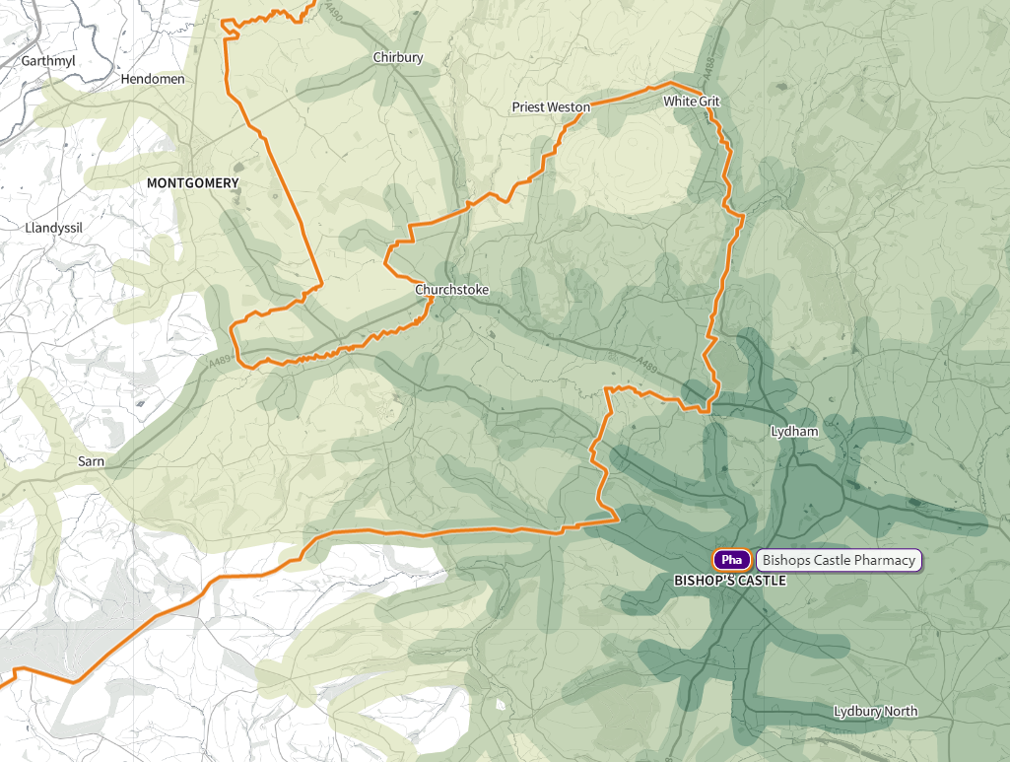

© Crown copyright and database rights 2021 Ordnance Survey 100016969 | parallel | Mapbox | OpenStreetMap contributors

Taking account of the above the health board does not consider the pharmaceutical needs assessment needs to be amended in light of this comment.

The following off-system comment was received in relation to this question.

“As outlined in Question 4, the needs identified have not been robustly evidenced and as such there is a question over whether these are needs in terms of Market Entry. To identify non-provision of a service as an unmet need creates a gap and a consequent invitation for applications to provide that service.

The PNA needs to contain copies of designated controlled area maps if it is to meet this requirement. This is particularly important given the rural nature of the Powys area.

The NHS (Pharmaceutical Services) (Wales) Regulations 2020 non-statutory guidance1 states:

Page 15 Pharmaceutical Services Provision by GPs –Within their PNA, LHBs will need to include information on the area or areas that their dispensing doctors have outline consent to dispense to, along with information on which premises those doctors have premises approval for. It is suggested that LHBs either include maps of their controlled localities within their PNA or provide the web link (URL) to where they are published on the LHB’s website.

Page 36 Maps of Controlled Localities - Under Paragraph 7 of Schedule 3 of the Regulations, LHBs continue to be under a duty to precisely delineate the boundary of any controlled locality that is determined on a map, or to remove the delineated boundary of a locality that has ceased to be a controlled locality. Such maps are to be made available for inspection and should be included in the LHB’s PNA. It is important that the boundaries of controlled localities are clearly marked, using appropriate geographical markers, for example rivers, not simply the squared off grid markings overprinted on Ordnance Survey maps. They should also be at a sufficient level of detail to enable any enquirer to tell whether any particular location falls within a controlled locality or not.

Page 36 Determination that an area is a controlled locality

Changes can occur to the appropriate designation of an area, particularly where an urban area is expanding into the surrounding countryside, or where there has been a substantial development permitted in what has hitherto been a controlled locality. The reverse is much rarer but can happen, for example, where an industrial area in the country (for example mining) ceases.

Without the inclusion of maps of controlled localities there is no assurance that patients receiving pharmaceutical services from their doctor, reside in properly determined controlled localities; there has been a lot of development on the outskirts of rural towns and, areas that were thought to be controlled localities may no longer be. In addition, unless the Health Board is able to provide evidence by way of a delineated map of their controlled areas the Health Board will not be able to take any action on any application it receives until it has been determined that the application is in a controlled area or not.

[Organisation] reserves the right to inspect maps of controlled area in line with Paragraph 7 of Schedule 3 of the Regulations and, to request a determination as to whether or not an area is controlled in line with Regulation 13 (2).”

The health board has noted the non-statutory guidance which indicates that maps of controlled localities should (rather than must) be included in the pharmaceutical needs assessment. It has noted that to do so is not a statutory requirement. As the pharmaceutical needs assessment will be in the public domain for up to five years, and sections cannot be updated on an as required basis, there is a risk that including the current controlled locality maps means that they will remain in the public domain even if they are subsequently amended following a determination under regulation 13(2) of the NHS (Pharmaceutical Services) (Wales) Regulations 2020.

The health board is, however, working with NHS Wales Shared Services Partnership to ensure that copies of the maps are available on request.

The survey then asked whether the document has provided information to inform how pharmaceutical services may be commissioned in the future. The health board has noted that the majority said it has.

Figure 22 – Has the pharmaceutical needs assessment provided information to inform how pharmaceutical services in the health board’s may be commissioned in the future?

Two comments were made in response to this question.

- Yes - Mentions needs in Llanwrtyd which does not affect Haygarth
- No - There appears to be no mention dealing with cross-border (Wales-England) objections, or in the case of Churchstoke of objections from [name of practice].

The health board has noted the first comment.

The following off-system comment was received in relation to this question.

“The purpose of the PNA is to assess and set out how the provision of pharmaceutical services can meet the health needs of the population of a health board’s area for a period of up to five years. There is no provision within the PNA to look beyond a five year period.

It is unclear whether a robust exercise will now be undertaken to match the significant opportunities to meet the health needs of local patients with the underutilised capacity in the local community pharmacy network.”

The health board is pleased to note that there is underutilised capacity within pharmacies and can confirm that it will continue to work with pharmacies to extend the range of enhanced services that are commissioned.

Turning to whether or not the pharmaceutical needs assessment has provided enough information for contractors to plan future pharmaceutical services provision the health board has noted that only one respondent said no.

Figure 23 – Has the pharmaceutical needs assessment provided enough information to inform future pharmaceutical services provision and plans for pharmacies and dispensing appliance contractors?

One comment was left in response to this question, namely that there appears to be no mention dealing with cross-border (Wales-England) objections, or in the case of Churchstoke of objections from [name of practice]. The health board has responded to this comment above.

One off-system comment was made in relation to this question.

“In section 1.5.4 the PNA has assessed pharmacy contractors’ ability to increase capacity should there be an increase in demand for pharmaceutical services via the pharmacy contractor questionnaire (AWPD exercise). The exercise confirmed that 16 pharmacies (70%) said that they have sufficient capacity within their existing premises and staffing levels to meet an increase in demand, with the remaining seven pharmacies (30%) saying they didn’t but could make adjustments in order to do so. It was also pleasing to note that a significant part of the network was also investing in the future with 12 pharmacies having plans to develop or expand their premises or service provision. This should provide the health board with the confidence to develop the contribution made by its pharmacy network.

It is noted that not all dispensing doctors responded to the dispensing doctor questionnaire. The absence of answers to the Dispensing Doctor questionnaire leads to a hiatus in the understanding of the: the delivery options made available by dispensing doctors; capacity to cope with additional demand and the availability of other dispensing related services in some areas.

There is conflicting information in relation to population: On page 4 of the executive summary it is stated that “The mid-year 2019 estimates put the health board’s population at 132,435 and it is projected that the population will decline in size during the lifetime of this document” but on page 20 it is stated that “demand for pharmaceutical services is increasing for a number of reasons including the continued increase in the number of items being prescribed and a growing population.” A growth or decline in population may affect future pharmaceutical provision so this must be clear.

The PNA does include information on new developments where applicable. GP Practice mergers and relocations have also been considered. It is noted that there are no planned GP practice mergers but one practice, Caereinion Medical Practice, will be moving into a new health centre in 2022 (an already approved move).”

The health board has noted this comment and can confirm that the statement on page 20 has been corrected.

The consultation then asked whether there are any pharmaceutical services that could be provided in the future by pharmacies that have not highlighted. The health board is pleased to note that no-one has identified such services.

Figure 24 - Are there any pharmaceutical services that could be provided in the community pharmacy setting in the future that have not been highlighted?

One off-system response was received in relation to this question.

“The PNA reviews the provision of Essential, Advanced and Enhanced Services in each of the 3 clusters. The review of enhanced services however has been undertaken with reference to the current list of commissioned services and has not looked at those services that could be put in place to meet identified population needs.

Section 1.1 on page 8 clarifies that ‘The purpose of the pharmaceutical needs assessment is to assess and set out how the provision of pharmaceutical services can meet the health needs of the population of a health board’s area for a period of up to five years’. This sets out a broader ambition where the needs of the population are assessed and those that can be delivered effectively and competently by the community pharmacy network will be treated as ‘pharmaceutical services’. CPW shares this broader view and would encourage the health board to look again at population health and wellbeing needs that could be met by community pharmacy. For example section 3.1.3 P48 sets out the challenge in managing diabetes in that, ‘with Aneurin Bevan University Health Board, Powys Teaching Health Board has the highest death rate (age-standardised) (2015-2017) at 12.3 per 100,000 population, compared to 11.0 per 100,000 population for Wales’ with the ‘highest prevalence rate in Mid Powys locality’. Community pharmacies see diabetic patients regularly, , and are well placed to educate, monitor and jointly manage people with diabetes and yet to date there is no official diabetes service in place.

Similarly section 3.2.1 on P53 confirms that ‘Alcohol is a major cause of death and illness in Wales with around 1,500 deaths attributable to alcohol each year (1 in 20 of all deaths). Across Wales consumption of alcohol has slightly decreased and adults under 45 now drink less. Whilst this decrease is good news, it masks persistent or increased drinking in over 45 year olds. Across Powys, 20.9% of respondents to the National Survey for Wales self-reported as non-drinkers, 61.0% as moderate drinkers, 15.2% as hazardous drinkers and 2.8% as harmful drinkers’. There is clearly a real opportunity to improve the health and wellbeing of the people of Powys by supporting them to reduce their alcohol consumption. Helping someone to reduce their alcohol consumption is an exercise in change management and is no different to helping someone to quit smoking. Over many years the pharmacies in Powys have demonstrated their ability to change the behaviour of smokers and yet the skills of the network and the accessibility of the network has not been leveraged to reduce alcohol consumption.

As pharmacies have confirmed their capacity to take on more services, [organisation] feels that an opportunity should not be lost to utilise the excellent work undertaken in conducting the PNA in order to develop a comprehensive list of local services to be introduced in the years ahead so that pharmacy capacity and local population needs can be better aligned.”

As stated above, the health board is pleased to note that there is underutilised capacity within pharmacies and can confirm that it will continue to work with pharmacies to extend the range of enhanced services that are commissioned.

Views were then sort on any impact the pharmaceutical needs assessment may have on the Welsh language.

In response to whether there are any developments that could:

- Have a positive impact upon Welsh speakers,
- Help to increase opportunities for people to use the Welsh language, or
- Reduce any negative impacts upon Welsh speakers

Two people said ‘Yes’.

Figure 25 – Are there any developments in pharmaceutical services that could: a) have a positive impact upon Welsh speakers? b) help to increase opportunities for people to use the Welsh language? c) reduce any negative impacts upon Welsh speakers?

Three comments were made in response to this question.

- No – No idea about the current provision or demand for Welsh services. It certainly is not high in our region and not something that plays a big role
- Yes – Reinstate local dispensing services in branch surgeries, use these as bases for additional community based services for rural areas to supplement the services provided via pharmacies in larger urban areas.
- Yes – There should be an opportunity for Welsh language labelling and instructions for those who need or request it.

The health board has noted that the first comment was made by a dispensing practice. The second comment is linked to the previous comment regarding Sennybridge and the health board has responded to it above.

With regard to the third comment, the health board has noted that The Medicines Act 1968 requires dispensing labels to be printed in English. As a minimum, therefore, any labels would need to be bilingual, and this would lead to labels that are too large to fit onto many of the containers that medicines are dispensed into or are available in. In addition, it may lead to the braille labelling on the box being covered over. The health board has therefore not amended the pharmaceutical needs assessment in respect of this point but has noted the suggestion.

The health board has noted the off-system comment that was received in relation to this question.

“The community pharmacy network is the most accessible part of the NHS in Powys and successfully provides a range of health and well-being services to those who’s preferred language is not English. [Organisation] feels strongly that use of the Welsh language in the delivery of pharmaceutical services is vitally important and believes that all Welsh speakers will continue to be treated with dignity and respect.

The network complies fully with the Welsh Language Standards as they apply to the health sector.

The Health Board has the ability to publish a list of pharmacies which provide their services in the Welsh language if they so choose.”

When asked if the developments in pharmaceutical services will treat the Welsh language any less favourable than the English language the health board has noted that one person said ‘Yes’ and one said “No”.

Figure 26 - Will the developments in pharmaceutical services treat the Welsh language no less favourably than the English language?

Two comments were made in response to this question.

- Don’t know – Very little Welsh spoken in our population
- No - Welsh language will be treated less favourably if there is no opportunity for Welsh language labelling and instructions for those who need or request it.

The health board has responded to the second comment above.

The health board has noted the following off-system response to this question.

“[Organisation] is confident that the provision of future pharmaceutical services will equally meet the needs of Welsh speakers. Those members of staff that are Welsh speakers wear badges to identify themselves and health board translation services are available for those that require the service.

It is important however to recognise that there is a patient safety consideration, in that there is a risk that a less than accurate translation could affect the quality and accuracy of healthcare decisions made, to the detriment of the patient and therefore we believe, at least in the lifetime of the PNA, that clinical consultations will continue to be recorded through the medium of English.”

In order to ensure that no developments had been missed the consultation asked if there any developments that will arise within the lifetime of the pharmaceutical needs assessments that have not been identified. For example, housing developments, regeneration projects, or new premises for the provision of NHS services. One person said “Yes”.

Figure 27 - Are there any developments that will arise within the lifetime of the pharmaceutical needs assessments that have not been identified?

Two developments were identified:

- The development of the proposed health hub in Newtown, and
- The growing residence and employment in Churchstoke.

With regard to Newtown, the health board has noted the timing of this development and that it is expected to fall within the lifetime of the next pharmaceutical needs assessment as it is at a very early stage.

The health board has noted that 160 houses are to be built in Churchstoke between 2011 and 2026 but is of the opinion that this would not lead to a need for a pharmacy within the village particularly as there is no evidence that residents have difficulty accessing pharmaceutical services at present.

The health board has noted the following off-system response to this question.

“We are not aware of any developments that may arise within the lifetime if this PNA that have not been identified. However, individual pharmacy contractors, members of the public and others with local knowledge may well alert the health board of any developments they are aware of.”

The consultation then asked where respondents agreed with the conclusions of the pharmaceutical needs assessment and the health board has noted that three said “Yes” and three said “No”.

Figure 28 - Do you agree with the conclusions of the pharmaceutical needs assessment?

Two people who said “No” expanded upon their response.

- Access to pharmacy/dispensing services in the south of the county needs to be addressed/reinstated.
- For the reasons stated above [Churchstoke]

The health board has responded to both of these points above.

The following off-system response was received in relation to this question.

“[Organisation] agrees that there are no current or future gaps in the provision of any Essential or Advanced Services nor any gaps in future Enhanced Services. In relation to the supposed gaps in current Enhanced Services we recommend that the PNA is reworded to reflect the need for the existing pharmacy in Llanwrtyd Wells and the Health Board to work together to increase the availability and uptake of the service, rather than identify a formal “gap in the provision of pharmaceutical services.”

The health board has responded to this point above.

Finally, those responding to the consultation were asked whether they had any further comments. Two people did.

- Is Sustainability being looked at in both prescribing (eg inhalers) and procurement of medications?
"Green Health Wales" is working to promote these principles in line with the Decarbonisation Strategy set out by the Welsh Government and the Future Generations Act and can provide information if required or contact [name], PTHB sustainability manager.
- With reference to access within 20 minutes by car,
• Executive Summary, page 2
• Conclusions, para 11.3.1
• Full Assessment, para 5.1.1 and 11.3.1
…we ask that the PTHB use a more sophisticated means of accessing access other than 20 minutes by car which equates to approx. 13.5miles.

The health board has noted that the first comment relates to a matter that is outside the scope of the pharmaceutical needs assessment and therefore no amendment of it is required.

The health board notes that all of the Welsh health boards have adopted a travel time of 20 minutes by car and is therefore satisfied that this is a satisfactory measure to use. It does however recognise the rurality of the area and the standard of the road network.

The following off-system response was received from another health board.

“Thank you for sharing the Powys Teaching Health Board’s first Pharmaceutical Needs Assessment. As [name of health board] shares a border with yourselves we acknowledge that you have identified a need for the provision of the enhanced service’s Emergency Hormonal Contraception, Smoking Cessation Level 3, Flu Vaccination, Common Ailment Service and Emergency Medicine Supply in the Llanwrtyd Wells area, a town around 4 miles from the Hywel Dda-Powys Border.”

The health board has noted this response.

One other off-system response was received to this question.

- “a) Locality Chapters – it would be helpful for the reader if a list of the pharmacies and their addresses were contained within each cluster’s chapter.

- b) There appears to be a discrepancy between the information from 2011 census data on car ownership (24.3% of the households in the health board’s area did not have a car or van) when compared to Figure 9 which indicates 15% of the households do not have a car or van. It is suggested that the data contained within the PNA is checked to ensure the correct statistics have informed the PNA.

- c) Some of the maps are not discernible and are missing some of the towns and possibly pharmacies e.g. Map 16 does not name the major town of Newtown. This makes it very difficult for the reader to distinguish the area the hat section/chapter is referring to.

- d) Page 76 – There is conflicting information regarding whether the dispensing doctor premises were taken into account for the purpose of drive times. It is stated that the Health Board has chosen a travel time of 20 minutes by car as an appropriate access standard (we are surprised in a rural area that this was not nearer 30mins). In order, to assess whether residents are able to access a pharmacy in line with this standard travel times were analysed by any NHS Wales Informatics Service. The text then goes on to say “As can be seen from the map below, there are parts of the health board that are not within a 20 minute drive of a pharmacy or dispensing doctor premises”. A detailed map shows the areas which are not within a 20 minute travel time of a pharmacy; they tend to be in areas of very low population density. The health board then makes the statement “the position would improve if access to the dispensing practice premises is taking into account”.

[Organisation] suggests that it is made clear whether drive times to dispensing doctor premises are taken into account and if they are not, why?

- e) In section 1.5.2, Page 17 it is noted that ‘when asked if they are aware of the other services that pharmacies provide as part of the NHS, the services that people were most aware of are:

Flu vaccinations (second most commonly used),
Common ailments scheme (most commonly used),
Medicines use review service (third most commonly used), and
Help to stop smoking’.

As awareness of community pharmacy services is not as high as it could be, [Organisation] would suggest that this identifies a need to step up communications and marketing within the Health Board area if transfer of workload away from GP practices, and other less appropriate providers, is to be achieved. [Organisation] would encourage the health board to embark on a local marketing and awareness raising campaign to encourage the local population to Choose Well.

[Organisation] recognises the work undertaken by PTHB to produce their first Pharmaceutical Needs Assessment.

We would suggest that the PNA is reworded to reflect the need for existing providers of pharmaceutical services and the Health Board to work together to increase the availability and uptake of the service, rather than identify a formal “gap in the provision of pharmaceutical services”.

[Organisation] would encourage the Health Board to take advantage of the work undertaken, by using the health and needs data within the PNA to inform the development of the community pharmacy network going forward.

In response:

- This information is available in appendix L but has been added to each locality chapter.
- This has been corrected and the health board can confirm that the information in the graph is the correct information.
- This issue has been raised with the team that produced the maps. Due to software and scaling issues it cannot, unfortunately, be resolved.
- The pharmaceutical needs assessment has been clarified that it is only travel times to a pharmacy that have been mapped and an explanation as to why travel times to a dispensing practice have not been mapped has been added to section 5.1.1.
- The health board has noted this comment.

4 Summary conclusions

The health board is pleased to note that the overall response to the consultation has been positive. No concerns have been raised regarding non-compliance with the regulatory requirements, no pharmaceutical services provision has been missed and the main conclusions are agreed with other than in relation to the identification of the need for specified enhanced services in Llanwrtyd Wells.

The health board has considered whether or not the pharmaceutical needs assessment requires modification in light of the consultation and has determined that it does not, other than in relation to:

- the additional information which has been included in relation to the provision of pharmaceutical services,
- information related to the number of items prescribed in 2020/21 and where they were dispensed, and
- some minor typographical corrections.

A list of all the amendments made can be found in section 6 below.

5 Equalities monitoring

Three of the eight responses were from members of the public. Of these:

- One is 35 to 44 years old, one is 45 to 54 years old and one is 55 to 64 years old;
- At birth two were described as female and one as male;
- Two describe themselves as female and one as male;
- One describes themselves as British, one as English and one as Welsh;
- All three describe their ethnicity as White;
- With regard to sexual orientation, one said they are heterosexual/straight and two preferred not to say;
- With regard to religion, one said they are Christian (all denominations) and two preferred not to say;
- One is married or in a same-sex civil partnership, one is not and one preferred not to say
- Two said that they do not consider themselves to be disabled, and one preferred not to say;
- All three stated that their preferred language is Welsh;
- One said they cannot understand spoken Welsh, can cannot speak, read or write Welsh. Two preferred not to say; and
- One said that they look after or give help or support to family members, friends, neighbours or others because of either a long term physical or mental ill-health disability or problems related to old age. One said they do not and one preferred not to say.

6 Amendments

The following amendments have been made to the pharmaceutical needs assessment:

- A change of ownership application was granted for the pharmacy at 51 Long Bridge St, Llanidloes and since 27 April 2021 has been owned by How Pharm Ltd.
- The executive summary has been amended to reflect the fact the consultation has now taken place.
- Section 1.1. has been amended to clarify that there are only two types of application for inclusion in the pharmaceutical list that are not based on needs identified in the pharmaceutical needs assessment.
- Section 1.5.6 has been amended to reflect the fact the report on the consultation is now included at appendix K.
- Section 2.14 has been amended so that the bullet points and graph match.
- Section 5.1. has been amended so that it states “August 2021” rather than “November 2020”.
- The number and percentage of people dispensed to by their GP practice has been updated in various sections to reflect the position as of May 2021.
- Information on the percentage of items dispensed by pharmacies in the health board’s area along with the percentage dispensed or personally administered by the GP practices has been added to various sections.
- Those sections referring to access to premises have been amended to make it clear that the travel time is only to pharmacies and does not include the travel time to dispensing practices. An explanation as to why that has not been included has been added to section 5.1.1.
- Those sections referring to opening hours have been updated to reflect the position as of August 2021. However, there had been no changes since the consultation version of the document was finalised.
- Information on the number of pharmacies providing each of the advanced and enhanced services has been updated in chapters 5, 8, 9 and 10 to reflect the outturn position for 2020/21 and the position as of August 2021 has been added.
- Section 5.1.4 has been updated to reflect the fact the cap on the number of discharge medicines reviews that a pharmacy can undertake in a year has been removed.
- Section 5.1.16 has been updated to reflect the fact the care home service was suspended during the Covid pandemic and was reintroduced in April 2021 pending a national review of the service specification.
- Section 5.2.1 has been updated to include information for 2020/21.
- Chapter 6 - information on the number of items prescribed by the GP out of hours service, continence community specialist nursing service and optometrist independent prescriber in 2020/21 has been added, along with details of where they were dispensed.
- Section 6.11- the map showing the location of smoking cessation services has been updated to reflect the position as of August 2021.
- The locality chapters have been updated to include information on where prescriptions were dispensed in 2020/21.
- The “Other NHS services” section of each of the locality chapters has been updated to include information on the number of items prescribed in 2020/21 and where they were dispensed.
- The “Choice with regard to obtaining pharmaceutical services” section of each of the locality chapters has been updated to include information on the number of contractors that dispensed items written by the GP practices in 2020/21.
- Executive summary and chapter 9 – the health board’s preference to work with the existing pharmacy in order to meet the need for specified enhanced services has been added in the relevant sections.

Appendix L – opening hours

Powys Local Development Plan 2011-2026
Health Maps Wales, NHS Wales Informatics Service
StatsWales. Population density per square kilometre of land area (1991 onwards), by Welsh local authorities
ONS UK business: activity, size and location
Brecon Beacons National Park Local Development Plan 2007-2022
StatsWales mid-year 2019 population estimates by local authority
StatsWales mid-year 2019 population estimates by local authority
Visit Britain, GB Tourism Survey 2019 annual report
These figures also include Ceredigion and Powys.
Visit Britain, The Great Britain Day Visitor 2019 annual report
Visit Britain, International Passenger Survey 2019
Nomis KS201EW - Ethnic group
Nomis DC2105EW – proficiency in English by age
Nomis QS204EW main language
Nomis KS207WA Welsh language skills
Welsh Government, Welsh Index of Multiple Deprivation 2019
StatsWales, Total Fertility Rate and General Fertility Rate by area
Powys Wellbeing Assessment 2017
Public health Wales Observatory, Measuring inequalities 2016. Trends in mortality and life expectancy in Powys Teaching Health Board
Powys Wellbeing Assessment 2017
Nomis QS303EW - Long-term health problem or disability
Public health Wales Observatory, Measuring inequalities 2016. Trends in mortality and life expectancy in Powys Teaching Health Board
Nomis KS404EW - Car or van availability
The Welsh NHS Confederation, The key priorities for carers in Wales
Welsh Government Gypsy and traveller caravan count, January 2020
Nomis DC2101EW Ethnic group by sex by age
Powys County Council, Powys Homelessness Review
Welsh Government National rough sleeper count: November 2019
Welsh Cancer Intelligence and Surveillance Unit cancer incidence in Wales, 2001-2017
NHS Wales Informatics Service, Health Maps Wales - mortality
Diabetes UK, Diabetes in Wales
NHS Wales Informatics Service, Health Maps Wales - endocrine, nutritional and metabolic diseases
GP QOF database, Wales 2019 data
Powys Well-being Assessment, 2017
NHS Wales Informatics Service, Health Maps Wales – external causes of morbidity and mortality
Social Care Wales Population Projections Platform, Daffodil Cymru
ASH, Smoking and respiratory disease factsheet, September 2020
NHS Wales Informatics Service, Health Maps Wales – diseases of the respiratory system
Public Health Wales, HIV and STI trends in Wales data tables, June 2017
Public Health Wales Observatory, Public Health Outcomes Framework
Public Health Wales Observatory, Public Health Outcomes Framework
Public Health Wales Observatory, Alcohol in Wales
StatsWales, Adult lifestyles by local authority and health board
StatsWales, Adult lifestyles by local authority and health board
Pharmacy consumer research. Pharmacy usage and communications mapping – Executive summary. June 2009
Gender Identity Research and Education Society Trans Health Factsheets
Aldridge RW et al. Morbidity and mortality in homeless individuals, prisoners, sex workers, and individuals with substance use disorders in high-income countries: a systematic review and meta-analysis. Lancet 2018;391(10117):241-50
Faculty for Homeless and Inclusion Health, Homeless and Inclusion Health standards for commissioners and service providers October 2018
O’Connell JJ. Premature Mortality in Homeless Populations: A Review of the Literature. Nashville, National Health Care for the Homeless Council. 2005
Toxic Mix: The health needs of homeless young people, Centrepoint 2014
Matthews Z. The health of Gypsies and Travellers in the UK. Better Health Briefing Paper 12. Race Equality Foundation. 2008.
Cemlyn S et al. Inequalities experienced by Gypsy and Traveller communities: A review. Equality and Human Rights Commission. 2009
Fitzpatrick S et al. Multiple exclusion homelessness amongst migrants in the UK. Eur J Homelessness 2012;6(1):31-58
Borland R and Zimmerman C. Caring for trafficked persons: Guidance for health providers. Geneva, International Organization for Migration. 2012
Gwent Social Services and Well-being Act Population Needs Assessment May 2017
Hampshire County Council Veterans, Reservists and Armed Forces Families Health Needs Assessment 2015
National Public Health Service for Wales, 2005. Health Impacts of Seasonal Demographic changes in areas with high levels of tourism in the UK – Key findings from the literature.
Journal of Immigrant and Minority Health (2021) 23:298-307, Perceptions and Experiences of Health and Social Care Utilisation of the UK‑Nepali Population, Simkhada et al
Help Me Quit
Public Health Wales Observatory Public Health Outcomes Framework reporting tool
Powys Local Planning Authority Joint Housing Land Availability Study (2019)
Public Health Wales Observatory Public Health Outcomes Framework reporting tool
Powys Local Planning Authority Joint Housing Land Availability Study (2019)
Public Health Wales Observatory Public Health Outcomes Framework reporting tool
Powys Local Planning Authority Joint Housing Land Availability Study (2019)
Brecon Beacons National Park Authority Annual Monitoring Report 2018/19
On the fourth week, a pharmacy opens over the border in the area of Swansea Bay University Health Board.

